Exempt Dealing and Notifiable Low Risk Dealing (NLRD) Application Form and Record of Assessment,

Applicants to Complete Sections 1–21 ONLY

Research Office use only

La Trobe Institutional Biosafety Committee (LTIBC) Number
Approval Date
Expiry Date
OGTR Submission Number
OGTR Submission Date

1 | Project Title

2 | Principal Investigator
Is this person a La Trobe University staff member? |  |  |  | YES |  |  | NO
Name
Position
Qualifications |  |  |  |  |  | Staff ID Number:
Research group
Department
School
Organisation
Phone no.
Email address
Will this person undertake dealings? |  |  | YES |  | NO

3 | Does this application replace an existing approval?
YES NO
If YES provide all relevant reference numbers

4 | How is the project funded?  Provide funding details and all relevant reference numbers

5 | Are any other approvals required for this project?
YES NO
Human ethics PRIME number: |  | Animal ethics PRIME number: | Other:

6 | Is this project a collaboration with an external party?
YES NO
If YES provide the name and role of all collaborative parties

7 | Project Objectives  Note that objectives should be concise and express the purpose of the dealings

8 | Project Summary  Provide a simple overview of the program of activity that involves Gene Technology (i.e. background, aims, intended use/purpose of the Genetically Modified Organism (GMO) etc.)

9 | Dealings Classification Summary  Note that more than one box may be checked
 | List the classification(s) as determined from Schedule 2 and Schedule 3 of the current Gene Technology Regulations 2001 [e.g., Sch 2, Part 2, Item 9; Sch 3, Part 2.1(e)]
Type of Dealing |  | Classification
Exempt Dealing
NLRD Suitable for PC1
NLRD Suitable for PC2
NLRD Suitable for PC3
NLRD Suitable for PC1 and PC2
You MUST confirm the following. If your dealings are an NLRD in Schedule 3 Part 3, then contact the Ethics, Integrity and Biosafety team on biosafety@latrobe.edu.au to discuss GMO licence requirements.
Not an NLRD listed in Schedule 3, Part 3 | Comments:

10 | Types of GMOs – Host organism, vectors and donor genetic material  List all of the GMOs to be generated or used
Common name and scientific name of the unmodified host |  | Vectors and method of transfer | Donor genetic material –  identity, class and species of origin | Classification of dealings as per Section 9

11 | Personnel

Class(es) of Personnel who may work with the GMOs
Note that more than one box may be checked
Researchers (e.g., Post-Docs/Technicians)
Students (e.g., Undergraduate and Postgraduate)
La Trobe Animal Research and Teaching Facility (LARTF) Personnel
Visitors (only those that will deal with a GMO)
Support staff (only those that will deal with a GMO)
Contractors (e.g., for waste disposal or transport)
Other (specifically indicate who):

Will Personnel have appropriate training?
Note that all Personnel who intend to work with GMOs must complete La Trobe University Biosafety and Biosecurity Awareness Training (BBAT) available on LMS and facility induction training. The Principal Investigator must ensure that all training is undertaken by Personnel prior to the commencement of their work with GMOs.
The Principal Investigator must maintain a list of Personnel applicable to this project and records of training within the Certified Facility.
All Personnel that will be dealing with the GMOs must be listed in the ‘Research Personnel’ tab in PRIME. Following approval of your application, submit the Biosafety Personnel Training Record for Dealings with GMOs in PRIME that includes all current Personnel that will be dealing with the GMOs. Please note that an updated Biosafety Personnel Training Record must be submitted with your annual report every year.
YES NO
If NO provide an explanation/justification for LTIBC assessment

Details of any additional training required
Provide details of any additional training that may be required to carry out dealings described in this application (e.g., other laboratory inductions, working with retro-viral systems, cell culture techniques, animal handling, etc.)

12 | Facilities

Class(es) of the Office of the Gene Technology Regulator (OGTR) certified facilities required for work with GMOs
Note that more than one box may be checked
PC1 Facility
PC2 Laboratory
PC2 Animal Facility
PC2 Plant Facility
PC2 Invertebrate Facility
PC2 Aquatic Facility
PC2 Constant Temperature Room
PC2 Large Scale Facility

List all of the facilities to be authorised under this project
Building name | Room number(s) | Classification level and facility type | Certification number | Certification expiry date
e.g., R.L Reid Building | Level 1: Rooms 101–104 | PC2 Laboratory | Cert-3543 | 01.06.2025

13 | Hazard identification involving the proposed GMO dealings

Are any of the proposed HOST organisms, or classes of GMOs, potentially harmful to, or have a history of causing disease in otherwise healthy organisms and/or the environment?
Healthy organism | Identified hazard(s)
Humans
Animals
Plants
Environment
No, none of the host organisms or classes of GMOs are considered harmful to any of the above

Will, or have, any viral vectors be used in the project?
If YES use the OGTR tables to assist with appropriate classification in section 9
YES NO | Comments:
Are the viral vectors replication defective?
YES NO NA | Comments:
Can the vectors transduce/infect human cells?
YES NO NA | Comments:

Are any of the proposed DONOR DNA considered harmful to humans?
No, the donor DNA has been characterised, does not confer an advantage and is not considered harmful
 | Donor DNA considered to be Pathogenic, or that are implicated in causing disease | Comments:
 | Donor DNA considered to be Oncogenic in humans | Comments:
 | Donor DNA considered to be Immunomodulatory in humans | Comments:
 | There is an advantage conferred on the organism by the genetic modification | Comments:
 | The modification increases virulence, pathogenicity or transmissibility | Comments:
 | The GMO secretes or produces an infectious agent | Comments:
 | The donor DNA is not characterised | Comments:
 | The donor DNA encodes a toxin, or is from a toxin producing organism(s) | Comments:

Are there any additional potential hazards to human health and/or the environment (e.g., use of sharps, use of animals, creation of aerosols etc)?
YES NO | Comments:

14 | Risk Management of proposed GMO dealings
Based on the potential hazards identified in section 13, document the risk analysis and describe the control measures to be implemented to mitigate harm to humans, animals, plants and/or the environment (exposure to or release into the environment of the GMO). See the pages below for risk assessment criteria.
Identified hazard |  | Risk | Likelihood  (without controls in place) | Consequence (without controls in place) | Risk rating | Control measures | Risk rating with implemented controls
e.g., E. coli containing vector that expresses gene A |  | Exposure of personnel to aerosols from mixing, vortexing and/or centrifugation of samples/cultures | Possible | Minor | Moderate | - All tubes allowed to rest for at least 1 minute prior to opening  - Where aerosols are likely, properly fitted P2/N95 masks worn by users  - For cultures of risk group 2 microorganisms, all work will be undertaken inside a Class 2 Biological Safety Cabinet  - Centrifugation using aerosol prevention caps/safety buckets where necessary | Low

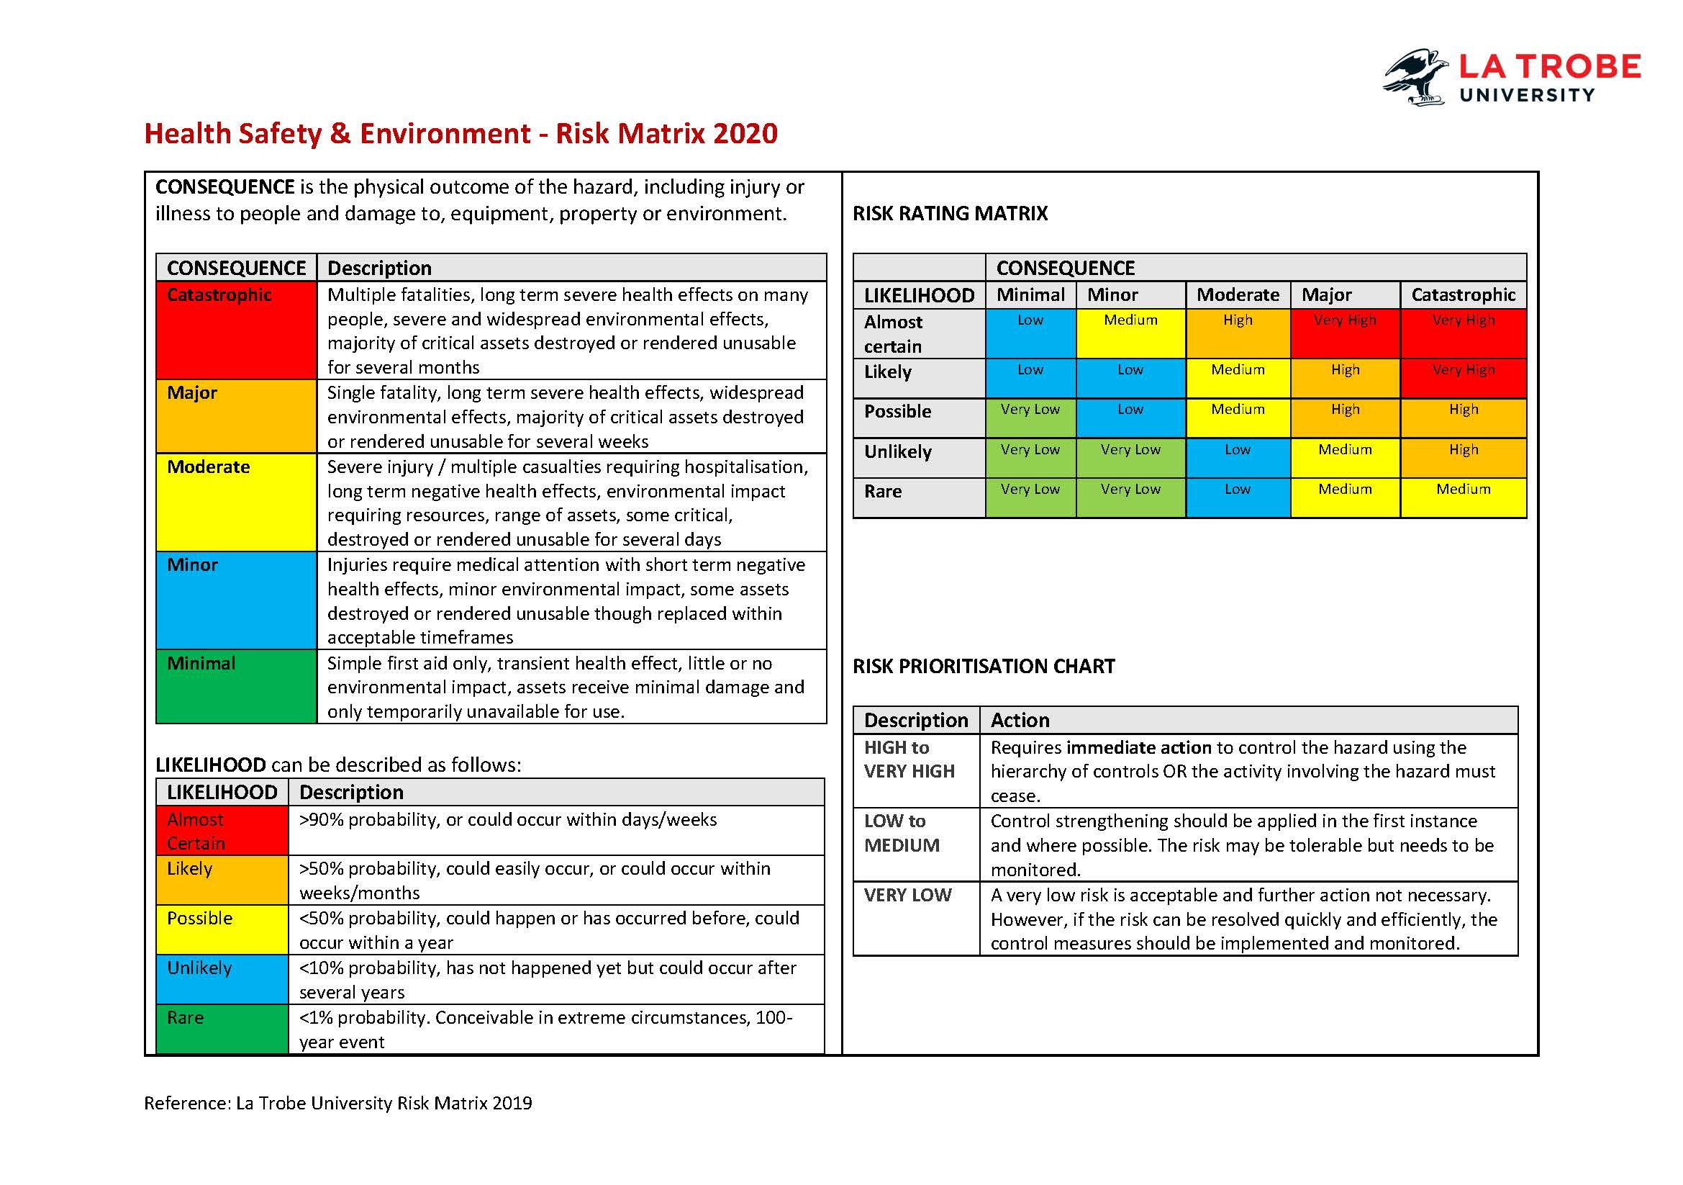

Hierarchy of controls

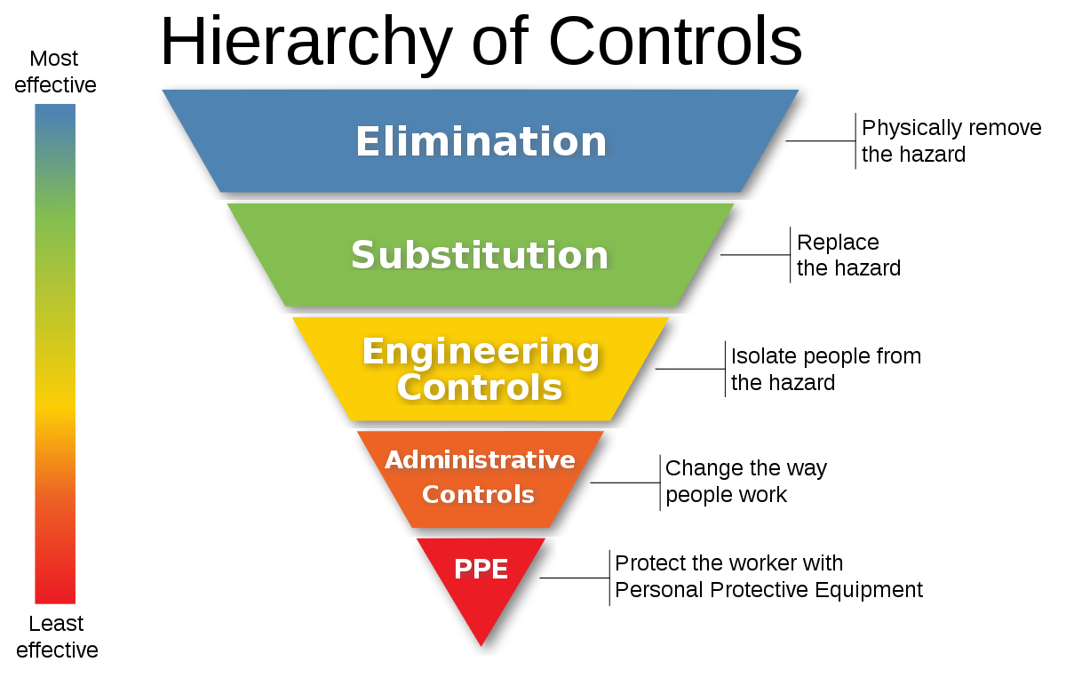

Types of controls
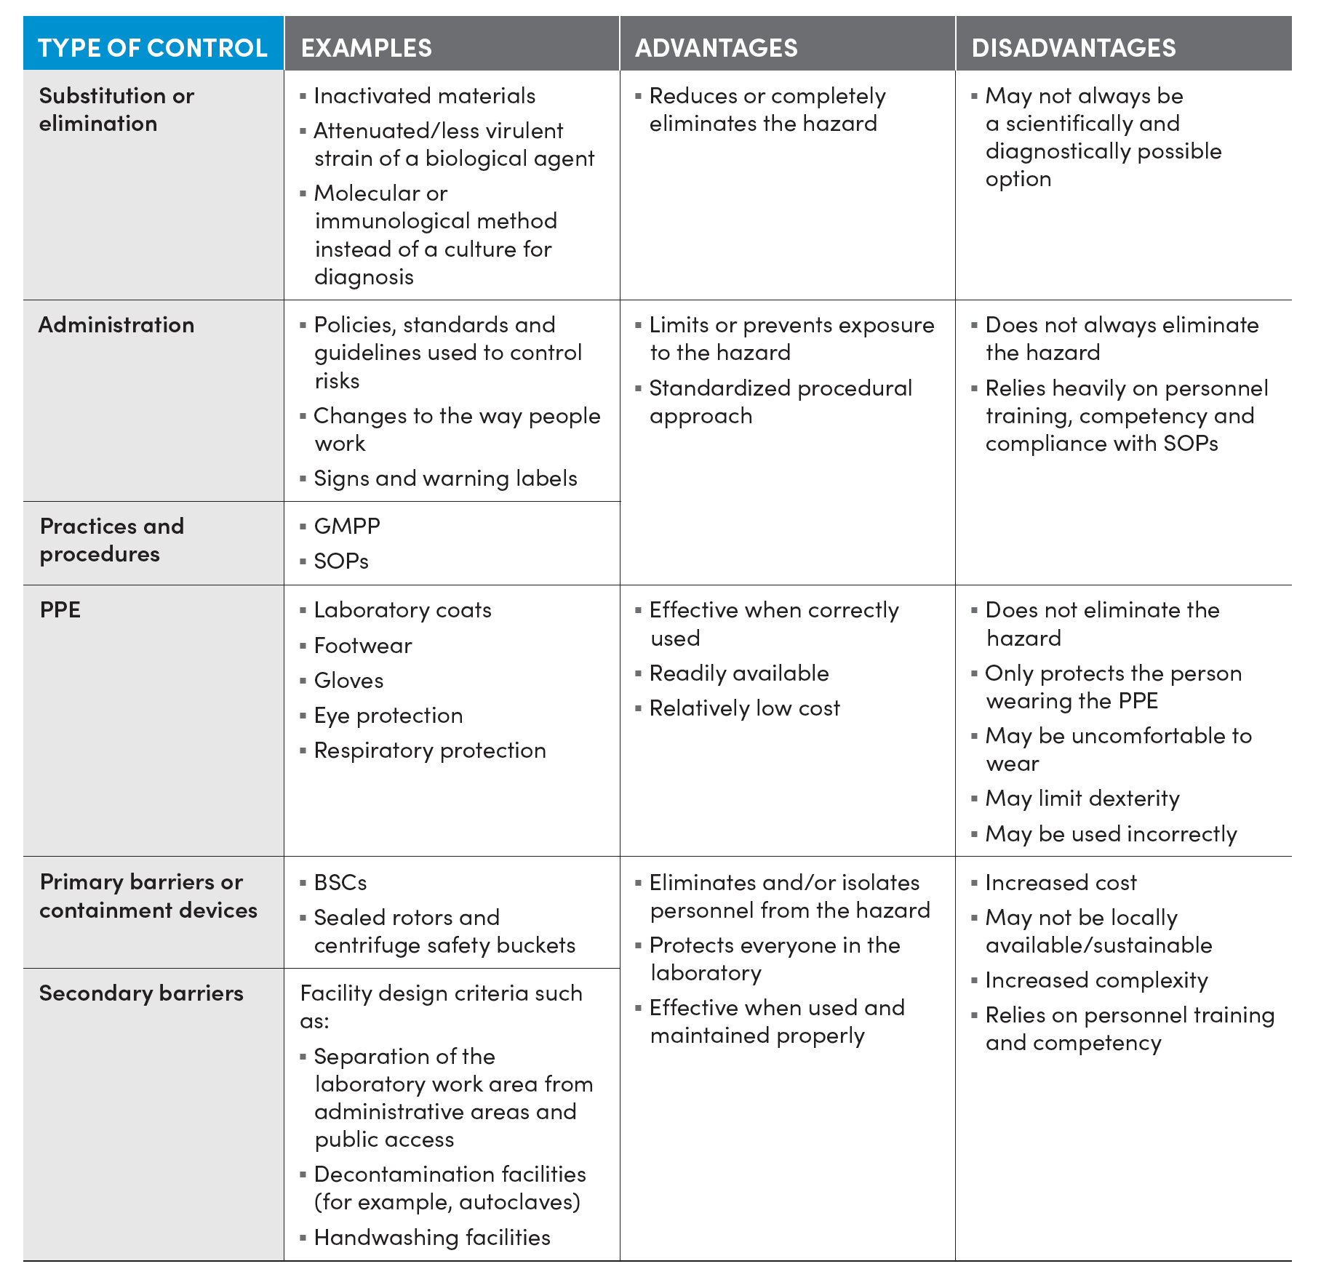

15 | Action Management Plan for an unintentional release of a GMO
In the event of an unintentional release of a GMO the following must be followed:
- Relevant notifications made (i.e. Facility supervisor, Ethics, Integrity and Biosafety (EIB), LTIBC, OGTR), noting that the EIB will notify the OGTR.
- Noting the location(s) and extent of presence or escape of the GMO(s).
- Containment and recovery strategies (if applicable) implemented.
- Methods for rendering the GMO(s) non-viable (if applicable) undertaken.
- Following instructions provided by representatives of the LTIBC and/or OGTR.
Note: in the event of a suspected unintentional release, the LTIBC must be notified immediately
Acknowledgment to follow this action plan
YES NO |  | Comments:

16 | Do you intend to import GMOs into Australia?  You need to ensure that you have the necessary import approvals (e.g., import permit) and that the conditions of use in that permit allow for GMOs and the activities/dealings that you require. Transport must be in accordance with the current OGTR Guidelines for the Transport, Storage and Disposal of GMOs and the LTIBC Guidelines for the Transport of Biological Material
YES NO |  | Comments:

17 | Do you intend to export GMOs out of Australia?  You need to ensure that you have the necessary registration approvals for the transfer
YES NO |  | Comments:

18 | Will there be transport of GMOs between certified facilities within LTU or external to LTU?  Transport must be in accordance with the current OGTR Guidelines for the Transport, Storage and Disposal of GMOs and the LTIBC Guidelines for the Transport of Biological Material
YES NO  within LTU  external to LTU |  | Provide transport details:

19 | Will there be storage of GMOs outside of certified facilities?  Storage must be in accordance with the current OGTR Guidelines for the Transport, Storage and Disposal of GMOs
YES NO |  | Provide storage details:

20 | How will GMOs be made non-viable and disposed of?  Provide decontamination and disposal details. Disposal must be in accordance with the current OGTR Guidelines for the Transport, Storage and Disposal of GMOs and the LTIBC Waste Management Guidelines

21 | Principal Investigator Declaration
- By submitting this application, I declare that I and the project personnel will comply with all legislative and regulatory requirements as they apply to gene technology and GMOs.
- I confirm that the information provided in this application is true and correct.
- I agree to report any deviations to the LTIBC as soon as possible.
- I will seek approval from the LTIBC for any modifications to the research prior to their implementation and understand that any modification that varies the scope of the original proposal assessed and approved by the LTIBC may require the submission of a new application.
- I agree to keep and maintain the records necessary for this approval regarding details of all GMOs used and held, and the training of all personnel undertaking dealings.

NAME:
SIGNATURE: |  |  | DATE:

How to submit this form
- Log into PRIME Researcher Portal
- Under Ethics Applications, click + New IBC Application
- Add all research personnel in the Research Personnel tab
- Upload all completed forms and supporting documentation as separate documents in the Documents tab
- Click on Submit to Research Office by the relevant closing date

Schedule 2—Dealings exempt from licensing
(regulation 6)
Note: Subregulation 6(1) sets out other requirements for exempt dealings.

Part 1—Exempt dealings

Item | Description of dealing
2 | A dealing with a genetically modified Caenorhabditis elegans, unless:  (a) an advantage is conferred on the animal by the genetic modification; or  (b) as a result of the genetic modification, the animal is capable of secreting or producing an infectious agent.
3 | A dealing with an animal into which genetically modified somatic cells have been introduced, if:  (a) the somatic cells are not capable of giving rise to infectious agents as a result of the genetic modification; and  (b) the animal is not infected with a virus that is capable of recombining with the genetically modified nucleic acid in the somatic cells.
3A | A dealing with an animal whose somatic cells have been genetically modified in vivo by a replication defective viral vector, if:
(a) the in vivo modification occurred as part of a previous dealing; and
(b) the replication defective viral vector is no longer in the animal; and
 | (c) no germ line cells have been genetically modified; and
(d) the somatic cells cannot give rise to infectious agents as a result of the genetic modification; and
(e) the animal is not infected with a virus that can recombine with the genetically modified nucleic acid in the somatic cells of the animal.
4 | (1) Subject to subitem (2), a dealing involving a host/vector system mentioned in Part 2 of this Schedule and producing no more than 25 litres of GMO culture in each vessel containing the resultant culture.
(2) The donor nucleic acid:
(a) must meet either of the following requirements:
(i) it must not be derived from organisms implicated in, or with a history of causing, disease in otherwise healthy:
(A) human beings; or
(B) animals; or
(C) plants; or
(D) fungi;
(ii) it must be characterised and the information derived from its characterisation show that it is unlikely to increase the capacity of the host or vector to cause harm; and
Example: Donor nucleic acid would not comply with subparagraph (ii) if its characterisation shows that, in relation to the capacity of the host or vector to cause harm, it:
(a) provides an advantage; or
(b) adds a potential host species or mode of transmission; or
(c) increases its virulence, pathogenicity or transmissibility.
(b) must not code for a toxin with an LD₅₀ of less than 100 micrograms per kilogram; and
(c) must not code for a toxin with an LD₅₀ of 100 micrograms per kilogram or more, if the intention is to express the toxin at high levels; and
(d) must not be uncharacterised nucleic acid from a toxin-producing organism; and
(e) if the donor nucleic acid includes a viral sequence—cannot give rise to infectious agents when introduced into any potential host species, without additional non-host genes or gene products that:
(i) are not available in the host cell into which the nucleic acid is introduced as part of the dealing; and
(ii) will not become available during the dealing; and
(f) if the donor nucleic acid includes a viral sequence—cannot restore replication competence to the vector.
5 | A dealing involving shot-gun cloning, or the preparation of a cDNA library, in a host/vector system mentioned in items 1 to 6 of the table in Part 2 of this Schedule, if the donor nucleic acid is not derived from either:  (a) a pathogen; or  (b) a toxin-producing organism.

Part 2—Host/vector systems for exempt dealings

2.1 Hosts and vectors
(1) A reference to a host mentioned in this Part is a reference to a host mentioned in column 2 of an item of the table in this clause.
(2) A reference to a vector mentioned in this Part is a reference to a vector mentioned in column 3 of an item of the table in this clause.
(3) A reference to a host/vector system mentioned in this Part is a reference to any of the following:
(a) a system involving a host mentioned in column 2 of an item of the table in this clause and a vector mentioned in column 3 of the same item;
(b) a non-vector system involving a host mentioned in column 2 of an item of the table;
(c) a system involving a GMO mentioned as a vector in column 3 of an item of the table (except item 7), without a host.
Note: Column 1 of the table is included for information only.

Hosts and vectors
Item | Column 1  Host class | Column 2  Hosts | Column 3  Vectors
1 | Bacteria | Escherichia coli K12, E. coli B, E. coli C or E. coli Nissle 1917—any derivative that does not contain:  (a) generalised transducing phages; or  (b) genes able to complement the conjugation defect in a non-conjugative plasmid | Any of the following:  (a) non-conjugative plasmids;  (b) lambda bacteriophage;  (c) lambdoid bacteriophage;  (d) Fd, F1 or M13 bacteriophage
2 | Bacteria | Bacillus—asporogenic strains of the following species with a reversion frequency of less than 10^{–7}:  (a) B. amyloliquefaciens;  (b) B. licheniformis;  (c) B. pumilus;  (d) B. subtilis;  (e) B. thuringiensis | Any of the following:  (a) non-conjugative plasmids;  (b) other plasmids and phages whose host range does not include B. cereus, B. anthracis or any other pathogenic strain of Bacillus
3 | Bacteria | Pseudomonas putida strain KT2440 | Non-conjugative plasmids
4 | Bacteria | The following Streptomyces species:  (a) S. aureofaciens;  (b) S. coelicolor;  (c) S. cyaneus;  (d) S. griseus;  (e) S. lividans;  (f) S. parvulus;  (g) S. rimosus;  (h) S. venezuelae | Any of the following:  (a) non-conjugative plasmids;  (b) plasmids SCP2, SLP1, SLP2, pIJ101 and derivatives;  (c) actinophage phi C31 and derivatives
5 | Bacteria | Any of the following:  (a) Agrobacterium radiobacter;  (b) Agrobacterium rhizogenes (disarmed strains only);  (c) Agrobacterium tumefaciens (disarmed strains only) | Disarmed Ri or Ti plasmids
6 | Bacteria | Any of the following:  (a) Allorhizobium species;  (b) Corynebacterium glutamicum;  (c) Lactobacillus species;  (d) Lactococcus lactis;  (e) Oenococcus oeni syn. Leuconostoc oeni;  (f) Pediococcus species;  (g) Photobacterium angustum;  (h) Pseudoalteromonas tunicata;  (i) Rhizobium species;  (j) Sphingopyxis alaskensis syn. Sphingomonas alaskensis;  (k) Streptococcus thermophilus;  (l) Synechococcus species strains PCC 7002, PCC 7942 and WH 8102;  (m) Synechocystis species strain PCC 6803;  (n) Vibrio cholerae CVD103-HgR;  (o) Zymomonas mobilis | Non-conjugative plasmids
7 | Fungi | Any of the following:  (a) Kluyveromyces lactis;  (b) Neurospora crassa (laboratory strains);  (c) Pichia pastoris;  (d) Saccharomyces cerevisiae;  (e) Schizosaccharomyces pombe;  (f) Trichoderma reesei;  (g) Yarrowia lipolytica | All vectors
8 | Slime moulds | Dictyostelium species | Dictyostelium shuttle vectors, including those based on the endogenous plasmids Ddp1 and Ddp2
9 | Tissue culture | Any of the following if they cannot spontaneously generate a whole animal:  (a) animal or human cell cultures (including packaging cell lines);  (b) isolated cells, isolated tissues or isolated organs, whether animal or human;  (c) early non-human mammalian embryos cultured in vitro | Any of the following:  (a) plasmids;  (b) replication defective viral vectors unable to transduce human cells;  (c) polyhedrin minus forms of the baculovirus Autographa californica nuclear polyhedrosis virus (ACNPV)
10 | Tissue culture | Either of the following if they are not intended, and are not likely without human intervention, to vegetatively propagate, flower or regenerate into a whole plant:  (a) plant cell cultures;  (b) isolated plant tissues or organs | Any of the following:  (a) Disarmed Ri or Ti plasmids in Agrobacterium radiobacter, Agrobacterium rhizogenes (disarmed strains only) or Agrobacterium tumefaciens (disarmed strains only);  (b) non-pathogenic viral vectors

Schedule 3—Notifiable low risk dealings in relation to a GMO
(regulations 12 and 13)

Part 1—Notifiable low risk dealings suitable for at least physical containment level 1
Note: Because of subregulation 12(1), a dealing mentioned in this Part is not a notifiable low risk dealing if it is also a dealing of a kind mentioned in Part 3.

1.1 Kinds of dealings suitable for at least physical containment level 1
The following kinds of notifiable low risk dealings must be undertaken, unless paragraph 13(2)(c) or subregulation 13(3) applies, in facilities certified to at least physical containment level 1 and that are appropriate for the dealings:
(a) a dealing involving a genetically modified laboratory guinea pig, a genetically modified laboratory mouse, a genetically modified laboratory rabbit or a genetically modified laboratory rat, unless:
(i) an advantage is conferred on the animal by the genetic modification; or
(ii) the animal is capable of secreting or producing an infectious agent as a result of the genetic modification;
(c) a dealing involving virions of a replication defective vector derived from Human adenovirus or from Adeno-associated virus, either without a host or with a host mentioned in item 9 of Part 2 of Schedule 2, if the donor nucleic acid:
(i) cannot restore replication competence to the vector; and
(ii) does not confer an oncogenic modification or immunomodulatory effect in humans.

Part 2—Notifiable low risk dealings suitable for at least physical containment level 2 or 3
Note: Because of subregulation 12(1), a dealing mentioned in this Part is not a notifiable low risk dealing if it is also a dealing of a kind mentioned in Part 3.

2.1 Kinds of dealings suitable for at least physical containment level 2
The following kinds of notifiable low risk dealings must be undertaken, unless paragraph 13(2)(c) or subregulation 13(3) applies, in facilities certified to at least physical containment level 2 and that are appropriate for the dealings:
(a) a dealing involving whole animals (including non-vertebrates) that:
(i) involves genetic modification of the genome of the oocyte or zygote or early embryo by any means to produce a novel whole organism; and
(ii) does not involve any of the following:
(A) a genetically modified laboratory guinea pig;
(B) a genetically modified laboratory mouse;
(C) a genetically modified laboratory rabbit;
(D) a genetically modified laboratory rat;
(E) a genetically modified Caenorhabditis elegans;
(aa) a dealing involving a genetically modified laboratory guinea pig, a genetically modified laboratory mouse, a genetically modified laboratory rabbit, a genetically modified laboratory rat or a genetically modified Caenorhabditis elegans, if:
(i) the genetic modification confers an advantage on the animal; and
(ii) the animal is not capable of secreting or producing an infectious agent as a result of the genetic modification;
(b) a dealing involving a genetically modified plant;
(c) a dealing involving a host/vector system not mentioned in paragraph 1.1(c) or Part 2 of Schedule 2, if neither host nor vector has been implicated in, or has a history of causing, disease in otherwise healthy:
(i) human beings; or
(ii) animals; or
(iii) plants; or
(iv) fungi;
(d) a dealing involving a host/vector system not mentioned in Part 2 of Schedule 2, if:
(i) the host or vector has been implicated in, or has a history of causing, disease in otherwise healthy:
(A) human beings; or
(B) animals; or
(C) plants; or
(D) fungi; and
(ii) the genetic modification is characterised; and
(iii) the characterisation of the genetic modification shows that it is unlikely to increase the capacity of the host or vector to cause harm;
Example: A genetic modification would not comply with subparagraph (iii) if, in relation to the capacity of the host or vector to cause harm, it:
(a) provides an advantage; or
(b) adds a potential host species or mode of transmission; or
(c) increases its virulence, pathogenicity or transmissibility.
(e) a dealing involving a host/vector system mentioned in Part 2 of Schedule 2, if the donor nucleic acid:
(i) is characterised, and the characterisation shows that it may increase the capacity of the host or vector to cause harm; or
(ii) is uncharacterised nucleic acid from an organism that has been implicated in, or has a history of causing, disease in otherwise healthy:
(A) human beings; or
(B) animals; or
(C) plants; or
(D) fungi;
(f) a dealing involving a host/vector system mentioned in Part 2 of Schedule 2 and producing more than 25 litres of GMO culture in each vessel containing the resultant culture, if:
(i) the dealing is undertaken in a facility that is certified by the Regulator as a large scale facility; and
(ii) the donor nucleic acid satisfies the conditions set out in subitem 4(2) of Part 1 of Schedule 2;
(g) a dealing involving complementation of knocked-out genes, if the complementation is unlikely to increase the capacity of the GMO to cause harm compared to the capacity of the parent organism before the genes were knocked out;
Example: A dealing would not comply with paragraph (g) if it involved complementation that, in relation to the parent organism:
(a) provides an advantage; or
(b) adds a potential host species or mode of transmission; or
(c) increases its virulence, pathogenicity or transmissibility.
(h) a dealing involving shot-gun cloning, or the preparation of a cDNA library, in a host/vector system mentioned in items 1 to 6 of the table in Part 2 of Schedule 2, if the donor nucleic acid is derived from either:
(i) a pathogen; or
(ii) a toxin-producing organism;
(i) a dealing involving virions of a replication defective viral vector unable to transduce human cells and a host not mentioned in Part 2 of Schedule 2, if the donor nucleic acid cannot restore replication competence to the vector;
(j) a dealing involving virions of a replication defective non-retroviral vector able to transduce human cells, either without a host or with a host mentioned in Part 2 of Schedule 2, if:
(i) the donor nucleic acid cannot restore replication competence to the vector; and
(ii) the dealing is not a dealing mentioned in paragraph 1.1(c);
(k) a dealing involving virions of a replication defective non-retroviral vector able to transduce human cells and a host not mentioned in Part 2 of Schedule 2, if:
(i) the donor nucleic acid cannot restore replication competence to the vector; and
(ii) the donor nucleic acid does not confer an oncogenic modification or immunomodulatory effect in humans;
(l) a dealing involving virions of a replication defective retroviral vector able to transduce human cells, either without a host or with a host mentioned in Part 2 of Schedule 2, if:
(i) all viral genes have been removed from the retroviral vector so that it cannot replicate or assemble new virions without these functions being supplied in trans; and
(ii) viral genes needed for virion production in the packaging cell line are expressed from independent, unlinked loci with minimal sequence overlap with the vector to limit or prevent recombination; and
(iii) either:
(A) the retroviral vector includes a deletion in the Long Terminal Repeat sequence of DNA that prevents transcription of genomic RNA following integration into the host cell DNA; or
(B) the packaging cell line and packaging plasmids express only viral genes gagpol, rev and an envelope protein gene, or a subset of these;
(m) a dealing involving virions of a replication defective retroviral vector able to transduce human cells and a host not mentioned in Part 2 of Schedule 2, if:
(i) the donor nucleic acids does not confer an oncogenic modification or immunomodulatory effect in humans; and
(ii) all viral genes have been removed from the retroviral vector so that it cannot replicate or assemble new virions without these functions being supplied in trans; and
(iii) viral genes needed for virion production in the packaging cell line are expressed from independent, unlinked loci with minimal sequence overlap with the vector to limit or prevent recombination; and
(iv) either:
(A) the retroviral vector includes a deletion in the Long Terminal Repeat sequence of DNA that prevents transcription of genomic RNA following integration into the host cell DNA; or
(B) the packaging cell line and packaging plasmids express only viral genes gagpol, rev and an envelope protein gene, or a subset of these.

2.2 Kinds of dealing suitable for at least physical containment level 3
(1) A kind of dealing that:
(a) is a kind mentioned in clause 2.1; and
(b) involves a micro-organism that satisfies the criteria in AS/NZS 2243.3:2010 for classification as Risk Group 3;
must be undertaken, unless paragraph 13(2)(c) or subregulation 13(3) applies, in facilities certified to at least physical containment level 3 and that are appropriate for the dealings.
(2) For the purposes of paragraph (1)(b), a genetically modified micro-organism is taken to satisfy the criteria in AS/NZS 2243.3:2010 for classification as Risk Group 3 if the unmodified parent micro-organism satisfies those criteria.
(3) However, subclause (2) does not apply in relation to a replication defective retroviral vector that meets the criteria in paragraph 2.1(l) or (m).

Part 3—Dealings that are not notifiable low risk dealings
Note 1: The following list qualifies the list in Parts 1 and 2, and is not an exhaustive list of dealings that are not notifiable low risk dealings.
Note 2: If a dealing is not a notifiable low risk dealing, or an exempt dealing, as provided by these Regulations, a person undertaking the dealing must be authorised by a GMO licence unless the dealing is within one of the other exceptions to licensing provided by the Act: see section 32 of the Act.

3.1 Kinds of dealings
(1) A dealing of any of the following kinds, or involving a dealing of the following kinds, is not a notifiable low risk dealing:
(a) a dealing (other than a dealing mentioned in paragraph 2.1(h)) involving cloning of nucleic acid encoding a toxin having an LD₅₀ of less than 100 micrograms per kilogram;
(b) a dealing involving high level expression of toxin genes, even if the LD₅₀ is 100 micrograms per kilogram or more;
(c) a dealing (other than a dealing mentioned in paragraph 2.1(h)) involving cloning of uncharacterised nucleic acid from a toxin-producing organism;
(d) a dealing involving virions of a replication defective viral vector and a host not mentioned in Part 2 of Schedule 2, if:
(i) the donor nucleic acid confers an oncogenic modification or immunomodulatory effect in humans; and
(ii) the dealing is not a dealing mentioned in paragraph 2.1(i);
(e) a dealing involving a replication competent virus or viral vector, other than a vector mentioned in Part 2 of Schedule 2, if the genetic modification confers an oncogenic modification or immunomodulatory effect in humans;
(f) a dealing involving, as host or vector, a micro-organism, if:
(i) the micro-organism has been implicated in, or has a history of causing, disease in otherwise healthy:
(A) human beings; or
(B) animals; or
(C) plants; or
(D) fungi; and
(ii) none of the following sub-subparagraphs apply:
(A) the host/vector system is a system mentioned in Part 2 of Schedule 2;
(B) the genetic modification is characterised and its characterisation shows that it is unlikely to increase the capacity of the host or vector to cause harm;
(C) the dealing is a dealing mentioned in paragraph 2.1(g);
Example: A genetic modification would not comply with sub-subparagraph (B) if, in relation to the capacity of the host or vector to cause harm, it:
(a) provides an advantage; or
(b) adds a potential host species or mode of transmission; or
(c) increases its virulence, pathogenicity or transmissibility.
(g) a dealing involving the introduction, into a micro-organism, of nucleic acid encoding a pathogenic determinant, unless:
(i) the dealing is a dealing mentioned in paragraph 2.1(g); or
(ii) the micro-organism is a host mentioned in Part 2 of Schedule 2;
(h) a dealing involving the introduction into a micro-organism, other than a host mentioned in Part 2 of Schedule 2, of genes whose expressed products are likely to increase the capacity of the micro-organisms to induce an autoimmune response;
(i) a dealing involving use of a viral or viroid genome, or fragments of a viral or viroid genome, to produce a novel replication competent virus with an increased capacity to cause harm compared to the capacity of the parent or donor organism;
Example: A dealing would comply with paragraph (i) if it produces a novel replication competent virus that has a higher capacity to cause harm to any potential host species than the parent organism because the new virus has:
(a) an advantage; or
(b) a new potential host species or mode of transmissibility; or
(c) increased virulence, pathogenicity or transmissibility.
(j) a dealing, other than a dealing mentioned in paragraph 2.1(l) or (m), with a replication defective retroviral vector (including a lentiviral vector) able to transduce human cells;
(k) a dealing involving a genetically modified animal, plant or fungus that is capable of secreting or producing infectious agents as a result of the genetic modification;
(l) a dealing producing, in each vessel containing the resultant GMO culture, more than 25 litres of that culture, other than a dealing mentioned in paragraph 2.1(f);
(m) a dealing that is inconsistent with a policy principle issued by the Ministerial Council;
(n) a dealing involving the intentional introduction of a GMO into a human being, unless the GMO:
(i) is a human somatic cell; and
(ii) cannot secrete or produce infectious agents as a result of the genetic modification; and
(iii) if it was generated using viral vectors:
(A) has been tested for the presence of viruses likely to recombine with the genetically modified nucleic acid in the somatic cells; and
(B) the testing did not detect a virus mentioned in sub-subparagraph (A); and
(C) the viral vector used to generate the GMO as part of a previous dealing is no longer present in the somatic cells;
(o) a dealing involving a genetically modified pathogenic organism, if the practical treatment of any disease or abnormality caused by the organism would be impaired by the genetic modification;
(p) a dealing involving a micro-organism that satisfies the criteria in AS/NZS 2243.3:2010 for classification as Risk Group 4;
(q) a dealing involving a micro-organism that satisfies the criteria in AS/NZS 2243.3:2010 for classification as Risk Group 3 and that is not undertaken:
(i) in a facility that is certified by the Regulator to at least physical containment level 3 and that is appropriate for the dealing; or
(ii) in a facility that the Regulator has agreed in writing is a facility in which the dealing may be undertaken;
(r) a dealing involving a GMO capable of sexual reproduction, the sexual progeny of which are, as a result of the genetic modification, more likely to inherit a particular nucleotide sequence or set of nucleotide sequences (when compared to inheritance from the unmodified parent organism);
(s) a dealing involving a viral vector that can modify an organism capable of sexual reproduction, so that the sexual progeny of the organism are more likely to inherit a particular nucleotide sequence or set of nucleotide sequences (when compared to inheritance from the unmodified parent organism).
Note: A modification that increases the likelihood of inheritance of a nucleotide sequence or sequences, as described in paragraphs (r) and (s), is generally known as an engineered gene drive.
(2) For the purposes of paragraph (1)(p), a genetically modified micro-organism is taken to satisfy the criteria in AS/NZS 2243.3:2010 for classification as Risk Group 4 if the unmodified parent micro-organism satisfies those criteria.
(3) For the purposes of paragraph (1)(q), a genetically modified micro-organism is taken to satisfy the criteria in AS/NZS 2243.3:2010 for classification as Risk Group 3 if the unmodified parent micro-organism satisfies those criteria.
(4) However, subclause (3) does not apply in relation to a replication defective retroviral vector that meets the criteria in paragraph 2.1(l) or (m).

NOTE: The remainder of this form is for OFFICE USE ONLY

Record of Assessment (for Research Office use only)
Regulation 13B(a) of the Gene Technology Regulations 2001 requires an IBC that has assessed a proposal as being an NLRD to make a record of its assessment, in a form approved by the Regulator, and specifies the information that this record must contain.
The information contained within this application and assessed by the LTIBC are in accordance with Regulation 13B(a)(i)-(x) of the Gene Technology Regulations 2001.

Regulatory Requirements
APPROVED
APPROVED WITH CONDITIONS
NOT APPROVED
Name and description of the dealing(s) to be undertaken:
The LTIBC has assessed: | The dealing(s) as being a kind of dealing mentioned in Part 1 or 2 of Schedule 3 (and not mentioned in Part 3 of Schedule 3  The facilities or classes of facilities as being an appropriate physical containment level and type for the dealing(s)  The persons or classes of persons as having the appropriate training and experience to undertake the dealing(s)
LTIBC additional conditions/comments:

LTIBC Approval Number:
LTIBC Expiry Date:
Name of Principal Investigator:
IBC Name: | La Trobe Institutional Biosafety Committee
IBC Number: | OGTR #310
Accredited Organisation: | La Trobe University
Accreditation Number: | Accr-055
OGTR Submission Number:
OGTR Submission Date:
LTIBC Chair Signature: |  | Date:

OGTR Submission Template (for Research Office use only)
IBC_Assessed | IBC_NLRD_Identifier | Assessment_Date | IBC_Name | Notifying_Organisation | Proposing_Organisation | Project_Title | GMO_Details | Dealing_Type
Only submit NLRDs to the Gene Technology Regulator that have actually been assessed to be a NLRD.  (The answer to this should be "True".) | Enter a unique identifier (this can include letters and numerals and other characters),  eg. "COL 2011/43"  Please do not enter extraneous information in this field such as project titles/purpose. | This must be a date only (no text) between 21 June 2001 and 30th June of the reporting period (future dates not permitted).  Use any date format you wish - the cell will format the date automatically. | This is the IBC used by the organisation. e.g. ABCD Institutional Biosafety Committee. | Name of the organisation that submitted the NLRD proposal to the IBC. This should also be the organisation that notifies the Regulator. | Name of the organisation(s) proposing to undertake the NLRD. This can be a number of organisations involved in undertaking the dealing.  DETAILS ONLY REQUIRED FOR DEALINGS ASSESSED DURING AND AFTER THE 2018-2019 REPORTING PERIOD. | Brief project title, for listing on OGTR website (exclude name of the supervisor).  DO NOT include any CCI information in the title. | Genus and species (where known) and for viruses, the family. If not known, describe the GMO as best you can. For multiple GMOs, please separate by a comma, or semi colon. | "[1 Sep 2011]" followed by the paragraph number(s) relating to the kinds of dealing relevant for each containment level as detailed in Schedule 3 of the Gene Technology Regulations e.g. [1 Sep 2011] PC1 - (a), PC2 - (a), (m) and (l), PC3

Conducting dealings with Genetically Modified Organisms under the Gene Technology Act 2000 and Gene Technology Regulations 2001. Regulation 13B(a) requires an IBC that has assessed a proposal as being an NLRD to make a record of its assessment, in a form approved by the Regulator, and specifies the information that this record must contain. The information requested within this application to be assessed by the IBC are in accordance with Regulation 13B(a)(i)-(x).
Notifiable Low Risk Dealings (NLRD’s) are listed in Schedule 3 of the Gene Technology Regulations 2001. It is a requirement under the Gene Technology Act 2000 that applications for NLRD’s be submitted to the IBC for consideration prior to commencement of GM dealings. In addition, La Trobe University requires submission of applications for any dealings that may be Exempt as listed in Schedule 2 of the Regulations.
As per the Gene Technology Regulations 2001 ‘characterised’ means: - in relation to a nucleic acid – the nucleic acid has been sequenced and there is an understanding of potential gene products or potential functions of the nucleic acid; OR - in relation to a genetic modification – the gene or genomic region which is modified has been sequenced and there is an understanding of: - potential gene products or potential functions of the gene or genomic region; AND - the likely effect of the genetic modification on the gene products or functions.
As per the Gene Technology Regulations 2001 ‘advantage’ means: in relation to an organism that is genetically modified, a superior ability in its modified form, relative to the unmodified parent organism, to survive, reproduce or otherwise contribute to the gene pool.
As per the Gene Technology Regulations 2001 ‘pathogenic’ means: in relation to an organism, having the capacity to cause disease or abnormality.
As per the Gene Technology Regulations 2001 ‘oncogenic modification’ means: a genetic modification capable of contributing to tumour formation, including modifications that cause at least 1 of the following: - defects in DNA proofreading and repair; - defects in chromosome maintenance; - defects in cell cycle checkpoint mechanisms; - uncontrolled cell proliferation; - resistance to apoptosis; - cellular immortalisation.
For a comprehensive guide on how the OGTR implements risk analysis of GMOs see the OGTR Risk Analysis Framework (2013).

