CatOrana - Natural Capital Report (interim 1)

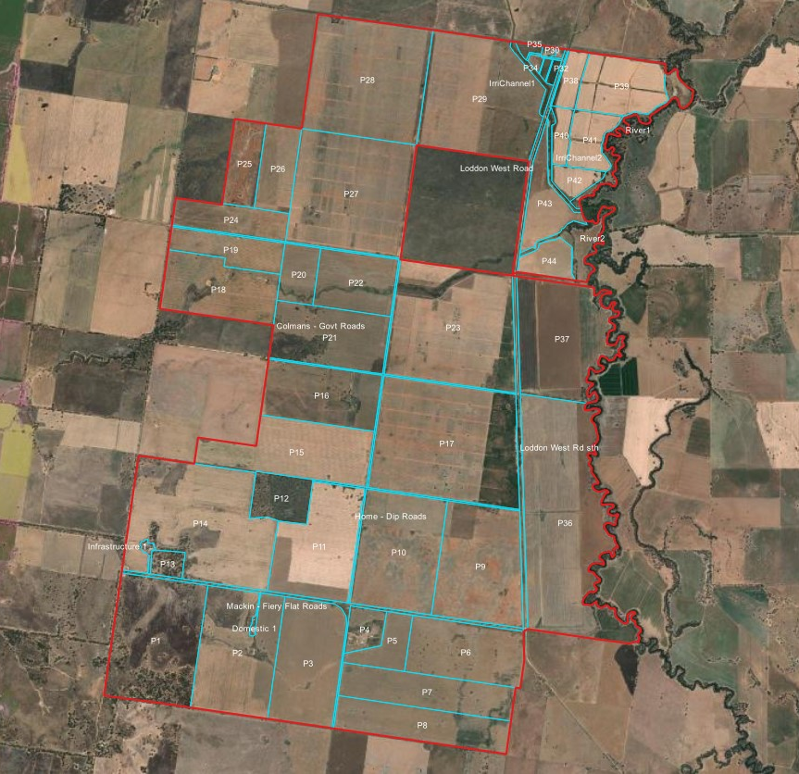 | 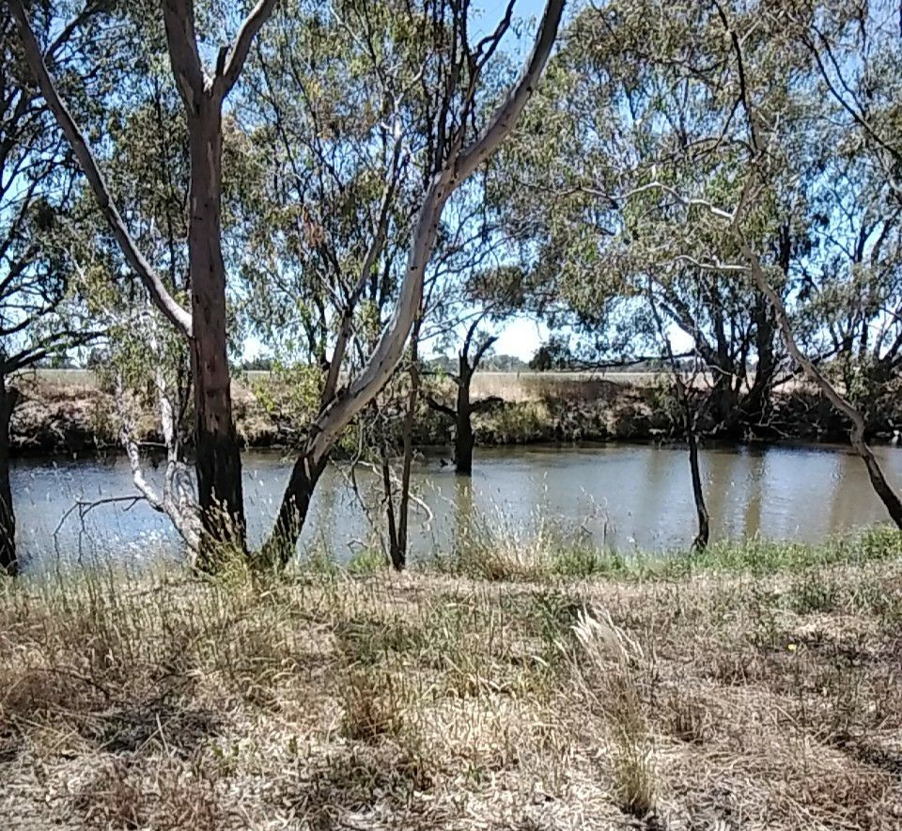
About this report  This report is an INTERIM report of the Natural Capital of Orana. It has been prepared for research purposes including the development of natural capital measurement and accounting methods. It contains the Natural Capital Accounts and an explanation of how the accounts have been developed. | Disclaimer  This interim report has been prepared for the purposes of demonstrating how natural capital information may be compiled and presented to farmers. It does not constitute financial or investment advice and should not be relied on for this purpose. To the extent permitted by law La Trobe University accepts no responsibility for any loss, claim or liability incurred by any party in connection with this report.

Natural Capital Accounting  Orana is participating in research with respect to natural capital accounting (NCA) and is making an important contribution to develop ways to:  - record and explain (account for) any changes to a farm’s natural capital;  - estimate the contribution natural capital makes to the ability of a farm business to achieve its financial, environmental, and social goals;  - present information about natural capital in a form that is useful to people who make decisions about its management; and  - communicate its performance to selected stakeholders.  Orana has had natural capital data collected via experimental methods using a combination of satellite imagery analysis and field observations. This has been compiled and is presented in accounting tables to test and develop the capacity of natural capital accounting to assist Orana to set and achieve its financial, environmental, and social goals and to help communicate their environmental performance to their stakeholders.  Note: The interim accounts and statements presented in this report are not designed to be a complete and comprehensive representation of the natural capital being managed by [participating farm] but are complete enough to enable learning and improvement in natural capital accounting designs and concepts. The reports and accounts designed for participants in the Farm-Scale Natural Capital Accounting project will be updated with more detailed information to provide a comprehensive representation of natural capital. | Information about this interim report  This interim report is structured in the following manner:  - Environmental Performance reports provide information about the resource use intensity and pollution generated by the farms operations.  - Natural Capital Type & Condition Extent provides information about the different types of natural capital assets that comprise the farm.  - Natural Capital – Condition for Grazing provides information about how many hectares of the property are in each grazing classification, representing differing provisioning services for livestock.  The report is accompanied by:  - A document describing the state & transition model that have been used to classify the different types of ecosystems and a glossary.  - A map of the farm showing the different types of natural capital assets, the grazing classification of the areas, and the paddocks of the property.  Your feedback is requested  We ask that you go through the report and let us know if the environmental performance of the business natural capital information doesn’t match your perception of the property or if you have any questions.  We also ask that you give us feedback about the way the information has been presented.  We will use this feedback to improve the report and to further develop natural capital accounting.

Contents
Orana - Natural Capital Report (interim 1) 1
Natural Capital Accounting 2
Information about this interim report 2
Your feedback is requested 2
Contents 3
Table of tables 4
Environmental Performance 5
Summary/overview (whole business) 5
GHG Emissions 5
Resource use efficiency and pollution generation 7
Environmental Performance (per product) 8
Non-renewable (finite) resources 10
Notes to Environmental Performance reporting 11
Natural Capital: Type & Condition Extent 12
Natural Capital: Condition for Grazing 14
Biodiversity – Bird species list 16
Methods used to measure Natural Capital 19

Table of tables
Table 1: Summary of greenhouse gas emissions (GHG) for the whole farm business. 6
Table 2: Selected resource use efficiency and pollution estimates for the whole farm business. 7
Table 3: Summary of pollution intensity of sheep meat production 8
Table 4: Summary of pollution intensity of crop production 9
Table 5: Estimates of proportion of finite resources used in enterprise (that the enterprise has no present substitute for). 10
Table 6: Notes to the Environmental Performance Estimates 11
Table 7: Ecosystem Type and State by extent (ha) 12
Table 8: Grazing classification by extent (ha) 14
Table 9: Bird Species Observations 16
Table 10: Natural Capital measurement design for ecosystem condition assessments 20

Environmental Performance

Summary/overview (whole business)
Increasingly, businesses in the agricultural supply chain are asking for information about farm performance on key environmental issues such as pollution generation and efficiency of resource-use. This report aims to provide this information and to estimate the farm’s dependence on non-renewable inputs.
This section provides a summary of the environmental performance of selected elements of the farm business:
- Greenhouse gas (GHG) emissions
- Rainfall use efficiency
- Pollution of air and water
- Use of non-renewable (finite) resources

Note: we intend to provide estimates of carbon storage and sequestration in the final accounts to provide participants with a ‘net’ GHG estimation.

GHG Emissions
The estimates of the GHG emissions generated as part of the farm operation have been calculated using methods that are consistent with Australia’s National Inventory Report 2020 (Australia’s Greenhouse Gas Inventories reporting submitted under the United Nations Framework Convention on Climate Change (UNFCCC) and the Kyoto Protocol (KP)).
The estimates represent the emissions associated with the operation of the farm and have been grouped under the Scope 1, 2 and 3 categories as defined by the Greenhouse Gas Protocol (www.ghgprotocol.org). The units are tonnes of carbon dioxide equivalent per year (tCO_{2-e} .yr⁻¹).
Scope 1 - DIRECT |  | Scope 2 – INDIRECT |  | Scope 3 - INDIRECT
Emissions generated from operations directly on farm, including:  - Livestock (enteric, manure, urine)  - Use of fossil fuels on farm  - Fertiliser use on farm (nitrous oxide, leaching, atmospheric deposition)  - Crop and pasture residue breakdown |  | Emissions generated by your electricity provider in producing the electricity consumed on farm |  | Emissions generated by other parties in the production and transport of goods used on your farm, including:  - Purchased inputs (fertiliser, chemicals)  - Purchased livestock

We have further split the emissions based on the source of the carbon associated with the emission:
- Geosphere source refers to emissions of GHG from fossil sources (coal, oil, gas), and represent a very long carbon cycle (millennia)
- Biosphere source refers to emissions of GHG from biological sources including livestock and vegetation, and represent a much shorter carbon cycle (years / decades)
Table 1: Summary of greenhouse gas emissions (GHG) for the whole farm business.
GHG Emissions | Estimated 4-year average (tCO_{2-e} .yr⁻¹)
GHG Emissions | Geosphere Source (see Note 1, Table 6) | Biosphere Source (see Note 2, Table 6) | Total
Livestock Enterprise | 93.02 | 457.60 | 550.61
SCOPE 1 (Direct)
Enteric methane/manure/urine/leaching and atmospheric deposition | 0.00 | 141.29 | 141.29
Fuel use in livestock enterprise (diesel, petrol, gas) | 0.06 | 0.00 | 0.06
Fertiliser applied (nitrous oxide, leaching, and atmospheric deposition) to pastures and crops fed to livestock | 2.05 | 0.04 | 2.09
Pasture/Fodder crop residues (breakdown of residues) | 0.00 | 0.00 | 0.00
SCOPE 2 (Indirect)
Electricity use in livestock enterprise | 3.98 | 0.00 | 3.98
SCOPE 3 (Indirect)
Pre-farm (production and transport of purchased livestock and inputs applied to pastures and crops fed to livestock) | 86.93 | 316.27 | 403.19
Crop Enterprise | 18,862.12 | 3,304.32 | 22,166.44
SCOPE 1 (Direct)
Fuel use in cropping enterprise (diesel, petrol, gas) | 6.36 | 0.00 | 6.36
Fertiliser applied (nitrous oxide, leaching, and atmospheric deposition) to crops that were for sale | 776.50 | 43.70 | 820.20
Crop residues (breakdown of residues) | 0.00 | 0.00 | 0.00
SCOPE 2 (Indirect)
Electricity use in cropping enterprise | 68.70 | 0.00 | 68.70
SCOPE 3 (Indirect)
Pre-farm (production and transport of purchased inputs applied to crops) | 18,010.56 | 3,260.63 | 21,271.18
Total Estimated Emissions | 18,955.13 | 3,761.92 | 22,717.05
SCOPE 1 (Direct) totals | 784.97 | 185.03 | 970.00
SCOPE 2 (Indirect) totals | 72.68 | 0.00 | 72.68
SCOPE 3 (Indirect) totals | 18,097.48 | 3,576.89 | 21,674.38

Resource use efficiency and pollution generation
Table 2: Selected resource use efficiency and pollution estimates for the whole farm business.
Enterprise / Metric | Description | Estimate
Livestock Enterprise
Rainfall use efficiency | The amount of production given the amount of rainfall.  Dry Sheep Equivalent per ha per 100mm of rainfall. | 0.14 DSE/ha/100mm rainfall
Water use | Livestock drinking and embedded water in fodder | 7.33 Litres H₂O / kg liveweight
Water pollution generated | Includes estimates of Nitrogen leeched from fertiliser on pastures and crops fed to livestock | 0.00 kg N leached / kg liveweight
Waste generated | Packaging waste associated with purchased inputs for the production systems (e.g. wrapping on bales, containers for liquid inputs) | 1.11 kg waste / kg liveweight
Cropping Enterprise
Rainfall use efficiency | The amount of production given the amount of rainfall.  Tonne of crop per ha per 100mm of rainfall. | 0.07 T/ha/100mm rainfall
Water use | Irrigation of crops for sale and embedded water in purchased inputs | 328.50 Litres H₂O / Tonne crop
Water pollution generated | Includes estimates of Nitrogen leeched from fertiliser on crops | 0.00 kg N leached / Tonne crop
Waste generated | Packaging waste associated with purchased inputs for the production systems (e.g. containers for liquid inputs) | 9.36 kg waste / Tonne crop

Environmental Performance (per product)
The following tables provide estimates of resource use intensity and pollution associated with each product produced by the business. We use multi-year averages to represent the usual performance of the business. Apportionment of resources or pollution to a product is based on the biophysical proportion, not the value in monetary terms. We have explained how the estimates are produced in ‘Notes’ to the Environmental Performance Estimates (see Table 6).

Resource use and pollution intensity – Sheep meat production
Table 3: Summary of pollution intensity of sheep meat production
Sheep – based on kg liveweight sold |  |  |  | Benchmark
Metric | Units | 4-year average | Notes (see Table 6) | WA Wheet Sheep Zone - 300-600mm
Water Pollution Generated | kg N leached / kg liveweight | 0.00 | 3 | N/A
Air Pollution Generated | kg pollutant / kg liveweight | TBC | 4 | N/A
GHG emissions (livestock emissions + emissions associated with pasture and fodder management) | kg CO₂e / kg liveweight | 11.23 | 5 | 9.4
Waste (non-biodegradable) | kg waste / kg liveweight | 0.04 | 6 | N/A
Water use (livestock drinking and embedded water in fodder) | litres H₂O / kg liveweight | 19.85 | 7 | 84.5
Normalised stress weighted water consumption (including evaporation) | litres H₂O-eqiv/ kg liveweight | 26.88 | 8 | 10
Nitrogen use efficiency | kg N applied / kg liveweight | 0.07 | 9 | N/A
Lime use efficiency | kg Lime applied / kg liveweight | 0.00 | 10 | N/A
Phosphorus use efficiency | kg P applied / kg liveweight | 0.11 | 11 | N/A

Resource use and pollution intensity – Crop production (including fodder crops)
Table 4: Summary of pollution intensity of crop production
Crop – based on TONNE of crop produced |  |  |  | Benchmark
Metric | Units | 4-year average | Notes (see Table 6) | TBA
Water Pollution Generated | kg N leached / Tonne crop | 0.00 | 3 | TBA
Air Pollution Generated | kg pollutant / Tonne crop | TBC | 4 | TBA
GHG emissions (fuel use, fertiliser use) | Tonne CO₂e / Tonne crop | 3.86 | 5 | TBA
Waste (non-biodegradable) | kg waste / Tonne crop | 9.36 | 6 | TBA
Water use (including water used in preparation of applied fertilisers) | litres H₂O / Tonne crop | 328.50 | 7 | TBA
Normalised stress weighted water consumption | litres H₂O-eqiv/ Tonne crop | 444.90 | 8 | TBA
Nitrogen use efficiency | kg N applied / Tonne crop | 28.25 | 9 | TBA
Lime use efficiency | kg Lime applied / Tonne crop | 6.53 | 10 | TBA
Phosphorus use efficiency | kg P applied / Tonne crop | 13.76 | 11 | TBA

Non-renewable (finite) resources
An important consideration in assessment of farm enterprise sustainability is the degree of dependence on finite resources. These include phosphorous and lime supplied from mines and water sourced from fossil aquifers.
We estimate that the proportion of inputs that are finite is 2.8% of total inputs (by weight).
Table 5: Estimates of proportion of finite resources used in enterprise (that the enterprise has no present substitute for).
Finite resource | 4-year average (tonnes) | Proportion
Phosphorous | 76.69 Tonnes from mined stocks | 2.3% of nutrient replenishment (tonnes)
Lime | 37.45 Tonnes from mined stocks | 100.0% of pH remediation (tonnes)
Fossil Water | 0 Litres from fossil aquifers | 0% of total water use

Notes to Environmental Performance reporting
This section explains the estimation methods. The detailed calculations and scientific references for these are available in an open access publication. Search in Sustainability Account, Management and Policy Journal for: “A natural capital accounting framework to communicate the environmental credentials of individual wool-producing businesses”. Authors: Ogilvy, O’Brien, Lawrence, Gardner. https://www.emerald.com/insight/content/doi/10.1108/SAMPJ-06-2021-0191/full/html.
Table 6: Notes to the Environmental Performance Estimates
Note | Reporting element | Estimation method
1 | GHG from geosphere | This is an estimate of the GHG emissions associated with the use of fossil fuels (oxidation of materials sourced from geological storages).
2 | GHG from biosphere | This is an estimate of the GHG emissions generated from biological sources including livestock and clearing and oxidation of vegetation.
3 | Water Pollution Generated | This is an estimate of nitrogen from fertiliser and manure leeching into waterways and storages.
4 | Air Pollution Generated | We don’t have a practical method to estimate this at the moment, so this remains an ‘empty cell’.
5 | GHG emissions  (livestock emissions + emissions associated with pasture and fodder management) | This is a summary of the total GHG emissions (all sources) associated with a product.
6 | Waste  (non-biodegradable) | This estimates the generation of non-biodegradable waste from packaging e.g., silage wrappers, chemical containers.
7 | Water use  (livestock drinking and embedded water in fodder) | This estimates the consumption of water by livestock and the water embedded in fodder consumed by livestock.
8 | Normalised stress weighted water consumption (including evaporation) | This is a reflection of the use of water in the context of the amount of rainfall (water stress) of the region of operation. It adjusts water use estimates to reflect relative rainfall.
9 | Nitrogen use efficiency | This estimates the amount of nitrogen used to produce a product.
10 | Lime use efficiency | This estimates the amount of lime used to produce a product.
11 | Phosphorus use efficiency | This estimates the amount of phosphorus used to produce a product.

Natural Capital: Type & Condition Extent
This section provides a summary of the natural capital of the farm. It provides information about the extent (area) of each of the different the types of ecosystems that comprise the natural capital of the farm (Column 1). This table also includes the corresponding ecosystem ‘state’ code so you can see where it fits in the state & transition model (Column 2). We have also provided a brief explanation of each type of natural capital (Column 3). The area of each is provided in Column 4. Please refer to the reference material for additional information about the state & transition models.
The Farm-scale Natural Capital Accounting team has performed analysis of spatial imagery and used field observations (the ecologists who visited your farm) to classify each paddock (or sub-paddock) on your farm according to the type of ecosystem it represents. The findings for each paddock have been consolidated into a summary that tells us the extent of each ecosystem type. This can be used in future to estimate the ecosystem services your farm business, your family, your community and your livestock are receiving from the natural capital of the farm.
Table 7: Ecosystem Type and State by extent (ha)
Orana - Ecosystem Type and State by extent (ha) as @ 18/10/2021
Ecosystem Type | Ecosystem State | Ecosystem State long description | Area (ha)
Woodland | Transitioning Woodland 1 | Transitioning Woodland 1 - some historical clearing - regeneration - ground layer with high native diversity | 154.94
Woodland | Transitioning Woodland 3 | Transitioning Woodland 3 - little regeneration - mostly exotic ground layer | 40.64
Woodland | Transitioning Woodland 4 | Transitioning Woodland 4 - no regeneration - exotic ground layer | 58.74
Grassland | Modified Grassland 5 | Modified Grassland 5 - perennial exotic ground layer | 87.79
Pasture | Derived Grassland 1 | Derived Grassland 1 - diverse native ground layer | 339.44
Cropland | Crops 1 | Non-irrigated crop with scattered trees | 170.74
Cropland | Crops 2 | Non-irrigated crop - no trees | 2,314.54
Cropland | Crops 3 | Irrigated crop | 671.10
Planted vegetation | Exotic Woody Vegetation 3 | Perennial Horticulture | 1,219.18
Planted vegetation | Planted Native Trees 2 | Planted native trees - maturing (10-40 years) | 10.15
Infrastructure | Domestic Infrastructure | Domestic Infrastructure | 25.37
Infrastructure | Roads & Laneways | Roads & Laneways | 135.31
Infrastructure | Sheds & Yards | Sheds & Yards | 2.13
Infrastructure | Water Infrastructure | Water infrastructure (dams, channels) | 20.86
Total |  |  | 5,250.93

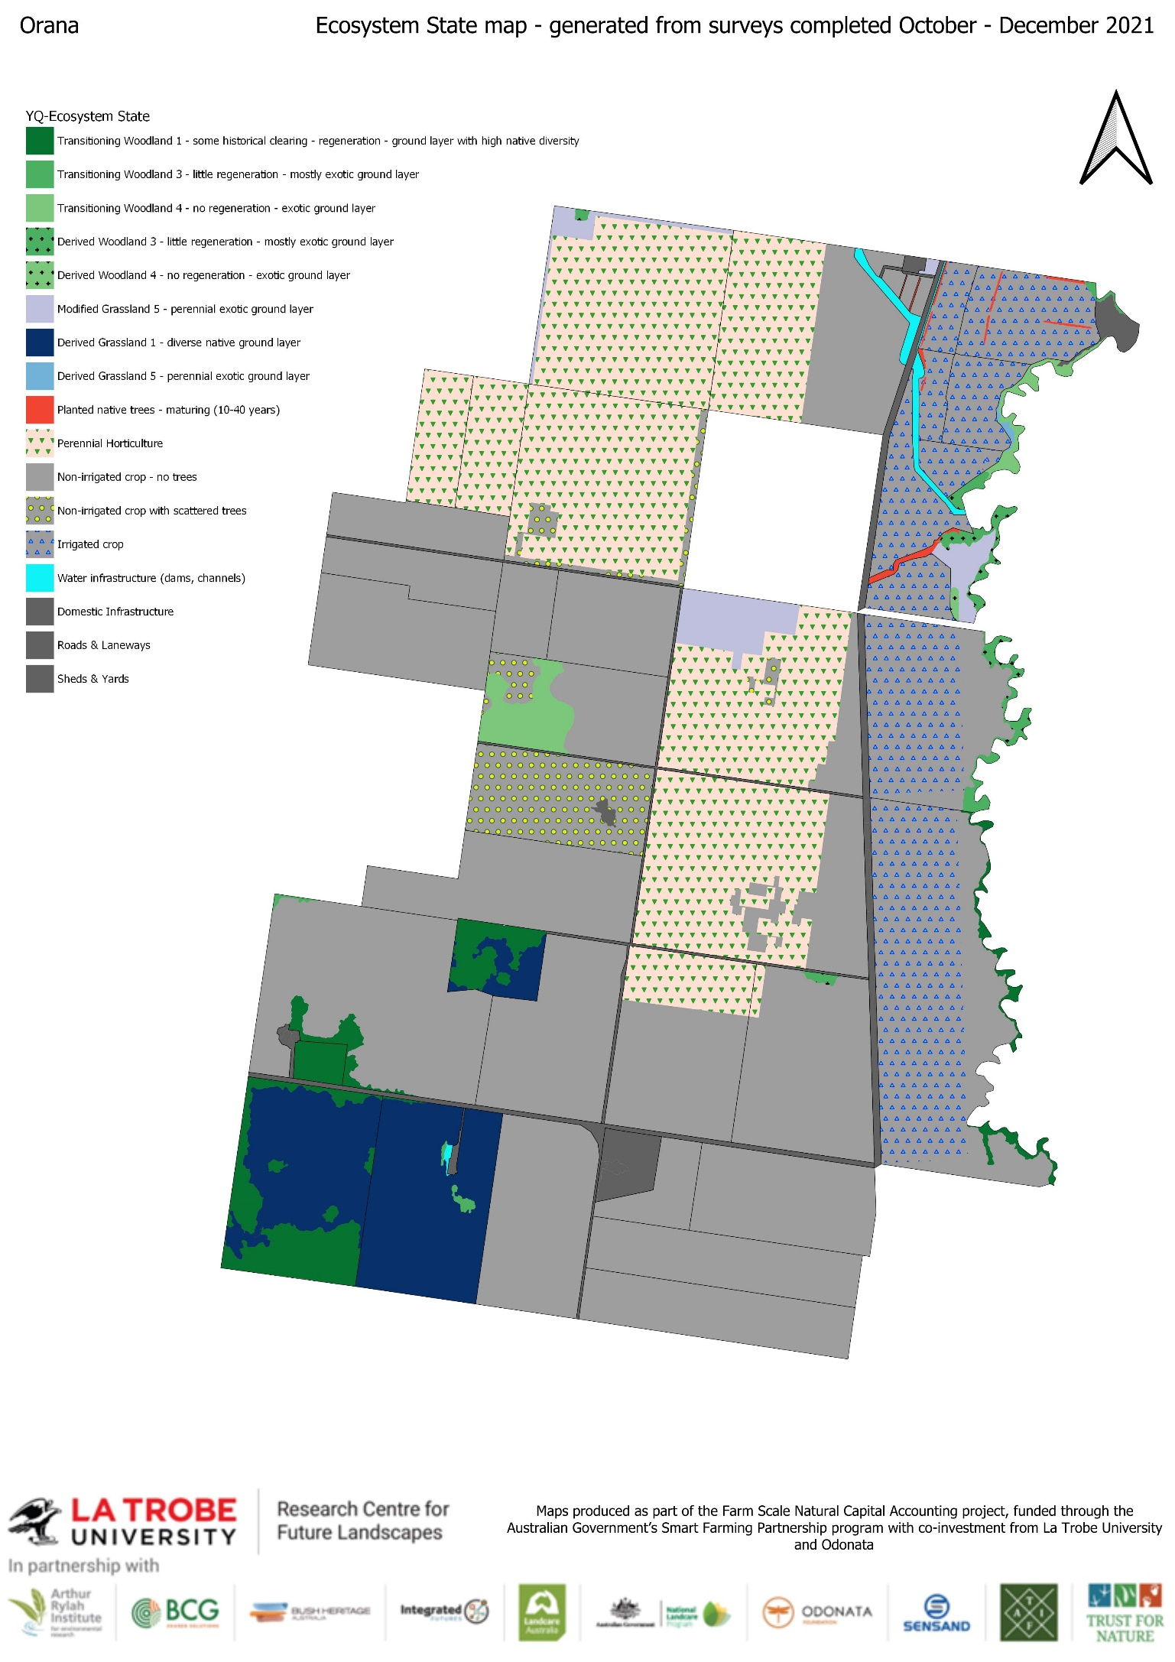

Natural Capital: Condition for Grazing
This section provides a summary of the area (extent) of ecosystems that are in each grazing classification (A, B, C, D and NA) for livestock grazing. These assessments have been made using a combination of spatial imagery analysis and field observations and represent the assignment to a classification based on the structural characteristics of the pasture systems. Please refer to the reference material for a description of the classifications.
Note that areas of each ecosystem type on the farm have been rated for their condition with respect to providing grazing services for livestock. You may choose to use this information to help you decide whether you want to continue with your current management practices or whether you want to make changes that might affect the grazing condition.
Table 8: Grazing classification by extent (ha)
Orana - Grazing classification and extent (ha) by Ecosystem Type and State as @ 18/10/2021 |  |  | Grazing Classification
Ecosystem Type | Ecosystem State | Ecosystem State long description | A | B | C | D | NA
Woodland | Transitioning Woodland 1 | Transitioning Woodland 1 - some historical clearing - regeneration - ground layer with high native diversity | 18 | 28 | 109 | 0 | 0
Woodland | Transitioning Woodland 3 | Transitioning Woodland 3 - little regeneration - mostly exotic ground layer | 0 | 0 | 21 | 19 | 0
Woodland | Transitioning Woodland 4 | Transitioning Woodland 4 - no regeneration - exotic ground layer | 0 | 0 | 43 | 15 | 0
Grassland | Modified Grassland 5 | Modified Grassland 5 - perennial exotic ground layer | 0 | 88 | 0 | 0 | 0
Pasture | Derived Grassland 1 | Derived Grassland 1 - diverse native ground layer | 205 | 0 | 135 | 0 | 0
Cropland | Crops 1 | Non-irrigated crop with scattered trees | 0 | 0 | 0 | 0 | 171
Cropland | Crops 2 | Non-irrigated crop - no trees | 0 | 0 | 197 | 0 | 2,117
Cropland | Crops 3 | Irrigated crop | 0 | 0 | 0 | 0 | 671
Planted vegetation | Exotic Woody Vegetation 3 | Perennial Horticulture | 0 | 0 | 0 | 0 | 1,219
Planted vegetation | Planted Native Trees 2 | Planted native trees - maturing (10-40 years) | 0 | 0 | 0 | 0 | 10
Infrastructure | Domestic Infrastructure | Domestic Infrastructure | 0 | 0 | 0 | 0 | 25
Infrastructure | Roads & Laneways | Roads & Laneways | 0 | 0 | 0 | 0 | 135
Infrastructure | Sheds & Yards | Sheds & Yards | 0 | 0 | 0 | 0 | 2
Infrastructure | Water Infrastructure | Water infrastructure (dams, channels) | 0 | 0 | 0 | 0 | 21
Total |  |  | 223 | 116 | 506 | 35 | 4,372

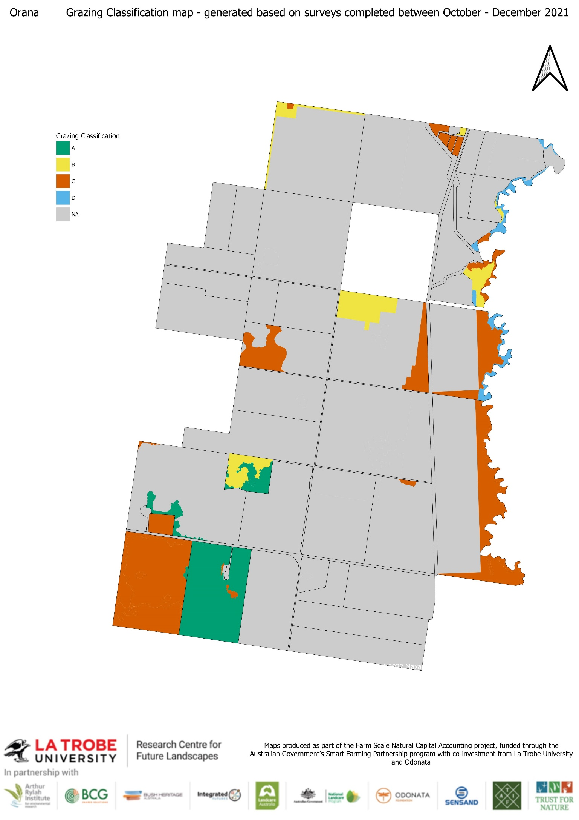

Biodiversity – Bird species list
The following bird species have been observed on the property during the field assessments done to date. The ‘# of sites at which species detected’ refers to the number of biodiversity survey sites at each species was recorded. Species’ ‘reporting rate’ refers to the proportion of surveys during which a species was recorded (total number of surveys = number of sites x number of visits). ‘Habitat preference’ refers to the type of habitat in which the species typically occurs: either ‘open country’, ‘open-tolerant’, ‘wetland’ or ‘woodland-dependant’. Conservation status refers to current status according to national and state threatened species conservation legislation: the Commonwealth Environmental Protection and Biodiversity Conservation Act 2000 (EPBC), NSW Biodiversity Conservation Act 2016, Tasmanian Threatened Species Protection Act 1995, and the Victorian Flora and Fauna Guarantee Act 1988.
Table 9: Bird Species Observations
Habitat Preference | Common Name  (* = introduced species) | Scientific Name | Conservation Status |  | # Sites at which species detected | Reporting Rate
Habitat Preference | Common Name  (* = introduced species) | Scientific Name | EPBC | Victorian Flora and Fauna Guarantee Act 1988 | # Sites at which species detected | Reporting Rate
Woodland | Common Bronzewing | Phaps chalcoptera |  |  | 3 | 0.03
Woodland | Peaceful Dove | Geopelia placida |  |  | 2 | 0.02
Woodland | Tawny Frogmouth | Podargus strigoides |  |  | 1 | 0.01
Woodland | Sacred Kingfisher | Todiramphus sanctus |  |  | 1 | 0.01
Woodland | Brown Treecreeper | Climacteris picumnus | Vulnerable |  | 6 | 0.16
Woodland | Black-chinned Honeyeater | Melithreptus gularis |  |  | 1 | 0.01
Woodland | Red Wattlebird | Anthochaera carunculata |  |  | 3 | 0.04
Woodland | Yellow-plumed Honeyeater | Ptilotula ornata |  |  | 2 | 0.02
Woodland | Spotted Pardalote | Pardalotus punctatus |  |  | 2 | 0.02
Woodland | Yellow Thornbill | Acanthiza nana |  |  | 1 | 0.04
Woodland | Crested Shrike-tit | Falcunculus frontatus |  |  | 1 | 0.01
Woodland | Golden Whistler | Pachycephala pectoralis |  |  | 1 | 0.01
Woodland | Grey Shrike-thrush | Colluricincla harmonica |  |  | 3 | 0.05
Woodland | Grey Fantail | Rhipidura albiscapa |  |  | 1 | 0.01
Woodland | Restless Flycatcher | Myiagra inquieta |  |  | 3 | 0.05
Woodland | White-winged Chough | Corcorax melanorhamphos |  |  | 5 | 0.09
Woodland | Red-capped Robin | Petroica goodenovii |  |  | 2 | 0.02
Woodland | Rufous Songlark | Megalurus mathewsi |  |  | 2 | 0.02
Woodland | Diamond Firetail | Stagonopleura guttata | Vulnerable | Vulnerable | 1 | 0.01
Waterbirds | Australian Shelduck | Tadorna tadornoides |  |  | 1 | 0.01
Waterbirds | Yellow-billed Spoonbill | Platalea flavipes |  |  | 1 | 0.01
Rank grass/swamp | Superb Fairy-wren | Malurus cyaneus |  |  | 6 | 0.11
Rank grass/swamp | White-fronted Chat | Epthianura albifrons |  |  | 3 | 0.03
Open-tolerant | Laughing Kookaburra | Dacelo novaeguineae |  |  | 2 | 0.02
Open-tolerant | Sulphur-crested Cockatoo | Cacatua galerita |  |  | 2 | 0.05
Open-tolerant | Red-rumped Parrot | Psephotus haematonotus |  |  | 8 | 0.12
Open-tolerant | Crimson Rosella | Platycercus elegans |  |  | 1 | 0.01
Open-tolerant | Eastern Rosella | Platycercus eximius |  |  | 12 | 0.22
Open-tolerant | Noisy Friarbird | Philemon corniculatus |  |  | 1 | 0.01
Open-tolerant | White-plumed Honeyeater | Ptilotula penicillata |  |  | 7 | 0.21
Open-tolerant | Noisy Miner | Manorina melanocephala |  |  | 5 | 0.11
Open-tolerant | Striated Pardalote | Pardalotus striatus |  |  | 9 | 0.21
Open-tolerant | Yellow-rumped Thornbill | Acanthiza chrysorrhoa |  |  | 5 | 0.08
Open-tolerant | Black-faced Cuckoo-shrike | Coracina novaehollandiae |  |  | 5 | 0.07
Open-tolerant | Pied Butcherbird | Cracticus nigrogularis |  |  | 4 | 0.06
Open-tolerant | Dusky Woodswallow | Artamus cyanopterus |  |  | 2 | 0.05
Open-tolerant | Willie Wagtail | Rhipidura leucophrys |  |  | 10 | 0.16
Open-tolerant | Jacky Winter | Microeca fascinans |  |  | 1 | 0.01
Open-tolerant | Tree Martin | Petrochelidon nigricans |  |  | 3 | 0.03
Open country | Crested Pigeon | Ocyphaps lophotes |  |  | 6 | 0.07
Open country | Black-shouldered Kite | Elanus axillaris |  |  | 3 | 0.03
Open country | Black Kite | Milvus migrans |  |  | 2 | 0.02
Open country | Nankeen Kestrel | Falco cenchroides |  |  | 6 | 0.06
Open country | Brown Falcon | Falco berigora |  |  | 4 | 0.04
Open country | Galah | Eolophus roseicapilla |  |  | 17 | 0.34
Open country | Long-billed Corella | Cacatua tenuirostris |  |  | 4 | 0.06
Open country | Australian Magpie | Gymnorhina tibicen |  |  | 22 | 0.41
Open country | Magpie-lark | Grallina cyanoleuca |  |  | 3 | 0.04
Open country | Little Raven | Corvus mellori |  |  | 10 | 0.11
Open country | Australian Raven | Corvus coronoides |  |  | 5 | 0.05
Open country | Welcome Swallow | Hirundo neoxena |  |  | 6 | 0.07
Open country | Common Starling* | Sturnus vulgaris |  |  | 4 | 0.04
Open country | House Sparrow* | Passer domesticus |  |  | 2 | 0.02
Grassland | Stubble Quail | Coturnix pectoralis |  |  | 5 | 0.08
Grassland | Horsfield's Bushlark | Mirafra javanica |  |  | 4 | 0.06
Grassland | Brown Songlark | Cincloramphus cruralis |  |  | 1 | 0.01
Grassland | Australian Pipit | Anthus australis |  |  | 9 | 0.16

Methods used to measure Natural Capital
To satisfy the requirements for confidence in the NCA’s within the project budget for NC measurement, we have used a mix of measurement approaches to assess the natural capital of Orana. These include informal and formal farmer observations, remote sensing, rapid ecological assessments by performed independent experts. A detailed methodology document has been designed to underpin the NCA. It describes the sampling scheme (sampling strategy and protocols) used to assess the type and condition of the ecosystems. This is updated as required in response to changing management goals and practices.
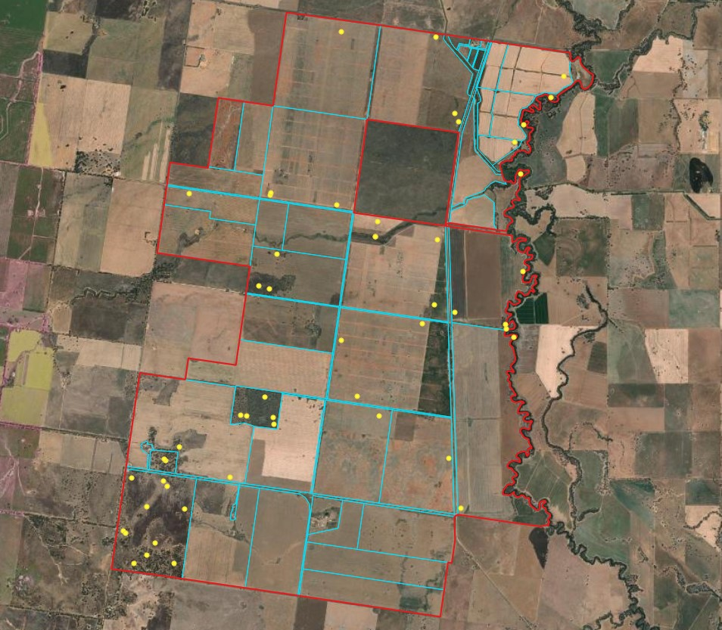
52 surveys were undertaken by trained field ecologists as part of the Farm-scale Natural Capital Accounts program. The locations of the are shown in the adjacent map.
Table 10 summarises this information providing details of site locations for direct observations and which ecosystem units condition estimates have been imputed from these values.

Table 10: Natural Capital measurement design for ecosystem condition assessments
Orana - Ecosystem condition measurement process as @ 18/10/2021
Condition Data Source | Ecosystem State | Paddocks where the source information was used to impute the Ecosystem State
Visited - P21 | C1 | P16, P21, P23, P27
Visited - P14 | C2
Visited - P19 | C2 | P15, P17, P18, P21, P22, P24, P8
Visited - P23 | C2 | P32, P33, P34, P35, P36, P37
Visited - P29 | C2
Visited - P9 | C2 | P10, P11, P17, P20, P3, P5, P6, P7
Visited - P36 | C3 | P38
Visited - P37 | C3 | P39, P40, P41, P42, P43, P44
Visited - P42 | C3
Visited - P1 | DG1 | P1
Visited - P12 | DG1 | P12, P2
Visited - P37 | DW3 | River1
Visited - River2 | DW3 | P14, P2, P28, P9, River1
Visited - P10 | EWV3 | P26
Visited - P17 | EWV3
Visited - P23 | EWV3
Visited - P27 | EWV3 | P25
Visited - P28 | EWV3 | P29
Visited - P23 | MG5 | P28, P30, River1, River2
Visited - P39 | PNT2
Visited - P1 | TW1
Visited - P1 | TW1
Visited - P12 | TW1
Visited - P13 | TW1 | P1, P36
Visited - P14 | TW1 | P1, P12, P2
Visited - P36 | TW1 | P36
Visited - P37 | TW3 | P37, P39, River1
Visited - P21 | TW4
Visited - River1 | TW4 | River2
Remote Imagery | PNT2 | P38, P39, P40, River2, TL1, TL2

Environmental performance reporting refers to the reports of the consumption and use of resources such as water and fertiliser and the generation of pollution including waste to landfill, GHG emissions, and other emissions (e.g., soil, manure and plant residues to water and air).
Uses methods of estimation described by the National Greenhouse Gas Inventory and related ERF publications.
Farm emissions tend to vary significantly season to season due to production variations, so we use a multi-year average to reflect the usual performance of a business.
S.G Wiedemann et al 2016, Resource use and greenhouse gas emissions from three wool production regions in Australia
We don’t have a practical method to estimate this at the moment, so this remains an ‘empty cell’.
Benchmarks for crops are still under development, as it is not practical to have a generic benchmark across a consolidated set of crops, but rather benchmarks at individual crop types (or classes of crops – e.g. coarse grains) is more appropriate. These benchmarks will need to be locally relevant as well, as yields vary dramatically across different agro-ecological zones.
We don’t have a practical method to estimate this at the moment, so this remains an ‘empty cell’.
Aquifers that contain fossil water and that are not able to be significantly recharged from surface water or other aquifers.
Fossil fuel amounts are already reported. The entity considers that suitable substitutes (e.g., electric vehicles) will be available in future. Accordingly, the entity considers that it has no obligate dependence on fossil fuel.
Publication and open access of this article was made possible with the support of Australian Wool Innovation (AWI).

