
MOTOR VEHICLE ACCIDENT CLAIM FORM
1. INSURED: LA TROBE UNIVERSITY
Campus |  | College |  | School
2. DRIVER
Name:
Address: | Postcode:
Phone No. |  |  | Date of Birth
Licence No.  Please attach copy of  Licence to form |  | Expiry Date: |  |  |  |  | Years Driving:
Employee/Family/Student/Other (circle appropriate answer)
Has driver attended a University sponsored driver training course? |  |  |  |  |  |  |  | Yes/No
Did driver consume any alcohol or take any drugs  within 12 hours prior to the accident?. |  |  |  | Yes/No If yes, state how much and when:
Did the driver undergo a breath or blood test? |  |  |  | Yes/No If Yes, state the result
3. INSURED VEHICLE
Year, Make & Model |  | Colour |  | Reg No.
University vehicle or
Exec Officer contribution scheme (please circle)
4. OTHER VEHICLE DETAILS
Year, Make & Model
Registration No.: |  |  | Colour:
Insurance Company:
Driver’s Name:
Address: | Postcode:
Phone No. |  |  |  | Date of Birth
Licence No. |  |  |  | Expiry Date:
Registered Owner |  |  |  | Phone No.:
Address: | Postcode:
5. DAMAGE TO OTHER VEHICLE
Area of damage: |  | Cost
6. WITNESS TO ACCIDENT
Name: |  | Phone No. |  | Age:
Address: | Postcode:
7. ACCIDENT DETAILS
Date: |  |  | Time:
Location: (street/suburb)
Use of vehicle at time of accident: |  | Private or Business
8. GENERAL
Who do you consider was at fault and why?
How long (hours, minutes) had you been driving
immediately prior to the accident?
Weather & road condition at the time of the accident?
Did the Police attend the accident?  If No, was the accident reported to the Police?  If Yes, which Police Station? |  | Yes/No
Who do the Police consider was at fault?
What speed were the vehicles doing at  the time of the accident? | Your vehicle …………….kph.  Other vehicle………………kph
Was there any damage to your vehicle prior  to the accident? | Yes/No If Yes, give details

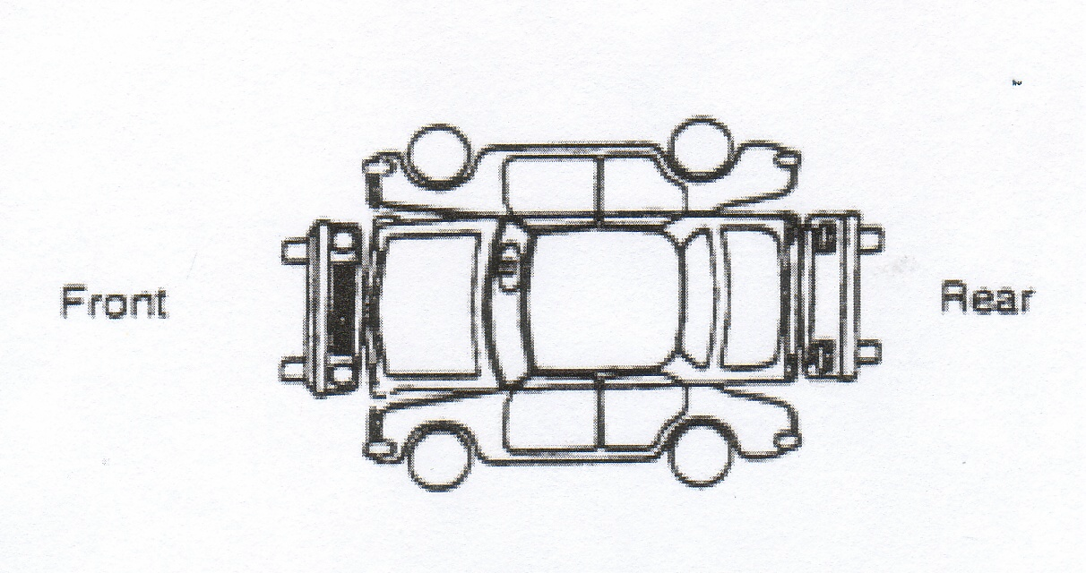
9. DESCRIPTION OF ACCIDENT (explain what happened and show details of damage on diagram)
…………………………………………………………………………………………………………………………….……
…………………………………………………………

…………………………………………………………

…………………………………………………………

…………………………………………………………..

…………………………………………………………

…………………………………………………………

…………………………………………………………………………………………………………………………………

…………………………………………………………………………………………………………………………………

…………………………………………………………………………………………………………………………………

…………………………………………………………………………………………………………………………………
…………………………………………………………………………………………………………………………………

Diagram of Accident (indicate north)

The information is to the very best of my knowledge
and belief, true in every respect. Signature of driver:……… ………… … Date: …………….

As Head of School/Department, I authorise any policy excess or other costs to be borne by:
Company Code: Account: Cost Centre: Fund:

Name: (Print) ………………………………………..
Signed: …………………………………………….. Date: ……………………………

