Installing and using Folder Monitor

# About Folder Monitor

LabArchives Folder Monitor allows you to upload files from your computer or another network location to your notebook. For example, you can use it to upload files generated from an instrument.

*Note: Nothing needs to be installed on the computer on which the files to be uploaded are located, just install Folder Monitor on the computer you use to access the Online Research Notebook.*

# Setting up Folder Monitor

## What you need to do

1. Install Folder Monitor
   1. Install Folder Monitor from the La Trobe Software Center (if your pc or laptop is running the latest version of Windows or Mac OS)

OR

* 1. Install Folder Monitor directly from the Online Research Notebook (if your pc or laptop is running an earlier version of Windows or Mac OS)

1. Log in to Folder Monitor, saving your details so that future logins are automatic
2. Create an Upload Rule

## Install Folder Monitor from the La Trobe Software Center

1. Follow the installation procedure as detailed in <https://latrobe.service-now.com/kb_view.do?sysparm_article=KB0010766>

## Install Folder Monitor directly from the Online Research Notebook

### Download the configuration file

1. If you are currently logged in to the Online Research Notebook, click the triple bar icon at the top of the Online Research Notebook, go to **Downloads**, and select **Folder Monitor**:

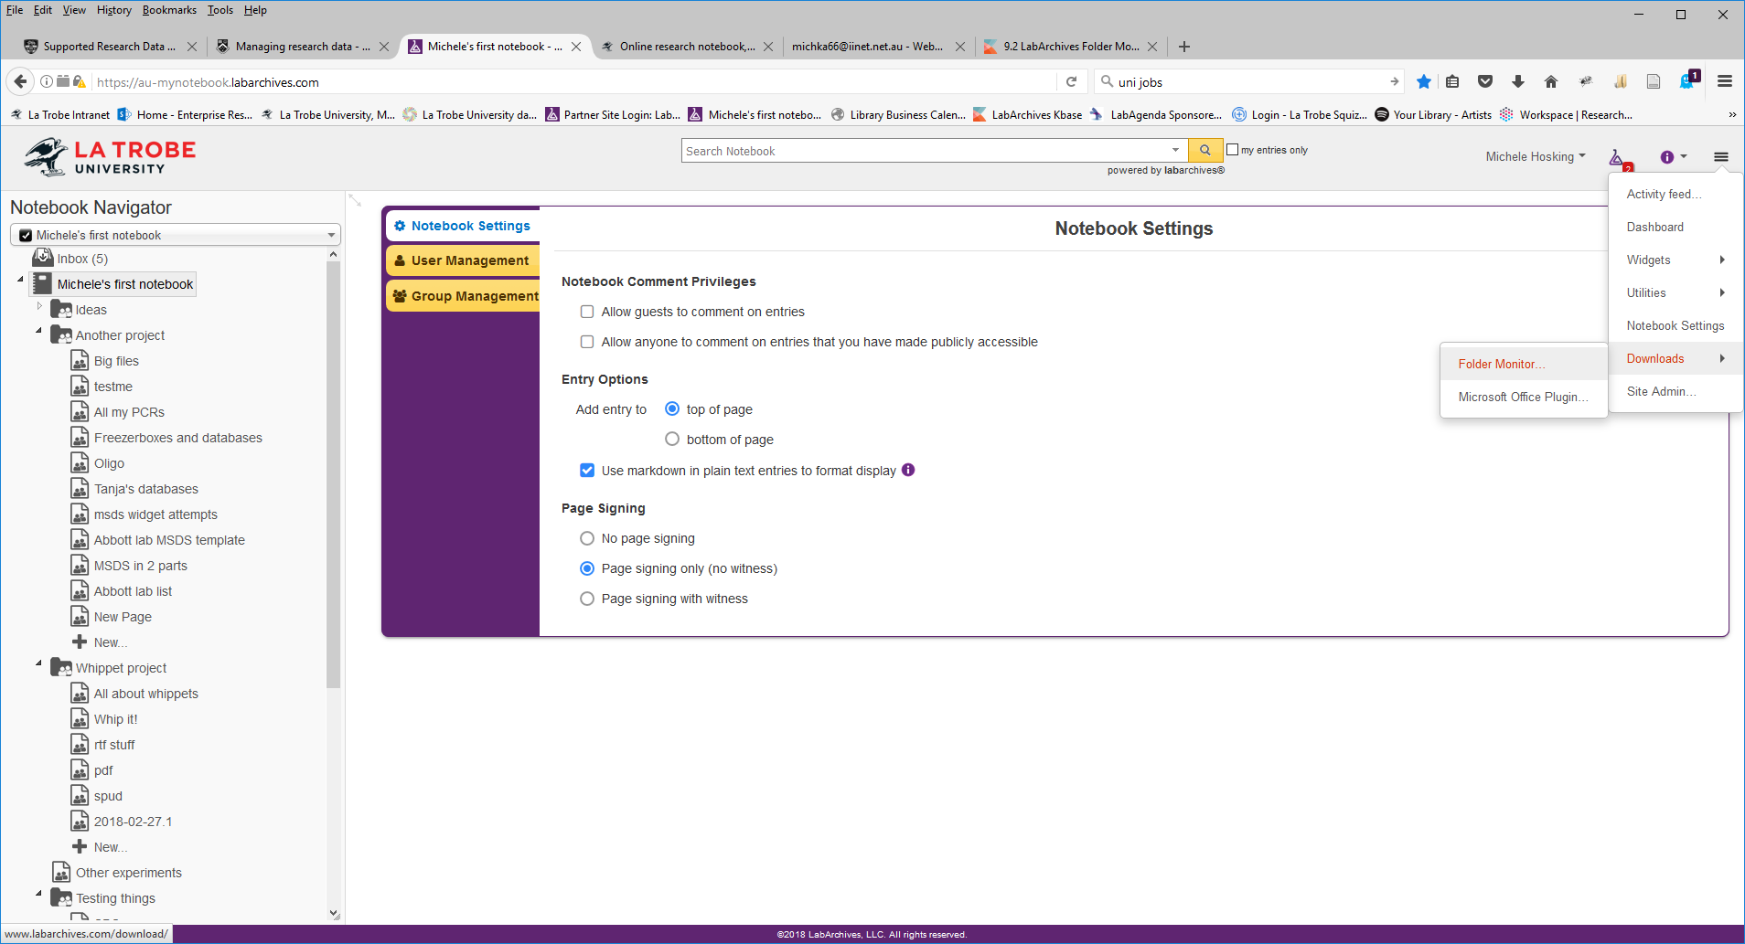

(or go straight to <http://www.labarchives.com/downloads/>)

1. Download the version you need.

Choose this option if you use a Windows pc:

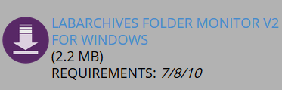

Choose this option if you use a Mac:

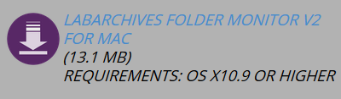

### Install Folder Monitor

*Note: La Trobe Windows users may need to set up a Local Admin account in order to be able to install the plugin. Instructions are available at* [*https://latrobe.service-now.com/ict?id=kb_article&sys_id=640059506f82c680d654c6168d3ee411*](https://latrobe.service-now.com/ict?id=kb_article&sys_id=640059506f82c680d654c6168d3ee411)

1. To install the plugin, open the file that you downloaded; it will step through the installation process, as per the following screenshots.

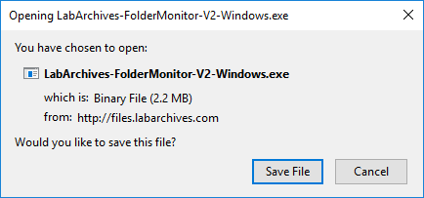

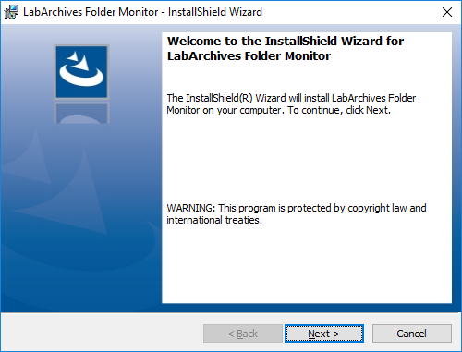

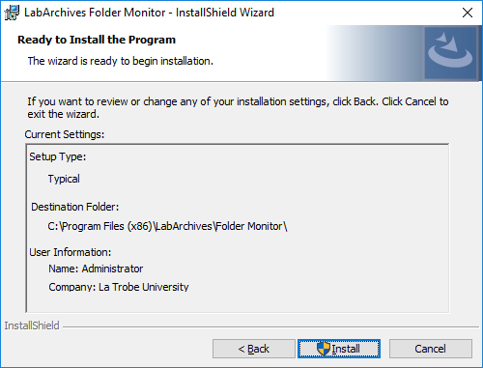

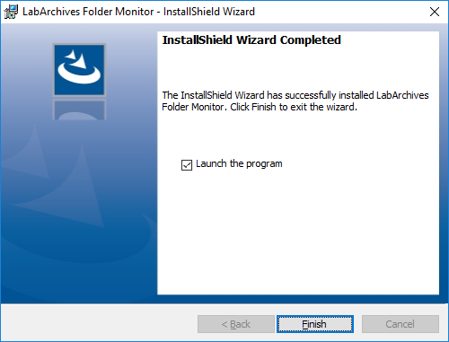

## Log in to Folder Monitor

To log in to Folder Monitor, you use your email address as login and need to generate a token to use as password. Keep in mind there is a one hour time limit for this token, but if the token expires, a new one can always be generated.

1. To generate the token, go into LabArchives and go to LA App authentication:

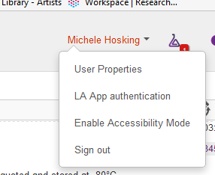

1. Copy the password token

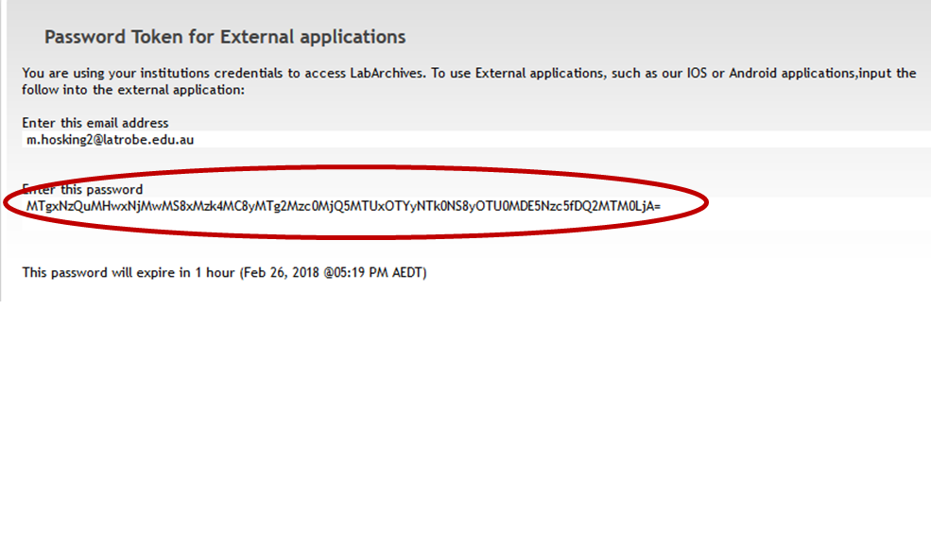

1. In the Folder Monitor login window, make sure you’re using the Australian server, enter your email address in the Login/Email field and paste the token into the Password field:

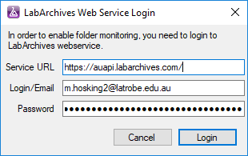

1. Select Login.
2. Click on Settings

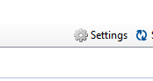

1. Tick the ‘Start automatically…’ checkbox.

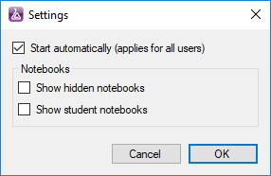

From now on, you should be logged in automatically whenever you start your pc. If this doesn’t happen, you’ll need to follow this procedure up to step 4.

## Create an Upload Rule

To create an upload rule, you need to:

* Choose the folder to be monitored
* Set criteria for types of files to be uploaded
* Nominate a location within your notebook where files will be sent.

You can create multiple rules if you wish.

1. The first time you use Folder Monitor, the **Upload Rule Editor** will be open by default. Thereafter, you will need to click the **Add Rule** button to open it.

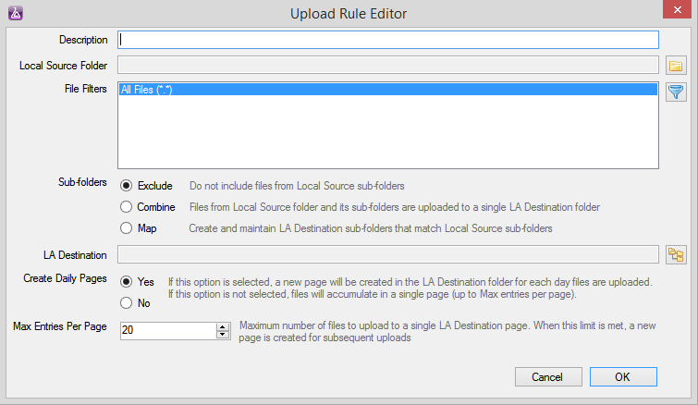

1. Give your rule a **Description**.
2. Click the **Select folder** icon to the right of the **Local Source Folder** box.
3. In the **Browse For Folder** window, navigate to and select a folder on your local machine or network, then click **OK**.

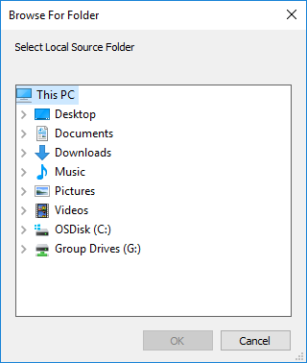

1. **File Filters** will be set to All Files (*.*).To create a filter, click on the filter icon to the right of the **File Filters** field.
2. In the **File Filter Selection** window, select one or more options from the list (or define your own filter by selecting **Add Filter**).

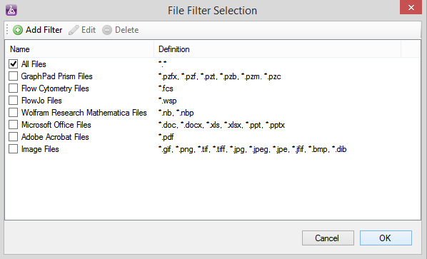

1. Click **OK** to close the **File Filters** window
2. If your source folder has sub-folders that contain files that match the file filter criteria for this rule, you have the following options for those sub-folders, choose from the following options:

* **Exclude:** Will upload only the files in your source folder and ignore its sub-folders completely.
* **Combine:** Will combine all files in your local source folder and its sub-folder(s) and upload these as a group to your notebook.
* **Map:** Folders and sub-folders will be created in the designated notebook following the same structure and naming convention used in your local source.

1. Choose the **Select folder** icon to the right of the **LA Destination** field.
2. In the **LabArchives Target Folder** window, navigate to and select the notebook and folder to be the destination for the uploaded files.
3. Click **OK** to complete the selection.

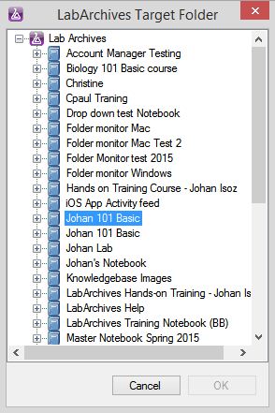

1. Specify whether you would like to **Create Daily Pages**.

* If you choose **Yes** (which is the default setting), a new page will be created for each new day files are uploaded. When that page reaches its file limit within the same day, a new page is created.
* If you choose **No**, the uploaded files will accumulate on a single page until the maximum number of files is met.

1. Specify the **Max Entries per Page**. The default is 20.
2. Select **OK** to save your Upload Rule.

### When new files are found

*Note that each time you log back into LabArchives, if new files are found in your local source folder and/or its sub-folders, you will see the* ***New Files Found*** *window with options to upload files as in the screenshot below. However, if new files are found while Folder Monitor is running, they will be uploaded automatically.*

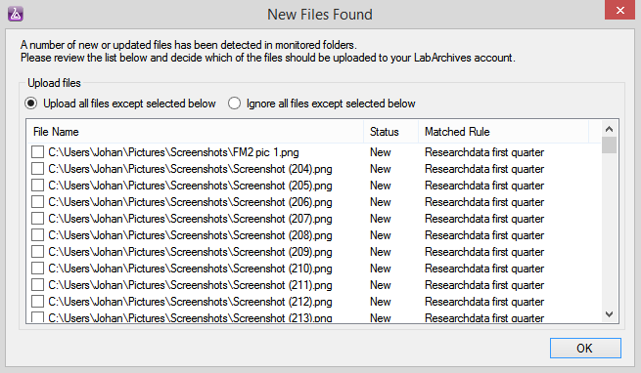

# Troubleshooting[1]

The following issues may cause Folder Monitor problems:

## Forbidden characters in filenames

< (less than)

> (greater than)

: (colon)

" (double quote)

/ (forward slash)

\ (backslash)

| (vertical bar or pipe)

? (question mark)

* (asterisk)

## Large source folder or file

When the source folder is approaching 1 GB in size it can sometimes prevent the upload from starting and make Folder Monitor shut down. When this happens, we recommend that the user split the folder into subfolders or create rules for each sub-folder instead. It's not the number of files, but the size of the combined folder that is causing the problem.

Also, keep in mind that Folder Monitor will not upload files larger than 250MB.

# Support and further information

## Support

For assistance with setting up and using Folder Monitor, [contact LabArchives Support](https://www.labarchives.com/support/#supportcontact).

## Further information

This procedure has been adapted for La Trobe researchers from the LabArchives Knowledgebase articles [LabArchives Folder Monitor for Windows](https://www.labarchives.com/labarchives-knowledge-base/7-01-1-labarchives-folder-monitor-for-windows/) and [LabArchives Folder Monitor for Mac](https://www.labarchives.com/labarchives-knowledge-base/7-01-2-labarchives-folder-monitor-for-mac/).

For more information about Folder Monitor, refer to the [LabArchives Knowledgebase](https://www.labarchives.com/labarchives-knowledge-base/category/eln/folder-monitor-microsoft-office-plugin-inbox-and-mobile-app/labarchives-folder-monitor/).

1. <https://www.labarchives.com/labarchives-knowledge-base/7-01-1-labarchives-folder-monitor-for-windows/>, accessed 20 December 2022.