Getting started with the Online Research Notebook

1. Decide whether the Online Research Notebook will meet your research data management needs.

You may wish to:

* Watch the introductory video on the [Getting Started](http://www.latrobe.edu.au/research-infrastructure/digital-research/software-and-tools/online-research-notebook/getting-started/) webpage
* Discuss your needs with a member of the Library’s Research Team, [libraryresearchsupport@latrobe.edu.au](mailto:libraryresearchsupport@latrobe.edu.au?Subject=Request%20for%20information)
* Read the [Guidelines for use of the Online Research Notebook](https://www.latrobe.edu.au/research-infrastructure/digital-research/software-and-tools/online-research-notebook/)

1. Get your group involved

If you are part of a research team or lab team, it makes sense for the whole team to start using the Online Research Notebook together.

1. Get trained

* Sign up for one of LabArchives’s *ELN for Research* webinars: <https://www.labarchives.com/webinars/>. These are held twice a month.

OR

* Check out the training videos on [LabArchives’s youtube channel](https://www.youtube.com/user/LabArchives). Again, it’s the ones for the Professional Edition that you need – La Trobe does not currently use the Classroom Edition.

1. Consider the following questions (any decisions made now can be changed later as needed).

If you’re using the Online Research Notebook as a solo researcher:

* 1. How will you organise the structure of your notebook(s)?
  2. Does anyone else need access to your notebook? If so, what level of access will you grant? For example, if you are an HDR student, you would normally provide your supervisor(s) with access to your notebook.

If you’re using the Online Research Notebook as group

1. Who will be the Owner of your notebook(s)?

Usually, it’s the research group’s leader, but sometimes ownership is delegated to another member of the team. There can be only one Owner.

1. Will each researcher in the group have their own notebook, or will there be one notebook that everyone uses?
2. How will you organise the structure of your notebook(s)?

Consider:

* What folders are needed, will there be a hierarchy of folders?
* What access permissions will be assigned to each researcher?
* To which parts of the notebook will each researcher have access?

Generally, best practice is to keep user permissions as simple as possible, to minimise user confusion and administrative headaches.

1. Will notebook pages be signed, and if so, by whom?

All researchers should consider the following:

1. Do you need to set up integrations with any other applications?
2. Will you import any existing Excel spreadsheets or csv (comma separated value) text files as databases or freezer boxes into the online research notebook?
3. Which devices will you use to access the online research notebook? Will you use the LabArchives app (available for both iOS and Android)?
4. If you intend using the Online Research Notebook within the laboratory, will there be equipment permanently located in the lab or do you plan to use portable devices?

Consider:

* Is there sufficient space available in the lab?
* How to meet the requirements of biosafety, biosecurity and gene technology legislation

Seek advice from the Research Office’s [Senior Biosafety Advisor](mailto:biosafety@latrobe.edu.au) and your School’s Laboratory Services Manager.

1. Do you have external collaborators who need to access part or all of your notebook?
2. Start using your notebook.

# Logging in to the online research notebook

1. Go to <https://aushib.labarchives.com/select_institution> (and bookmark this link for future use).
2. From the **Select Institution** box, select La Trobe University.

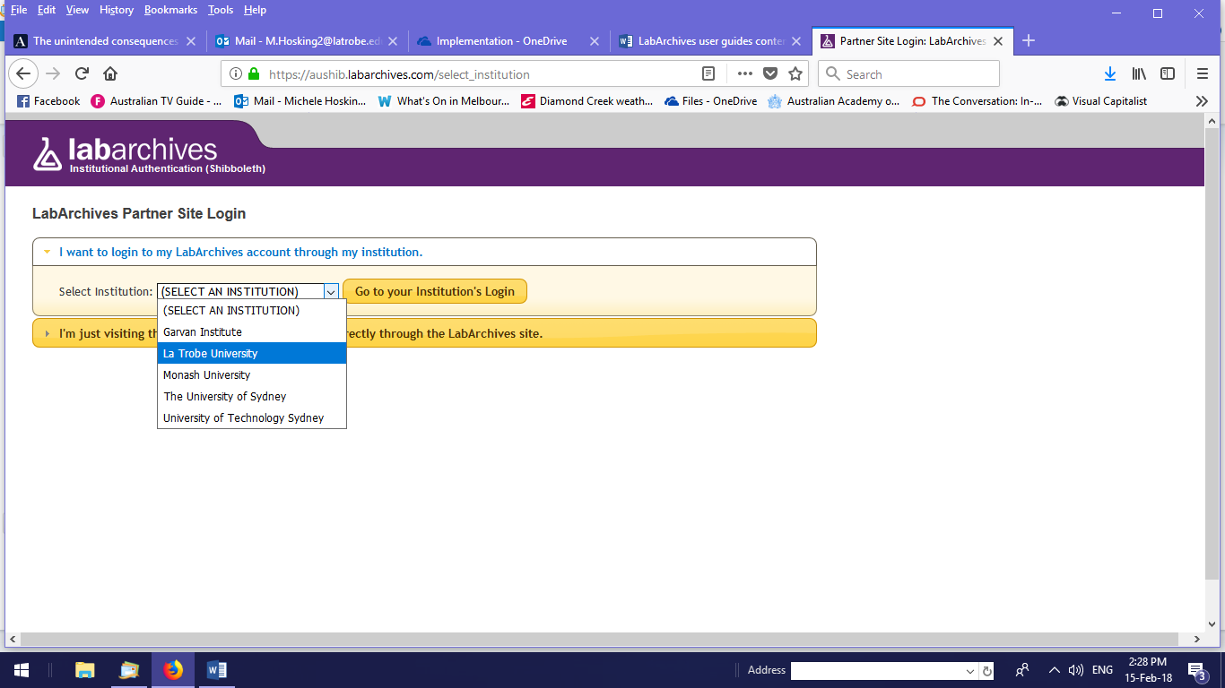

1. You will be redirected to the La Trobe login screen.
2. Enter your usual La Trobe credentials to log in.
3. Select **I do not have a LabArchives account and need to create one**.
4. Select **Create new account**.
5. You will see your account information and can update the details if you wish.

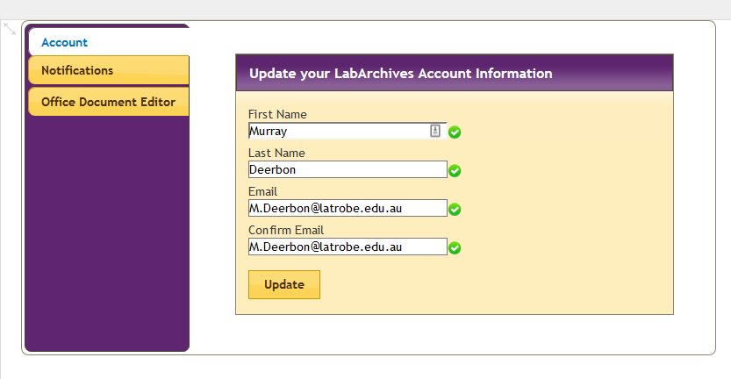

1. You can now start using the Online Research Notebook.

*Note: You’ll receive an email from LabArchives confirming that your account has been activated. You’ll also receive an email confirming any updates made to your account information.*

# Support and further information

For assistance with logging into the Online Research Notebook and creating your account, [ask for help from LabArchives directly](https://www.labarchives.com/support/#supportcontact).

## Further information

Further information can also be found in the [LabArchives Knowledgebase](https://www.labarchives.com/labarchives-knowledge-base/category/eln/getting-started/).