Swap Requests and Joining Waitlists in Allocate+
How to place yourself on a waitlist for a class:
- Log in to Allocate+ and select Timetable from the left-hand side of the screen.
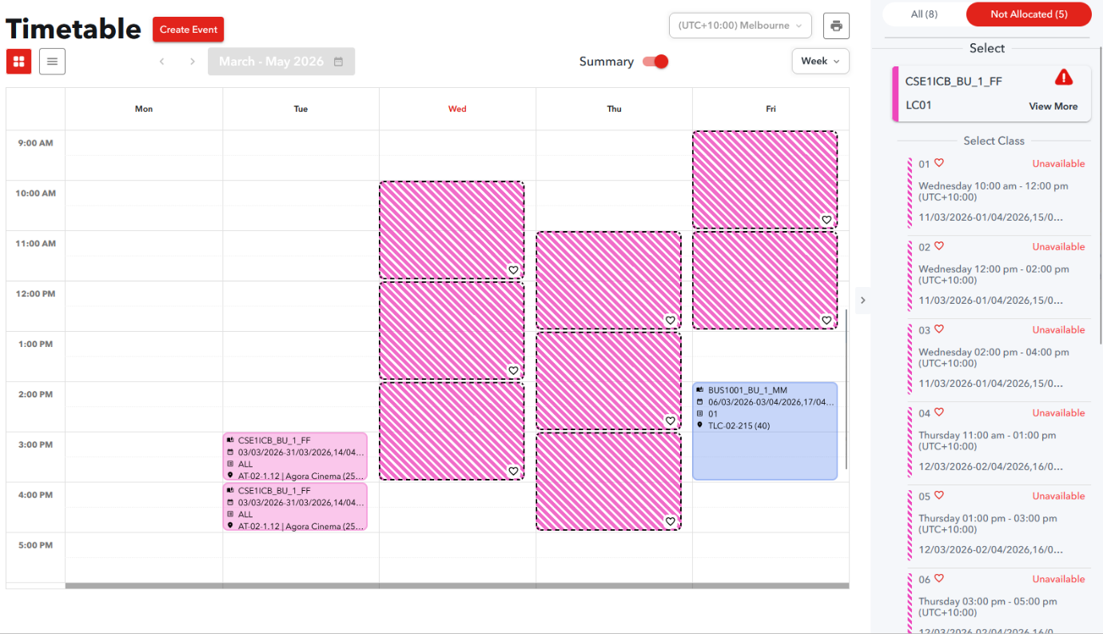
- Select the subject and activity you wish to join the waitlist for by selecting the activity on the right-hand side of the screen. Classes that are already full will show as Unavailable.
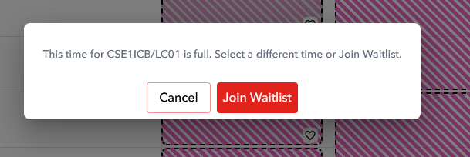
- Select the class time you want to join the waitlist for and select Join Waitlist from the pop-up screen. You will then be automatically added to the waitlist for this class.
- If you change your mind, you can remove yourself from the waitlist by selecting the same class from the list and selecting Remove.
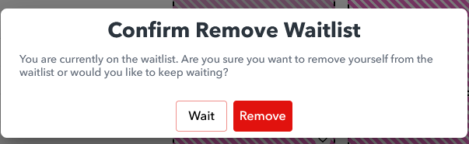
You can join the waitlist for multiple classes. If you are then allocated to one of the classes you requested, you will be removed from the waitlist for the other class.
How to Request a Class Swap
Requesting a class swap is done the same way as joining a waitlist. For a swap to work, you need to already be allocated to a class for the same subject.
If there is no space available, you will be added to the waitlist for that class.
If a swap is available, when you select Join Waitlist, you will immediately be swapped into the requested class and receive the below message:
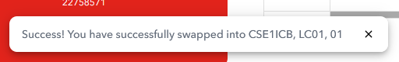
If there are no available classes for your subject, you will need to join the waitlist. It is also recommended that you contact your subject coordinator.
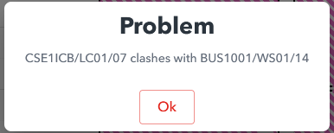
Please note that you will not be able to join the waitlist or request a swap for a class that clashes with a class you are already allocated to. If you try to do this, you will receive the below message:

The following rules apply to swap requests and waitlist requests:
- Swap requests and waitlist requests can only be made during ‘Allocation Adjustment’ periods.
- In some cases, space can become available in a class without automatically processing your swap. If you have a pending swap or waitlist request for an activity, but you notice that the class has space available, you should select the activity!
- Swap and waitlist requests are anonymous and there is no need to find a ‘partner’ to swap classes. The system will handle this for you.
- You will not be asked to confirm your request again before it is processed. Therefore, if you change your mind about a swap or waitlist request, you should log in and cancel it as soon as possible.

