Research Application Summary (RAS)

The Research Application Summary (RAS) is an online e-form that collects information about your proposal through the University’s research management system, ResearchMaster (RM).
It is a University requirement that approval will need to be obtained from Head of School and/or College before submitting a proposal and/or executing a funding agreements/contracts with an external research funder. Researchers will need to submit a RAS for all research grants, research collaborations and consultancies, including those administered by other institutions.
Once a RAS has been submitted, the Research Office is notified and will facilitate the review of the submission by the Head of School and/or College. The School/College will review and determine if they support the submission after considering any relevant resourcing implications (e.g. research team’s time commitment to the project, any other internal cash/in-kind support committed in the application etc.).
Only when the RAS has been reviewed and approved by the School/College, can the proposal be submitted to the funder and accepted once awarded by La Trobe University as the administering organisation.

How to log in to Research Master
Go to: https://researchmanagement.latrobe.edu.au/RME6/Login.aspx
Staff and students can log in by using their La Trobe username and password.

Browser requirements
- Windows - Firefox or Internet Explorer are best
- Mac - Firefox or Safari are best

Submitting a RAS:

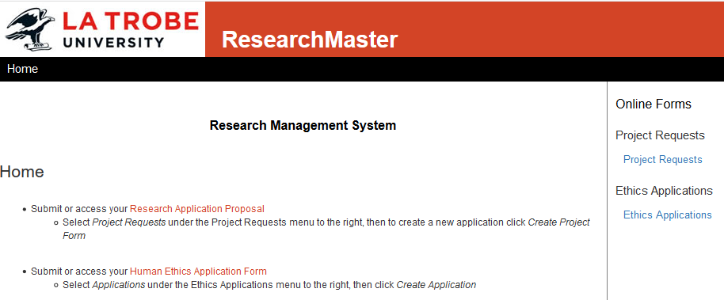
Click on the hyperlink ‘Project Requests’

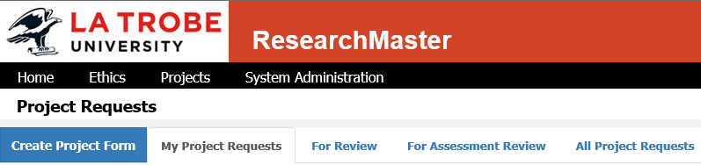
Click on the Create Project Form tab

Select External Research Funding Application (click on the abbreviation)

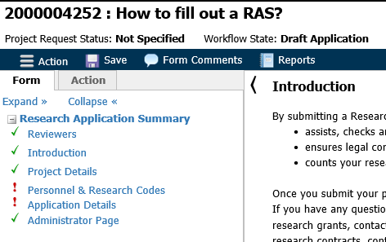
Answer questions on each page and proceed to the next page using the green arrows at the bottom of the page.
(* Denotes mandatory field)

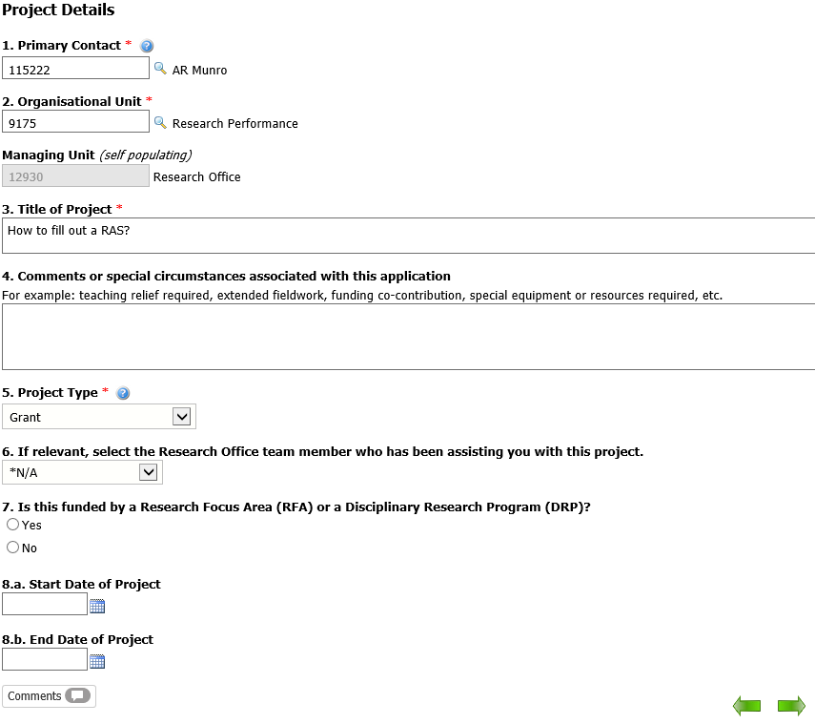
- Select a project type
A Research Grant means:
- pre award (ARC, NHMRC, all other grants)
- post award (ARC, NHMRC, all other grants and related variations)
A Research Contract means:
- quotes or tenders for client-driven research projects
- collaborative research with government or industry partners
Non-research Consulting (Note: Do not submit a RAS for these; instead, please contact researchcontract@latrobe.edu.au).
Click green arrow right to go to next page
These will automatically populate with details of the person that initiated the RAS.
To change Primary Contact:
- Type new Primary Contact’s full name in the box
- Click on or Press Tab key
(This will automatically populate with the person’s ID)
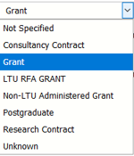
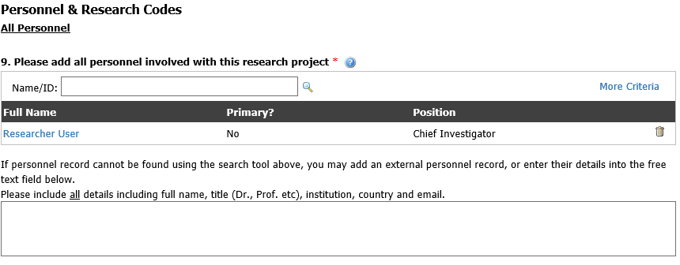
External investigators can be listed in the free text field

Click on ‘More Criteria’ for more search fields.

Please list ALL personnel involved in the project, including external investigators by searching for them in the system.
Note:
- ID refers to the Research Master unique identifier. This may not be a persons staff or student ID.
- The person that initiated the application process will automatically be listed as primary on the application.

Click on hyperlink for details of the person

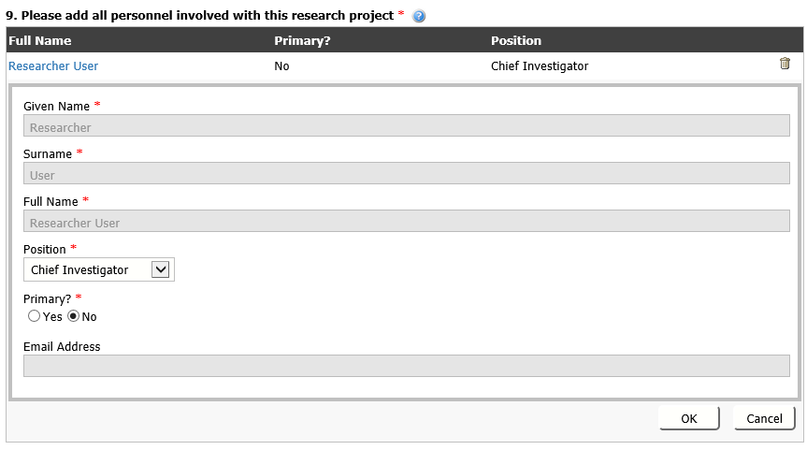
Please select a position/role for all personnel.
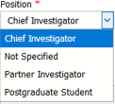
All greyed-out areas are pre-populated fields and cannot be changed in the e-form.
Only one (1) person can be listed as primary
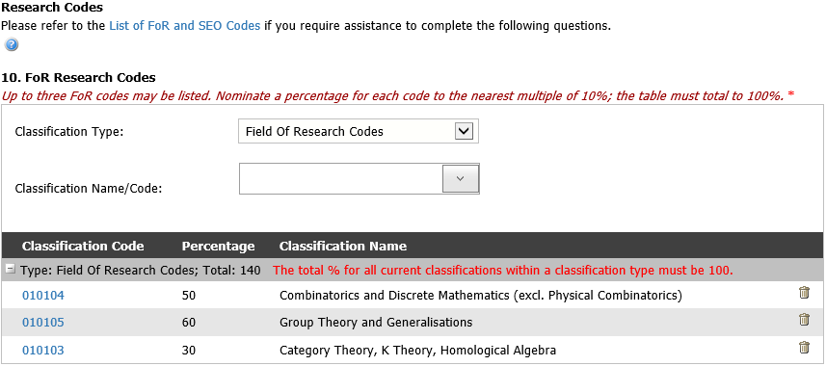
Up to three FoR Codes and three SEO Codes may be listed per project.
Nominate a percentage for each code. All codes must total 100% or a warning will appear.

Click on the trashcan to remove any codes

Type in the classification name or code, or select from the drop down list.

Please refer to link for further details on type of research
https://www.abs.gov.au/ausstats/abs@.nsf/66f306f503e529a5ca25697e0017661f/22E4C184CA111129CA25697E0018FD78?opendocument

The total percentage must be 100%
The total value will calculate once the next arrow is clicked.

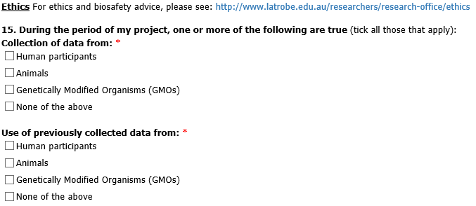
Please refer to the Ethics and Biosafety link for more information.

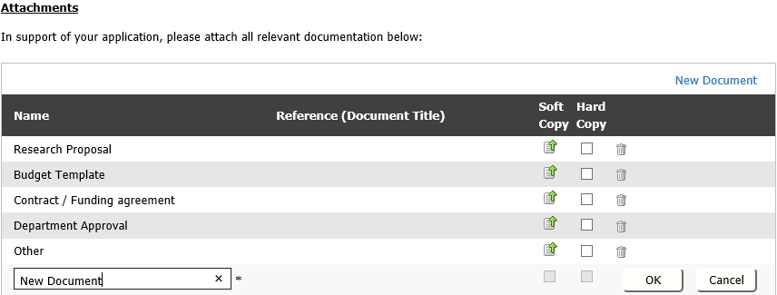
Click the upload button next to the relevant document type to attach documents
Click here to add additional documents.
Then enter a name for the document (bottom left) and click ‘OK’

Click on the trashcan to remove any documents

These will become available after clicking OK

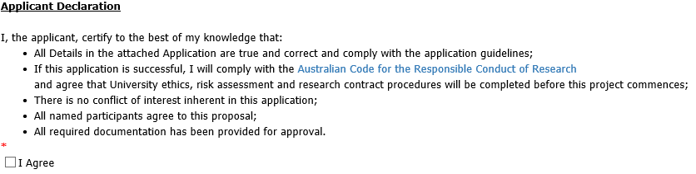
Tick to agree to the declaration

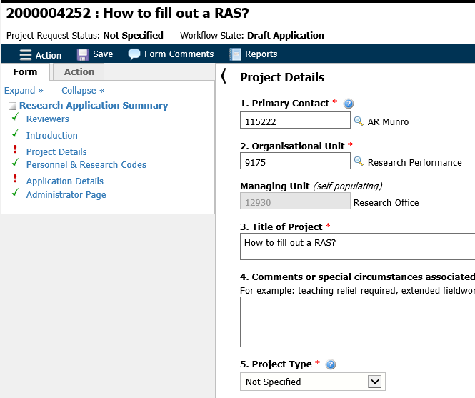
All mandatory fields are noted with a red asterisk (*)
An exclamation mark (!) next to a page means there is/are missing information on mandatory field/s.

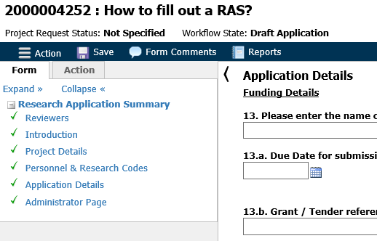
To successfully submit all pages must have a green tick next to all pages.

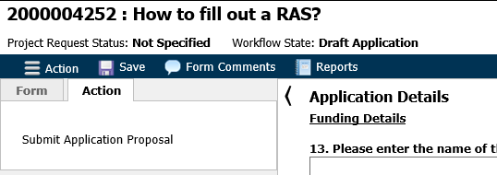
To submit the application, click on the ‘Action’ tab and then ‘Submit Application Proposal’.
A pop-up message will tell you, your application has been submitted.
Research Office will manage the approvals on your behalf and contact you if required

Contacts
ResearchMaster login or external personnel, contact researchmasteradmin@latrobe.edu.au or call x6843
Research Grants: researchgrants@latrobe.edu.au or call x1134
Consulting and Contracts: researchcontract@latrobe.edu.au or call x1124

