# Ashley MARIANI Dylan MARTORELL

Sean HOGAN Yuria OKAMURA

**CHART FORM**

# 18092018 - 27102018

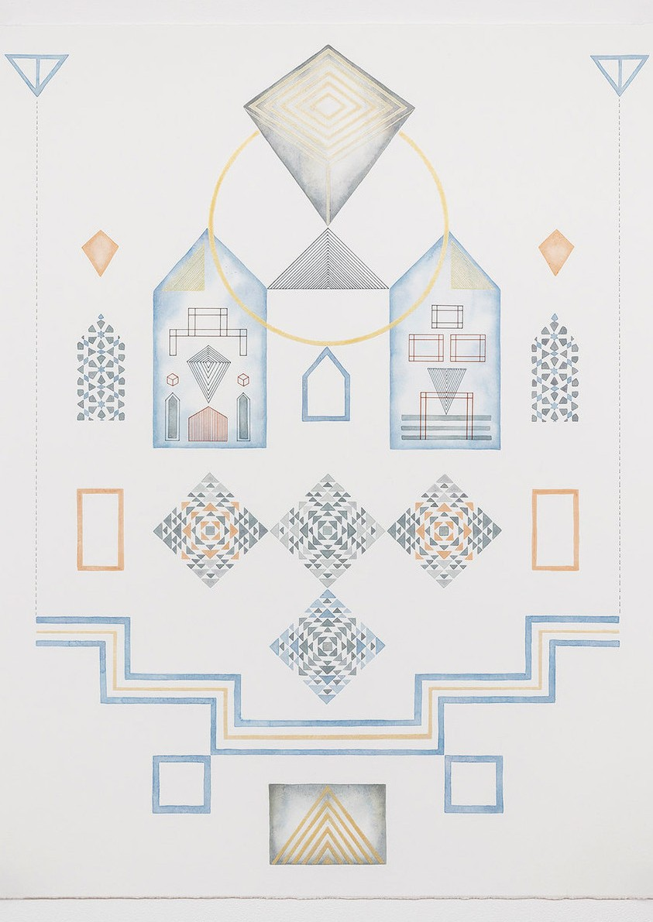

latrobe.edu.au/art-institute

Education Resource

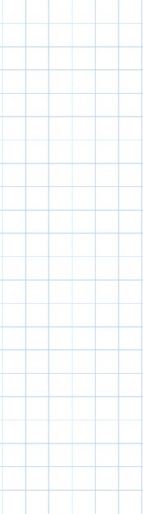

**CHART**

**FORM**

This exhibition brings together

four Australian artists whose works evoke flow charts, graphs and process maps. The exhibition celebrates the aesthetics of data visualisation and the meaning that is implied by this type of representation.

The work of Sean Hogan makes an immediate impact as visitors approach the gallery. Hogan has pieced together 32 canvases of gradiated colour to create a grid that embraces the formality of a graph. Graphs by definition are pictorial devices that are used to

illustrate quantitative relationships. There are certainly relationships at play between these carefully placed panels, however the connections here are purely aesthetic rather than quantative.

Dylan Martorell’s work on the other hand, does represent real data.

Martorell’s drawings are actual musical scores and instruct those who speak their language (the musicians) to undertake specific actions in oder to complete the work (by performing it).

Facing the scores are the subtle and complex watercolours of Yuria Okamura. These works appear

to be instructive, simulating the language of flow charts and the colour palette of scientific text- books and yet there is no real data informing them.

Serving as a contrast to the formal lines of Okumura are the unashamedly hand-made stitches of Ashley Mariani. Mariani’s embroidered works represent the

workings of the left and right sides of the brain, one systematic and apparently logical, the other free- form and organic.

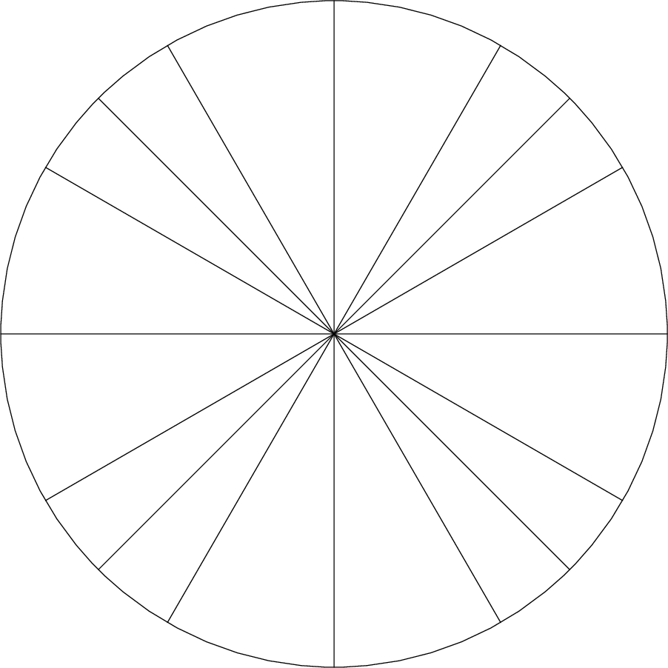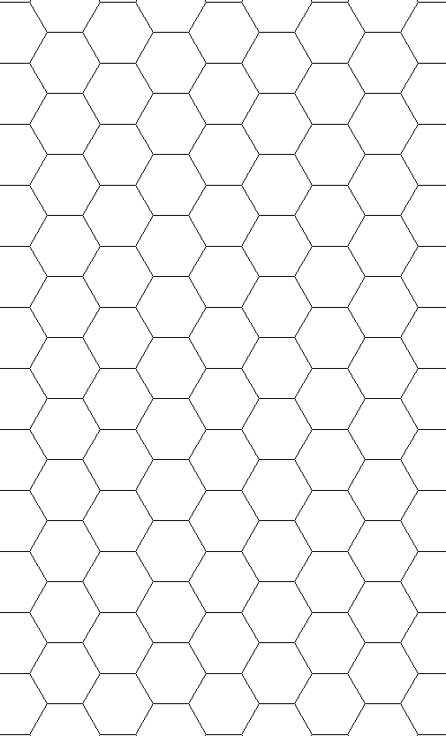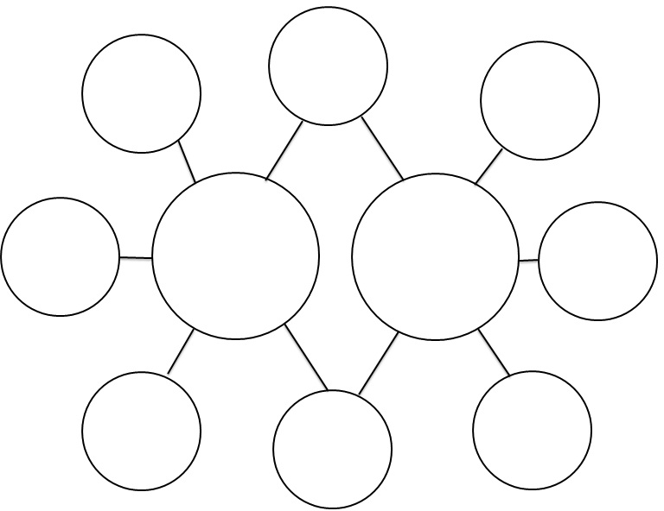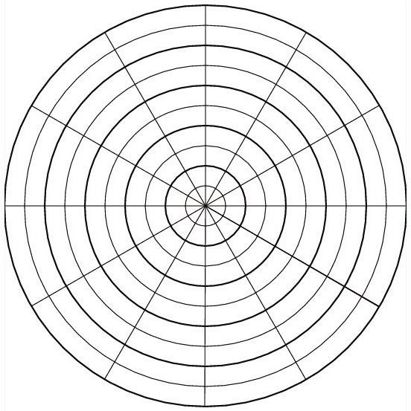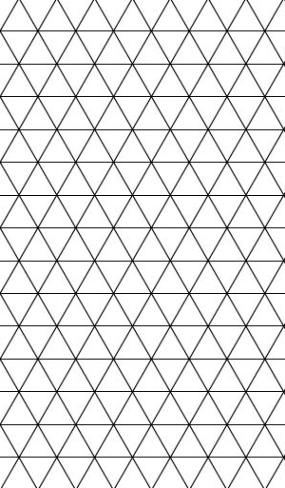

Listen carefully to a piece

of music and try recording the

sounds on a graph with colours. Calm sounds

might be ‘blue’, loud sounds could be red. Can you make a ‘score’ like Dylan Martorell?

Chose a topic to survey your friends

or family on. Can you colour code their

responses and represent them in a graph without using numbers or letters?

What do your thoughts look like?

Can you draw a diagram of what your thought process might look like when you are studying? What about when you are daydreaming. Are they different like Ashley Matorell’s embroidered works?

Collect an assortment of graph paper and mathematical instruments. Make an artwork using only these tools along

with coloured pencils and/or watercolour.

Can you make an artwork that ppears instructional like Yuria Okamura?