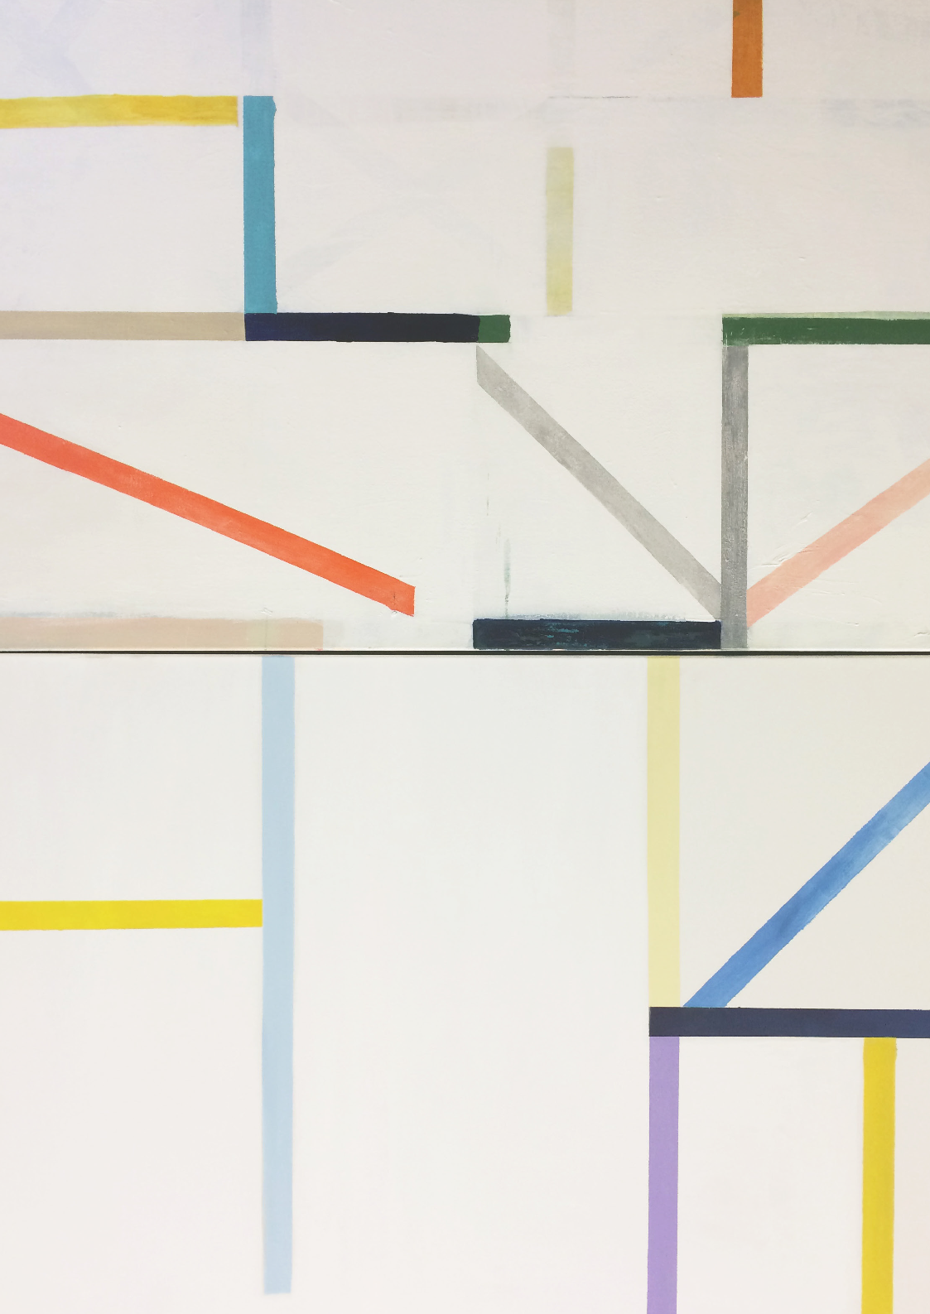This exhibition brings together six Australian artists who use mostly traditional mediums, such as pencil drawing, wood carving and painting on canvas.
latrobe.edu.au/art-institute

The artworks are bright and playful, sometimes causing the viewer to double-take at the illusions they produce. Space is fragmented, three-dimensionsal forms appear to spring forward from the paintings that accompany them,
drawings slip out of their frames onto the gallery walls and a surreal pairing of a wristwatch and bread creates a sense of absurdity.

The artists explore the notion of the ‘glitch’; where an error, fragmentation, mutation or repetition can inadvertently create productive outcomes. The title of the exhibition suggests that there is a grammar or syntax - a set of rules, systems and structures that denote or describe these glitches. This visual language is manipulated by the artists to create unexpected forms and opportunity for new interpretations.

The design of the exhibition also embraces this aesthetic (grammar) of the glitch - with the room’s white painted edges cutting-in over the grey walls. Grey is the transitory tone between the black of the previous exhibition and the white walls of the next, suggesting that the preparation of the space has been haulted or experienced a glitch of some kind.
Glossary:
Aesthetic: a set of principles underlying the work of
a particular artist or artistic movement

Glitch: an unexpected usually temporary, minor problem or deviation from a set path

Grammar: a system of rules that defines the
structure of a language

Surreal: having the disorienting, hallucinatory quality of a dream; unreal; fantastic. Surrealism is a modern movement in art and literature that tries to express the subconscious mind.

Syntax: the arrangement of words and phrases to
create well-formed sentences in a language.

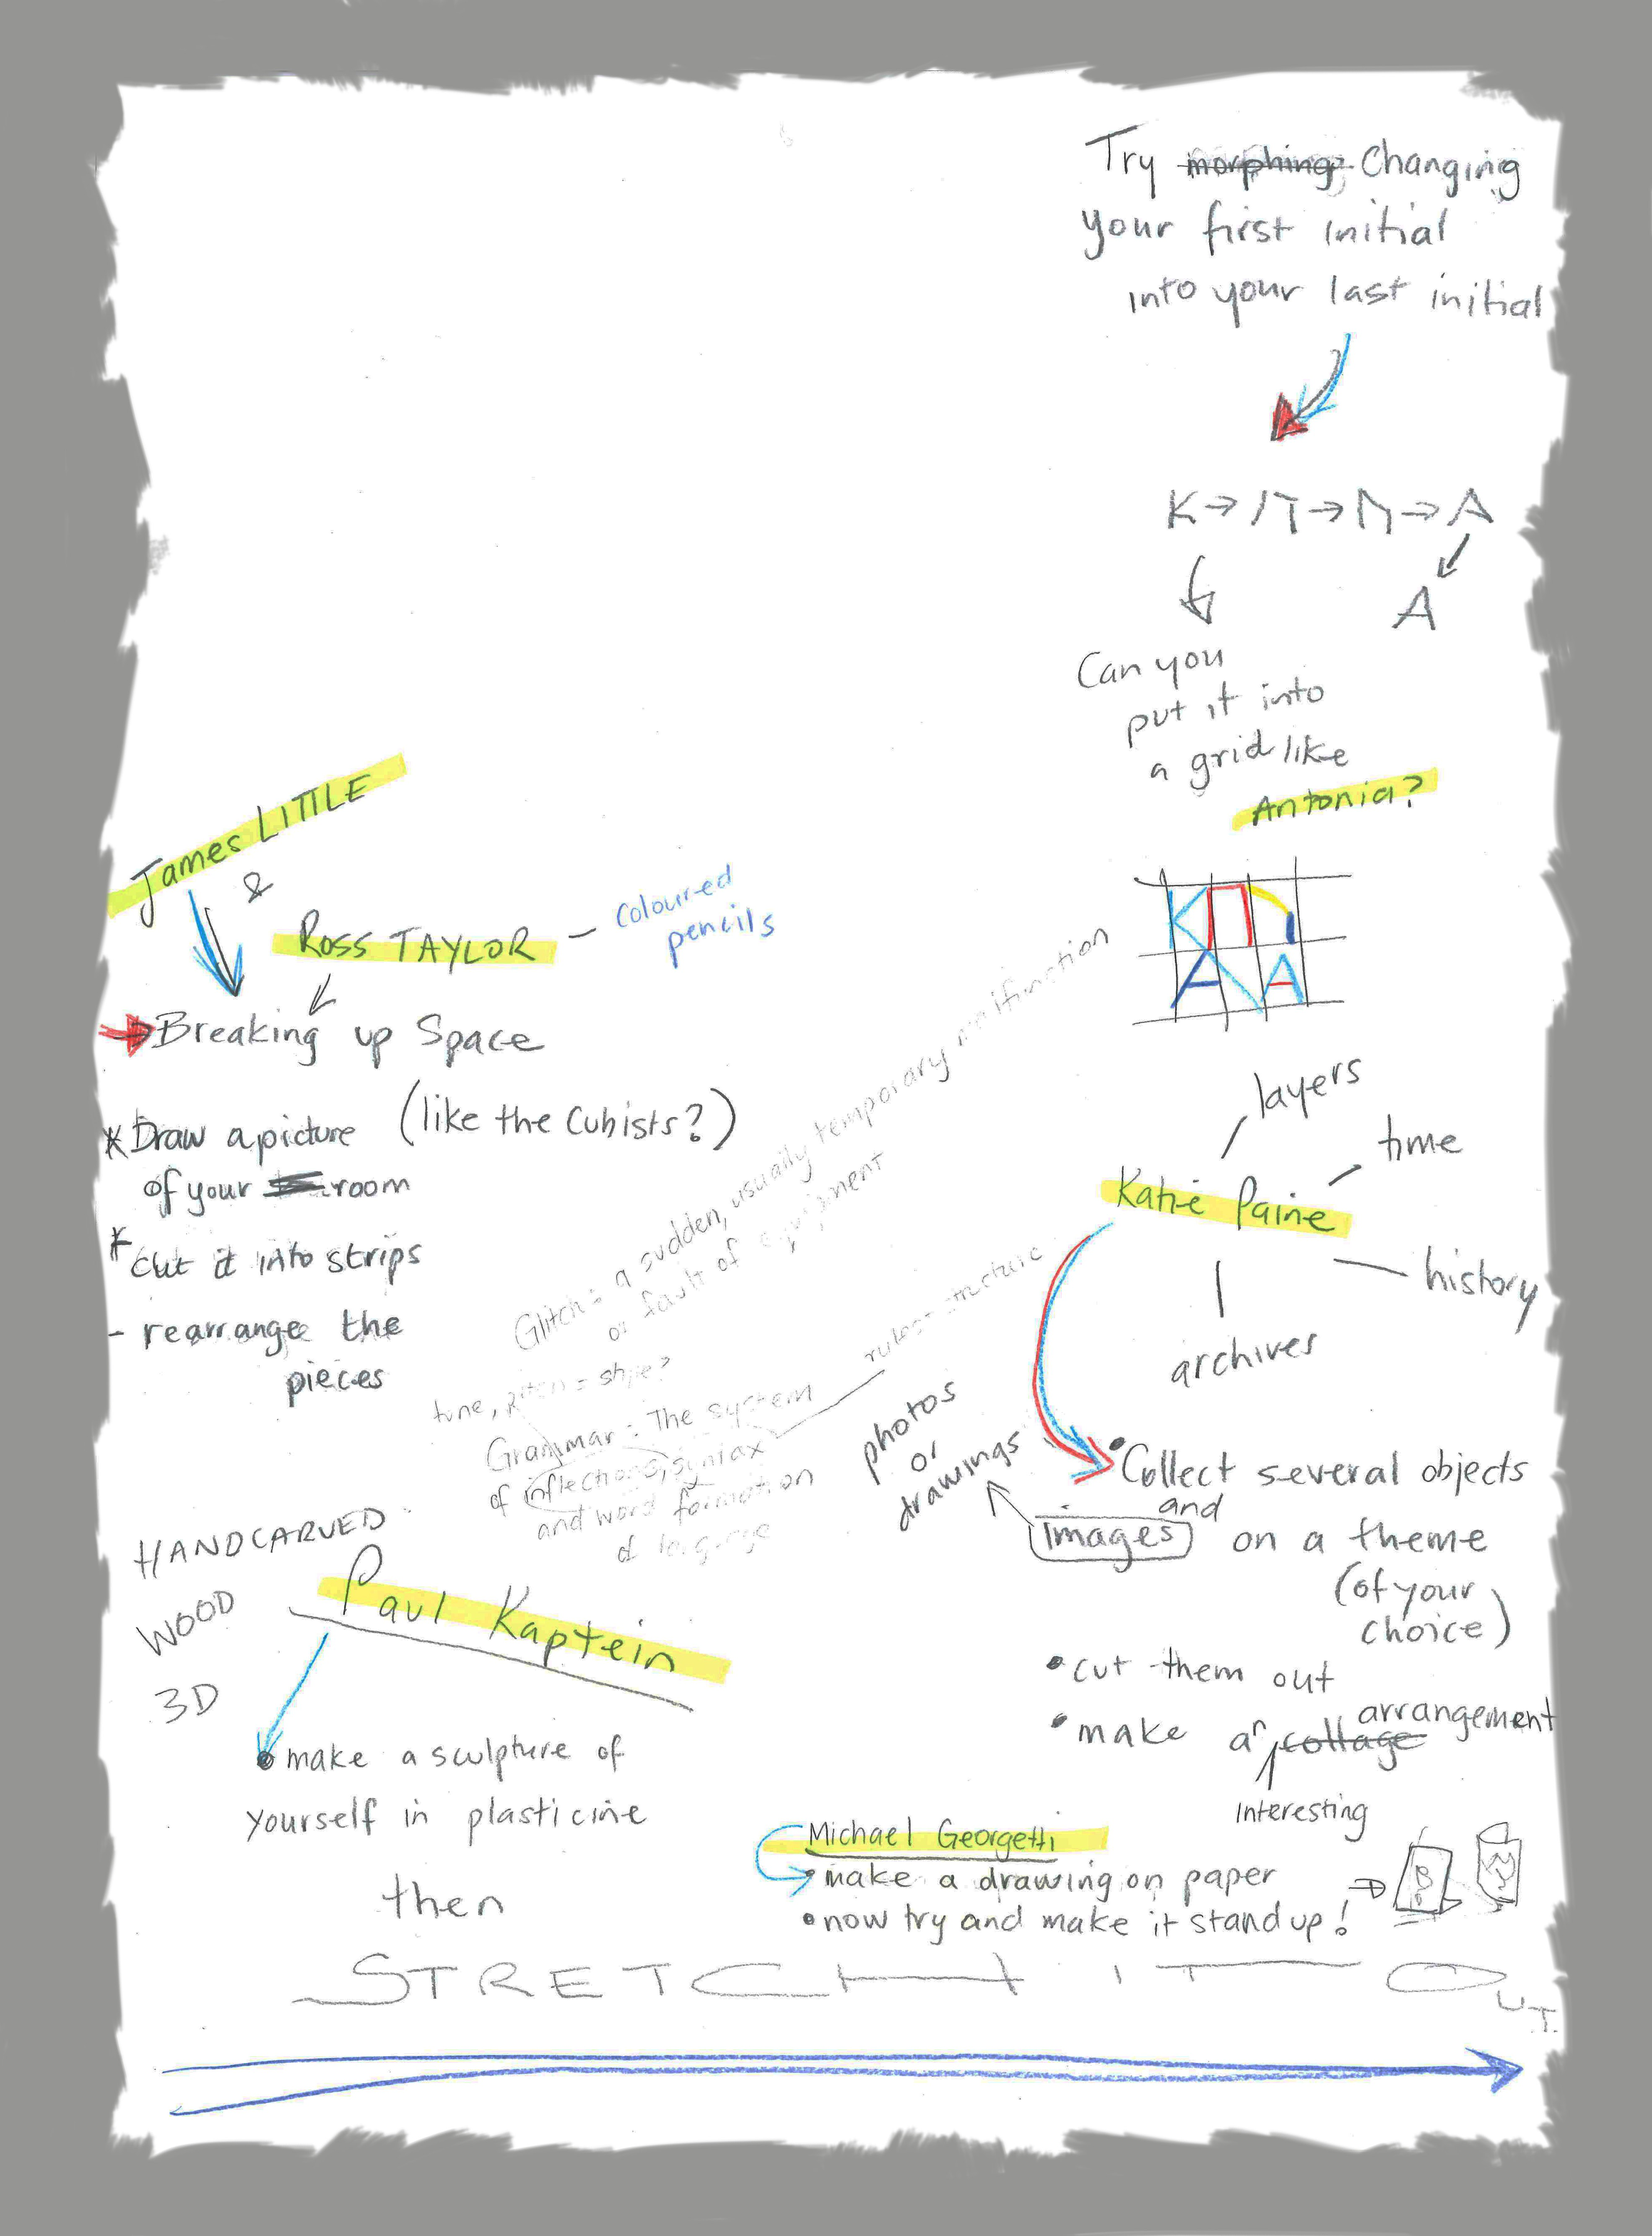Antonia SELLBACH

James LITTLE

Katie PAINE
G

Michael GEORGETTI

Paul KAPTEIN

Ross TAYLOR

T

C

