LA TROBE UNIVERSITY
ALBURY-WODONGA NAIDOC AWARDS –
2016
Nomination Booklet

Nomination Booklet

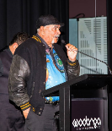
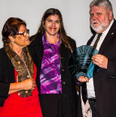
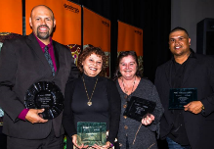
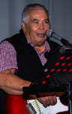
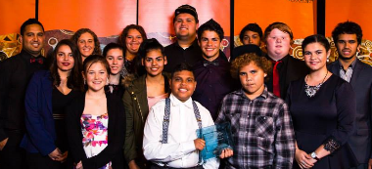
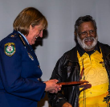
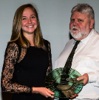
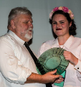

THIS YEARS ALBURY WODONGA NAIDOC AWARDS ARE PROUDLY SUPPORTED BY:

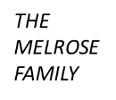
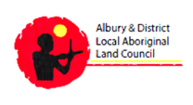
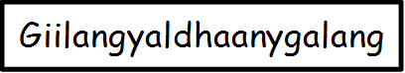
We live in a vibrant and active community, with many of our local Aboriginal and Torres Strait Islander peoples making great contributions to the community through music, art, culture, community, education, environment, sport, employment and politics. La Trobe University values the continuing contributions of Aboriginal and Torres Strait Islander people make to the university and to the broader community. We are proud to be involved with the Albury Wodonga NAIDOC Celebrations. If you would like someone in our community to be recognised for their contribution, then complete this nomination form for the Albury-Wodonga NAIDOC Awards –2016.

Winners and finalists in all categories will be announced after the Welcome to Country/Opening Ceremony of the Songlines Festival at the Wonga Wetlands Wiradjuri Campsite (in the marque) which will be held on the 6th July 12.00 – 5.00.

Nominations for the La Trobe University Albury-Wodonga NAIDOC Awards – 2016 close and must be received by 5pm on Friday 17th June 2016.

Enquiries about the awards please contact:
Dr Pettina Love, Indigenous Student Services Officer
La Trobe University, Albury-Wodonga Campus
on (02) 6024 9796 or 0428 059 946 or p.love@latrobe.edu.au.

CATEGORIES OF AWARDS
Based on consultation with various stakeholders and taking into consideration the award categories of the National NAIDOC awards, awards will be presented to recipients in the following eight categories.
- Uncle Arthur Melrose Memorial Encouragement Award
- Elder of the Year
- Youth of the Year
- Community Person of the Year
- Scholar of the Year
- Artist of the Year
- Sportsperson of the Year
- Volunteer of the Year
- Appreciation Award

GUIDELINES FOR ELIGIBILITY
- All people nominated for an Albury-Wodonga NAIDOC Award – 2016, must be Aboriginal and/or Torres Strait Islander, except the Appreciation Award which is open to Non-Indigenous people.
- People aged 16–25 years are eligible for the Youth of the Year Award.
- The Scholar of the Year Award will be judged on achievement in secondary and/or tertiary study.
- Visual and/or performing artists including musicians are eligible for the Artist of the Year Award.
- A person can be nominated for more than one category award. However, a nomination form must be received for each category they are being nominated.

SELECTION PROCESS
The selection process for each Award category is as follows:

Call for Nominations
Calls for nominations will be circulated amongst the Albury-Wodonga community advising of awards and categories.

Addressing Eligibility Requirement
Nominees must meet the eligibility requirements and award criteria outlined in each of the categories. Nominations that do not meet the eligibility requirements will not be considered.

Shortlisting
Shortlisting of award nominations will be undertaken by members of a selection panel. All nominations will be reduced to a shortlist of no more than three. Shortlisting will be done on the basis of nominators addressing the award criteria as outlined in the Award Criteria section. Shortlisted nominees will be invited to attend the awards ceremony.

Selection Panel
- The selection panel for all Awards all will consist of representatives of the Office of the Director of Indigenous Education, La Trobe University and LAECG representatives based in either Mildura, Shepparton, Bendigo or Bundoora. All members of the selection panel will be unrelated and have no personal bias to any of the nominators or the nominees.

Decision Dates
Final decisions concerning Award finalists will be made upon reviewing all nominations for each Award category.
- 24th June – Nominees that have been shortlisted to receive an award will be notified by Dr Pettina Love; and
- NAIDOC Week - Award winners and finalists will be announced at the Awards ceremony.

Announcement of Winners
Winners and finalists will be announced and presented with an award as part of the Songlines Festival at the Wonga Wetlands Wiradjuri Campsite which will be held on the 6th July 12.00 – 5.00. The Award ceremony will be held directly after the Welcome to Country/Opening Ceremony for the Songlines Festival in the marque.

AWARD CRITERIA

Please support the award nomination by completing the nomination form – on pages 6 – 8.

Uncle Arthur Melrose Memorial Encouragement Award
Please nominate individuals for the Uncle Arthur Melrose Memorial Encouragement Award using the award criteria below:
1. This award is presented to an Aboriginal and/or Torres Strait Islander individual to encourage them to continue with their personal journey.
2. The award is intended to highlight their achievement in any/or all of the following areas: kindness, courageousness, persistence, quiet achievement, personal ethics, family values, steadfast character and humour.

Elder of the Year Award
Please nominate individuals for the Elder of the Year Award using the award criteria below:
- The Aboriginal and/or Torres Strait Islander Elder exemplifies the values important to Aboriginal and Torres Strait Islander people
- Demonstrated commitment and contribution to benefit Aboriginal and Torres Strait Islander people over the long term, and demonstrated achievement in this area
- The Elder is an inspirational leader and role model
- Demonstrated involvement in the Aboriginal and Torres Strait Islander community at the local, regional and/or national levels

Youth of the Year Award; Community Person of the Year Award; Scholar of the Year Award; Artist of the Year Award; Volunteer of the Year Award; and Sportsperson of the Year Award
Please nominate individuals for any of the above five awards using the award criteria below:
- Demonstrated excellence in their nominated category
- The Aboriginal and/or Torres Strait Islander individual’s status as an inspirational role model for Aboriginal and Torres Strait people and the broader Australian population
- Demonstrated leadership
- The individual’s future goals and likely impact
- Demonstrated commitment to personal/vocational/career development

Appreciation Award
Please nominate individuals for the Appreciation Award using the award criteria below:
1. This Award is presented to a Non-Indigenous person who has demonstrated commitment and made a contribution to benefit Aboriginal and Torres Strait Islander people over the long term, and has demonstrated achievement in this area
2. Demonstrated involvement in the Indigenous community at the local, regional and/or national levels

SUBMITTING YOUR NOMINATION FORM

In person:

Dr Pettina Love
Indigenous Student Services Officer
Room 4234, Level 2, Building 4 – Administration Building
La Trobe University
WODONGA

By mail to:

Dr Pettina Love
Indigenous Student Services Officer,
Office of the Director, Indigenous Education
La Trobe University
WODONGA VIC 3690

By email to: p.love@latrobe.edu.au

Reminder, nominations close and must be received by 5pm on Friday 17th June 2016.

Awards Nomination Form

AWARD CATEGORY
In accordance to the award criteria, please nominate one category per nomination
Uncle Arthur Melrose Memorial Encouragement Award
Elder of the Year
Youth of the Year
Community Person of the Year
Scholar of the Year
Artist of the Year
Sportsperson of the Year
Volunteer of the Year
Appreciation Award

DETAILS OF NOMINEE
Title: First Name: Surname:
Age:
Gender: Male Female
Are you: Aboriginal Torres Strait Islander Non-Indigenous
Address:
State: Postcode:
Telephone: Mobile:
Email:

Signature of Nominee |  | Date

DETAILS OF NOMINATOR
Title: First Name: Surname:
Age:
Gender: Male Female
Are you: Aboriginal Torres Strait Islander Non-Indigenous
Is your nominee Colleague Family member Friend Other
Address:
State: Postcode:
Telephone: Mobile:
Email:

Name of Nominee:
Name of Nominator:
Award Category: | Uncle Arthur Melrose Memorial Encouragement Award / Elder / Youth /  Community Person / Scholar / Artist / Sportsperson / Volunteer Award/  Appreciation Award

Provide a short paragraph to tell us about your nominee and why you have nominated them for the award:
Please write a short paragraph providing as much details as you can and consider the award criteria that the nomination is for. For example:
- In what ways have they demonstrated excellence?
- How have they contributed to their community?
- How are they an inspirational role model?
You can attach extra pages and supporting material.

Name of Nominee:
Name of Nominator:
Award Category: | Uncle Arthur Melrose Memorial Encouragement Award / Elder / Youth /  Community Person / Scholar / Artist / Sportsperson / Volunteer Award  Appreciation Award
Signature of Nominator |  | Date

THANKYOU and GOOD LUCK

