Microsoft Office Plugin for the Online Research Notebook

About the plugin
LabArchives’s Microsoft Office Plugin integrates the Online Research Notebook with Microsoft Word, Excel, and PowerPoint. The plugin enables you to:
- open a file from your notebook from within a Microsoft Office application
- save a new or existing file to your notebook from within a Microsoft Office application

Setting up the plugin

What you need to do
- Download the Microsoft Office plugin for your operating system
- Install the plugin
- Obtain a password token from the Online Research Notebook
- Log in to the Online Research Notebook from a Microsoft Office application, saving your details so that future logins are automatic

Download the Microsoft Office plugin
- If you are running the latest version of Windows or Mac OS on your pc or laptop, you can install the plugin from the La Trobe Software Center. Follow the installation procedure as detailed in https://latrobe.service-now.com/kb_view.do?sysparm_article=KB0010766. Once installation is complete, proceed to the Obtain a password from the Online Research Notebook procedure on page 5 below.
If you are not running the latest version of Windows or Mac OS, you can download the plugin from the Online Research Notebook.
- In the Online Research Notebook, click the triple bar icon at the top of the Online Research Notebook, go to Downloads, and select Microsoft Office Plugin:

- Download the version you need.
Choose this option if you use a Windows pc:
Choose this option if you use a Mac:
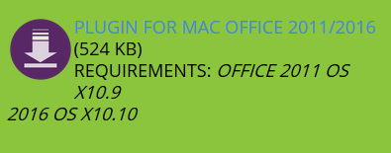

Install the Microsoft Office plugin
Note: La Trobe Windows users may need to set up a Local Admin account in order to be able to install the plugin. Instructions are available at https://latrobe.service-now.com/ict?id=kb_article&sys_id=640059506f82c680d654c6168d3ee411
- To install the plugin, open the file that you downloaded; it will step you through the installation process, as per the following screenshots.
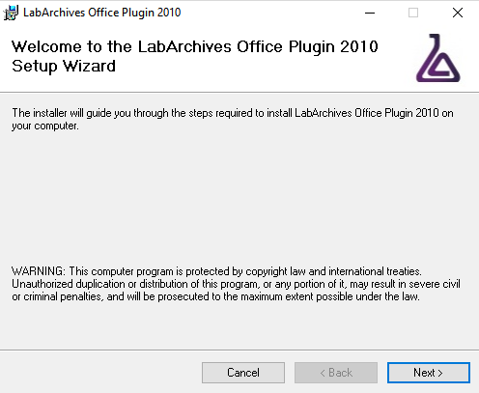
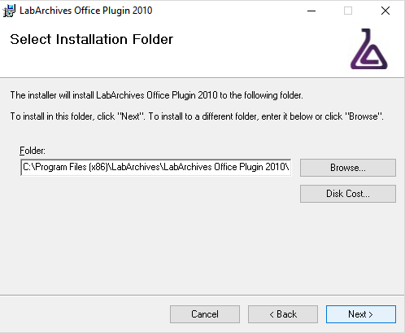
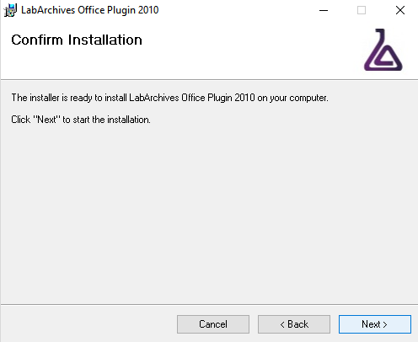

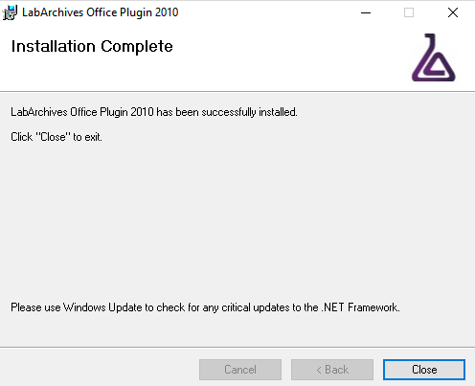

Obtain a password token from the Online Research Notebook
- Log into the Online Research Notebook in your preferred browser
- Select LA App Authentication under the User Management menu.
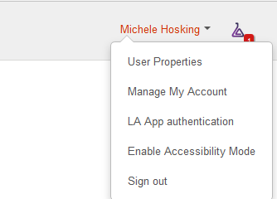
- A Password token for external applications screen will appear. Note that this token will expire in one hour.
- Copy the password token.

Log in to the Online Research Notebook from a Microsoft Office application
- In your Microsoft Office application, select the option to log in to LabArchives.
If you’re using Windows, you’ll find the Log in to LabArchives option in the File menu:
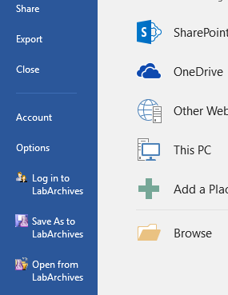
If you’re using a Mac, the option is under LabArchives in the File menu:
- Change the LA server to the Australian server: https://auapi.labarchives.com
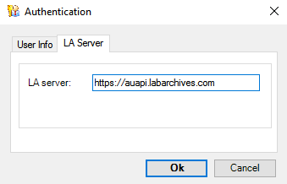
- Enter your email address, paste in the password token and tick the Remember Me checkbox (to avoid the need to generate a new password token each time you log in).
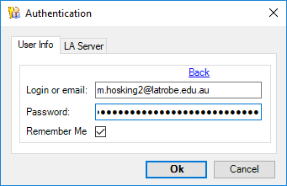
- Select OK to complete login. You will now be able to access files stored in the Online Research Notebook and save files to it.

Support and further information

Support
For assistance with the La Trobe Software Center, contact IS via Ask Services.
For assistance with installing the Microsoft Office plugin and accessing the Online Research Notebook within Microsoft Word, Excel or Powerpoint, contact LabArchives Support.

Further information
This procedure has been adapted for La Trobe researchers from the LabArchives Knowledgebase article Microsoft Office Plugin for Windows.
For further details about the Microsoft Office Plugin, refer to the LabArchives Knowledgebase article.

