Working offline and the Online Research Notebook

Options for uploading files created while offline
Although the Online Research Notebook does not currently provide automatic synchronisation of data created while offline (i.e. when you do not have an internet connection), it does offer several options that you may find useful for getting your offline data into your notebook.
Attach files: If you have only a small number of files to add to your notebook, the simplest option is to go into your notebook and attach each file as a new entry.
Email files to your inbox: You can email files to your inbox in the Online Research Notebook, then move them to the appropriate notebook location. Refer to the LabArchives Knowledgebase article for more information.
Create a link to a file or folder: If you want to link to files created while working offline instead of attaching the files into your notebook, you can create a link to the folder on your computer or network in which they are located. Access the procedure to link to files and folders.
Folder monitor: LabArchives Folder Monitor allows you to upload files automatically from your computer or another network location to your notebook. Access the procedure to install and use Folder Monitor.
Save files to the Online Research Notebook from integrated applications:
- Upload Microsoft Word, Excel, and Powerpoint files directly into your notebook using the Microsoft Office plugin. Access the procedure to install and use the Microsoft Office plugin.
- Upload GraphPad Prism files directly into your notebook. Access the procedure to integrate the Online Research Notebook with GraphPad Prism.

Options for accessing notebook content while offline
There are two ways to create an offline, read-only copy of your notebook:
Create an offline HTML copy: The copy will be a complete copy of the notebook, including files you have attached to the notebook. Note that this option is only available if you have access to all the content in a notebook.
Create a PDF copy: The copy will be a single PDF file and it will not include files that you have attached to the notebook. You can use this option regardless of whether you have access to all the content in a notebook, or only part of the content – only the content you have access to will be included in the PDF file.

Make an offline HTML copy of a notebook
If you have access to all the content in a notebook, you can create an offline HTML copy of it. The copy will be a complete copy of the notebook, including attached files.
- Open the notebook you wish to copy.
- In the hamburger menu at the top right of the page, select Utilities and then Create Offline Notebook.
- At the Confirmation prompt, choose OK.
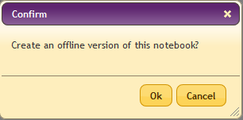
- In the Create Offline Notebook window, choose Continue Working. Your notebook will be copied as a compilation of offline HTML documents contained within a .zip archive.
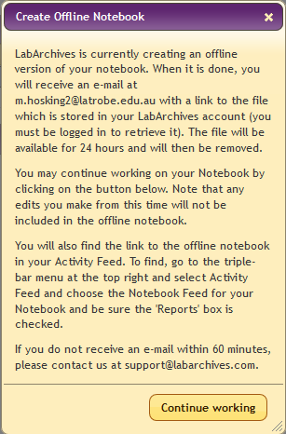
- You will receive an email containing a link to download your offline copy. Depending on the size of your notebook, it may take quite some time to download.
- Once the download has finished, open the zip archive and extract all contents to the destination of your choice.
- To open the notebook, open the file named notebook_home_page.

Make a PDF copy of a notebook
You can create a PDF copy of the content you have access to in a notebook. The copy will not include any files that are attached to the notebook.
- Open the notebook you wish to copy.
- In the hamburger menu at the top right of the page, select Utilities and then Notebook to PDF.
- In the Confirm window, select the options you want then click OK.
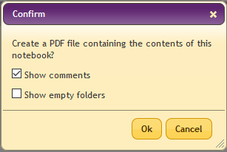
- In the PDF Generation window, choose Continue Working.
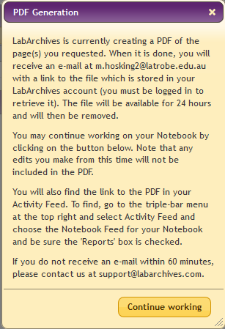
- You will receive an email containing a link to download your PDF copy. Click the link to access the file.

Support and further information
For assistance with creating a copy of your notebook, contact LabArchives Support.
Further information about the procedures contained in this user guide can be found in the following LabArchives Knowledgebase articles:
Create offline notebook
Download your notebook to pdf

