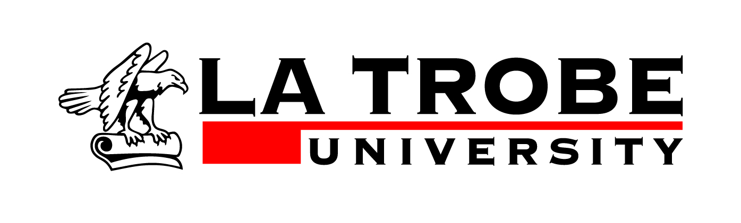

Library Collection Development - Donation form
La Trobe University Library welcomes gifts of materials that enhance the collection.
All donations received by La Trobe University Library are assessed according to the
guidelines published in its Collection Development Framework.
Material that is deemed not suitable for inclusion in the collection is not kept by the Library and is disposed of in the most appropriate way e.g. given to another library, discarded or sold.
I agree to transfer ownership of this material to the La Trobe University Library, subject to the above conditions.
Donor's signature …………………………………………………………… Date ………….……….………….
Name ……………………………………………………………………………………………….……………….
Telephone ……………………………………………. Email …………………………………….……………...
I agree to the disclosure of my name and my donation on the University website or in
other University publications.

I do not agree to the disclosure of my name and my donation on the University website
or in other University publications.’
Remarks……………………………………………………………………………………………………………..
………………………………………………………………………………………………………………………..
………………………………………………………………………………………………………………………..
Please print this form, sign it and enclose with the material for donation, addressed to:
Manager, Scholarly Collections
La Trobe University Library
Bundoora
VIC 3086, Australia

Privacy statement
The information on this form is collected for the primary purpose of processing and recording Library donations. Other purposes of collection may include administrative activities and statistical analyses.
If you choose not to complete all the questions on this form, it may not be possible for the Library to accept and process the donation.

*****************************************************************************************************************************
Received by Library staff member ……………………………….. Date ………………Number of items ................

