Exit planning procedures for the Online Research Notebook

Introduction
Details of notebook-related exit planning requirements for La Trobe researchers can be found in the Guidelines for use of the Online Research Notebook.
This user guide sets out the various procedures that may apply to researchers who are leaving La Trobe.

Exit planning procedures

Making a copy of notebook content
Prior to leaving La Trobe, a departing researcher may elect to make a copy of the notebooks or notebook content to which they have access:
- Make an offline HTML copy of a notebook (where the researcher has access to the entire notebook)
- Make a PDF copy of all or part of the notebook; this could be the part(s) of a notebook to which the researcher has been granted access, or selected parts of a notebook where the researcher does not wish to copy the entire notebook.

Transferring ownership of a notebook
Refer to the Guidelines for use of the Online Research Notebook for information about transfer of ownership requirements. Note that these procedures are only available to notebook Owners:
- Transfer notebook ownership (to a La Trobe staff member)
- Clone a notebook
- Transfer notebook ownership to a non-La Trobe account

Make an offline HTML copy of a notebook
If you have access to all the content in a notebook, you can create an offline HTML copy of it. The copy will be a complete copy of the notebook, including attached files.
- Open the notebook you wish to copy.
- In the hamburger menu at the top right of the page, select Utilities and then Create Offline Notebook.
- At the Confirmation prompt, choose OK.
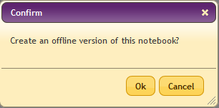
- In the Create Offline Notebook window, choose Continue Working. Your notebook will be copied as a compilation of offline HTML documents contained within a .zip archive.
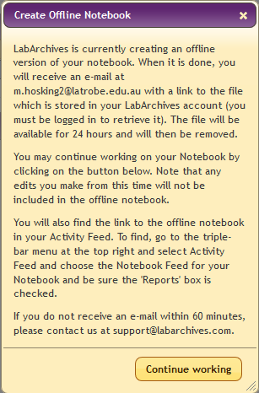
- You will receive an email containing a link to download your offline copy. Depending on the size of your notebook, it may take quite some time to download.
- Once the download has finished, open the zip archive and extract all contents to the destination of your choice.
- To open the notebook, open the file named notebook_home_page.

Make a PDF copy of a notebook
You can create a PDF copy of the content you have access to in a notebook. The copy will be a not include any files that are attached to the notebook.
- Open the notebook you wish to copy.
- In the hamburger menu at the top right of the page, select Utilities and then Notebook to PDF.
- In the Confirm window, select the options you want then click OK.
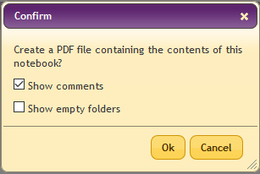
- In the PDF Generation window, choose Continue Working.
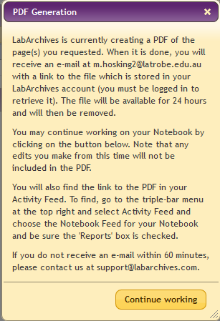
- You will receive an email containing a link to download your PDF copy. Click the link to access the file.

Transfer notebook ownership
Only a notebook’s Owner can transfer ownership to another user. Ownership can be transferred to another La Trobe user of the Online Research Notebook. To be able to transfer ownership beyond La Trobe, see separate procedure Transfer notebook ownership to a non-La Trobe account.
- Open the notebook you wish to transfer to a new owner.
- In the hamburger menu at the top right of the page, select Notebook Settings.
- Select the User Management tab and check that the user to whom you want to transfer ownership is listed there. If they are not, add them using the New User option.
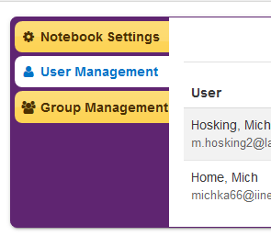
- Select Transfer Ownership
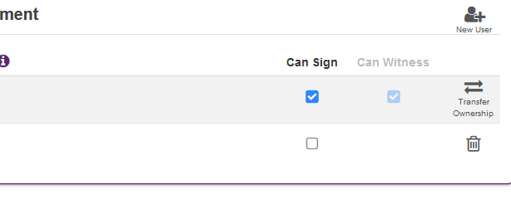
- Select the La Trobe user who is to be the new owner, then click Transfer Ownership.
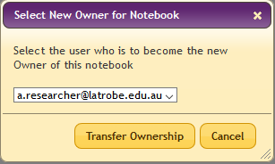

Transfer notebook ownership to a non-La Trobe account
Note:
- Staff researchers may create a clone of their notebooks to take with them when they leave La Trobe, subject to approval by their Head of School.
- Students who have completed their candidature may transfer ownership of their notebook(s) to a non-La Trobe user account, subject to approval by their Supervisor.

- Obtain approval to transfer notebook ownership:
Staff: Contact your Head of School for written approval to transfer your cloned notebook(s) to a non-La Trobe account, then proceed to step 2 below.
Students: Contact your Supervisor for written approval to transfer your notebook(s) to a non-La Trobe account, then proceed to step 7 below.
- Open the notebook you wish to clone.
- In the hamburger menu at the top right of the page, select Utilities and then Notebook Manager.
- In Notebook Manager, locate the notebook you wish to clone and choose Clone.

- At the Clone This Notebook prompt, select Clone Notebook.
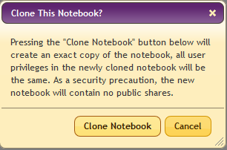
- You will now have a clone of your notebook, with the same name as the original with “- copy” appended, e.g. “My notebook – copy”.
- Place a request with ICT Ask Services to enable transfer your notebook(s) to a non-La Trobe account, attaching a copy of approval from your Head of School or Supervisor.
- ICT will temporarily enable transfer of ownership beyond La Trobe and will advise the timeframe available for you to complete the transfer.
- Open the notebook you wish to transfer to a new owner.
- In the hamburger menu at the top right of the page, select Notebook Settings.
- Select the User Management tab and check that the user to whom you want to transfer ownership is listed there. If they are not, add them using the New User option.

- Select Transfer Ownership
- Select the user who is to be the new owner, then click Transfer Ownership.
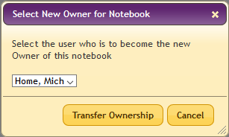

Support and further information
For assistance with the procedures contained in this user guide, contact LabArchives Support.
Further information about exit planning can be found in the Guidelines for use of the Online Research Notebook.
Further information about the procedures contained in this user guide can be found in the following LabArchives Knowledgebase articles:
Notebook Manager
Create offline notebook
Download your notebook to pdf
Transferring ownership of a notebook

