Setting up the LabArchives app

About the LabArchives app
The LabArchives app is free and is available for use with iOS and Android devices. It allows you to access the Online Research Notebook from your portable device of choice.
Note that the full LabArchives web application can also be used on any device and screen size – for more information, see the LabArchives Knowledgebase.

Setting up the app

What you need to do
- Download the app
- Obtain a password token from the Online Research Notebook
- Log in to the app, saving your details so that future logins are automatic

Download the app

iOS devices
- Download the LabArchives app from the Apple App Store.
- Go to your Settings and locate LabArchives
- Set the Custom Server option to On, then enter the url for the Australian data centre: https://auapi.labarchives.com

Android devices
- Download the LabArchives app for the Australian region from Google’s Play Store.

Obtain a password token from the Online Research Notebook – for both iOS and Android
- In a web browser on the device you want to use the app on, log in to the Online Research Notebook as usual.
- Navigate to the LA App authentication option:
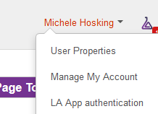
- The following screen displays. You’ll use the email address and password token listed here to log in to the LA app.
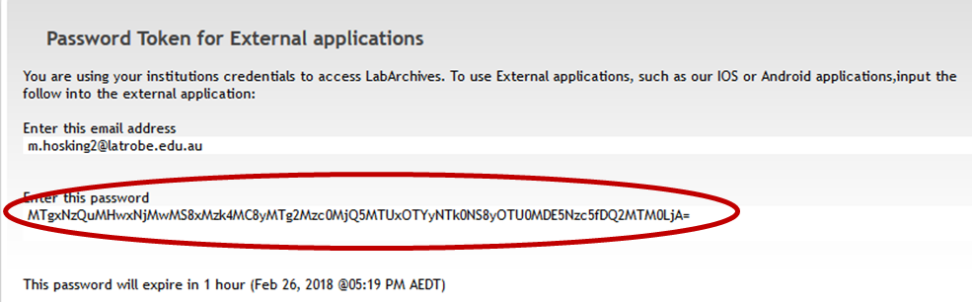
- Copy the password token.

Log in to the app

iOS devices
- Open the LabArchives app.
- Enter your email address in the Login field
- Paste the password token into the Password field.
- Click Login.
- After successful login, you will see all your notebooks.
- Go to your Settings and locate LabArchives
- Make sure the Autologin option is switched On.

Android devices
- Open the LabArchives app.
- Enter your email address in the Login field
- Paste the password token into the Password field.
- Click Login.
- After successful login, you will see all your notebooks.
- Click the Settings icon
- Turn Autologin to On.

An alternative: Emailing the password token
If you access the LabArchives Password Token for External Applications page on a different device from the one you’ll be using the app with, you could paste the password token into an email and send it to yourself.
- Access email via the device on which you want to use the LabArchives app.
- Copy the password token from the email message and paste it into the app’s Password field.

Troubleshooting

Expires parameter error
If login fails and you see the following error:
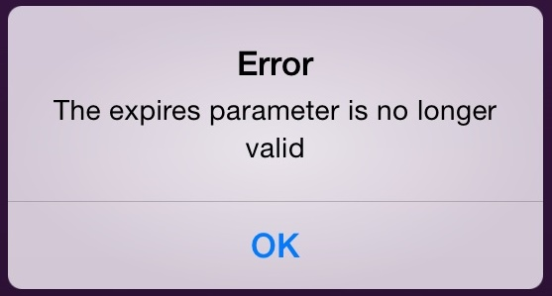
It means that Autologin is Off and the password token you used has expired. You’ll need to obtain a new password token and then turn Autologin to On in your Settings.

Support and further information

Support
For assistance with installing and using the app, contact LabArchives Support.

Further information
This user guide has been adapted for La Trobe researchers from the LabArchives Knowledgebase articles Android App and iOS App.
For further details about the app, refer to the LabArchives Knowledgebase.

