Logging in to the Online Research Notebook for the first time

1. Go to <https://aushib.labarchives.com/select_institution> (and bookmark this link for future use).
2. From the **Select Institution** box, select La Trobe University.

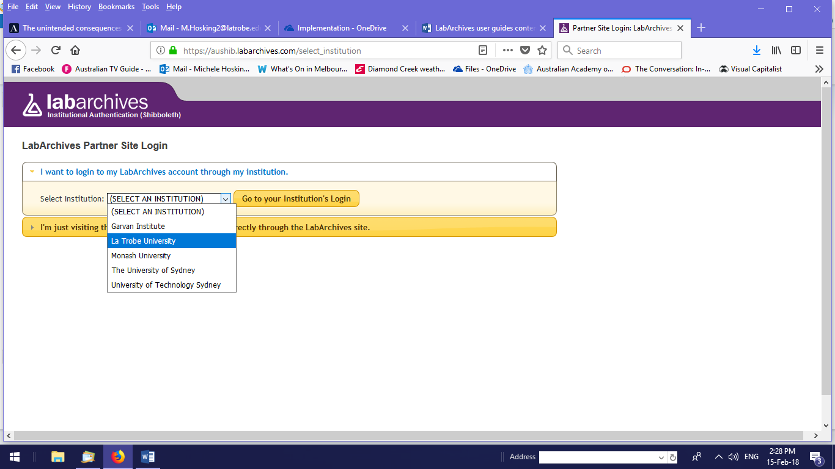

1. You will be redirected to the La Trobe login screen.
2. Enter your usual La Trobe credentials to log in.
3. Select **I do not have a LabArchives account and need to create one**.
4. Select **Create new account**.
5. You will see your account information and can update the details if you wish.

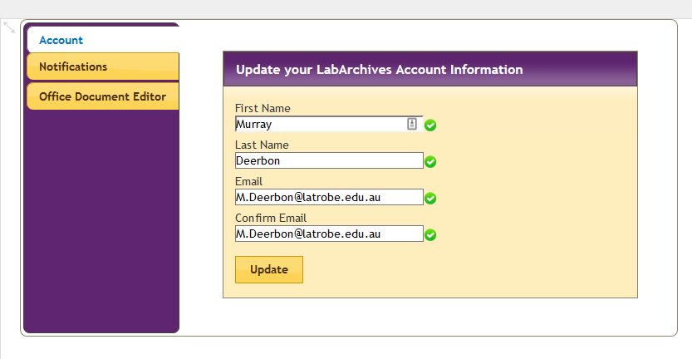

1. You can now start using the Online Research Notebook.

*Note: You’ll receive an email from LabArchives confirming that your account has been activated. You’ll also receive an email confirming any updates made to your account information.*

# Support and further information

## Support

For assistance with logging into the Online Research Notebook and creating your account, [ask for help from LabArchives directly](https://www.labarchives.com/support/#supportcontact).

## Further information

Further information can also be found in the [LabArchives Knowledgebase](https://www.labarchives.com/labarchives-knowledge-base/category/eln/getting-started/).