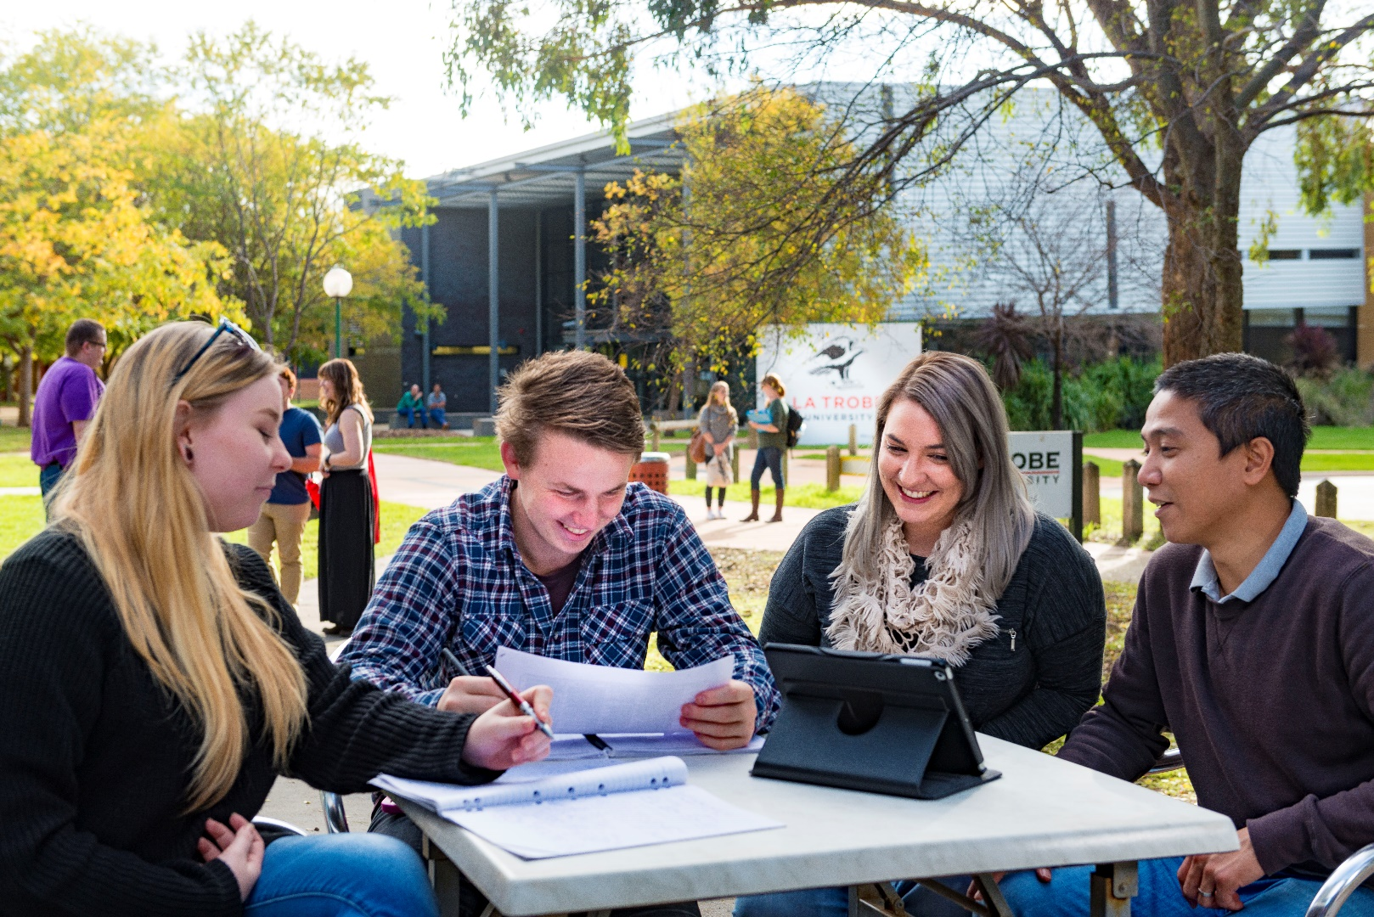

Apply Now - $1,500 Fellowships for Bachelor students interested in a hands-on research role

Joss Family Fellowship for Future Researchers
September 2022

Table of Contents
Apply Now - $1,500 Fellowships for Bachelor students interested in a hands-on research role 3
Project 1: Outfoxing the fox: new ways to protect endangered turtles from invasive red foxes 4
Discipline area: Ecology, Conservation Biology 4
Project 2: Electrochemical analysis of lithium - chloranilate networks 5
Discipline area: Synthetic chemistry, crystallography, electrochemical analysis. 5
Project 3: Investigating RA synthesis in the epididymis 6
Discipline area: Biomedical Science 6
Project 4: A history of Albury-Wodonga Campus of La Trobe University 7
Discipline area: History, Archival Studies 7
Project 5: Tracing Human Trafficking at Sea 8
Discipline area: Social Sciences, Sociology, CJLS, Human Geography 8

Apply Now - $1,500 Fellowships for Bachelor students interested in a hands-on research role

Five research projects, under the supervision of Albury-Wodonga Campus researchers, are on offer, covering disciplines such as:
- Ecology, Conservation, Biology
- Synthetic Chemistry, Crystallography, Electrochemical Analysis
- Biomedical Science
- History, Archival Studies
- Social Sciences, Sociology, CJLS, Human Geography

Toward the end of the research period, the Fellows and their supervisors will present their research project at a campus Research Symposium.

Details of the fellowships are as follows:

Fellowship $250 per week (tax-free), $1500 total

Tenure Six weeks, weekly hours to be negotiated with supervisor. Supervisors will endeavour to design flexible research schedules that fit with part time work. This is designed to be a taste of research!

Commencement All programs will begin in December 2022. Completion dates will be negotiated with the supervising academic staff member.

Selection Project supervisors will make the final decision. Only one fellowship will be awarded per student.

Application Students are required to submit their resume and the fellowship application form.

Eligibility: Undergraduate students from La Trobe university with a minimum of 180 credit points are eligible to apply, however, preference will be given to students based at the Albury-Wodonga Campus.

Designed to provide a taste of research experience to undergraduate students, this program will not be offered to Honours students who will be undertaking research as part of their Honours program.

Submission Closes 11.59pm on 16 October 2022 by email to hoc.aw@latrobe.edu.au

The Joss Family Fellowship for Future Researchers, Award
The two most outstanding students (as determined by a selection committee including one
senior independent researcher) will each receive an additional $2,000 funding to continue
involvement in the research project.

La Trobe University thank the generosity of the Joss Family who sponsor this program.

Project 1: Outfoxing the fox: new ways to protect endangered turtles from invasive red foxes

Discipline area: Ecology, Conservation Biology

Academic Supervisors: James Van Dyke, Donald McKnight

Project Overview:
Freshwater turtles have declined in the Murray-Darling catchment by 70-90% since the 1970s (Chessman, 2011 Wildlife Research). Invasive red foxes appear to be the major threat, because they destroy turtle nests before the eggs can hatch (Spencer and Thompson, 2005 Conservation Biology). Turtle populations are now composed mainly of elderly adults due to decades of lost recruitment. Unfortunately, lethal controls often used to manage fox populations have been ineffective as even a single fox can destroy and entire nesting beach (Spencer et al, 2017 Conservation Biology). We are working on a range of projects to develop and test ways to protect turtle nests from foxes, including individual nest protection, fencing off nesting beaches, and floating islands. Summer projects available in 2022-23 mainly focus on surveying adult turtle populations at our study sites, to see what their population structure is like before nest protection has occurred. However, projects later in the year (February) could also involve mark-recapture and radiotelemetry of hatchling turtles, to develop a baseline knowledge of hatchling turtle ecology.

Objectives:
- Determine the best method for protecting hatchling freshwater turtle nests from foxes
- Determine the demographics of turtle populations in the Murray River catchment
- Discover the ecology and behaviour of hatchling freshwater turtles

Methods:
- Trapping and mark-recapture of adult freshwater turtles
- Mark-recapture and radiotelemetry of hatchling turtles
- Surveys for turtle nesting areas for future conservation projects

Project 2: Electrochemical analysis of lithium - chloranilate networks

Discipline area: Synthetic chemistry, crystallography, electrochemical analysis.

Academic Supervisor: Dr Keith White

Project Overview:
Coordination polymers are crystalline substances composed of metal ions linked together by multi-dentate ‘ligands’. Coordination polymers are of interest because by combining ligands with appropriate physical and chemical properties together with metal centres with preferred geometries, it is possible to exert some level of control over the structure of a coordination network. For example, the combination of metal ions known to possess 4-connecting ‘square’ geometry with linear bridgings ligand may result in a 2-dimensional network with square windows, like that shown in Figure 1. Such network materials may be constructed using components that are redox active resulting in interesting electronic interactions between network components and/or with external electrical sources.
This project involves the preparation and electrochemical analysis of lithium networks combined with chloranilate. Chloranilate is a redox active ligand known to bind strongly to metal centres offering the prospect of generating robust coordination polymers that contain bridging units that may undergo redox processes and show interesting conductivity.
This project will be conducted at the La Trobe, LIMS1 Laboratories, Bundoora campus.
Figure 1: An example of a 2-dimensional, metal ion (blue sphere), ligand network with square grid topology

Objectives:
- Prepare and structurally characterise crystalline lithium – chloranilate networks
- Conduct electroanalytical studies on structurally characterised materials, including cyclic voltammetry and conductivity measurements

Methods:
Research students will develop skills in the following areas
- Chemical synthesis, in particular techniques towards the synthesis of network solids that are crystalline in character
- Structural analysis of crystalline substances, with a particular focus on X-ray crystallography
- Electrochemical analysis

Project 3: Investigating RA synthesis in the epididymis

Discipline area: Biomedical Science

Academic Supervisor(s): Dr Cathryn Hogarth

Project Overview:
The epididymis is a long and very tightly coiled tube that connects the testis to the vas deferens. While transiting through the epididymis, sperm acquire motility and the ability to fertilize an egg. As a result, proper epididymal function is essential for normal male fertility. While the importance of retinoic acid (RA), the active metabolite of vitamin A, has been well studied in the testis, far less is known regarding its function within the epididymis. Previous studies have shown that a RA gradient exists along the length of the epididymis (Pappas et al, Biol Reprod, 1993) and genetic elimination of RAR function within the epididymis leads to severe inflammation and infertility (Costa et al, Biol Reprod, 1997; Jauregui et al, Development, 2018). These results suggest that RA plays an important regulatory role in controlling epididymal function. An improved understanding of how the epididymis synthesizes RA will provide new insights into possible treatments for epididymitis, a painful disorder in humans that results in excessive inflammation within the epididymis and can lead to infertility.

Objectives:
- Determine which cell types within the epididymis can synthesize RA
- Assess the changes in epididymal cell function following inhibition of RA synthesis.

Methods:
- Detection of endogenous mRNA and protein for the RA synthesis enzymes using in situ hybridization and immunofluorescence in epididymal tissue.
- Treatment of immortalized epididymal cells with antagonists of the RA synthesis enzymes, RNA extraction, qRT-PCR analysis for effects on the expression of genes associated with epididymal function.

Project 4: A history of Albury-Wodonga Campus of La Trobe University

Discipline area: History, Archival Studies

Academic Supervisor: Dr Jennifer Jones

Project Overview:
The Albury-Wodonga (AW) Campus of La Trobe University (LTU) was established in 1991, following integration with the Wodonga Institute of Tertiary Education (WITE). In late 2021, a community members donated archival documents pertaining to the establishment of the LTU AW campus for preservation and research purposes. As a historian located at AW campus, Dr Jennifer Jones was approached to coordinate the appraisal and preservation of the donated materials. Following best practise in Critical Archives Studies, this project seeks to build a more ‘participatory’ archive than the production of archives has traditionally enabled. By researching personal and community stories about the items that a donor has sought to preserve, the project will ensure that more diverse representations of the AW community are gathered and maintained.

Objectives:
This project aims to preserve and understand this body of documentary evidence, which includes meeting minutes, memo’s, pamphlets and photographs, through a systematic cataloguing and housing process. Together, the researchers will assess the importance of the donated materials by undertaking historic research into the social context in which the texts were created. The researchers will then identify key community stakeholders for targeted recruitment into the planned oral history phase of the project.

Methods:
The student researcher will assist in the assessment, housing and cataloguing of the collected materials,
- Each item be described and historically contextualised in order assess its historic value.
The collection will be sorted into chronological order and housed in specialist archival folders boxes for preservation.
- A catalogue will be created to provide a searchable database of the items.
- The researchers, in collaboration with the donor contact person and through local networks, will then create a list of potential interviewees for approach.

Project 5: Tracing Human Trafficking at Sea

Discipline area: Social Sciences, Sociology, CJLS, Human Geography

Academic Supervisor: Associate Professor Sallie Yea

Project Overview:
This role involves two components. First is the creation of a database of fishing vessels that have been named as involved in human and labour rights abuses of their crew and/ or for illegal fishing activities. These second is the administering of a survey to gauge the level of awareness of and concern about slavery in fishing and agricultural supply chains in Australia. The role requires internet searching of reports about fishing vessels (particularly Taiwanese and Chinese) and entering information into a database and the administering or a consumer survey and transfer of results to an excel file. The role contributes to a project being conducted by Dr Sallie Yea on slavery in fisheries and agriculture in the Indo-Pacific region and the ways it impacts Australia. Students who have taken HIS2HTS (From Slavery to Human Trafficking) or subjects in Sociology, Social Work, History or Business Studies may find this role of interest.

Objectives:
- To contribute to the understandings of important dimensions of human trafficking and modern-day slavery through a case study of the fishing and seafood industry;
- to document the prevalence of forced labour in fishing vessels;
- to establish the degree of knowledge and concern Australian consumers have about seafood slavery and human trafficking in fisheries and agriculture.

Methods:
Internet online searching; survey.

