EMPLOYABILITY ASSESSMENT TOOLKIT
Task: | Job Application Task
Task type: | Written Reflective
Value: | 25%
Length: | ONE page cover letter; TWO-THREE page resume; 500 word reflective
Level: | Transition through/ out

Task Objectives:
1. Research employment opportunities of interest (self-management)
2. Analyse a position description and write a tailored resume and cover letter (problem solving; planning and organising)
3. Reflect on employability skills (reflection)

Task Rationale:
A job application is your first opportunity to tell a prospective employer about yourself, your skills, and why they should hire you. Having a chance to practise this process and to receive feedback about is invaluable

Task Description:
For this task you need to write a Job Application. There are FOUR parts to this task:
Part 1: Find a job advertisement that is relevant to your chosen field and deconstruct the advertisement to identify the employability skills, knowledge and experience required for that job. You MUST use the table below to record this information. This is a hurdle task. No marks are allocated to Part 1.
Part 2: Write a ONE page cover letter in which you respond to any selection criteria.
Part 3: Write a TWO to THREE page tailored resume.
Part 4: Write a 500 word reflection on what you learned about the job search and application process, and how you feel about your current level of employability

Additional information:
Part 1 - Job search
Your lecturer may post links to discipline-specific job search sites on the LMS. In addition to these, you may wish to refer to the job search tips from LMS Careers and Employment. Some job advertisements require you to respond to selection criteria. This assessment task does not require a response to selection criteria. You may either:
1) Search for a job advertisement that does not require a response to selection criteria; or
2) Use a job advertisement that does require a response to selection criteria but instead focus on writing a high quality cover letter, supported by your tailored resume.
Table of employability skills, knowledge and experience Analyse the requirements of the position that are detailed in the job advertisement. You are to use the following table to demonstrate that you can identify the employability skills, knowledge and experience mentioned in your chosen job advertisement. In addition, you need to provide real examples of instances where you have demonstrated/developed these identified aspects of employability. Examples should be used in your cover letter to clearly articulate to the employer why you are the ideal candidate for the advertised job. Once completed, submit your table via the LMS.

Identified employability skills, knowledge and experience | Statement that mentioned this in the position description | Your own example of your demonstrated ability of this aspect of employability required
e.g. communication* | Excellent communication skills | I have two years experience working part-time on the register at my local Coles supermarket. This position has enabled me to develop strong skills in customer service as well as the ability to communicate effectively with people of all ages and backgrounds.
*The example in the table above corresponds to the job advertisement shown below (source: www.seek.com.au). Please remove this from the table that you submit.
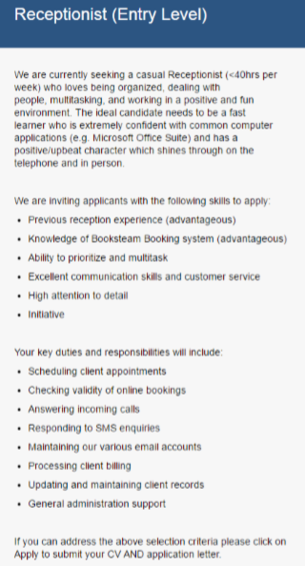

Part 2: Resume
Use the following information to help you to construct an achievement oriented resume tailored to your chosen job advertisement.
- Personal Details First name, surname, residential address, contact phone number and email.
- Ensure that your email address is professional: partygirl@hotmail.com is not appropriate, sarahjones@hotmail.com is appropriate.
- LinkedIn URL – ensure that your LinkedIn profile is up to date.
- Career Objective Optional. If included, ensure that it is tailored to the specific employer/position description and highlights your key skills.
- Education Tertiary and high school – only list high school education if you are a recent school leaver and have relevant achievements to list. Include the dates, course title, and institution name. Highlight key accomplishments and activities relevant to the position description. List the most recent education experience first and work backwards (reverse chronological order).
- Training and Professional Development Include the date, course title, institution name, and length of course. List in reverse chronological order.
- Key Professional Skills Optional. 3-4 points of skills relevant to the specific position description, with a sentence or two (maximum) to evidence how each skill was developed.
- Course Placements Alternatively titled: Clinical Placement or Work Integrated Learning Experience or Work Experience. Use bullet points to highlight relevant achievements and responsibilities. List in reverse chronological order.
- Employment History Use bullet points to list your key responsibilities and achievements for each role – these must be relevant to the position description. Provide a clear and concise indication of the complexity of the responsibilities listed, and the outcomes achieved – do not simply list a generic duty statement. List in reverse chronological order.
- Community Involvement Alternatively titled: Volunteer Work. List in reverse chronological order. Remove this section if there is nothing to include.
- Memberships Include memberships of professional or industry bodies (some associations have student memberships). Remove this section if there is nothing to include.
- Hobbies and Interests Optional. Include this section only if it reinforces your message of suitability for the advertised position, e.g. team sport participation to reinforce the message of having experience working effectively in teams.
- Referees Supervisor/Manager/Academic. Avoid personal referees. Usually 2 to 3 people. Include each referee’s title, company, email, and contact phone number. Hard copy references are generally not required.
Remember:
- In Australia, resumes are generally 3-4 pages, unless otherwise specified by the employer.
- Tailor your resume to the position description and the organisation’s expectations.
- Use a simple and professional layout with consistent styling.

Part 3: Cover Letter
The general structure of a cover letter is outlined below. Use it to help you to construct a cover letter tailored to your chosen job advertisement. A cover letter is your opportunity to sell yourself to a prospective employer. Give relevant and recent examples of your experiences, demonstrated skills and knowledge, and personal qualities that align to the position description. Explain why you are the preferred applicant for the position. Ensure that your letter it is no longer than one page.

Applicant’s address
Employer’s address
Date
Dear (title and name, if possible),
Paragraph 1: Introduction - Outline what you are applying for and what you are studying E.g. I wish to apply for the position of (job title) with (company name), as advertised on… E.g. As part of my Bachelor of Business studies, I am looking to gain work experience/work placement/WIL at (name the company).
Paragraph 2: Outline your relevant skills, qualifications, and experience appropriate to the position. E.g. My studies in (specify area) and my active participation in (specify area/organization)…has allowed me to develop…
Paragraph 3: Make links between your skills and the skills that the employer is requesting. Show the employer that you have researched the company/workplace by highlighting some information about it. Express why you wish to work for the employer, and why you would be a valuable contributor. E.g. I am able to assist your company because… E.g. I am aware that (company name)…
Paragraph 4: Conclude by suggesting that you would like to discuss your application further and can be contacted on…Finally, thank the employer for considering your application. E.g. I would value the opportunity to discuss this with you and…
Yours sincerely, [space for signature] Applicant’s name

Tips to a successful Resume and Cover letter
1. Ensure that both documents are formatted in a professional and presentable manner.
2. Ensure correct grammar, punctuation and spelling throughout; demonstrate your ability to convey information clearly and fluently using high-quality written language.
3. Use action verbs to describe the skills you have applied. This webpage provides information on action verbs: http://careernetwork.msu.edu/resources-tools/resumes/action-verbs.html.
4. Ensure that your application is appropriate for the intended audience.

Part 4: Reflection
The reflection component of this assessment task requires you to reflect on:
1. Job search and job application process
- What did you learn?
- What did you find challenging?
- What could you do better next time you apply for a job?
2. Your employability
- What skills, knowledge and experience could/should you develop to enhance your employability?
- How could you address these gaps? (Do you have a Career Action Plan?)
Remember to submit the link to your PebblePad reflection
Access PebblePad templates by following these steps:
  - Go to https://v3.pebblepad.com.au/login/latrobe/
  - Log into PebblePad
  - Click ‘Resources’ (see screenshot 1 below)
  - Click on the resource that your lecturer has asked you to use (see screenshot 2 below)
  - Use to resource to complete your reflection, saving as you go (‘Save’ is located at the top left, beside ‘Preview’) Once completed
  - Click ‘I want to…’
  - Click ‘Share’ (I would like to share this)
  - Click ‘Share asset with the web’
  - Click ‘Copy this URL’ and paste the URL in a word document
  - Click ‘Update share’ and exit PebblePad
  - Submit the word document with the URL

Implementation Guide for Staff

It is recommended that you include a stage to check that the job advertisements, sourced by students, include sufficient information for them to complete a high quality and tailored application. This stage, outlined in the shaded section of the table below, could involve asking students to check that the job advertisements of their peers meet the requirements of the task (i.e. enable them to demonstrate strong job application writing skills). As detailed in the table, this stage could be facilitated online or in a face-to-face tutorial setting.

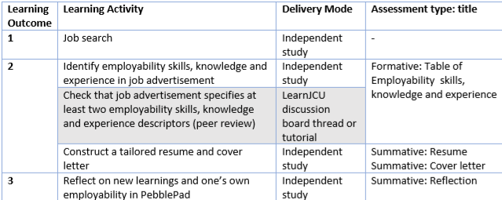

Key Terms You may wish to provide students with the following definitions:
Graduate employability is a “set of achievements – skills, understandings and personal attributes – that makes graduates more likely to gain employment and be successful in their chosen occupations, which benefits themselves, the workforce, the community and the economy.” (Yorke, 2006, p. 8)
Evidenced by the application of a mix of personal qualities and beliefs, understandings, skilful practices and the ability to reflect productively on experience (Yorke, 2006), graduate employability goes beyond the simplistic notion of the university providing graduates with skills to get a job. In the context of a rapidly changing and unpredictable future labour market, to remain employable, individuals need “skills, knowledge, resilience, focus and tenacity to stay marketable and be the equivalent of a desired commodity.” (Kinash, et al., 2014, p. 8)
Skills: Competencies needed to perform the job or certain tasks. E.g. communication skills, teamwork, analytical and problem solving skills, personal management skills, interpersonal effectiveness, digital literacy, leadership or management skills, learning skills, academic competence in reading and math, strong work values.
Knowledge: Facts, information or skills, acquired through experience and/or education, required for the job – not always mentioned in a position description.
Experience: Demonstrated mastery of a situation or subject gained through involvement or exposure; may be either, accumulated over time or gained through exposure to a single and specific momentary event.
PebblePad Templates:
You need to select the template that you want students to use to complete the Reflection component of this assessment task. The most appropriate templates for reflection activities are circled in the screenshot below. Ensure that you let students know which template to use.

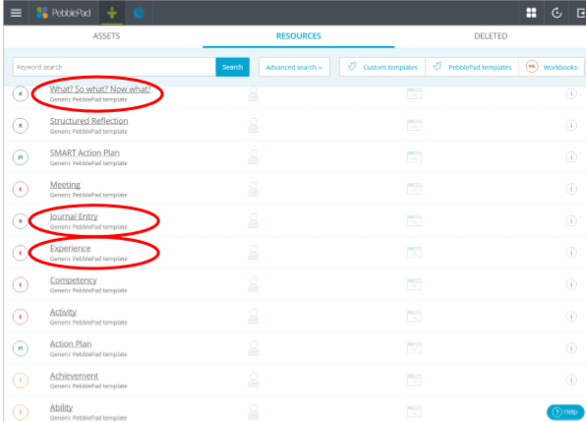

Rubric:
Criteria | Outstanding (80-100% or Upper D to HD) | Sound (65-79% or C to mid D) | Satisfactory (50-64% or P) | Unsatisfactory (0-49% or N)
Table
Critical Thinking | - Comprehensive identifies employability skills, knowledge and experience from the job advertisement | - Identifies multiple employability skills, knowledge and experience from the job advertisement | - Identifies some employability skills, knowledge and experience from the job advertisement | - Identifies few or no employability skills, knowledge and experience from the job advisement
Resume and Cover Letter
Critical thinking and evidence | - Links relevant and robust evidence to the employability skills, knowledge and experience | - Links relevant evidence to the majority of identified employability skills, knowledge and experience | - Links relevant evidence to some of the identified employability skills, knowledge and experience | - Links little or no evidence to the identified employability skills knowledge and experience.
Written Communication  Structure and Style | - Consistently adheres to the structure of a resume (e.g. reverse chronology, section headings) and cover letter (e.g. paragraphing)  - Adopts highly cohesive and fluent language to effectively engage the prospective employer  - Applies visually appealing and professional formatting to highlight strengths to the prospective employer. | - Mostly adheres to the structure and sequencing conventions of a resume (e.g. reverse chronology, section headings) and cover letter (e.eg paragraphing)  - Adopts cohesive and fluent language to engage the prospective employer  - Applies professional formatting to highlight strengths to the prospective employer | - Adheres to the structure and sequencing conventions of a resume and cover letter in parts.  - Adopts appropriate language to engage the prospective employer/  - Applies basic formatting. | - Applies unconventional and inconsistent structure and sequencing to resume and cover.  - Adopts language that lacks cohesive and fluency and/or is inappropriately pitched to the prospective employer.  - Applies formatting that lacks professionalism and detracts from strengths.

Syntax and mechanics | - Uses sophisticated and accurate sentence structures including the appropriate use of action verbs.  - Uses correct grammar, punctuation and spelling throughout | - Uses conventional sentence structures including the appropriate use of action verbs.  - Mostly uses correct grammar, punctuation and spelling. | - Uses mostly conventional sentence structures with some use of action verbs.  - Occasionally lapses in correct grammar, punctuation and/or spelling but not enough to interfere with the meaning conveyed. | - Uses unconventional sentence structures with limited or no use of action verbs.  - Makes frequent errors in grammar, punctuation and/or spelling that interfere with the meaning conveyed.
Reflection
Reflective thinking | - Insightfully reflects on new learnings and employability  - Identifies employability gaps  - Identifies a comprehensive and viable set of actions to address employability gaps for enhanced job prospects. | - Reflects on new learnings and employability.  - Identifies employability gaps.  - Identifies viable actions to address employability gaps. | - Reflects on new learnings and employability  - Identifies employability gaps  - Identifies some actions to address employability gaps | - Has difficulty reflecting on new learnings and employability  - Does not identify employability gaps nor actions

