How to book a room – Melbourne campus

Contents

Log in………………………………………………………………………… page 1
Search rooms……………………………………………………………..… page 2
Book a room………………………………………………………………… page 3

Log in
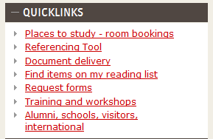 | From the library home page, click “Places to study – room bookings” under “Quicklinks”.
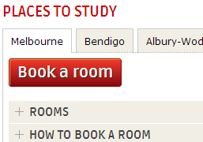 | Click “Book a room”.
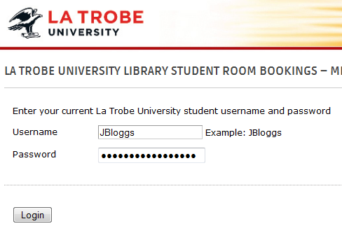 | Enter your student username and password  Click “Login”.
Page 1 of 3

Search rooms
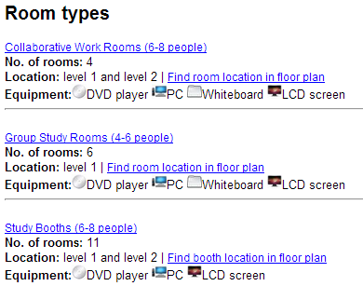 | Choose a room type and click on the heading
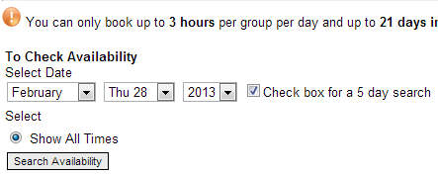 | Select a date.  Tick box “Check box for a 5 day search” if you want to search 5 days in a row.  Click “Search Availability”
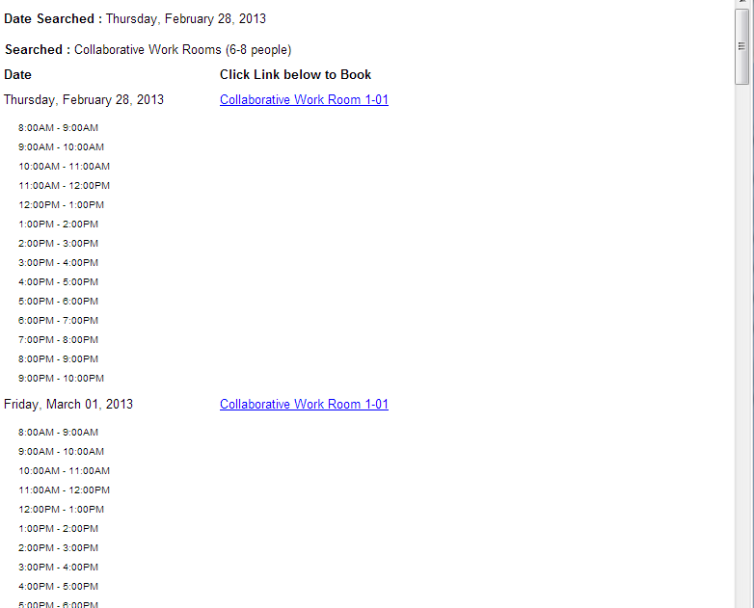 | Scroll down to look at all available times for each room.  If you do a 5 day search, you need to scroll down to the next room to look at that room’s 5 day availability.
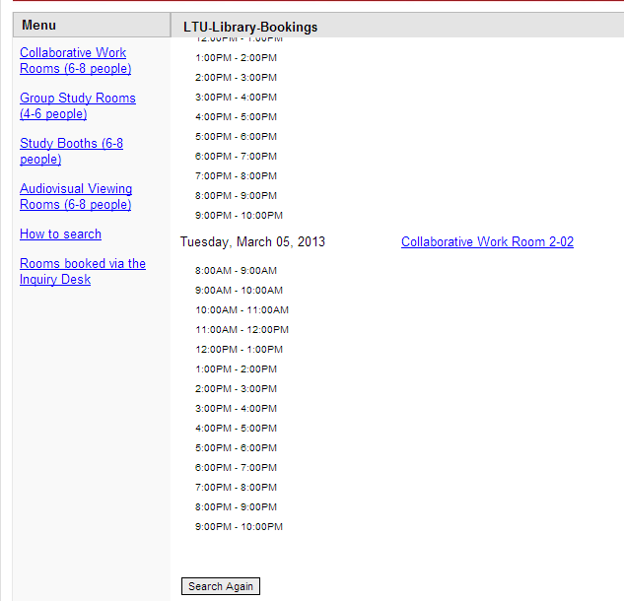 | If you can’t find a suitable time, click on ‘Search Again’ at the bottom of the page or click on another room type in the menu.
Page 2 of 3

Book a room
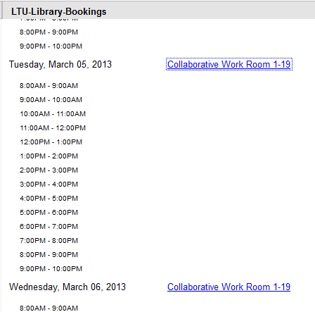 | Once you find a suitable time, click on the room link for the date you want.
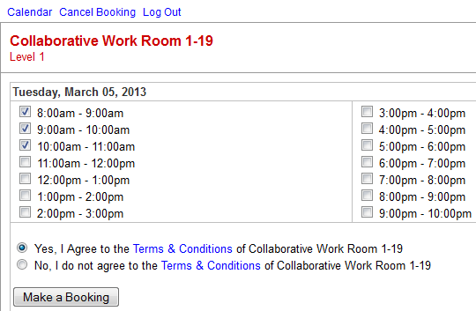 | Tick the times you want. You can only book 3 hours per group per day.  Click “Yes, I agree to the Terms & Conditions”.  Click “Make a Booking” and follow the prompts on the screen until you get a booking confirmation.
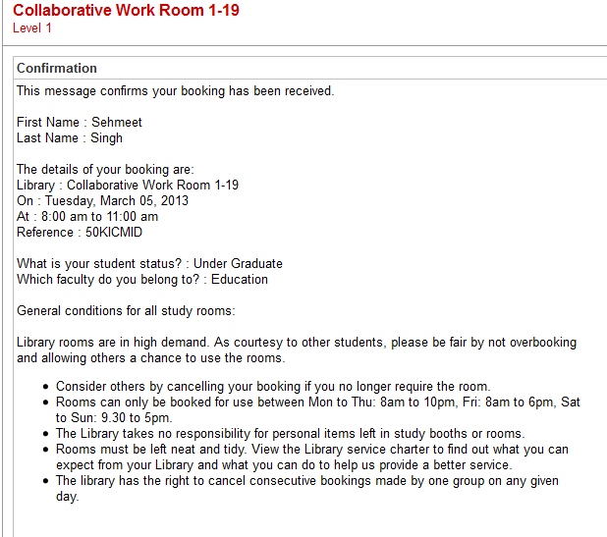 | A booking confirmation email will be sent to your student email address. To cancel a booking, click on the cancel link in your confirmation email.
Page 3 of 3

