**How to download a progress report: instructions for supervisors**

**Background:**

**This document provides guidance for supervisors on:**

* Downloading a progress form and its attachments, eg in order to send a report to other progress committee members

There are 2 ways for supervisors to download a form:

1. Using the download option when submitting the form – this won’t download any attachments
2. Downloading the report and attachments as a zip file using My Academic – this can be done at any time

More information about the progress policy can be found on the GRS website: <http://www.latrobe.edu.au/grs/progress>

More information on using My Academic can be found on the My Academic [LMS page](https://lms.latrobe.edu.au/course/view.php?id=52592).

**Instructions:**

**Dowloading a form when submitting it**

1. When you submit your supervisor’s report, the confirmation pop up box includes a link to click on to download the form. This will save a pdf of the report itself but will not include any files that were attached to the report

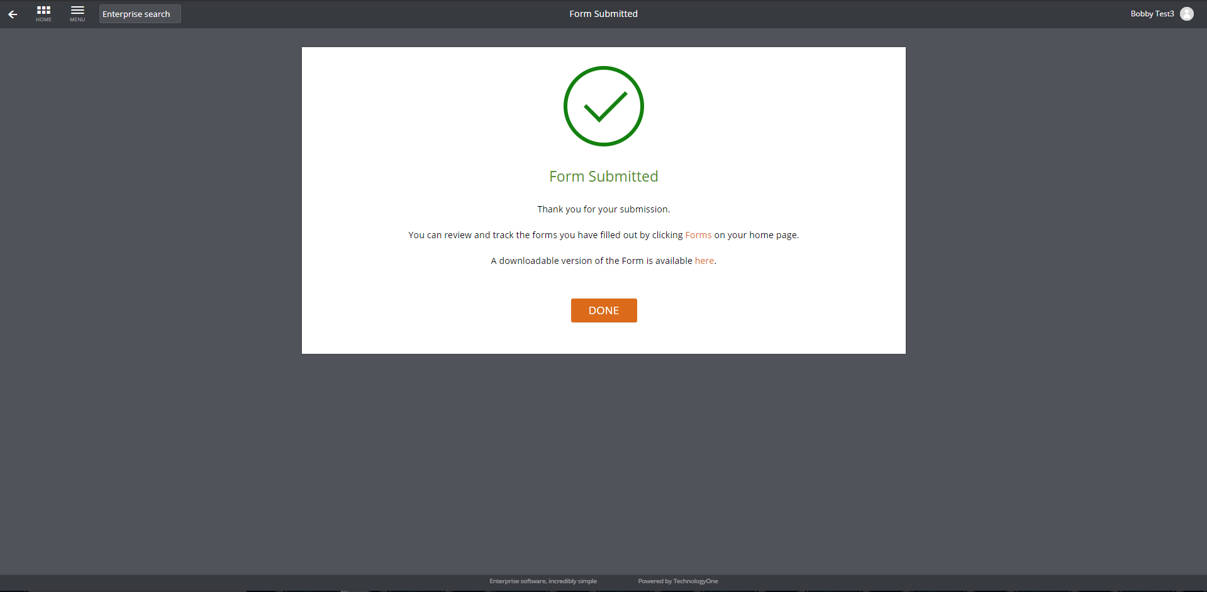

**Dowloading a form via My Academic**

1. Log into [My Academic](https://latrobe.t1cloud.com/T1Default/CiAnywhere/Web/LATROBE/Workplace)
2. Select the My Academic workplace (1) and then click on the Students tile (2)
3. Search for the relevant student by entering the student’s name in the search bar as **GivenName%FamilyName** or by entering their **Student ID** and clicking on the magnifying glass





Any results matching the input criteria will appear in a list below the search field:





**TIPS:**

* The % symbol acts as a wildcard, so if you search for ‘stu%dent’, the search will return any students who have ‘stu’ and ‘dent’ in their name. If you don’t use the % sign (ie ‘Stu Dent’) the search will only return students whose full name matches this search *precisely* – ie students with no middle name.
* If the student you are searching for doesn’t appear, try clearing the filter that is applied automatically by clicking on the filter icon (1) and selecting ‘clear all’ (2):

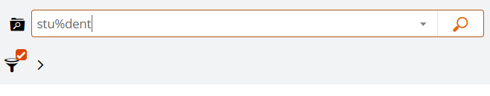

**(1)**

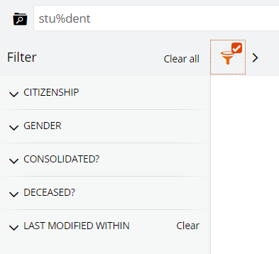

**(2)**

* If your student still doesn’t appear and you were searching by name, try searching by student ID number

1. Once you have found the student you are looking for, click on the ‘View’  button to open the student’s record:

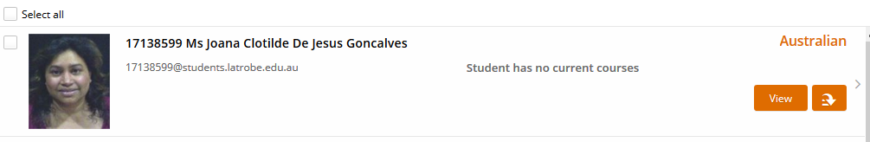

1. Click on the ‘Forms Summary’ tab on the left-hand side of the screen to see a list of all forms (reports) which have been created for that student. This will include any completed reports as well as any that are in progress.

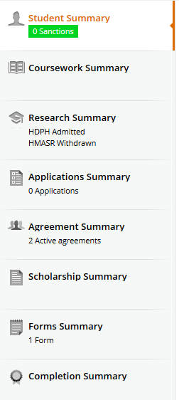

1. Click the ‘View’ link next to the form to open the form

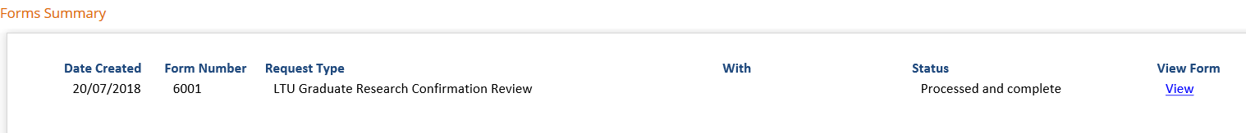

1. Click on the options  button up the top (1) and select ‘download’ (2)

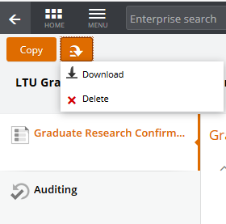

**(2)**

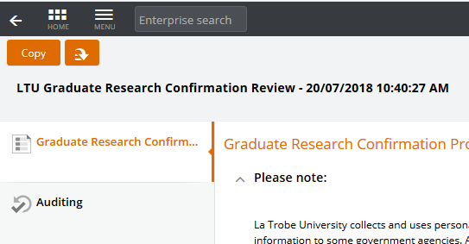

**(1)**