LabArchives users who are new to La Trobe University

# Introduction

At La Trobe, LabArchives is known as the Online Research Notebook. La Trobe has an enterprise licence for the Professional Edition of LabArchives, which means that any La Trobe researcher, whether they are a staff or student researcher, can use LabArchives free of charge.

This user guide includes the following information:

How to log in to La Trobe’s Online Research Notebook (LabArchives)

Access the notebooks you created through your other LabArchives account

# How to log in to La Trobe’s Online Research Notebook (LabArchives)

1. Go to <https://aushib.labarchives.com/select_institution> (and bookmark this link for future use).
2. From the **Select Institution** box, select La Trobe University.

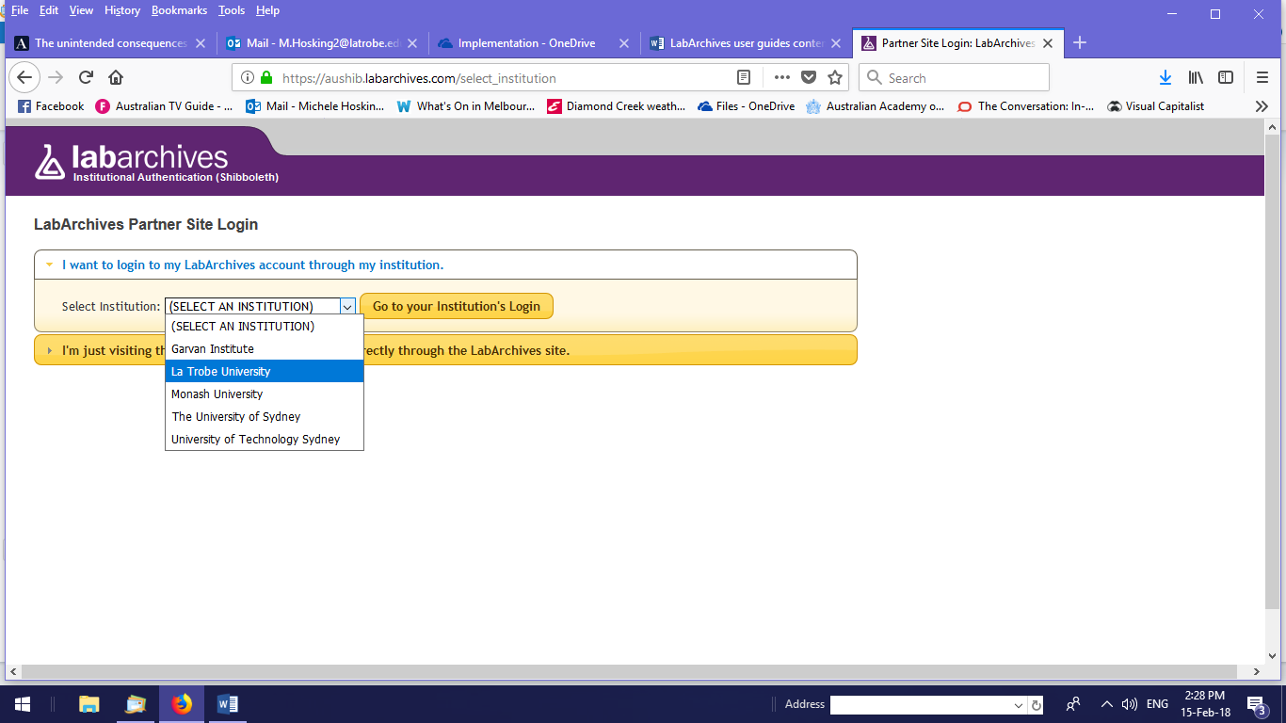

1. You will be redirected to the La Trobe login
2. Enter your usual La Trobe credentials to log in (i.e. the same username and password that you use to log in to your La Trobe pc and the La Trobe network).
3. Select **I do not have a LabArchives account and need to create one**.
4. Select **Create new account**.
5. You will see your account information and can update the details if you wish.

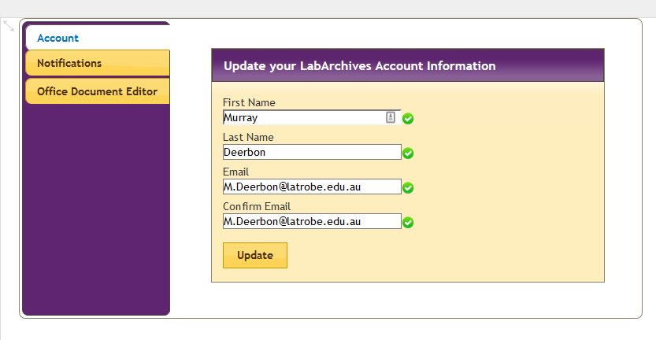

1. You can now start using the Online Research Notebook.

# Access the notebooks you created through your other LabArchives account

If you own notebooks through another LabArchives account to which you wish to have continuing access, there are several potential ways to achieve that, depending on your circumstances:

* Option A: Transfer ownership of the notebook(s) to your La Trobe LabArchives user account
* Option B: Clone the original notebook(s) and transfer ownership of the clone(s) to your La Trobe LabArchives user account
* Option C: Maintain two LabArchives accounts and share your existing notebook(s) with your La Trobe LabArchives user account.
* Option D: Make a read-only HTML or PDF copy of your notebook(s)

If the notebook(s) is associated with your personal subscription to LabArchives, you are free to choose whichever option best suits you.

However, if your LabArchives user account was provided through a previous employer’s subscription, you’ll need to check what you’re permitted to do with your notebook(s). For example, you may be required to transfer ownership of the original notebook(s) to your successor or another staff member where the employer owns the research data you produce. Option B may be the appropriate option in that situation, if the employer permits it.

There are site administrative settings in LabArchives that control what you are able to do, so in order to be able to transfer any notebook to your La Trobe LabArchives account, you may need to request permission from your previous employer.

# Further information

Procedures for options A, B and D above are available in the [Exit Planning and the Online Research Notebook](https://www.latrobe.edu.au/__data/assets/word_doc/0006/917250/Exit-planning-and-the-Online-Research-Notebook.docx) user guide, or you may wish to consult the [LabArchives Knowledgebase](https://www.labarchives.com/labarchives-knowledge-base/).