Linking to a file or folder on your computer or the La Trobe network

About linking to files and folders
There is a size limitation of 250 MB per file when uploading files to the Online Research Notebook. For larger files, you can create a link to the file stored at an external location that all your team can access, for example, your shared research or lab drive. (Note that if you store it on your own C drive, only you will be able to access it from the link in the Online Research Notebook.)
Linking can also be handy for files that will be frequently edited so that you do not need to repeatedly move them to your Notebook. It’s also an option for setting up access to a folder of files – although you could also consider using Folder Monitor to automatically upload files from a folder automatically, depending on the size of the files and your preferred approach.

Setting up your web browser to allow links to open
For security reasons, web browsers generally do not allow links to files located in local file systems to open by default. So if you want to be able to include a link to files or folders on your La Trobe group drive or lab drive in the Online Research Notebook, you’ll need to set up your browser to allow links to local files to work.

What you need to do
- Set up file linking for your web browser
- Create a link to an externally-stored file or folder

Set up file linking for your web browser
Follow the procedure for your preferred web browser(s):
- Chrome
- Firefox
- Internet Explorer
- Safari
Note that the Microsoft Edge web browser doesn’t support file linking as yet.

Chrome
To be able to open the linked folder/files in Chrome you need to install an extension. To do this:
- Click the 3 dots in the top right corner of your browser:
- Select More Tools then Extensions
- Choose Get more extensions
- In the Chrome Web Store, search for Enable Local File Links
- Click Add to Chrome
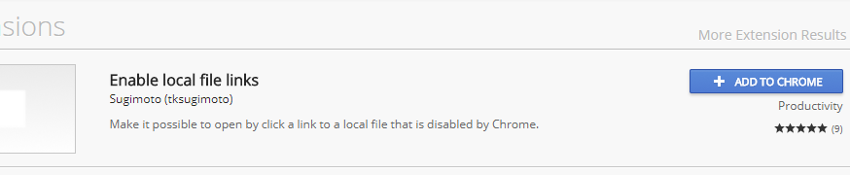

Firefox
To be able to open the linked folder/files in Firefox you need to install an additional add-on.
- Click the 3 horizontal lines in the top right corner of your browser
- Select Add-ons then click Extensions
- Search Available Add-ons for Local Filesystem Links
- Click Add to Firefox
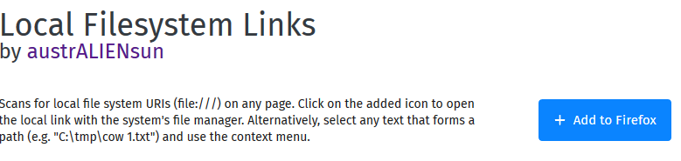
- Click Install.

- Choose your operating system:
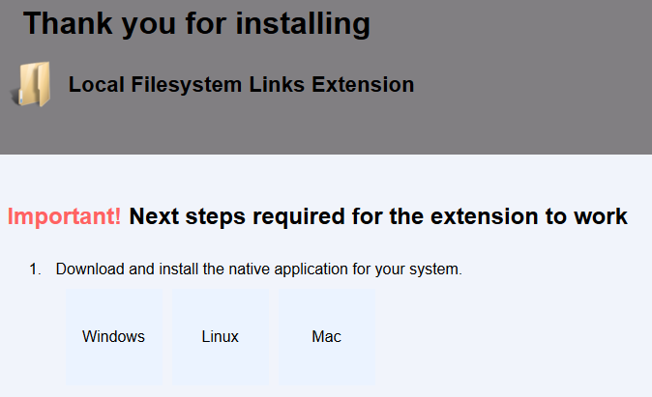
- Save the file
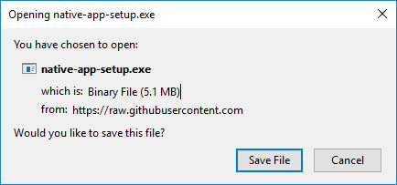
- Double click on the file you saved to run it.
- Click Next.
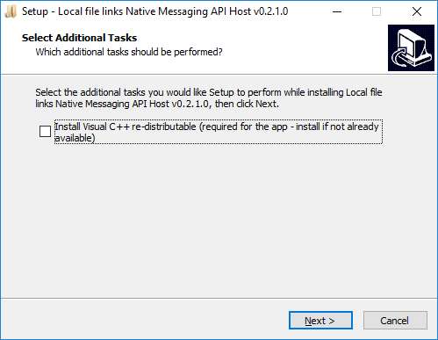

- Click Install.
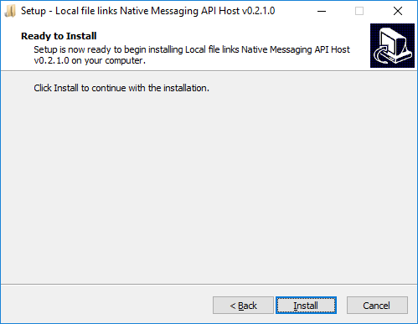
- Select Finish.
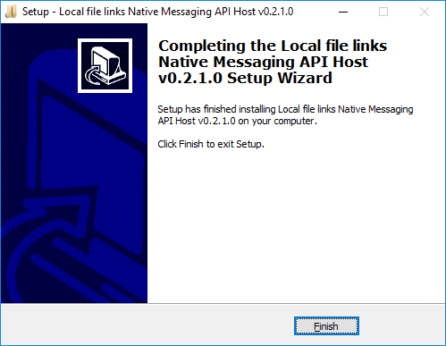

Internet Explorer
- In Internet Explorer, log in to LabArchives then go to IE’s Tools menu and choose Internet options.
Note: If your menu bar isn’t visible, you’ll need to right click at the top of your IE screen and select Menu bar:

- In the Internet options screen, select the Security tab, select Trusted sites and click on the Sites button.
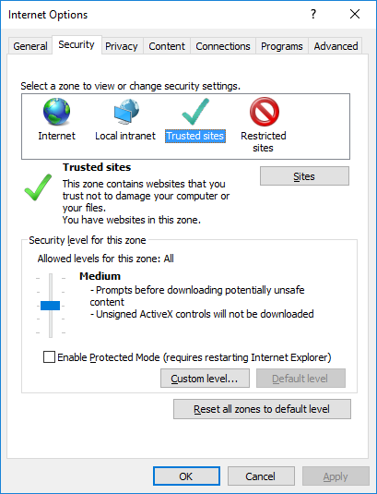
- The LabArchives URL should appear in the Add this website to the zone field. Choose Add to add it to the list of trusted websites.
- Then select Close.
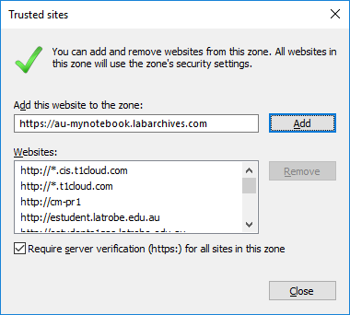
- Back at the Internet options screen, choose OK.
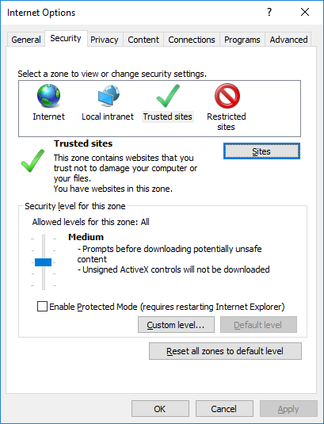

Safari
By default Safari doesn't allow access to local files. To enable this option:
- First you need to enable the develop menu.
- Click on the Develop menu
- Select Disable Local File Restrictions.

Create a link to an externally-stored file or folder
- Create or edit a rich text entry in the Online Research Notebook
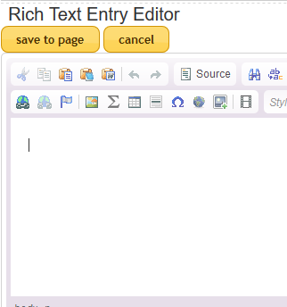
- Select the Link icon
- In the Link info tab, change the Protocol to <other>
- In the URL field, enter file:/// and then enter or paste in the path to the file or folder you wish to link to. If you have pasted the path from Windows Explorer, change the existing backslashes (\) to forward slashes (/).
Note: Further details on the syntax of the path to the file or folder follow this procedure.
- Click OK.
- Click Save to page – you now have a clickable link.

Syntax of the file or folder path
For Windows users, the standard URL is as follows:
file:///drive letter:/directory/subdirectory/file.extension
For example:
file:///R:/Bloggs lab/ Experiments/experiment_xyz.pdf
Note the use of forward slashes (/), rather than backslashes (\).
For Mac users there is normally with no drive letter, e.g.
file://Users/Joe/Desktop/Links.pdf

To find the path to your Windows file or folder
- Open Windows Explorer
- Navigate to the file or folder you wish to create a link to from LabArchives
- Highlight the path to the folder
- Copy the path and then paste it into a rich text entry in LabArchives.

Support and further information

Support
For assistance with setting up links to files, contact LabArchives Support.

Further information
This user guide incorporates content from Linking a Local File in the LabArchives Knowledgebase article Linking, which contains information about links of all kinds.

http://ccm.net/download/download-5573-file-access-helper accessed 16 October 2017

