Integrating the Online Research Notebook with GraphPad Prism

About the integration
GraphPad Prism (Version 5.04 / 5.0d and higher) integrates with LabArchives. The integration enables you to:
- Save Prism files into the Online Research Notebook
- Open a Prism file from the Online Research Notebook

Setting up the integration

What you need to do
- Download the configuration file
- Obtain a password token from the Online Research Notebook
- Log in to the Online Research Notebook from within GraphPad Prism, saving your details so that future logins are automatic

Download the configuration file
Before opening GraphPad Prism, follow this procedure to create the configuration file for Australian users from the LabArchives Knowledgebase.
- Refer to the section "Use GraphPad Prism and LabArchives for Australian users" in the article GraphPad Prism
- Save the file to C:\Program Files (x86)\GraphPad\Prism [version number].
Note that GraphPad Prism may be located in Program Files rather than Program Files (x86).
You may find that the following message displays if you have the file open in an application like Notepad and try to Save As to the path above:
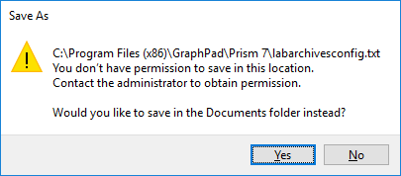
Click Yes to save the file to your Documents folder, then go into Window Explorer and copy the file from your Documents folder to the required location C:\Program Files (x86)\GraphPad\Prism [version number].

If the following message appears when you paste the file to that location, select Continue and the file should copy across successfully.
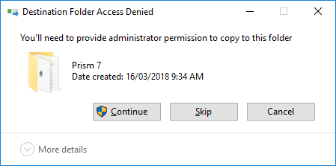

Obtain a password token from the Online Research Notebook
- Log into the Online Research Notebook in your preferred browser
- Select LA App Authentication under the User Management menu.
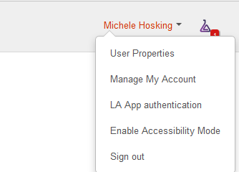
- A Password token for external applications screen will appear. Note that this token will expire in one hour.
- Copy the password token.

Login to the Online Research Notebook from within GraphPad Prism
- Open GraphPad Prism and select LabArchives:
Choose Login to LabArchives

- Enter your email address, paste in the password token and tick the Stay signed in checkbox (to avoid the need to generate a new password token each time you log in).
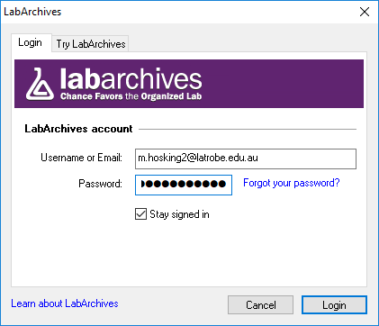
- Select Login to complete login. You will now be able to access files stored in the Online Research Notebook and save files to it.
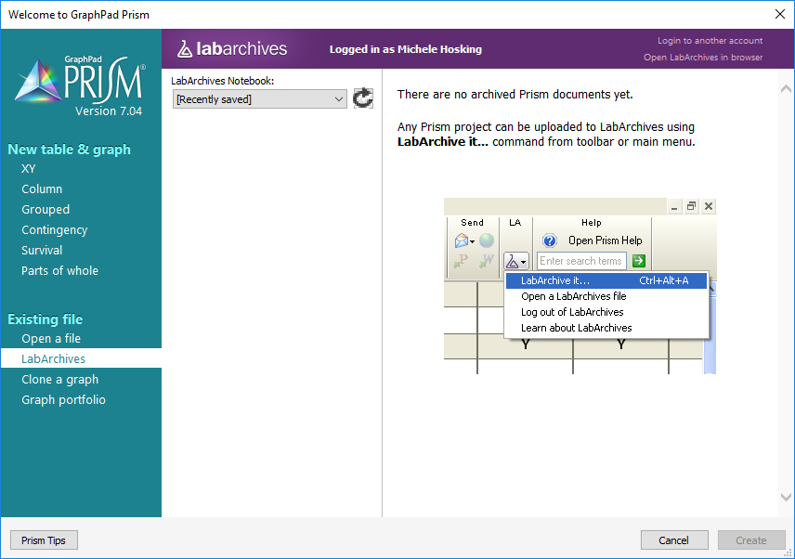

- You’ll now have a new LA section in your toolbar that allows you to open GraphPad Prism files that you have saved in the Online Research Notebook and save files you create in GraphPad Prism to the Online Research Notebook.

Support and further information

Support
For assistance with setting up and using this integration, contact LabArchives Support.

Further information
This procedure has been adapted for La Trobe researchers from the LabArchives Knowledgebase article GraphPad Prism. For further details about the GraphPad Prism integration, refer to the LabArchives Knowledgebase.

