Preparation
The Grammar of Glitch is a thematic exhibition conceived and developed by LAI Senior Curator, Dr Kent Wilson. The curator approached the artists with the curatorial rational for the exhibition and opened up a conversation around the works that might be appropriate to include.

Preparation
Presentation
Conservation
Promotion
The
Grammar
of
Glitch

- Education Resource

In the lead up to the exhibition:
- The curator spoke with the artists to discuss the overall look and feel of the exhibition
- Loan agreements were prepared
- The curator mapped out the exhibition design on paper and allocated spaces for each of the artworks
- Display requirements were assessed
- Gallery walls and artwork plinths were patched and painted
- Artworks were packed and transported to LAI by specialist art-freighters
- The curator commissioned a writer to produce a contextual essay for the exhibition room-sheet
- The curator prepared notes and briefed gallery front of house staff

The LAI installed most of the work, however Katie Paine came in to create the wall drawing that accompanies her photo-collages, Michael Georgetti personally arranged his installations and James Little took photographs in the gallery before having one printed and installed on the gallery wall. The
curator was responsible for all final decisions around lighting, work and text placements.
Prior to the installation, the artists provided:
- Electronic images of their work, including a ‘hero’ image suitable for the promotion of the exhibition
- Details of artwork including titles, year and

Conservation
About La Trobe
Art
Institute

La Trobe Art Institute (LAI) is an outward facing unit of La Trobe University. We present exhibitions that explore contemporary arts
practice and engage with issues relevant to our times. Our exhibitions include artwork from a combination of international, national and local artists with diverse backgrounds, at all stages of their careers.

The research of curatorial staff drives the LAI exhibition program and therefore we do not call for applications. Our program is driven by trends in contemporary arts practice and ideas,
rather than curatorial proscription. Artworks are not illustrative elements in a curatorial narrative but are the principal creative components of exhibition outcomes. Curatorial practice is a form onto itself but arts practice is never a secondary partner in the relationship.

In addition to operating a public gallery in View Street, Bendigo, the LAI is also responsible
for the University’s collections of art and artefacts and all associated public and educative programs.

The Grammar of Glitch

As this is an exhibition of contemporary works, long- term conservation issues are unlikely to arise. The fo- cus is therefore on ensuring that gallery staff adhere to correct handling and display procedures. White gloves are used and the installation carefully planned to ensure no works are at risk of damage. Front of House staff carefully monitor all artworks and in the unlikely instance that artwork becomes damaged or compromised in any way, the works are fully insured.

Promotion
Prior to the installation of the exhibition, the curator prepared an exhibition statement of approximately 300 words, suitable for promoting the exhibition. The LAI then formed a media release and sends it to local, state and national media agencies. Following this, the artist and curators make themselves avail- able for media interviews.

Each exhibition at La Trobe Art Institute is promoted:
- On the LAI website: http://www.latrobe.edu.au/ art-institute
- On social media https://www.facebook.com/ latrobe.lai/ , https://www.instagram.com/la- trobe_ai/
- and https://twitter.com/LaTrobe_AI
- In print in Art Almanac and Art Guide Australia and occasionally in Vault magazine

The LAI sent an electronic invitation to mailing-list subscribers prior to the exhibition launch.

Public Programs are a key component of exhibition promotion. Audiences are engaged at the Launch, through public talks and workshops throughout the exhibition.

Learning at LAI

LAI’s public and educative programs promote inter- disciplinary dialogue, participation and cultural inclusion through engagement with the University’s expansive collection of art and artefacts and the LAI’s contemporary exhibition program.

We offer a unique and stimulating experience for students from primary through to tertiary level. Discover how art can support learning across the curriculum through a range of activities guided by artists, curators, academics and La Trobe University students. Be inspired by our exhibitions, meet experienced art professionals and discover new ways to visually engage with ideas in the context of a University Art Museum.

Visit our webpage for more information on our dynamic exhibition program, upcoming talks and workshops and to sign up to our mailing list:

latrobe.edu.au/art-institute

Contact the LAI Public Programs Coordinator to book a free guided tour of our exhibitions or to discuss the ways that we can customise your visit to meet curriculum needs, ability and interests of your group.

lai@latrobe.edu.au | 03 5444 7272
Antonia Sellbach
James Little Katie Paine Michael Georgetti
Paul Kaptein Ross Taylor
This exhibition brings together six Australian artists who use mostly traditional mediums, such as pencil drawing, wood carving and painting on canvas.

The artworks are bright and playful, sometimes causing the viewer to double-take at the illusions they produce. Space is fragmented, three- dimensional forms appear to spring forward from the paintings that accompany them, drawings slip out of their frames onto the gallery walls and a surreal pairing of a wristwatch and bread creates a sense of absurdity.

The artists explore the notion of the ‘glitch’; where an error, fragmentation, mutation or repetition can inadvertently create productive outcomes. The title of the exhibition suggests that there is a grammar or syntax- a set of rules, systems and structures that denote or describe these glitches. This visual language is manipulated by the artists to create unexpected forms and opportunity for new interpretations.

The design of the exhibition also embraces this aesthetic (grammar) of the glitch- with the room’s white painted edges cutting-in over the grey walls. Grey is the transitory tone between the black of the previous exhibition and the white walls of the next, suggesting that the preparation of the space has been halted or experienced a glitch of some kind.

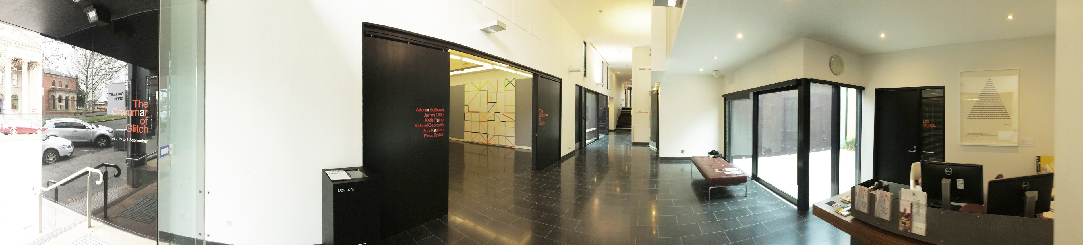
Presentation Make some notes about what you see:

What do you notice about the wall
text?

How is information about the artworks
presented?

What is the first thing you see, hear
and feel when you enter the gallery?

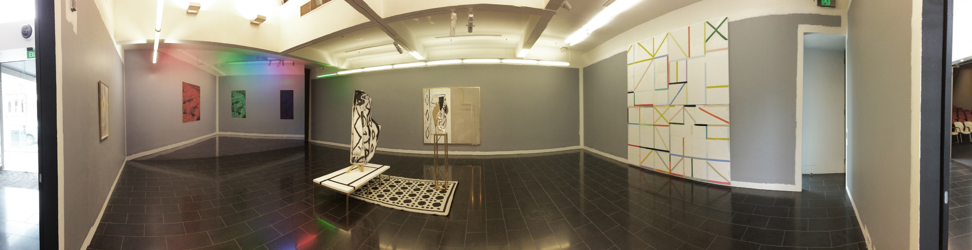
What colour are the walls?

How is the artwork positioned?

Can you see any connections between
the works?

What type of lighting is used?

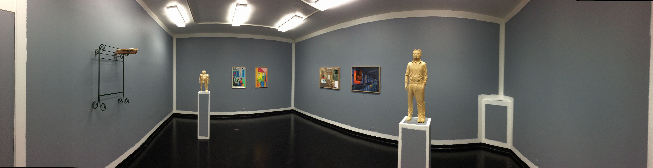
What is your favourite work? Why?

What is your least favourite part of the
exhibition?

What events or programs are planned to promote visitor engagement?

