Add users and assign privileges
Who can add users in the Online Research Notebook?
Only the Owner or an Administrator of a notebook can add a new user and share content.
About user roles and privileges
For a full breakdown of roles and privileges, see this article in the LabArchives Knowledgebase – but here are the most notable differences:
Owner: The lab head or research group leader will normally be the Owner. Each notebook will have one (and only one) Owner. This role has ultimate control over the notebook.
Administrator: There can be multiple Administrators. Assign the Administrator role to a user if you want that user to be able to:
- share the parts of the notebook to which they have access with others
- modify user permissions and monitor user activity in the notebook
User: A user assigned the User role can’t share with others nor can they modify permissions. Users can be assigned Read or Edit access to entries, pages, folders or the whole notebook.
Guest: The Guest role is very similar to the User role, with the following exceptions:
- any Edit access given to a Guest reverts to Read access after 60 days.
- Guests can’t comment on entries unless they are explicitly given permission to do so by an Administrator or the Owner.
Note: The Online Research Notebook allows you to use groups to manage users. This can be useful if you have many users with the same access needs. The LabArchives Knowledgebase has further information about group management.
However, if you have only a few users to manage, it can be simpler to do so individually. This procedure assumes that you will managing users individually and will not be using group level management.
Ways to add users in the Online Research Notebook
There are several different ways to add a user in the Online Research Notebook:
- User Management
- Sharing
- Mentions

Adding a new user in User Management
Use this way of adding a new user if they need access to more than one page or folder of the notebook, especially if they need ongoing Edit access. By default, a new user that you add in User Management (in Notebook Settings) will be assigned the User role.
- In LabArchives, open the notebook you want to work with.
- Click the triple bar icon at the top right and select "Notebook Settings".
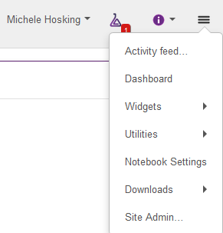
- Click on the User Management tab
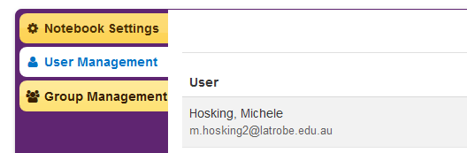
- At the top right-hand corner, click on New User
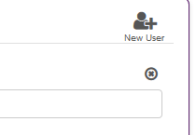

- Enter the email of the person you wish to add to the notebook and click Add User. The user will receive an automatic welcome email.
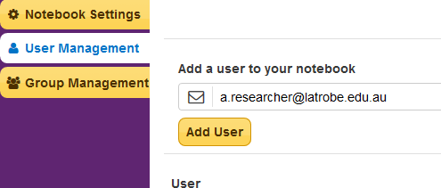
- Assign a role to the user.
- The new user is added to the Full Access group by default. This gives the user edit access to the entire notebook. If you do not want the user to have this level of access, you’ll need to remove them from the Full Access group. To do this, click on the pencil icon.
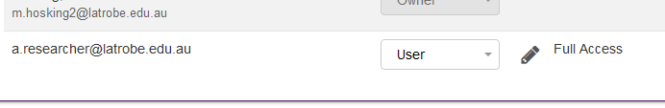
- Uncheck Full Access and click OK.
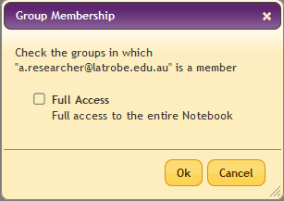
- At this point, the user exists but has no access to any notebook content. You can opt to give a user:
- Access to the entire notebook
- Access to only certain folders or pages of the notebook
- Different levels of access to different parts of the notebook
- Access to individual entries (to do this, you would share the entry with the user – see the LabArchives Knowledgebase article for details)
To assign access, right click on the notebook, folder or page and choose Permissions.
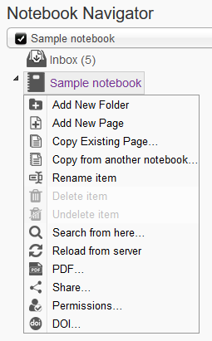
- In the Groups or People with Access tab, select the required access rights for the user

Adding a new user by sharing all or part of a notebook
You can share an entry, page, folder or entire notebook. If the researcher with whom you share does not already have access to your notebook, they will be automatically added as a user and assigned the Guest role. It’s most useful if the user needs:
- only temporary edit access, as after 60 days, access will revert to view only
- access to a single entry or page
- There are three places from which you can access the Share function:
  - In Notebook Navigator: To share a page, folder or notebook, right click on it and choose Share.
  - In Page Tools: To share a page, choose the Share icon.
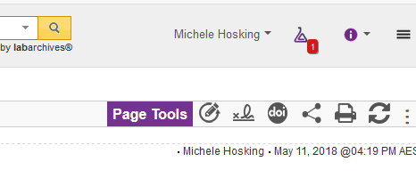

  - In an entry: To share an entry, choose the gear icon then select the Share option.
- In the Invite People tab of the Share window, add the email address of the researcher you wish to share with and choose either the To Edit or the To View radio button. The researcher will receive an email with a link to the shared content. If you wish, you can personalise the email message and send yourself a copy of the email.
- Click Send. If a user account does not already exist for the researcher, they will be prompted to create one on accessing the link in the email.
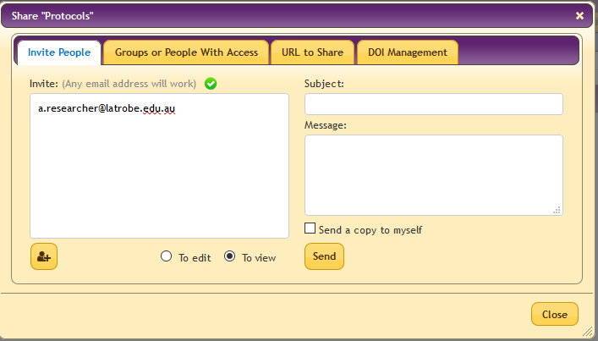

Adding a new user by adding a Mention
Use this way of adding a new user if that user needs access to a single entry on a page of the notebook.
- Users can be mentioned in a Comment to communicate or share an entry. Mentioning a user will alert them by email.
To create a Comment, choose the Comment icon.
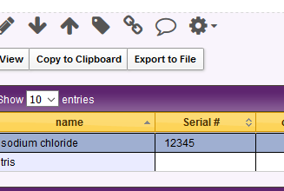
- To mention a specific user type the ‘@’ symbol or click LabArchives will automatically generate a list of suggested users with access, but for a new user, simply type their email address and then click Add Comment.
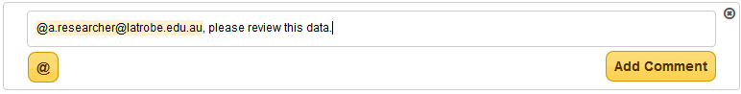
- In the confirmation box, select Add Comment with Mention. The researcher will receive an email with a link to the entry. If a user account does not already exist for the researcher, they will be prompted to create one on accessing the link in the email.
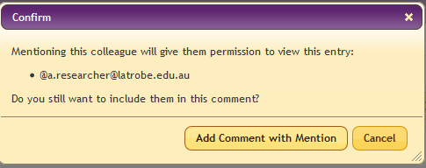

Further information

Support
For assistance with adding and managing users, contact LabArchives Support.

Further information
This procedure has been adapted for La Trobe researchers from the LabArchives Knowledgebase articles Sharing a Notebook, folder, page or single entry, User Management, Group Management and Comments and Mentions, all of which contain useful additional information.

