How to stop Mozilla Firefox from blocking ‘mixed content’ (such as an ECHO recording) on a page.
(Applicable for Firefox 23 or later).
Firefox version 23 or later will block mixed content pages (http + https) by default.
Just click on the grey shield in the address bar, and then select ‘Disable Protection on this Page’. (See images below).
Do this whenever this problem presents.
(You can turn this protection off completely, but it is not recommended by Firefox.)
1.
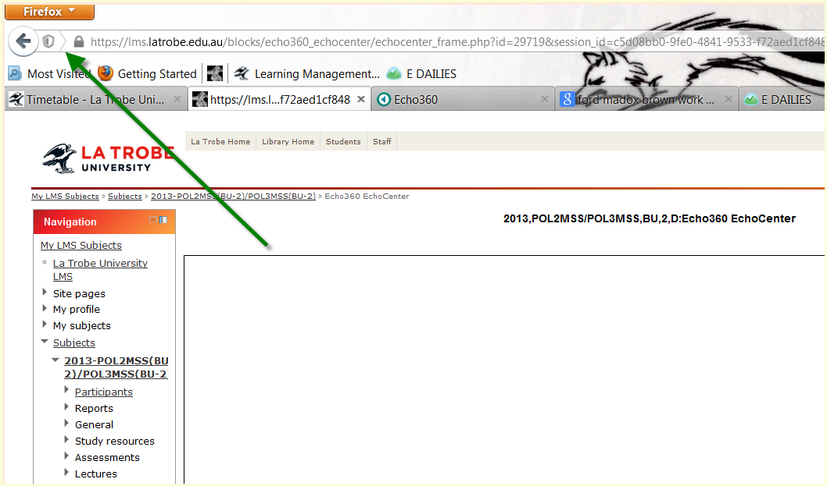

2.
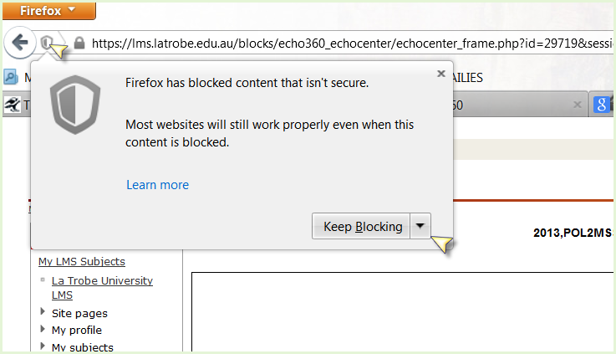
3.
