THE LISA MALONE SCHOLARSHIP

This scholarship pays tribute to the work of Lisa Malone, former resident of Wodonga and student in Social Work at La Trobe University. Lisa’s life was devoted to helping people in need within Australia and overseas. Her humanitarian work took her to Alice Springs where she worked with handicapped aboriginal children and also to El Salvador, Southern Mexico and Guatemala. Lisa was working with the United Nations as part of an aid team providing education programs for Mayan people when she and seven others died in a helicopter crash in 1998.

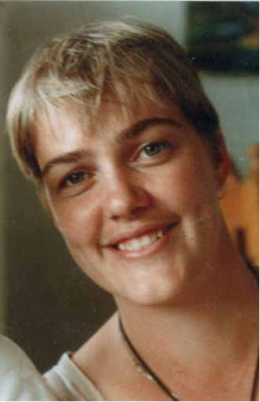

La Trobe University, with the support of the Albury-Wodonga community, The Border Mail and the Hume Building Society established the scholarship to commemorate Lisa’s life by recognising and supporting others who are also dedicated to the highest humanitarian ideals.

HOW MUCH IS THE SCHOLARSHIP?

The scholarship provides up to $2000 for a year of study at La Trobe University, Albury-Wodonga campus. Part time students are paid pro-rata.

WHO IS ELIGIBLE TO APPLY?

To be eligible to apply, you must:
- be able to demonstrate a commitment to humanitarian ideals, and
- be studying an undergraduate or postgraduate course at the Albury-Wodonga campus.

HOW ARE APPLICATIONS ASSESSED?

The following criteria is considered when awarding this scholarship:
- demonstrated commitment to social development in any discipline area, either in Australia or overseas;
- financial circumstances;
- academic achievement.

Applicants who are shortlisted will be invited to attend an interview on 9th March 2017 between 2.00pm and 4.00pm.

PREPARATION OF YOUR APPLICATION

- Detailed information: Make sure you provide full details requested in Sections 1, 2 and 3 of this application. Otherwise your application cannot be assessed. All information will be treated in strict confidence.
- False or misleading information: La Trobe University reserves the right to withdraw an offer of a bursary and re-assess the application if the University believes the recipient has provided false or misleading information in the application form or subsequently.
- Late applications: applications received after the closing date may be accepted by staff only if accompanied by a signed formal request outlining exceptional circumstances outside your control that have resulted in a late application, e.g. serious illness or other personal crisis. The selection committee will later determine whether or not a late application will be considered, based on the explanation you provide. (Note: Reasons relating to employment, placements, holidays or other activities that you choose to engage in are unlikely to be considered “exceptional”.)

COMPLETED APPLICATION FORM

- You may post your application to the address below, OR
- You may deliver it in person to one of the campuses listed below, addressed as indicated below.

Further enquiries and completed applications can be directed to:

The Lisa Malone Scholarship Committee
Student Administration
P.O. Box 821
Wodonga VIC 3689

Email: a.kerin@latrobe.edu.au

Or hand deliver to:
Student Administration Office
Building 4
University Drive
Wodonga VIC 3689

CONFIDENTIALITY
All information provided by applicants will be treated as confidential. At La Trobe University, we respect the privacy of your personal information. We collect personal information in your application to determine your eligibility for a scholarship, bursary or grant, and to assess your application as part of the ranking and allocation process. In accordance with privacy laws, personal information about you contained in your application will not be used for any other purpose or disclosed to any person who is not part of the La Trobe assessment and allocation process, without your permission. You may have the right to access personal information we hold about you, subject to any exceptions in relevant laws, by contacting the Scholarships Unit as noted below. The La Trobe University privacy policy can be viewed at: www.latrobe.edu.au/privacy/

PLEASE PRINT CLEARLY IN CAPITAL LETTERS

SECTION 1: PERSONAL DETAILS
  - Student ID Number

  - Family Name First Given Name

  - Address

Suburb or Town

State

Postcode

  - Other contact details where you can be contacted directly or a message can be left for you

Telephone (day time)

Mobile phone

Email

SECTION 2: PERSONAL INFORMATION
2.1 Please include a detailed resume.

2.2 Please include two written personal or professional references.

Please list the information attached:

SECTION 3: PERSONAL STATEMENT - TO BE COMPLETED BY STUDENT
You must include a personal statement outlining your academic qualifications, current or intended enrolment and commitment to social development and community welfare.
- Type your statement on a separate page; attach it to the application, with your name, signature and the date. OR
- Use this page to write your statement clearly.

DECLARATION (ALL APPLICANTS MUST SIGN BELOW)
All information provided by me in the following application, including any supporting documentation, is, to the best of my knowledge, true and correct.

I understand and accept that if the information provided by me in this application is deemed to be false or misleading in any way, whether it be before or after bursary monies have been awarded, La Trobe University has the right to withdraw the bursary. If the bursary is terminated or revoked, I may be liable for the repayment of the total sum of any payments incorrectly made to me.

I understanding that false or misleading information is a serious offence under the criminal code (Commonwealth).

I HAVE READ THE INFORMATION ON THIS FORM INCLUDING THE DECLARATION AND AGREE TO THESE CONDITIONS.

D | D | / | M | M | / | Y | Y | Y | Y
Student signature: Date:

