An Introduction to
iThenticate TM

Copyright © La Trobe University
Copyright in the information in this manual is vested in La Trobe University pursuant to the Australian Copyright Act 1968. Unless otherwise stated, no part may be reproduced by any process, unless permitted by the Australian Copyright Act 1968 or used for any commercial purposes without the written permission of La Trobe University.
Disclaimer
While every effort has been made by La Trobe University to ensure that the information in this manual is up to date and accurate, La Trobe University does not give any guarantees, undertakings or warranties in relation to the accuracy, completeness and up to date status of the information.
La Trobe University will not be liable for any loss or damage suffered by any person arising out of the reliance of any information in this manual.
La Trobe University accepts no responsibility or liability for the content available at any of the web sites referred to in this manual.
Trademark
iThenticate is a trademark of iParadigms, LLC.

Table of Contents
Session Objectives 5
Topic 1 – Let’s get started 6
Research Integrity 6
What is iThenticate? 7
Why use iThenticate? 7
Self-Plagiarism 8
Exercise 1 – Logging in to iThenticate and changing your Password 9
iThenticate Control Panel - Main Navigation Bar 10
Account Info 10
Settings 10
Folders 10
Topic 2 – Folders 11
Folders 11
My Folders – Folders 11
My Folders – Settings 11
Exercise 2.a – Rename the My Folders Folder Group 12
Exercise 2.b – Creating a new Folder Group 12
Exercise 2.c – Creating a new folder 12
Exclusions and Filters 13
My Documents 14
My Documents – Settings 14
Report Filters 15
Phrase Exclusions 15
Topic 3 – Submitting your Manuscript 16
File Types 16
File Sizes 17
What Size is my File? 17
Tips to Reduce File Size 17
Types of file Upload 17
Exercise 3 – Submitting your Manuscript 18
Topic 4 – The Similarity Report 19
What is a Similarity Report? 19
Viewing Modes 20
Match Overview 20
Match Breakdown 20
Viewing a Source 21
Viewing the Text Only Report 22
Exercise 4 – Viewing the Similarity Report 23
INDEX 24

Session Objectives
At the completion of this session, you will be able to:
- Locate the Australian Code for the Responsible Conduct of Research 2007, the La Trobe University Academic Integrity Statute 2015 and Research Integrity Policy.
- Locate the iThenticate portal
- Log in to iThenticate and change your password
- Use the Settings options to set your preferences
- Create folders to suit your preferences
- Submit a manuscript to your iThenticate account
- View and examine a Similarity Report (SR) and review your submission in relation to the SR
- Apply Report Filters and Phrase Exclusions to reduce the Similarity Index
- Share your iThenticate account to allow others to view a Similarity Report (SR)
- Manage and organise your manuscripts

Topic 1 – Let’s get started
At the completion of this topic, you will be able to:
- Describe the benefits of using iThenticate to check your work
- Define self-plagiarism and ways to avoid it
- Describe how iThenticate compares your work
- Locate the iThenticate portal
- Change your password
- Consider the Settings of your account

Research Integrity
Best practice in research at La Trobe University, as well as all other Australian Universities, is governed by the Australian Code for the Responsible Conduct of Research 2007. The Code aims to provide an understanding of responsible research practices. It emphasises the importance of citing the work of other relevant authors appropriately and accurately when disseminating research findings and adds that the use of the work of others “without acknowledgement” is unethical.
Australian Code for the Responsible Conduct of Research 2007
http://www.nhmrc.gov.au/guidelines-publications/r39
Academic Integrity Statute 2015
http://www.latrobe.edu.au/__data/assets/pdf_file/0020/633116/Academic-Integrity-Statute-2015.pdf
Research Integrity Policy
http://www.latrobe.edu.au/policy/documents/research-integrity-policy.pdf

What is iThenticate?
iThenticate is a web-based tool which can be used to match the text in your work against a large number of online sources. It has been designed to be used by researchers to ensure the originality of written work prior to submission for examination or publication.
When you submit your work to iThenticate, it will be compared to 49 million published research articles from more than 590 scientific, technical and medical publishers (a cache larger than that maintained by most university libraries). It will also be compared to 105 million research titles from databases and content providers such as:
- ABC CLIO
- Pearson, McGraw-Hill and Wiley
- ProQuest
In addition, iThenticate’s proprietary web crawler crawls around 10 million web pages per day and has created an archive of 60 billion web pages against which your work will be compared.

Why use iThenticate?
After comparing your manuscript to the sources described above, iThenticate generates a Similarity Report and also produces an overall similarity percentage for the report. You may think that the lower the percentage, the better but acceptable percentages of matching text can vary significantly from one manuscript to another.
You should carefully consider the strings of matching text provided in the Similarity Report.
The Similarity Report displays your submitted manuscript overlayed with numbered and colour-coded text reflecting strings of text that have been matched to other published works in iThenticate’s databases or web crawls. The colours and numbers correspond to matched sources which are displayed to the right of your manuscript. Any text that is in black and not bolded did not match sources in the iThenticate databases or web crawls. By submitting and resubmitting your manuscript to iThenticate you can review and refine your work by ensuring that you have not used the work of other authors without appropriate and accurate acknowledgement.
iThenticate does not detect plagiarism. iThenticate matches the text in your submitted manuscripts against the sources detailed above and provides an indication of any text matches. Only an experienced academic undertaking a review will be able to detect whether or not there has been a genuine attempt to plagiarise another’s work.
Using iThenticate can help you:
- avoid inadvertent plagiarism;
- prevent copyright issues from excessive use of your own or others’ text;
- comply with the Australian Code for Responsible Conduct of Research (2007).
This guide will help you get started using the software. See the Interpreting iThenticate Reports: a Guide for Researchers for help making sense of your reports and information about how it can be used throughout your writing process.

Self-Plagiarism
“Self-Plagiarism is defined as a type of plagiarism in which the writer republishes a work in its entirety or reuses portions of a previously written text while authoring a new work.”
(Source: https://cdn2.hubspot.net/hub/92785/file-5414624-pdf/media/ith-selfplagiarism-whitepaper.pdf accessed by A.Waterson 18.08.16).
You should exercise caution if using a work or portion of a previous publication. It is recommended that you insert the entire publication into your thesis if this is possible and if it fits well within the structure.
Concerns may arise if the previous publication was co-authored. If you’re using portions of the publication without acknowledgement, it won’t be clear whose work is being used.
If you can’t insert the entire publication into your thesis, it’s recommended that a statement is inserted at the beginning of any chapter that relies heavily on previously published work. The statement should state clearly your contribution to the work:
Sample Statement
Much of the content of this chapter has been published in X journal. Therefore, parts of this journal are quoted verbatim and referenced accordingly.
The paper(s) is:
Reference:
(Name of Candidate) played a significant role in the research, data collection and writing of the paper. Specifically etc …
You will also need to submit to your supervisor the written confirmation of your contribution by your co-authors, unless your supervisor is the executive author for the publication.

See http://www.latrobe.edu.au/__data/assets/pdf_file/0005/670541/Schedule-for-Presentation-of-Theses-for-Higher-Degrees-by-Research.pdf page 4 Jointly authored work.

Exercise 1 – Logging in to iThenticate and changing your Password
- Shortly after your candidature is accepted you will receive an email from noreply@ithenticate.com containing your username (which is your LTU email address) and a temporary password.
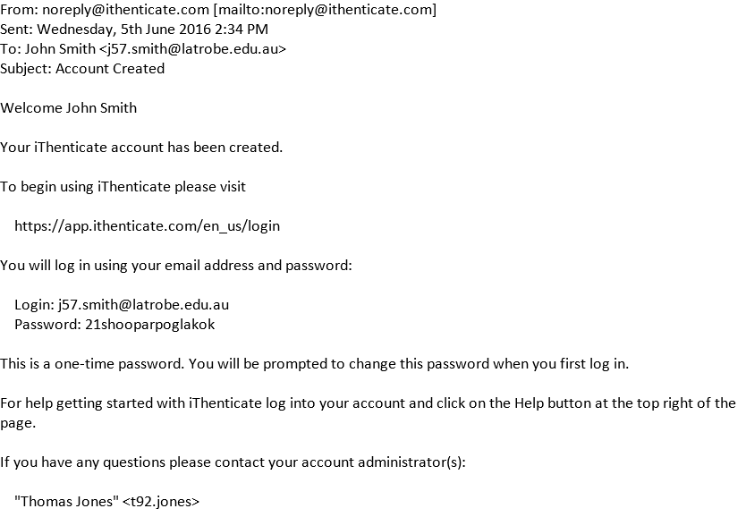
- To log in to iThenticate, click on the Login text at http://www.ithenticate.com/
- When you first log in, you will be prompted to enter and confirm your new password.
- To save the change to your password, click on the Update Profile button or click Cancel to cancel the change to the password.
- When you confirm your new password, the End User License Agreement will be displayed. You must agree to the terms and submit the form.
- The iThenticate Control Panel/Homepage will be displayed.

iThenticate Control Panel - Main Navigation Bar
Your iThenticate homepage has a number of elements. At the top of the screen is the Main Navigation bar. It has three tabs; Folders, Settings and Account Info.

Account Info
The Account Info screen contains information relating to your Profile. This information includes your First Name, Last Name and email address. You can also Upload a photo to the screen and change your password.

Settings
Selections you make on the Settings tab customises your view, language and preferences relating to your manuscripts. Choices on the Reports tab allow you to establish thresholds for email notifications regarding your Similarity and Content Tracking Reports.

Folders
The Folders tab takes you to the screen where you will do most of your work in iThenticate. The Toolbar is functional only when you are at the Folders screen. The Toolbar displays the Search, Trash and Move functions. The folders screen contains all of the functionality of iThenticate. From here you will, create, browse and share folders. Documents can be uploaded and submitted for checking to the iThenticate database. You can also delete documents or move them from one folder to another.

Topic 2 – Folders
On completion of this topic, you will be able to:
- Describe the benefits of using Folders to organise your work
- Personalise the name of My Folders
- Create a new Folder and add it to the My Folders (or Renamed) group
- Complete the Folder settings and select appropriate optional exclusion settings.
- Create Report Filters and Phrase Exclusions

Folders

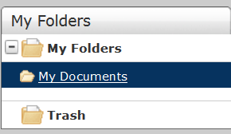
My Folders – Folders
When you first log in, you will have a Folder Group called My Folders and a Folder titled My Documents. A Folder Group allows you to organise your Folders and a Folder lets you store and organise your documents.
My Folders lists all the folders you have created. Click on any folder you’d like to browse and you’ll see the contents of the folder. There’s also a folder for Trash. The trash contains your deleted documents. To permanently delete any item in the trash, select the checkbox to the left of the document title and then click on the delete icon in the Toolbar.

My Folders – Settings
From the Settings tab you can change or personalise the default name of My Folders.
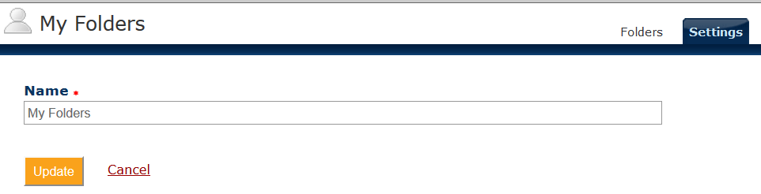

Exercise 2.a – Rename the My Folders Folder Group
- After logging in for the first time to iThenticate, you will only see one folder group, called My Folders.
- From the main navigation screen, on the Folders tab, select My Folders > Settings. Rename My Folders Folder Group.
- Select Update.

Exercise 2.b – Creating a new Folder Group
Creating new Folder Groups will help you to organise and keep track of your manuscripts. If you regularly conduct research, you may want to create a Folder Group for each new piece of work.
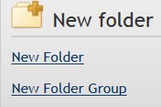
- Select New Folder Group from the Action column on the right of the screen.
- Type a name for your Folder Group and then choose Create. Note: The My Folders list cannot display more than 14 characters.
- At this point you can choose to rename your Folder Group or return to the Folders screen by selecting the Folders tab.

Exercise 2.c – Creating a new folder
You can create a new folder within any of your Folder Groups. You might consider creating folders for:
Pre-confirmation 10,000 words
Pre-candidature Substantial
Pre-submission 70,000 words
Or you could name your folder for a Journal or Conference to which you are submitting a paper. Remember to include the month and year.
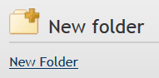
- From the Folders tab, select New Folder from the Action column on the right of the screen.
- Select the Folder Group to which you want to add the New Folder. By default, this will be the My Folders (or renamed) group. Then, give your Folder an appropriate name.
- Select your exclusions and filters as outlined on the following page.
NOTE: Exclusions and filters may be overwritten/edited using the Filter Edit function in the Document Viewer of the Similarity Report.

Exclusions and Filters
The exclusion of any quote, phrase, small match or small source guarantees that the item will not be considered as a match in a Similarity Report or Index. Filters and exclusions will need to be set differently for different tasks and situations. See Interpreting iThenticate Reports: A Guide for Researchers for more information.
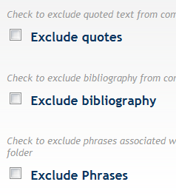
Excludes any matches contained in sections of quoted text. A quote is any text contained within double quotation marks.

Excludes any matches contained in a Bibliography. A Bibiography will be identified by words such as ‘Reference’, ‘Literature’, ‘Citations’, ‘Further reading’ etc
You can exclude matching with phrases associated with the folder from comparison of other documents submitted to this folder. Other phrases can be added from the Setting tab associated with the Folder.
If you choose to Exclude Small Matches, you must set a word count, below which match instances will be excluded. You might consider using this exclusion if there are three or four word phrases that you must use and which would be used extensively by others in your discipline.
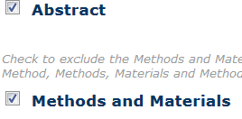
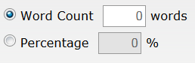
If you choose to Exclude Small Sources, sources with a word count or aggregate match percentage defined by you will be excluded from the Similarity Report. Warning: A percentage exclusion of even 1% could have a significant impact on a manuscript that has 120 pages. Bear this in mind when setting a percentage exclusion.
Your manuscript is unlikely to have a Section titled Methods and Materials but it will likely contain a Section titled Abstract. Tick this checkbox to exclude your Abstract from matching sources.

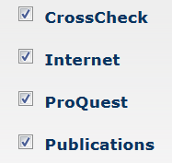
All of the search repositories are selected by default. It’s recommended that you don’t change this setting.
The repositories provide access to conference proceedings, research articles and books provided by the worlds’ scientific, technical and medical publishers.
iThenticate provides a database containing billions of current publicly available and archived internet pages of existing content. Tens of thousands of new pages are added on a daily basis.

My Documents
The My Documents element of the screen has three tabs: Documents, Sharing and Settings. The settings on these tabs relate to only this folder. If you create additional folders you can create different settings. If you want to, you may share one folder with a particular individual and another folder with others.

Documents: This tab displays the documents and corresponding Similarity Indices and Reports within the selected folder. If one or more documents is uploaded and processed by iThenticate, the display will change to include information about the report (including a Similarity % Index), the name of the Author, the date and time on which the document was processed and two icons: Move to Trash and Document Properties.

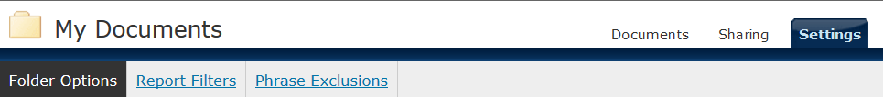
My Documents – Settings

Folder Options: In the Document settings you can override any exclusions and filters that you created when you added the New Folder. See page 15.
Sharing: The Sharing tab displays a list of other individuals within the La Trobe University iThenticate system with whom you can share documents within folders. Select the name of the individual and then choose Update Sharing.
Settings: The elements on this tab allow you to select the options for this folder in relation to exclusions of phrases or quotes.

Report Filters
You may want to exclude particular URLs from the search. For example, if you relied upon a website such as http://www.phrasebank.manchester.ac.uk/introducing-work/ an Academic Phrasebank to assist you with your academic writing, you could filter it out.

Phrase Exclusions
It’s important to identify and exclude discipline specific phrases or word string without which you are unable to describe methods, report results or write your conclusion.

Topic 3 – Submitting your Manuscript
At the completion of this topic, you will be able to:
- Recognise the appropriate type of file that can be uploaded to iThenticate
- Recognise the appropriate size of file that can be uploaded to iThenticate
- Describe a variety of file upload methods
- Submit a manuscript

File Types
Your manuscript can be in any of the following file formats to be uploaded to iThenticate:
- Rich Text Format (rtf)
- Plain Text (txt)
- MS Word(dox and docx)
- Word XML
- Adobe PostScript
- html
- Portable Document Format (pdf)
- WordPerfect (wpd)

NOTE: Files must be in text format. Scanned images of a document or an image saved as pdf will be rejected. Non-text information will not be included in the upload, this includes references to spreadsheets or other documents.
Files must contain at least twenty words of text.
iThenticate will not accept hidden, system, password protected, encrypted or read-only files.

File Sizes
The file should not be bigger than 400 pages of text and should not be larger, in size, than 40mB. If you are uploading a zip file, the zip file can contain 1000 files or 100mB of zipped information. Before uploading, you should check the contents of a zip file to ensure it includes only usable file formats.

What Size is my File?
Apple Mac: Select the file in question, press and hold the ⌘ key, then choose i Doing this will bring up the file information. The size of the file is the second line in the General Section.
Windows PC: When you have the file open, click on File > Info. In the right hand column under Properties, you’ll see the file size.
The file size will be shown in either kB (Kilobytes) or mB (Megabytes).. 1024 kB = 1mB

Tips to Reduce File Size
NOTE: Always use a copy of your Original manuscript when making changes.
You may find that the file you need to submit to iThenticate is over the allowed size limit. If this is the case, you will need to reduce the size of your file.
- Remove all non-text content
  - Images
  - graphs
- Remove headers and footers
- Remove page and line numbers
- Files greater in size than 40mB or 400 pages should be divided as appropriate to remain within the file size limits. The files can then be zipped into a single zip file.
- If your file has been saved as Portable Document Format (pdf), ensure that it is saved as text-based pdf. An image-based pdf cannot be processed by iThenticate.

Types of file Upload
iThenticate offers three methods of uploading your manuscript to the service.
- Upload a file – allows for submission of a single file
- Zip File Upload – allows for submission of a single zip file. A zip file may contain up to 1000 files or 100MB of zipped information. A zip file to be uploaded may not exceed either limit. Zip files should be checked to ensure only usable file formats are included in the upload.
- Cut & Paste – allows for the submission of plain text. This method allows you to submit only specific parts of a document that may require a Similarity Report. If you intend to use this method, it’s recommended that you create a word or text file and then copy the text from there and paste it into the web field. If the page refreshes or another browser error occurs, your text will not be lost.

Exercise 3 – Submitting your Manuscript
This exercise will use the Upload a File method.
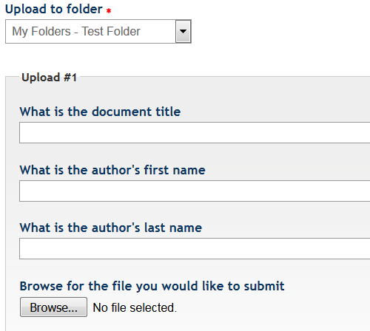
- In the Submit a document channel, select Upload a File. You have the option to upload your manuscript to a folder other than the default folder that has been selected.
- Give your manuscript a title. If you don’t enter a title for the manuscript in the field provided, the iThenticate service will use the document’s filename. Enter the first name and last name of the author. Then Browse for your manuscript.
- You can upload up to ten documents at a time using the Upload a File method. To submit another document, select Add another file.
- Click the Upload button to submit your manuscript. Alternatively, click Cancel to cancel the submission.

Topic 4 – The Similarity Report
After you have submitted your work to iThenticate and it has been compared to the sources described on page 9, iThenticate will generate a Similarity Report

What is a Similarity Report?
You will know when the report has been generated because the Date/Time of processing will be displayed, as will the Percentage Index of the report. This index indicates the percentage of similarity between the work you have submitted and the information that already exists in the iThenticate repositories that were selected for the search. (See Settings on page 14)
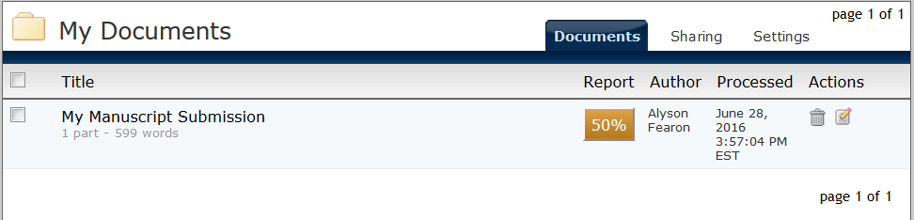
Clicking on the Percentage Index in the Report Column will open the iThenticate Document Viewer and display the Similarity Report.
In the Default View, The Similarity Report is divided into three distinct channels:
Paper Information - At the top of the Document Viewer screen you will see information about the submitted work including the paper title, date of processing, word count and the title of the folder from which the document was submitted. The number of matches and the number of sources where the matching text was found are also displayed.
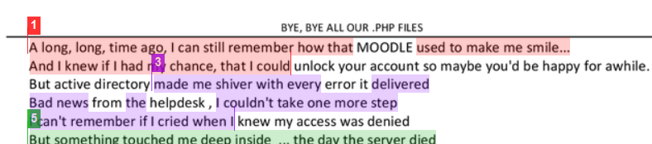
Paper Text – This channel displays the text of the submitted work. Any matching text is highlighted in a colour corresponding to the source listed in the Match Overview channel.
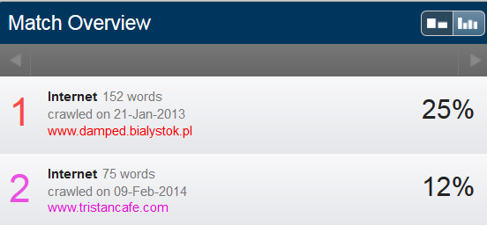
Match Overview - the list of sources that match the highlighted areas in the Paper Text

For detailed information about how to make sense of your Similarity Report and the different ways you can use it see the Interpreting iThenticate Reports: A Guide for Researchers.

Viewing Modes
The Document Viewer has four different viewing modes which allow you to sort and view the information provided in the Similarity Report in the manner that suits you best.
The four modes for viewing the Similarity Report are:
- Match Overview: This is the default viewing mode and it provides a list of all the parts of the paper which have matched text in the search repositories. The matches are colour coded and are listed from highest to lowest percentage of matching text.
- All Sources: This view contains an exhaustive list of all matches that have been identified.
- Match Breakdown: This view allows you to compare the top match source with all underlying sources.
- Side by Side Comparison: This is an in-depth view which displays a match compared with the original source content.

Match Overview
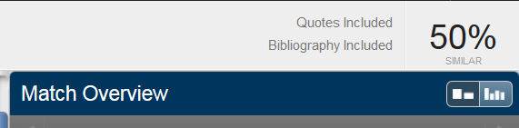
When you open the Document Viewer, you’ll see the Match Overview display. This is the default viewing mode and displays the top percentage matches. To change the view to All Sources, select the All Sources icon (on the right) and the sidebar will update to display the list of all matches that have been identified.

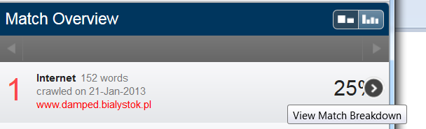
Match Breakdown
–To view the underlying sources for each match, you’ll need to display the Match Breakdown. To display this mode, hover your mouse over the match for which you want to see the underlying sources until an arrow icon appears. Selecting the arrow icon will update the screen to display all of the sources where matched text appears.

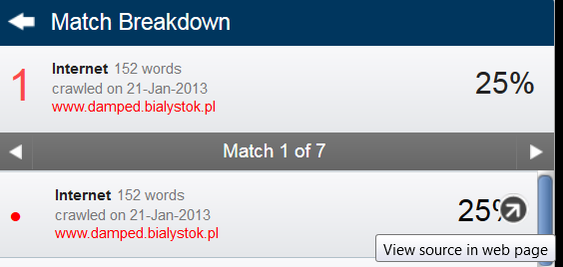
Viewing a Source
If a matched text source is available on the internet, you can open the web page in a new browser tab by hovering your mouse over the match in the sidebar and selecting the View Source in web page icon.
You can return to Match Overview by selecting the arrow to the left of the text at the top of the sidebar. To view a source from the Match Overview, click on a match within the document, if the source is a link it will be blue in colour. Click on the source link to open a new web page displaying the original source. Alternatively select Full Source Text and the text will be displayed in the sidebar.

Viewing the Text Only Report
You can navigate to the Text-Only Report by clicking on the Text-Only Report button at the bottom right of the Document Viewer. To return to the Document Viewer, select Document Viewer at the top left of the screen.
Clicking on the Text-Only Report displays the text-only view of the Similarity Report. Your report is displayed as unformatted text.
The Text-Only Report has four different viewing modes which allow you to sort and view the information in the manner that suits you best. To select a mode, click on the Mode pull down menu and select your preferred viewing mode.
The four modes for viewing the Text-Only Report are:
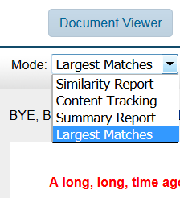
- Similarity Report: This is the default viewing mode and it provides a list of all the parts of the paper which have matched text in the search repositories. The matches are colour coded and are listed from highest to lowest percentage of matching text.
- Content Tracking: This view contains an exhaustive list of all matches that have been identified. Because the iThenticate databases are updated regularly, this view may have many matches from the same source. And duplicate sources will be date stamped.
- Summary Report: This view provides a simple, printable list of all the matches. Beneath the list, the paper is displayed highlighting the matching text.
- Largest Matches: This view displays the percentage of words that are part of a matching string. There may be an overlap of strings from some sources. If this is the case, the longer string will be displayed.

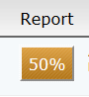
Exercise 4 – Viewing the Similarity Report
iThenticate can take from a few minutes up to 24 hours to generate a Similarity Report.
- When your Similarity Report has been generated, the % Icon will be displayed. Interpreting iThenticate Reports: A Guide for Researchers has information about percentages and how to interpret them. Select the % Icon in the Report column and the Document Viewer will be displayed.
- Toggle to the Text-Only Report and back to the Document Viewer. Note the differences.
- In the Document Viewer mode toggle to All Sources view.
- In All Sources view, display Full Source Text.

INDEX

ABC 9
Abstract 15
Academic Integrity Statute 2015 8
Account Info 12
All Sources 23
Australian Code for the Responsible Conduct of Research 2007 8
CLIO 9
Content Tracking 24
Document Viewer 14, 21
End User License Agreement 11
Exclude Small Matches 15
Exclude Small Sources 15
Exclusions 15
File Sizes 18
File Types 17
File Upload 18
Filters 15
Folder Group 14
Folders 12
Full Source Text 25
iThenticate 9
Largest Matches 24
LTU email address 11
Main Navigation 12
Match Breakdown 23
Match Overview 21, 23
McGraw-Hill 9
Move 12
My Documents 16
My Folders 13
Paper Information 21
Paper Text 21
Password 11
Pearson 9
Phrase Exclusions 16
plagiarism 9
ProQuest 9
Report Filters 16
Research Integrity Policy 8
Search 12
Self-Plagiarism 10
Settings 12
Sharing 16
Side by Side Comparison 23
Similarity Indices 16
Similarity Report 14, 21, 24, 25
Submitting your Manuscript 19
Summary Report 24
Text-Only Report 24
Trash 12
Update Profile 11
Upload a File 19
username 11
Viewing Modes 23
Wiley 9
Zip File 18

