La Trobe Business School and the School of Law

First Year Survival Guide

Strategies for Successful Study in the La Trobe University Business School and School of Law

2015

Table of Contents

1. Introduction | 3
2. Independent Learning Skills | 4
3. Writing in the La Trobe Business School and School of Law | 27
Business Writing Style | 28
Common Grammar Errors | 36
4. Referencing and Paraphrasing (How to Avoid Plagiarism) | 48
5. Guidelines for Assessment Tasks | 64
Case Studies | 65
Reports | 71
Essays | 80
Oral Presentations | 86
Teamwork | 92

Introduction

Welcome to the College of Arts, Social Sciences and Commerce. This Guide is intended for students of the La Trobe Business School and the School of Law at La Trobe University. If this is your first time studying at university, you will notice that there are a lot of new things to get used to.

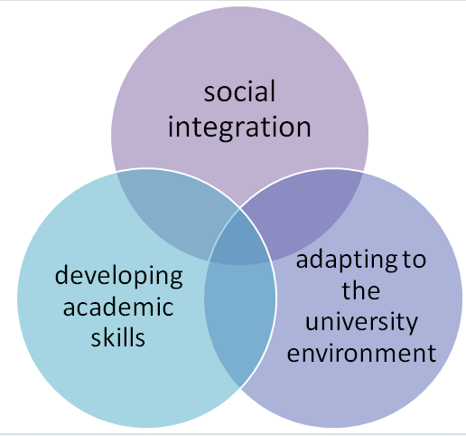
Who will I make friends with?
Where do I go for coffee?
What clubs should I join?
How can I contact my lecturer/tutor?
How do I do my timetable?
How do I write a Management report?
Where’s the College office?
What’s APA Referencing?
How can I change my subjects?

The La Trobe Business School and School of Law First Year Survival Guide has been written to introduce you to university study and to help you to develop the academic skills you will need, not only to survive your first year, but to excel!

In the following pages, you’ll be introduced to independent learning skills, disciplinary writing styles and basic grammar, referencing and paraphrasing, and guidelines for the common assessment tasks of essays, reports, problem questions and oral presentations.

1

Independent
Learning Skills

Learning to learn at university

Learning at university is different from learning at high school. If you are prepared for these differences, you can really enjoy the challenging and stimulating learning environment of university. The table below summarises some of the main differences between secondary and tertiary study.

Secondary school | University
guided homework tasks to assist learning | self-directed revision throughout semester – need to set your own homework
time often structured by teachers/curriculum/homework | need to manage your own study time
study tasks fairly evenly spread throughout the year | may have many assessments due at the same time
concepts often simpler | concepts often more challenging need to develop higher order thinking skills such as applying, analysing and evaluating
information often presented as black and white facts | a more critical approach to information required  need to understand that some  “facts‟ are more certain than others and there may be different opinions about what is true
writing tasks may not require in- text references and reference lists. | in-text references and reference lists required for most writing  very specific rules for referencing
smaller amounts of directed reading | extensive reading of text books and journal articles required  need to critically evaluate what you read
less emphasis on online materials | LMS used to communicate important information e.g. lecture notes, assessment information, online forums
easy to ask for help | help is available, but need to know who to ask or where to look online

Learning about learning

Learning is not the same thing as simply remembering. At university you will need to develop higher order thinking skills (see Bloom’s Taxonomy below). Many assessment tasks will require you to go beyond simply remembering and repeating information. You may be asked to apply what you have learnt to new situations or to analyse and evaluate information. This could mean pulling apart a writer’s arguments and evidence (analysing) and making judgments about them (evaluating). The highest level thinking skill is creating. This refers to the creation of new knowledge that has never been known before. This is a skill that is normally developed at postgraduate level.

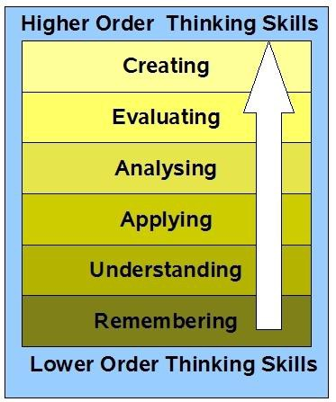

Bloom’s Taxonomy
(cognitive domain) Anderson and Krathwohl (2001)

Source: http://edorigami.wikispaces.com/Bloom's+Digital+Taxonomy

Monitor your learning

It takes time to develop the learning strategies you need to be successful at university. You may try several approaches to a task before you find a set of strategies that work for you. Monitoring your learning strategies involves a way of thinking called metacognition. Cognition means “thinking‟ and meta means “about‟ or
“beyond‟. Metacognition, therefore, means thinking about the way you think or learning about the way you learn. In this process, you are both the person doing the learning and the person “watching yourself‟ and reflecting on your learning.

Students who develop their metacognitive skills are more successful learners than those who don’t. It’s not difficult to become skilled at using metacognitive strategies to assist your learning. It just takes a bit of thought and awareness. You might like to think of it like playing a sport. When you’re on the playing field, you’re caught up in the moment and reacting to immediate tasks at hand. You can also mentally shift yourself to the grandstand and “watch yourself” playing. You can observe and analyse your performance and think about how you might perform better next time. You may even be able to apply what you’ve learned about yourself to your performance in a different sport.

In the same way, you are “on the playing field” when you are studying for an exam, doing an assessment task or taking notes in a lecture. You can also watch yourself doing the task “from the grandstand”. You can reflect on what works for you to help with your learning and what doesn’t work. For example, you may have found that when memorising a series of symbols or words, it was useful to practise recalling them out loud while walking or listening to music and plan to use this technique again. Alternatively, you may have wasted hours reading unrelated material when preparing an essay. Next time, you may decide to target your reading more closely to the essay question.

When engaging in a learning or assessment task, ask yourself the following questions:

Reflection in action
OBSERVE & MONITOR
How am I doing? Are the strategies I am using effective? Should I change the way I’m doing this now?

Reflection on action
PLAN
How can I improve my approach next time?
What new strategies can I try next time?
Reflection on action
EVALUATE
Was my approach to the task effective? What worked? What didn’t?

THE LEARNING CYCLE

Learning styles

Are you an active or reflective learner? A sensing or intuitive learner? A visual or verbal learner? A sequential or global learner? Everybody has a different mix of learning styles. It is helpful to know which ways of learning you favour so that you can adapt your study techniques accordingly. Would you revise more effectively in a group or on your own? Would drawing diagrams be more helpful to you than linear notes or summaries? Would skimming a chapter of a text book aid your understanding or be a waste of time?

To find out about your learning styles, take the Index of Learning Styles Questionnaire, devised by Soloman and Felder at NC State University in the USA: www.engr.ncsu.edu/learningstyles/ilsweb. When you have completed the online quiz, read about the study strategies that suit your learning style.

Below are some example items from the questionnaire:

- I tend to
  - understand details of a subject but may be fuzzy about its overall structure.
  - understand the overall structure but may be fuzzy about details.

- I prefer to get new information in
  - pictures, diagrams, graphs, or maps.
  - written directions or verbal information.

  - I remember best
    - what I see.
    - what I hear.

- When writing a paper, I am more likely to
  - work on (think about or write) the beginning of the paper and progress forward.
  - work on (think about or write) different parts of the paper and then order them.

University learning environments

At university, you will experience some or all of the following learning environments:

- Online learning – e.g. Learning Management System (LMS), La Trobe University website, LTU Ready4Uni website, LTU Library website, LTU Student Learning website, external websites

- Blended learning – a mixture of face-to-face and online learning in a subject

- The flipped classroom – online material and activities followed up with face-to-face activities

- Face to face learning on campus - lectures, seminars, tutorials, laboratory classes, workshops, group work

- Face-to-face learning off campus - field trips, placements, group work

Managing all of these different learning environments can be challenging. People have different learning environment preferences, so you may find some environments suit you better than others.

Online learning environments: A brief overview
All universities are increasing the amount of online learning opportunities offered to students. This is not happening because it is cheaper to offer online learning instead of face-to-face learning. In fact, online learning costs significantly more to design, develop and maintain than face-to-face learning. Doing some or all of your learning online offers you significant benefits. It gives you more flexibility as you can learn online at a time that suits you best. It also allows you to work at your own pace and enables you to go back over things you find difficult to learn.

Online learning environments at La Trobe University may involve:

Fully online subjects: usually offered through the LMS (see below) and may make use of videos, reading resources, podcasts and online discussion forums and blogs as tools for learning. A small number of subjects are currently offered in this mode.

Blended subjects: subjects which combine face-to-face learning with online learning. This gives you the flexibility to learn at a time and pace that suits you as well as giving you the opportunity to benefit from the expertise and enthusiasm of our academic staff. In a blended subject, the online learning is directly related to and complements face-to-face learning.

Flipped learning: a form of blended learning where students first engage with subject content online. This is followed up/reinforced in a face-to-face environment e.g. a tutorial, seminar or practical class.

The Learning Management System: Whether you are studying in a fully online subject or a subject that is mostly delivered face-to-face, you will need to use the online Learning Management System (LMS - also known as Moodle). The LMS is your central point to manage your university study. It is where you’ll find all of the important information for your subjects, as well as links to useful help and resources. You should check the LMS for each of your subjects at least several times a week. Make sure you have set up your username and password. More detailed information about getting started with LMS can be found here: http://www.latrobe.edu.au/students/it/teaching/lms

Tips for managing online and blended learning
The following section will help you to manage learning in online and blended environments. There are tips on using the LMS and learning and communicating online.

Navigating the LMS

- There is an LMS site for each of the subjects you are enrolled in each semester

- Don’t expect all LMS subject sites to have exactly the same layout. While many things are the same, different lecturers set up their LMS sites differently, according to what suits the subject matter. Spend some time getting to know where everything is on each subject LMS site.

- Your list of subjects includes the Academic Integrity Module. This is a compulsory quiz that all commencing students MUST complete. This shows the university that you understand academic integrity rules and how to avoid plagiarism.

- On the LMS site for each subject, make sure you check out the toolbar at the top of each LMS page. It gives you four options: La Trobe Home, Library Home, Students, Staff. Clicking on the student link will enable you to access:
- A link to where you can get help with using the LMS.
- A link to student IT support
- A link to information about copyright
- A link to the Student Learning website where you can find useful resources to help you study.
- A link to information about the Peer Learning Advisers who can help you with your study
- A link to the Academic Referencing Tool to help you with referencing for your assignments.

Learning and communicating online
- Online activities are designed to help you learn. What you learn in an online activity may help you to get more marks in a different assessment task or in exams. Even if there is only a small number of marks allocated to the online activity itself, completing the activity may help you to be more successful in the subject overall.

- In an online discussion in a subject, you don’t usually need to write in an academic style similar to how you would write in academic assignments. Each online environment is different, but most online discussions are not especially formal. You probably don’t need to write as formally as you would in an academic assignment. However, you may need to be more formal than you would when communicating online with people you know well. Check with your subject teaching staff if you are unsure what style of language is acceptable.

- You usually need to be much more careful about writing something that might offend someone in the online environment. Of course, it is never acceptable in any environment to use language that may offend or intimidate others. However, you need to take extra care when communicating online. In the online environment, you don’t have the benefit of seeing people’s facial expressions or gestures to know if they are feeling offended by your comments. It is also easy to ‘get the wrong end of the stick’ in online communications. Make sure that what you write could not be interpreted in a different way.

- A good rule of thumb when communicating online is you shouldn’t say something to or about a person online that you wouldn’t be prepared to say to their face. Even if you are communicating anonymously, respect for your fellow human beings is always important. That doesn’t mean you can’t disagree with others. It is possible to disagree respectfully by making sure that criticisms are restricted to the arguments and evidence and not used to make personal attacks on people.

- Using CAPITAL LETTERS in online posts is equivalent to shouting at someone face-to-face. This is not a respectful way to communicate.

- Sometimes, you may need to email a lecturer with a request for help, but how formal do you need to be? Some lecturers expect you to write formally in emails (e.g. Dear Peter); others do not (e.g. Hi Peter). It’s best to err on the side of caution when emailing a lecturer for the first time. If they write back to you using informal language, it is usually OK to respond in a similar tone. When asking a lecturer for help, it is best to be specific about your request. You are far more likely to receive a response from a busy lecturer if you ask a specific question rather than stating that you don’t understand a whole topic. Where possible, your first action when you don’t understand something is to post a question on the LMS discussion forum for that subject.

- Spelling and grammar are still important when communicating with others online. Good spelling and grammar aids communication, so it is always good to pay attention to these. Poor spelling and grammar can make a negative impression and distract people from what you are saying.

- It’s not polite to always correct other people’s grammar, spelling and typos in online communications. Everyone makes grammar and spelling mistakes from time to time, particularly if English isn’t their first language. Correcting other people’s writing errors can come across as ‘nit-picky’ and pedantic. It also distracts from the topic of discussion.

- It is perfectly fine to disagree with others, both online and face-to-face. The key is to restrict discussions to the arguments and evidence, and not make it personal. Disagreeing respectfully is a very important skill to develop.

- The rules for copyright and plagiarism also apply to the online environment, so it’s not OK to use other people’s images and text without acknowledgement. Other people’s ideas and images belong to them and so need to be acknowledged, regardless of the environment. The style of acknowledgement may vary, though. You may not need to use a formal referencing style, as long as you make it clear who the idea/image belongs to. Check requirements for individual subjects.

Further Resources

University of Newcastle Netiquette Guide: http://www.newcastle.edu.au/Resources/Teaching%20and%20Learning/In%20The%20Online%20Environment/Teaching/Module%204%20-%20Communicating/Netiquette_guide_august08.pdf

University of New South Wales Student Guide to Online Study: https://student.unsw.edu.au/online-study

Face-to-face learning environments
Face-to-face learning environments include lectures, tutorials, seminars, practical classes, workshops and group work. The following tips will help you develop the skills and strategies you will need to manage lectures and tutorial/seminar classes.

Tips for lectures
- It is a really good idea to print off your lecture notes if they are available on LMS and bring them to the lecture so you can annotate them. You can skim the slides before the lecture to get an idea of the content, and you can save time during lectures by simply annotating rather than writing detailed lecture notes.

- It is usually best to do prescribed reading before the lecture and use the lecture as a summary of your reading on a topic rather than an introduction to the topic.

- Ask questions during the lecture if there is an opportunity to do so. Most lecturers encourage students to ask questions. It shows you’re interested and can help other students too. Be careful not to dominate though!

- Make a note of anything you don't understand in the lecture. It is really helpful to do this after each lecture so that you can then follow up these questions.

- Don’t email your lecturer every time you find something difficult to understand. Most subjects have an LMS discussion forum where you can post questions. Check first to see if your question has already been answered there, and if not, post it. In some subjects, lecturers and tutors answer questions on LMS discussion forums. For questions of a personal nature that you don’t wish to share with other students, it is appropriate to email your lecturer, tutor, facilitator or demonstrator.
- Don’t re-write your lecture notes after every lecture. This would be overkill and is probably not a good use of time. Many first year students fall into the trap of mindlessly rewriting notes, often while thinking of something else. Don’t be one of them!

- When you’ve finished a series of lectures on a topic, use your lecture notes, prescribed reading and/or textbook to create revision notes, ideally in the form of diagrams or mind-maps. This allows you to get your head around a whole topic and you can synthesize information from a number of sources into a really good set of revision notes. The more active and visual you can be with your note-making, the better you’ll remember and understand material for exams.

Tips for tutorials and seminars

- Check (usually through LMS) if there’s any required reading or activities to be done before the class.

- Do the reading/activities and try to understand the main concepts presented.

- Think about your responses to the ideas in the readings/activities. Do you agree with them? Do you think the ideas are well-argued and well-supported? Are there any different ways of thinking about these ideas? University is not simply about rote learning information. It is also important to think critically about ideas and come to class ready to discuss your responses with others.

- Unless specifically asked to do so, there is no need to write a detailed summary of the required reading in preparation for every tutorial or seminar. This would take too long and your time would be better spent on other study activities.

- Make a note of any questions you have about the reading or related lecture material so that you can ask in the tutorial or seminar. Identifying what you DON’T understand is incredibly important for your learning. Face-to-face classes like tutorials and seminars are a really good opportunity to ask questions to expert teaching staff.
- It is always a good idea to think about how each piece of information or each idea you are learning fits with the main concepts presented in the subject. Think of each subject as a jigsaw puzzle of a landscape. You need to understand how the sky pieces, the tree pieces and the water pieces fit together to make the whole picture. In the same way, you need to think about how each piece of information or each idea fits with the main concepts of the subject to make up the picture of the whole subject.

Making a study plan
A study plan is not something to be left until exam time. To be successful at university, you need to study consistently throughout the semester, right from the first week. This study time is additional to the time you spend on assessment tasks. It is strongly recommended that you spend at least one hour studying and completing assessment tasks for every one hour contact time at university.
This means if you have 24 hours of lectures and prac classes every week, you should spend 24 hours a week on assessment tasks and additional study.

Organising your time
The Assignment Calculator in the library can be a useful way to manage your study- time for multiple assignments. Here is the link to it: http://www.lib.latrobe.edu.au/calculator/

A semester planner is a good way to start. It’s a good idea to make a big one to put up on your wall. Here’s a small section of one to give you an idea.

Semester Planner

WEEK  SUBJECT | 1  27 Feb  – 2  March | 2  5-9 Mar | 3  12-16  Mar | 4  19-23  Mar | 5  26-30  Mar (census date: 29 Mar) | 6  2-6 Apr | SEMESTER BREAK  6-13
ACC2CRE |  |  |  | (Mum’s 50th b’day Sun) | Assign- ement Due Wed (15%)
MGT2BET |  |  |  | Group report due (30%) |  | Group present ation (20%)

A grid can be useful to organise when to study.

Time | Monday | Tuesday | Wednesday | Thursday | Friday | Saturday | Sunday
9:00 |  | Work |  | Study | Work | Work | Study
10:00 | LAW2CTB  Lecture ELT6 | Work | ECP seminar MARB171 | Study | Work | Work | Study
11:00 |  | Work |  | LAW3ECP  lecture ELT3 | Work | Work | Study
12:00 |  | Work |  |  | Work | Work | Free time
13:00 | LAW2CTB  seminar HUED103 | Work | LAW2CTB  Lecture. ELT5 |  | Work | Work | Free time
14:00 |  |  |  |  |  | Work | Study
15:00 |  |  | Study |  | Socialise | Work | Study
16:00 | Touch Football | Netball | Study |  | Socialise | Work | Study

A ‘to do’ list can be useful to organise what to study.

Week 7 ‘TO DO’ list

ECO1IMA
- Revise lecture notes lectures 19 – 22 and write summaries (2 hrs)
Make mind map for problem questions - take- home exam
- Read Stonecash et al.ch. 2 p 49-60 & combine with lecture notes (2hrs)

LAW2CTB
- Read Ellinghaus- chapter 10 and make mind map (2 hrs)
✓Continue practicing problem solving (2 hrs)
- Review lecture notes for week 6 (2 hrs)
- Past exam (2011) questions (1 hr)
- Email lecturer about problems with topic 3

It is important to be realistic. Don’t set impossible goals for yourself. You’ll be more likely to stick to your timetable if you take into account the following points:
Allow for the limitations of your attention span. Avoid scheduling large slabs of time for one subject. Alternating subjects for study will help you to sustain your concentration and interest.

Work in terms of tasks not time. Rather than having a vague aim to „study biology for two hours’, set a particular section of work for each study period. A sense of achievement comes from successfully completing small tasks, and breaking the work up into smaller sections makes the whole process of study seem less daunting.

Review your approach. If your study plan is not working effectively, review your strategies and consider making changes. For example, you may have attempted to fit too much into your timetable, or your timetable may not be flexible enough to accommodate unexpected events. Resist the temptation to throw away your plan and allow yourself to fall in a heap. Some minor adjustments may be all you need to stay on track.

Make sure you include some recreation time. If you allocate time for recreational activity you will be less tempted to throw it all in and waste time avoiding study because of unrealistic demands you have made upon yourself.

Learn To Study

LTS
3 steps to
Learn To Study
@ university
Lecture
Topic
Swot vac
Before: Read text
book & PPT slides (if available).
After: Re-read text book & lecture notes - reflect, consider, raise questions, clarify, do practice exercises.
At the end of a topic -
put notes together, make connections, look for links, big picture, see relationships, clarify, summarise main ideas, mind map, do practice exercises
Refresh, recall,
practice recall, main ideas & details, test yourself, seek answers to problems/questions, Recognition → recall

is for lecture
L

Read text book or other required reading before the lecture (see “Reading for lectures” on p. 21)

Preview lecture note slides (if available) before the lecture to give you an idea of the main concepts to be presented in the lecture.

Combine material you have learned from your reading with your lecture notes according to the topic area. Underline / highlight / write comments in order to emphasise the main idea of each section.

Note any questions/problems. If you don’t understand something, try to formulate a question about what you don’t understand. Make the question as specific as possible, for example, “I don’t understand why low carbon dioxide concentrations cause stomata to open”. Try using the discussion forum on LMS to get answers to questions. If this doesn’t work, ask your demonstrator or lecturer.

Form a study group. Studying regularly (perhaps weekly) with a small group is a great way to learn. You can sort out difficulties with content, check that you’re on the right track and test each other to practise recall. It is also easier to stay motivated and on track when you study in a group.

is for topic
T
Organise notes into topics/areas. It is easier to remember individual details when they are grouped into mini-sections. Make a list of the areas you need to know in each subject and write down headings and subheadings.

Make notes. Don’t fall into the trap of spending 99% of your study time mindlessly writing out notes and 1% of your time actually looking at them. You should be making notes for each topic area in each subject throughout the semester so that they are ready for swot vac. The more ‘active’ you are in writing notes, the better you will be able to remember them. This may involve reconstructing your notes in a different format (see section on making notes from your reading on p. 21)

Do past exam papers and revision questions - You should do these at the end of each topic. Find the questions on a past paper that relate to a particular topic and do them after you finish each topic. At this stage, it is better to do past exam questions in an ‘open book’ style, using your lecture notes and textbooks to answer any questions you don’t know. IMPORTANT - exam formats may change from year to year, so check with your lecturer to find out if there are any major changes.

Audio – Try recording your summaries or prepared answers to practice questions onto a portable recording device. Comprehension improves if you listen and read at the same time. The other advantage for those who like multitasking is that you can listen while doing something else like walking, cooking or sitting on a bus.

is for swot vac
S

There is one week of study vacation, often called ‘swot vac’ at the end of each semester. During this period there are usually no lectures, tutes or prac classes. It is not possible to effectively learn all of the content for all of your subjects during this week unless you have been studying throughout the semester. Swot vac is a time for refreshing your memory about content you have previously learned and understood. The key principle during this period is to move from recognising to understanding to recalling:

Recognise Understand Recall

Distinguish between recognition, understanding and recall. Many students, after having read over material several times, assume that because it looks very familiar they have learned it. Simply being able to recognise material does not automatically mean that you understand it or will be able to recall it later in the exam.

Practise recall. The following suggestions may be useful:

Revise definitions from your glossary (see p. 23). Cover the definition side and practise recalling definitions; then cover the term side and practise recalling the terms.

Use your flash cards (see p. 23) with the question on the front and the answer on the back. Keep aside any that you got wrong and then do these again. Keep doing this until you get them all correct.

If you need to memorise diagrams, make large ones and stick them up on your walls.

Use rhymes and mnemonics to assist recall. For example, to remember electron loss and gain in oxidation and reduction, the following may be easy to remember: IRAC - Issue Rule, Analysis; Conclusion.

Revise with a friend or a study group to share knowledge and exam strategies and to practise recall.

Know what to expect. Your method of revision should consider the nature of the examination. Find out from your lecturers what the structure of the exam will be and what topics will probably be on the exam. Course outlines and handouts can provide important information about exam times, locations, formats and requirements. Exam review sessions are invaluable and not to be missed! Not only will they give you an idea of what will be on the exam, but also give you a chance to ask questions.
Former students may also be able to give you helpful information about what to expect.

Do practice questions. Either past exam questions or revision questions provided by your lecturer are useful. During swot vac, it is a good idea to practise doing exams under exam conditions in the time allotted, without looking at your notes or books.
Make sure you focus on anything you got wrong. It is critical that you study before doing the practice questions. That way you can check how effective your study has

been. If you do the questions prior to studying, you will focus on just answering those few questions, rather than learning all of the material that could be covered in the exam.

Reduce anxiety and stay motivated

Although a small amount of stress before exams may aid your performance, too much anxiety will negatively affect your exam performance. Around exam time, the La Trobe counselling service on the Melbourne campus runs group seminars on exam success. The Melbourne campus counselling webpage http://www.latrobe.edu.au/counselling/ also has information about study timetables, goal setting, planning and priorities. If you feel overwhelmed by exam stress or study motivation problems and unable to cope, you may like to make an individual appointment with one of the counsellors on your campus. You can find their contact details on the La Trobe Current Students homepage under „campus specific resources’.

There are several strategies you can try to reduce your anxiety before and during exams.

Start early and stay on track with your exam preparation to reduce your stress levels.

Look after your health. Get plenty of sleep, eat healthy food and try to find time to exercise. Many people find that yoga and breathing exercises can help keep them in tune both physically and mentally.

Keep things in perspective. Although it may seem at the time that the next exam will be the most important event in your entire life, this is probably not really the case and thinking like this only puts more pressure on yourself.

Take a break. Notice when you are tired or losing concentration. If you feel like this late at night, you could make more effective use of your time by going to bed and getting up earlier the next morning to study when your mind is feeling fresher. A good way to refresh a tired mind is to go on a brisk 15 minute walk. A 15 minute TV break is not usually refreshing and can easily turn into a one hour break.

Set rewards for yourself. Rewards for good progress can assist with motivation.
Try setting yourself a goal and rewarding yourself when you achieve it.

Some tips for specific types of exam questions

Multiple choice questions
Many students believe that to answer a multiple choice question they need only be able to recognise material and so need only do minimal revision. A well-written multiple choice examination, however, will require you not only to have a thorough knowledge of the subject, but also to be able to integrate and apply information and to discriminate between similar answers.

Carefully note the connecting words as well as the key words in both the question stem and possible answers.

Beware of double negatives. For example, the question might ask, “which of the following is true?”, and the first answer may read, “(a) it is not the case that...”

Think carefully about sentences with words such as never and always.
Try considering each alternative of a multiple choice question as a true/false statement and then choose the odd one out.

If you see an answer that you think is correct, check to make sure that the others are incorrect. You may find that you’ve been a bit hasty.

Does the question contain any clues to the answer? Do the alternative answers give clues? Through careful analysis and a process of elimination it may be possible to arrive at the correct answer even if at first sight you did not have any idea.

If you are not quite sure of an answer, guess (unless of course there is a penalty for incorrect answers).

Do not pay attention to old myths such as, „if you don’t know the answer always tick the first box’ or, ‘always pick the shortest or the longest answer’. An educated guess after careful consideration of all the options is more likely to score an extra point. Another popular myth is that if you change your answer you are more likely to change it to an incorrect answer. In fact, studies have been done which prove just the opposite.

Short answer and essay questions
Your main aim is to provide a clear, logical explanation that can be followed easily by your examiner.

Don’t rush into a question. Give yourself time to think about and plan your answer. Before writing, make notes or a brief outline to aid your memory if you have a mental block later.

Short answer - summarise the main issue in the first sentence. This means that you will have to carefully plan your answer first. Also, if you run out of time your examiner will be able to see where you were heading with your answer.
Do not repeat words from the essay question, e.g. “On May 22nd, David Brown

employed an editorial assistant to work part-time at the local newspaper he edited”.

Essay - your introduction should outline the main points of your argument. The body of the essay should consist of a logical sequence of these ideas. Have one main idea per paragraph and express the main point of the paragraph in the first sentence. The conclusion should provide a summary of your argument.

If you run out of time or misjudge things and still have a question to go, then write notes/points. Set out a plan of how you would have answered the question if you’d had time. A well-structured outline is often sufficient to achieve a pass for that question.

In a short answer question, content must be strictly relevant. Make sure that your answer is clear and concise. Padding wastes time and may lose you marks.

If appropriate, include clearly-labelled graphs or diagrams. These may help you to remember things which you have forgotten or provide you with a basis for your writing.

Problem-solving questions (particularly for Law subjects)

Read the question carefully. Take note of each part of the question you will have to address.

Check carefully what data you have been given and what has been left out.
Think about which legal rule might apply to the case you have been given. In what ways does it differ from the precedent?

Decide the order of the steps you will have to take in order to get to the answer.

Read through the question again and check each part; there is often more than one legal issue.

Include all of your reasons for the answer you give. That way even if the final outcome is incorrect, your examiner will be able to see where the mistake was made and may still award you some marks for your approach to the question.

Predict your grade!

The Study Success Predictor below lists behaviours that you should exhibit in order to excel in your subjects. Circle true or false for each of the following statements describing the way you will study in your first year subjects. Then add up your scores to predict your grade.

True / False I will read and use the First Year Survival Guide.
True / False For every hour I spend in class (lectures, tutes and pracs), I will spend one hour studying, even when I have no assignments to prepare.

True / False I will always do the required reading before every lecture.

True / False I will go over my lecture notes as soon as possible after the lecture to rework them and mark problem areas.

True / False I will do revision questions or past exam papers throughout the semester to test my understanding.

True / False I will create a glossary to record all of the key terms I need to know in each of my subjects.

True / False I will make flashcards and use mnemonics for myself to help me remember facts and equations.

True / False I will make diagrams or draw mental pictures of the concepts and experimental procedures discussed in class.

True / False I will “teach” concepts to friends, myself in the mirror, stuffed animals, or imaginary students.

True / False I will carefully follow all instructions relating to my written assignments so that I do not lose marks needlessly.

True / False I will learn how to use the library resources and systems (e.g. catalogue, data bases and research help desk) to find information for assignments.

True / False I will complete a draft of my written assignments in time to get feedback from others and make improvements.

True / False I will ask for help when I need it by talking to the lecturer, demonstrator or tutor after lectures, during practicals, or by making an appointment.

True / False I believe in my ability to do well in all of my subjects.

Now, predict your grade on the next page.

The predicted grade for your performance this semester is provided below:

Number of true responses | Predicted grade
11-14 | A
7-10 | B
4-6 | C
2-3 | D
Less than 2 | Fail

Note that you can change your predicted grade at any point by changing your behaviour so that more of the statements are true.

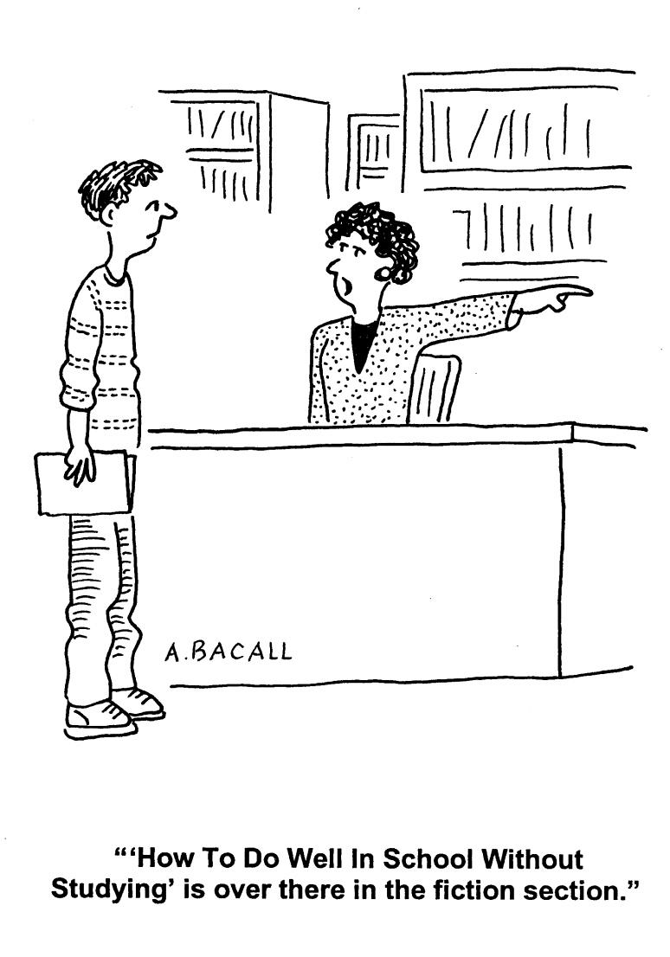

“How to do well at Uni without Studying is
over there in the fiction section.”

Getting the most out of your reading

In most of your subjects at university, you are expected to do a large amount of reading. You will need to do reading related to your studies to help you to understand the main concepts. You will probably have to read sources of information for essays, reports and other written assignments.

Reading for classes

Your subject content will be much easier to understand if you read your text book or other required reading before your class. Even a quick skim read of the relevant pages will give you some idea of the main concepts. You will also be more prepared to ask questions if you are familiar with the topic beforehand. If you haven’t been told which pages to read before the class, check your subject guide for the topic of the next class and try to locate the relevant part of the text book that deals with that topic.

Before a class
Preview the textbook section (or other prescribed reading) by skimming the relevant pages to get a general understanding of the topic area. This is the very least amount of reading you should do before each class. Try the following strategies when skimming:

take note of headings and sub-headings look at figures, tables and illustrations
read the first sentence of every paragraph to get the main ideas look for key words in the text
read chapter overviews or summaries

Then, read the section in detail. At this stage, don’t worry about anything you don’t fully understand. It may be covered more clearly in the lecture, and you can always follow it up later.

After a class or series of classes on a topic
Re-read the relevant sections of the textbook in more detail. Then, do the following:

Check your understanding
Make a note of anything you do not understand and follow it up by: reading about the same topic from another source
posting a question on the LMS discussion forum asking your lecturer, demonstrator or tutor asking another student in your class

Make notes
Use your reading material and your notes to make your own revision notes. There are several strategies for making effective notes from your reading. The more active you are when producing the notes, the better you will learn. Copying whole sentences from your textbook or notes is a very passive way to study and hence is not effective. Simply highlighting large chunks of information is also not a

very effective strategy for revising. Here are some suggestions for note making strategies:

1. Linear summaries for each topic. Numbering each point can help with recall in the exam. Keep summaries brief.

1. Mind Maps or other diagrams such as flow charts and grids. During an exam, it is often easier to recall information which has been represented diagrammatically. Colours are particularly helpful to stimulate the memory.

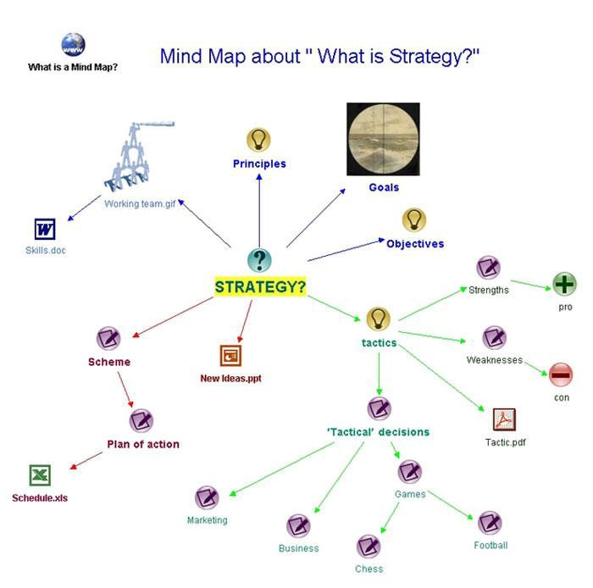

OpenLearn Labspace

There are a number of websites where you can get mind map software, e.g. Freemind, Inspiration, Thinkgraph, and Visual Mind. Some of these are free or freeware programs and others are commercial.

- Flash cards. If you have access to past exam papers or revision questions on LMS, you can copy and paste the question on one side and the answer on the other. This is especially useful for multiple choice questions. If you don’t have past questions or revision questions, you can create your own based on the topic areas you have studied.

(FRONT)
What is the highest court in the Australian judicial system?
- Supreme Court
- High Court
- County Court
- Magistrates Court
(BACK)

B. High Court

- Glossary. You may find you have many new terms to learn. Learning them gradually over the semester is the most effective way to remember them. Try keeping a small notebook where you can record new terminology for each of your subjects, as in the example below. Some of your first year subjects may have a glossary available on LMS or in your lab manual.

Term | Definition
Cost-benefit Analysis | an analysis of the cost effectiveness of different alternatives in order to see whether the benefits outweigh the costs
Globalisation | the process enabling financial and investment markets to operate internationally.

Reading for assessment tasks

Many assignments in first year require you to use ideas from sources such as books, and journal articles in your writing. It is very important that the information you use in your assignments comes from high quality, reliable, academic sources (see p. 28).
Information about finding and evaluating information sources can also be found on the Library website @ www.latrobe.libguides.com/libskills

Reading a journal article

As a first year student you are probably reasonably familiar with reading text books. Journal articles, however, may be unfamiliar and are more difficult to read. Journal articles (also called papers) in business, economics and law are written by experts for experts. They are published in journals which are usually available in both hard copy and online formats. Journals, such as those shown below, are collections of journal articles and are usually published several times a year.

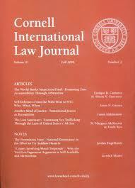

In business, journal articles are often structured around a problem or issue which the authors have investigated and developed new knowledge or theories as a result of their research.

Journal articles can be very difficult to understand at first year level. They often contain many technical terms and assume knowledge of complex concepts. When reading a journal article at first year, you are probably only looking for fairly basic information on a topic. You will rarely need to read the whole article in detail. It may be easier to start with review articles that give you an overview of a topic.

Target your reading

Before you begin reading a journal article, you need to stop and think about exactly what information you’re looking for. Different sections of a journal article will contain different types of information. The sections you will most likely need to read are the abstract, introduction and discussion.

Abstract
This gives you an overview of the whole journal article. It may provide some useful background information or give you a summary of the main findings related to the problem being investigated.

Introduction
You will usually find some background information in the introduction relating to what is already known about the problem being investigated. This section is likely to be the most useful place to look for information relating to your written assignments.
Method
This section has a variety of names, but is basically where you will find information about exactly what was done to gain knowledge about the problem. In an experimental paper, it usually describes the set up of the experiment, the materials used and the methods used. The method section is often very complex and difficult to read. This section may be of use if your assignment asks you to compare conflicting research findings about a particular problem. In this case, the methods section may provide information about the methods used which will enable you to evaluate which study finding is most likely to be more reliable. For most written assignments in first year, you will not need to read the methods section.

Conclusion
The discussion usually starts with a brief description of the main findings of the investigation. It then goes on to explain these findings in detail and compare them with the findings of other studies. You may find this section useful if you need to report on the current state of research about a particular topic.

Read and make notes

When reading a journal article, it is often a good idea to print it out and write comments and notes on the paper itself. Before reading and taking notes, it is very important to ask yourself, “What information am I looking for?” For example, if you have to write an introduction for a Law essay on homicide in Australia, you could ask the following questions:

  - Has urban crime increased or decreased since the introduction of harsher penalties?
  - What are the main types of crimes being committed?
  - Is there a correlation between urban crime and socio-economic status?
  - What can be done to decrease levels of urban crime?

When you read through the journal articles you have found, you should be searching for answers to these questions.

2

Writing in the La Trobe Business School and the La Trobe Law School

Writing styles in the Schools of Business and Law

Completing written assignments in the Schools of Business and Law requires different writing styles. You may find that there are different expectations and requirements for written assessments. For example, a Marketing report would have a different structure and language style to a legal Problem Question. Your subject guides will give you specific information regarding written assignment requirements for particular subjects.

The following are general features of good academic writing:

- Appropriate and relevant content

Writing in business, management and law subjects requires you to “stick to the topic‟. In essays, problem questions, literature reviews and short answer questions, everything you write must relate to the topic question. In essays and reports, everything you write in the introduction must be related to the thesis or problem statement and everything you write in your discussion must be related to your findings. You need to be careful not to “go off on a tangent” and start to present or discuss random ideas that are not related to the exact topic or question. Students often lose marks in assessment because they include irrelevant material that does not address the question. Tip! It’s a good idea to copy and paste the question on top of your assignment file, and refer to it regularly to make sure you are addressing all parts of the question.

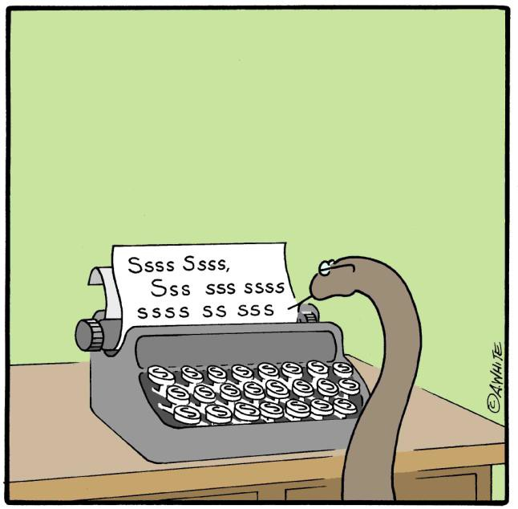

- Substantiated (supported) claims

In order to build a strong argument, claims made in academic writing need to be supported, usually with information from a reliable academic source.

Students get better marks in written assignments when they use good sources.

Students perform better in written assignments when they have used appropriate sources. Peer-reviewed journal articles, for example, tend to be more reliable and accurate than generalist texts.

- Use of high quality academic sources of information with adequate and accurate acknowledgement

It is VERY important to use reliable sources of information for your written assignments. For most (but not all) subjects, websites are NOT acceptable academic sources. Commercial (.com) websites are the most likely to be unreliable. The author of a commercial website is often not known and the pages may contain biased or inaccurate information. Ask your lecturer or tutor whether website information is allowed for a particular assignment.

When you use information from sources such as books and journal articles, you are using ideas that you did not create yourself. As these ideas belong to someone else, it is important to acknowledge the person or people who created the ideas. In academic writing, this is done by providing references to show where the ideas came from. Referencing at university is quite complicated and takes some time to learn.

There is a detailed guide to referencing in section 3.

For more information on finding credible sources and evaluating websites go to:
http://latrobe.libguides.com/libskills
To view the library’s short YouTube clip “Why can’t I just Google?‟ go to: https://www.youtube.com/watch?v=N39mnu1Pkgw

- Adequate and accurate paraphrasing of information

In addition to providing references, you also need to paraphrase information from other sources. This means you must put the ideas in your own words. This may seem strange and difficult at first, especially if the information is complex and hard to understand, but there are good reasons for paraphrasing. Paraphrasing shows the person who is marking your work that you understand what you are writing about. It also helps you to keep a consistent writing style. Every writer has their own style and your writing will flow more smoothly if all of the sentences are written in your own natural style. Even if you provide a reference, you still need to paraphrase information before you include it in your written assignment. If you don’t, you may be accused of plagiarism.

There is a detailed guide to paraphrasing and avoiding plagiarism in section 3.

- Appropriate academic style and language use (precise, concise, formal, clear)

  - Precise
Use specific terminology where appropriate

Good CEOs are always clear about what the company needs.

Effective CEOs are highly focused on the company vision, strategic goals and values.

Be careful with words like ‘it’ and ‘they’. Sometimes it is better to be specific about what ‘it’ is or ‘they’ are.

After the news the company’s shares went up.

The company’s market share rose by 4 points following the news about its merger with another company.

  - Concise – aim for maximum content, minimum words
If you are under the word count, you need to add more content rather than „pad out’ your writing with extra words. Adding ‘filler’ words will not get you any extra marks. It’s the number of ideas that are marked, not the number of words.

In my opinion, up until the present time, it is not really that clear what some of the effects might be of a manager’s behaviour on the morale of his or her employees.

The effects of managerial behaviour on employees’ morale are unclear.

  - Formal – avoid personal, emotional and colloquial (everyday) language
Avoiding personal language
It is advisable to avoid using personal language, particularly pronouns which refer to the reader e.g. you, your, us, our. It is sometimes acceptable to use I and we in academic writing, but this varies throughout the different scientific disciplines.

If you want to improve this workplace, you need to pay the employees more.
[informal]

Workplace satisfaction would increase with better remuneration of employees.
[more formal]

Avoid colloquial language
Colloquial language is everyday language which may be suitable when speaking, but should not be used in formal, academic writing.
Every day, more and more electronic stuff is chucked out and ends up in the tip. [informal]

Electronic waste is an increasing problem, with 75% of computers bought annually in Australia ending up in landfill (Australian Bureau of Statistics, 2006). [more formal]

Avoid emotional language
The use of emotional language may weaken an academic argument.

It is a disgraceful state of affairs that bank CEOs get huge salary bonuses at the end of the year, while sacking staff right before Xmas. [emotional & informal]

Many would argue that it is inequitable when bank CEOs receive financial bonuses at the expense of terminating workers’ positions. [more formal]

Avoid contractions
Formal, academic writing uses the full forms of words rather than shortened versions (contractions). NB This Guide is not a formal, academic piece of writing and so we have used contractions.

is not | isn’t
do not | don’t
will not | won’t

  - Clear structure and flow
Order points logically
This is important at the planning stage of your writing. It is very difficult to make a piece of writing flow well if the ideas are not presented in a logical order. Make sure you have one main unifying idea per paragraph and that the ideas within the paragraph lead logically from one to the next. Also take note of the order of paragraphs so that there is a logical progression from one main idea to the next.

Link ideas within and between paragraphs
Good flow in a piece of writing can be achieved by making clear links between your ideas and also making it clear how each main idea is related to the topic. Where possible, linking words and expressions should indicate the relationship between ideas. For example if you want to show that a second sentence is a result of the first sentence, you could start the second sentence with “as a result‟.

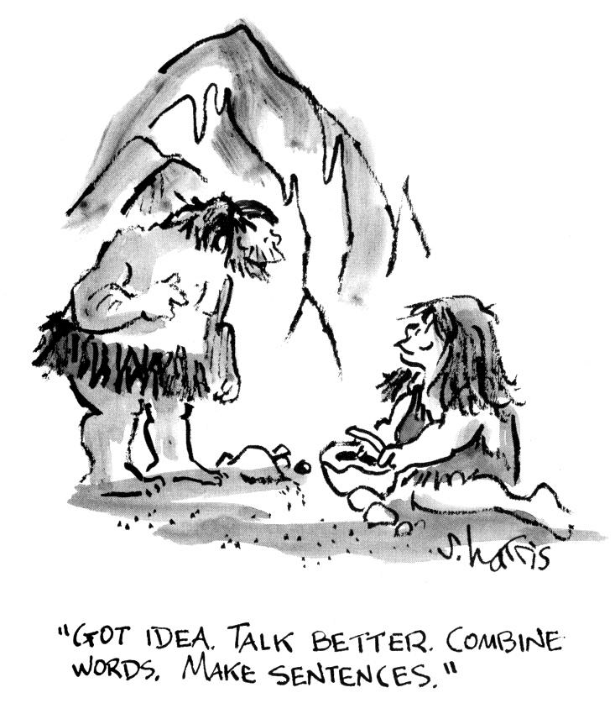

The following table gives a brief list of linking words and expressions.

Function | Linking word examples | Examples in sentences
Similarity | Similarly, Likewise,  In a similar way, A similar study… | Similarly, accountants are bound by ethical considerations …  A similar study also found a correlation between …
Contrast | In contrast, Conversely,  On the other hand, (less formal)  While…, … Although…., …  ….; however,…  ….However,… | In contrast, the British Court ruled against sentencing the perpetrator.  While there was strong evidence to suggest the crime scene had been interfered with, no investigation took place.  Although the design was adequate, insufficient planning had gone into the implementation stage.  There was an increase in the number of part- time jobs; however, there was no change in…
Cause → Effect | X causes Y X leads to Y X results in Y X leads to Y  X brings about Y As a result of  Because of X, …Y happened  Due to X, … Y happened Owing to X, … Y happened  As X happened, Y happened  Since X happened, Y happened  Because X happens, Y happened | A rise in house prices causes market demand to fall.  Absence of regular work meetings can lead to breakdown in communication channels..  As a result of the legal ambiguity, the jury was asked to reconsider the matter.  Due to a substantial rise in its profits, the company decided to expand..  As reckless corporate behaviour was not addressed by government regulators, a second global financial crash occurred.  Since there was no significant change in the company culture after the new manager was appointed, the CEO decided not to confirm his probationary period.

Function | Linking word examples | Examples in sentences
Effect → Cause | X results from Y  X was caused by Y X may be due to Y X could be a consequence of Y | High employee turnover results from a number of factors, including poor morale.  High rates of absenteeism could be a consequence of poor upward communication channels..
Additional point | *Moreover,  Furthermore, In addition, | Moreover, employees are more likely to remain in a job if they feel valued.  In addition, high remuneration does not always guarantee employee satisfaction..  * These linking words should be used infrequently. It is not necessary to have a linking word between every sentence. It is also much better to use more specific linking phrases e.g. “A further disadvantage is…”
Chronology (time order) | First, Firstly, After that, Then, Next, | A manager should first determine the cause of employee dissatisfaction.  After that, he or she should take steps to address each issue.  A plan should then be drawn up to implement the necessary changes in workplace culture.
Summary | In conclusion, To sum up,  In summary, In short, | In conclusion, intrinsic motivation is more likely to occur when employees feel valued and adequately rewarded.
Example | For example, To illustrate,  …such as… | For example, Truvalue Food Limited experienced high absenteeism in its employees until the company changed its culture.
Purpose | To  In order to So that So as to | A questionnaire was distributed to ascertain employee views.  The questionnaire was distributed in order to ascertain employee views.  The questionnaire was distributed so that  employee views could be ascertained.

Common grammar errors

In order to understand simple grammar errors, you need to know a little bit about basic sentence structure.

What is a sentence?

In order for a sentence to be complete it must usually contain a subject and a verb. A sentence must also convey a complete thought. For example, “A student is.‟ contains a subject and a verb but doesn’t express a complete thought. It doesn’t convey any information and is thus not a complete sentence.

The subject says who or what does the action e.g. “who wrote?‟

The verb is the “doing word‟ and describes an action or state.

For example,
The students
(subject)
wrote.
(verb)

A simple sentence can also have other elements:

An object answers the question „what‟ after the verb e.g. “wrote what?‟

The students
(subject)
wrote
(verb)
a report.
(object)

A complement says what something is/was etc.

For example,
The students
(subject)
were
(verb)
confused.
(complement)

An adverbial tells us how, when, where, or why.

The students wrote their reports carefully.
(subject) (verb) (object) (adverbial - how)

Eventually, the students wrote their reports carefully. (adverbial - (subject) (verb) (object) ( adverbial - how) when)

Notice that we use a comma when the adverbial element comes before the subject.

Some of the most common grammar errors
    - Comma splice error

A comma splice error occurs when two complete sentences are joined together by a comma. For example:

The benefits of this kind of corporate strategy are substantial, there are relatively few negative corollaries.
Comma splice errors are quite common, particularly for native speakers of English. They often result from the desire to avoid writing short sentences. A comma splice error can be fixed in different ways, depending on the length of the sentences.

      - If the two sentences are short, it is best to join them with a conjunction („joining word‟) such as “and‟, “so‟, or “but‟, as in the following example:

The benefits of this kind of corporate strategy are substantial, and there are relatively few negative corollaries.

      - If the two sentences are short and they are of equal grammatical weight and value, it is best to use a semicolon.

The benefits of this kind of corporate strategy are substantial; there are relatively few negative corollaries
      - If the two sentences are already rather long, it is better to put a full stop between and have two separate sentences.

The reported benefits of this kind of corporate strategy are substantial, particularly when used in conjunction with more traditional approaches to employee relations. Additionally, there are relatively few negative corollaries and these are generally low-risk.

    - Run-on sentence

Run on sentences are the same as the comma splice errors described above, except that there is no comma placed between the two sentences. These are less frequent than comma splice errors and can be fixed in the same way.

The benefits of this kind of corporate strategy are substantial there are relatively few negative corollaries

    - Sentence fragment

A fragment is an incomplete sentence. Fragments may be missing a verb or a subject or they may not convey a complete thought.

The benefits of this corporate strategy.

Example of a fragment that has a subject and a verb but does not express a complete thought.

Because the lemming was heading towards the cliff. ⇦ FRAGMENT

The above fragment contains a subject and a verb, but it does not contain a complete thought. We have the reason for something, but we don’t have the “something‟. This
is the most common form of fragment error. The word “Because‟ at the beginning has turned a complete sentence (“The lemming was heading towards the cliff.‟) into a fragment, which requires another part to be a complete sentence.

To correct this sentence it needs another part. For example:

Because the lemming was heading towards the cliff, others decided to follow.

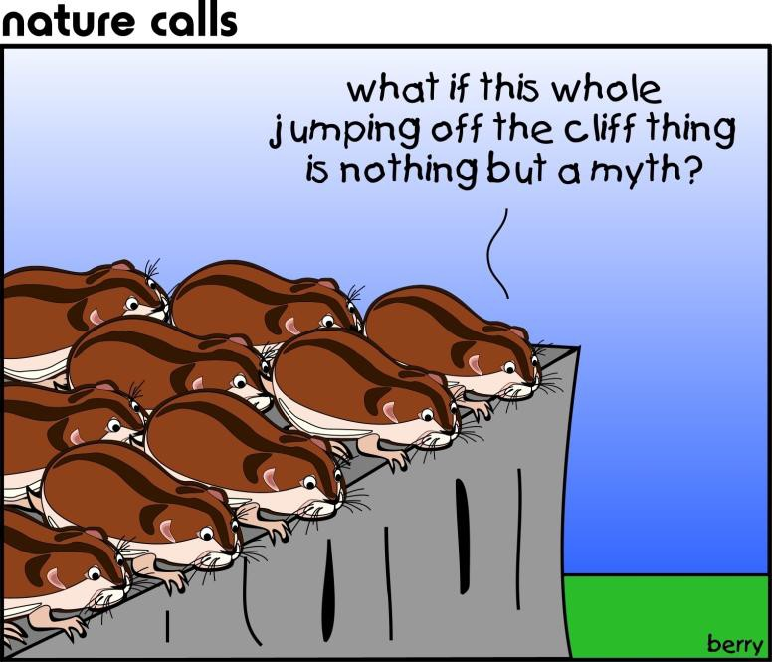

There are many words similar to “because‟ that when used in this way, require another part to make a full sentence. Some examples are given in the table below. Don’t be confused. This doesn’t mean that you can’t start a sentence with “Because‟ (a common urban grammar myth!). You can start a sentence with “Because” as long as you make sure to include the other part of the sentence.

 | Fragment example
because | Because checks and balances were not implemented at regular intervals.
although | Although the company was not solvent.
whereas | Whereas its competitor was struggling.
since | Since there were no other parameters.
unless | Unless future studies find otherwise.

All of the fragments in the above table could be corrected by adding another sentence part with a subject and a verb.

Example of a fragment with no verb or subject

Being a very headstrong and independent lemming with a mind of her own.

This fragment does not contain a full verb or a subject. The word “being” at the beginning of the sentence looks like a verb, but it is really only part of one. To be a full verb, an –ing word needs to be combined with a “helping verb” such as am, is, are, was or were. (e.g. The lemming is being stubborn). To fix the fragment in the above example, another part needs to be added to make it a complete sentence.

Being a very headstrong and independent lemming with a mind of her own, Fifi did not join the others in their rush towards the cliff.

Here’s another example of a fragment.

At the edge of the extremely steep cliff near a group of boulders.

The example above is a fragment because it only tells us the “where” part of the sentence. It does not contain a subject or a verb. We don’t know who is doing what. The fragment needs another part to make it a complete sentence.

At the edge of the extremely steep cliff near a group of boulders, the lemmings gathered for a brief, final meeting.

    - Subject verb agreement

In English grammar, subjects must ‘agree with’ verbs. We use different forms of verbs for different types of subjects. The following table gives some examples.

subject | example of subject | verb | object
I | (I) | like | learning grammar. that game.  doing it.  chocolate.
You | (You)
We | My friends and I
They | The people in the pub
He | That guy in our office | likes
She | The woman in the photo
It | (Even) my dog

Subject verb agreement with the verb “to be” is a little more complicated.

subject | example of subject | verb (to be) | complement/adverbial
I | (I) | am | a great example. extremely unreliable. in the right place.
You | (You) | are
We | My friends and I
They | The people in the pub
He | That guy in our office
She | The woman in the photo

It | (Even) my dog | is | Intoxicated.
Making subjects agree with verbs is fairly easy when the sentence is short and the subject is right next to its verb. However, when sentences are long and complex, subject verb agreement can be more difficult, as in the following example.

Punctuating long sentences, such as the ones in the following examples,
cause difficulties for many writers. (verb)

Punctuating long sentences, such as the ones in the following examples
causes difficulties for many writers. (verb)

In order to check whether the subject agrees with the verb, you first need to identify the main verb in the sentence (“cause‟ in the sentences above) and then ask who or what causes difficulties? The answer is “punctuating‟. Punctuating = “it‟, so we need to use the verb form with the “s‟ i.e. punctuating… causes difficulties…

Errors also frequently occur when the sentence starts with “there is/are‟.

There is not many studies which have investigated the science of navel gazing.

There are not many studies which have investigated the science of navel gazing.

    - Problems with commas

Few people writing in English know how to use commas correctly. A lot of the time, this doesn’t matter as many sentences “requiring” a comma can be easily understood even without the comma. However, there are some instances where a sentence becomes ambiguous, or even unreadable, without a comma.

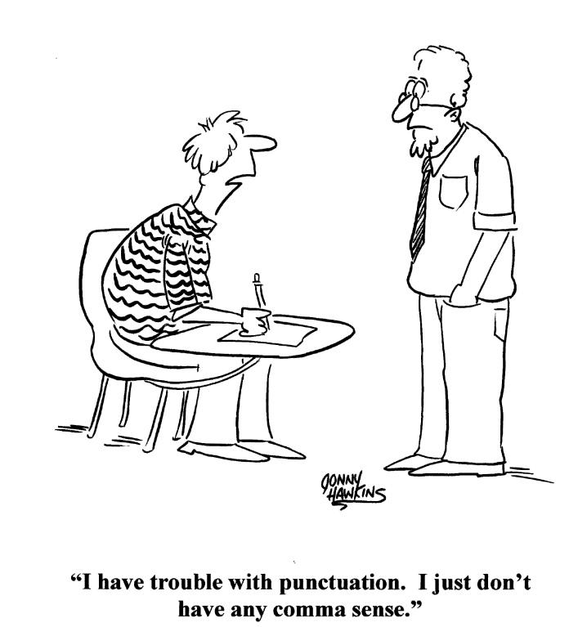
Example 1

I told them to eat, Lucy. I told them to eat Lucy.
The difference in punctuation is small, but the difference to Lucy is considerable.

Example 2
When we finally finished the meeting had already begun.

When we finally finished, the meeting had already begun
(introductory bit) (main part of sentence)

The first sentence is difficult to read because it may seem like the meeting was finished. In the second sentence, the comma after the introductory bit makes the meaning much clearer. The introductory part of the sentence is not a full sentence on its own. If there is an introductory bit at the beginning of a sentence, it‟s a good habit to always place a comma between it and the main part of the sentence.

Example 3

In the court reports were made about people altering accounts to escape prosecution.

In the court, (adverbial) reports were made about people altering accounts to escape prosecution (main part of sentence)

This is similar to example 2. The first sentence is difficult to read and its meaning is not clear because the words “court” and “reports‟ are often used together as a

compound noun. In the second example, a comma separates the adverbial element
“in the court‟ from “reports‟ and so makes the meaning of the sentence clear.

Example 4
Recent studies on the sustainability footprint of multinational companies, suggest that environmental values are not deeply entrenched.
Recent studies on the sustainability footprint of multinational companies suggest that environmental values are not deeply entrenched.
Do not use a comma after the subject of a sentence. When the subject of a sentence is very long, you may feel that you need to put a comma between the subject and the verb. This is not correct.

    - Parallel structure

Problems with maintaining parallel structure often occur when constructing lists, either as dot points or within a sentence. Items in a list should be the same type of word in terms of grammar, for example, a list of nouns or a list of verbs. The following examples should illustrate.

The objectives of this review are:

      - Outlining the main conceptual areas behind the science of navel gazing
      - To give an account of the controversy surrounding the benefits of navel gazing
      - The different ways to navel gaze

Each of the dot points has a different grammatical form. To give the items in the list parallel structure, they should have the same grammatical form as in the list of verbs (actions) below.

The objectives of this review are to:

      - outline the main conceptual areas behind the science of navel gazing
      - give an account of the controversy surrounding the benefits of navel gazing
      - describe the different ways to navel gaze.

    - Apostrophes

Apostrophes are notoriously difficult to use correctly. There is even a website showing examples of “apostrophe abuse‟ on signs from around the world: www.apostropheabuse.com/

However, once you know the rules, it’s really not that hard. Apostrophes are used for two main reasons:

1. To denote a missing letter

When we put two short words together, we use an apostrophe to show that a letter is missing. It is not common to use these shortened forms in academic writing. Here are some examples.

do not | ⇨ | Don’t
is not | ⇨ | Isn’t
you are | ⇨ | You’re
it is | ⇨ | It’s
we are | ⇨ | We’re

We do not use an apostrophe to make an abbreviation or acronym (e.g. CD, USB, ATM) plural. Also, we do not use an apostrophe when making years plural. So,

CD’s | CDs
USB’s | USBs
ATM’s | ATMs
1960’s | 1960s
90’s | 90s

To denote possession

Apostrophes are used to show possession or ownership of something, as in the following examples. Note that the apostrophe is placed after the “s‟ if the noun is plural. We can also use pronouns in place of the noun. The table below contains some examples.

singular nouns | pronoun | plural nouns | pronoun
The student’s writing | his/her | The students’ writing | their
The paper’s references | its | The papers’ references | their
The bee’s knees | its | The bees’ knees | their
The computer’s functions | its | The computers’ functions | their
Robyn’s office | her | n/a | n/a

We do not use apostrophes before an ‘s’ in plural nouns where there is no possession. Thus the following are incorrect.

SALE

Sofa’s only $199
For 3 day’s

only!

A point of confusion

The words that cause the most confusion when using apostrophes are it’s and its.

It’s – the apostrophe denotes a missing letter (i.e. short form of it is)
Its – is used to show possession but has no apostrophe (e.g. Its ears are big).

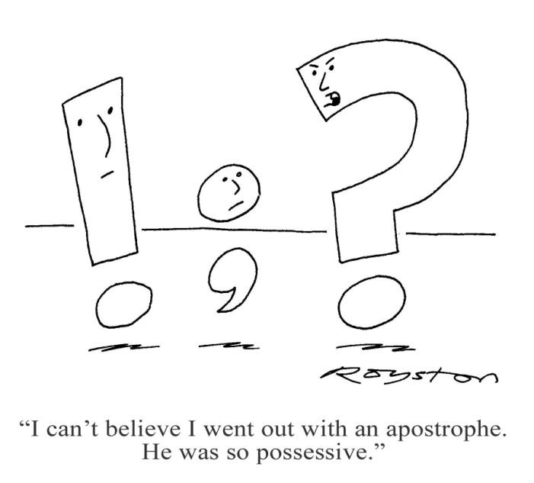

Commonly confused words
The English language can be very confusing, so it’s hard to avoid mistakes. Some commonly confused words are listed below.

word confusion | explanation
effect/affect | Effect is usually a noun.  e.g. There was no discernable effect on company morale.  Affect is usually a verb (action).  * remember ‘a’ for action & affect  e.g. Company morale was not discernably affected.
would of/would have | ‘Would of’ is incorrect. ‘Would have’ is correct.  The experiment would of worked. The experiment would have worked
few/less | Use few or fewer with ‘countable’ nouns.  e.g. There were few errors.  Use less with ‘uncountable’ nouns.  e.g. There was less evidence than he had hoped for.
comprise/consist | Use comprise without ‘of’.  e.g. A partnership comprises several elements ). Or: “…is comprised of several elements”.  Use consist with “of‟.  e.g. A partnership consists of several elements
its/it’s | Use it’s as a short form of “it is‟  Use its as a possessive (see p. 41)
practice/practise | Practice is a noun.  e.g. I need more practice with this technique.  Practise is a verb.  e.g. I need to practise this technique.

Singular/plural & Non-count confusion

Some commonly used words in business, economics and law have irregular plurals that can be confusing. The table below gives some examples.

Singular | plural
hypothesis | hypotheses
criterion | criteria
phenomenon | phenomena
thesis | theses
datum | data
medium | media
appendix | appendices/appendixes (both correct)
evidence | evidence (non-count)
stimulus | stimuli
index | indices/indexes (but different meanings)
analysis | analyses
axis | axes
research | research (non-count)
basis | bases
diagnosis | diagnoses
parenthesis | parentheses

A word about Microsoft Word grammar checker and spell checker

Automatic spelling and grammar checkers are not as accurate as a human editor, and given the current state of technology, the Microsoft

Word spell checker and grammar checker make mistakes, particularly the grammar checker. For example, the grammar checker often misses subject verb agreement errors or identifies a sentence as containing an error when it doesn’t, in fact, have one. Grammar checkers are useful for writers who have a knowledge of correct grammar. They can alert the writer to inadvertent mistakes and typos, but ultimately, it is the writer that makes the final decision whether to accept or reject the suggestion.

3

Referencing and Paraphrasing

(How to Avoid Plagiarism)

Introduction
Using references in your writing enables readers to check your ideas or follow up your sources for themselves and also gives due credit to the person/people who produced the original information. Ideas are a kind of “intellectual property‟, owned by their creators. Therefore, when you use someone else’s idea in your writing, it is important to clearly show the difference between your own ideas and theirs. If you do not make this difference clear, you may be accused of plagiarism. This is a serious academic offence and may result in failing an assignment or even a whole unit. A further reason for using references in your writing is to give your assignment weight and authority and back up your arguments.

When you use information from sources, most of the time you need to put it in your own words (called paraphrasing). The person who marks your writing will want to see evidence that you have understood the concepts you are discussing. Writing something in your own words shows that you have understood what you are writing about. Paraphrasing also helps to give your writing a consistent style as you blend your own sentences with paraphrased information from other sources into your own personal style.

This section aims to show you how to reference correctly and to provide guidance in paraphrasing and avoiding plagiarism. It is specifically targeted at first year students, but you may find it a useful reference for other year levels.

In the Business School and the Law School, there are a number of referencing systems, including the Australian Guide to Legal Citation (Law students), APA, Academy of Management and Harvard. Check your subject learning guides to find out what referencing system you should use, and try the Academic Referencing Tool on the library website, which gives detailed examples of different referencing styles in the La Trobe Business School and the La Trobe Law School..

The examples below use APA referencing.

Referencing
There are two places where references need to be included in a piece of writing:

- In-text references (citations) - in the text of your writing
- Reference list - at the end of your writing (before the appendix)

Every source (e.g. text book, journal, electronic source) that you cite in your report (in-text references) must be included in the reference list and every reference included in your reference list must be cited in your report.

It is VERY IMPORTANT to use the correct format for in-text references and reference lists. There are hundreds of different referencing styles. In a number of first year subjects in the School of Business, you are expected to follow the APA style of referencing, but please check with your School to find out what referencing system you are expected to use. In second year and beyond, you may be expected to use a different style of referencing. You should always check the

referencing style required for all written work submitted. To find out more about referencing, please go to http://www.lib.latrobe.edu.au/arm/

For more information on the APA referencing style and other referencing styles used at La Trobe University, go to the Academic Referencing Tool: http://www.lib.latrobe.edu.au/referencing-tool/

In-text references

Every idea that is not your own (e.g. information from a book or journal article) needs to include an in-text reference (also called a citation) to show where the idea came from. Even if you have put the information in your own words (paraphrased) you must still provide an in-text reference.

General Rule

In-text references in APA format give the author’s surname(s) and the year of publication. Note that there is always a comma after the author’s name and before the year, and that the full stop is positioned after the citation. When authors’ names are used as part of your sentence, the word “and‟ is used to separate the last author. For citations within parenthesis, the ampersand (&) is used to separate the last author.
Smith and Hoover (2010) found that business motivation decreased with surveillance.

There is some evidence that business motivation decrease with surveillance (Smith & Hoover, 2010).

Author or idea focus?

In-text references can either focus on the author or the idea, depending on which is the most important. In first year, you will probably focus more on the idea than the author. Author focused referencing is more commonly used when citing important research or experimental work. The following examples show these two types of in- text reference.

Idea focus

Example:
Very little is known about the factors that enable or constrain new companies in the creation of jobs (Shane, 2003; Dencker, Gruber & Shah, 2009).

Author focus

Example:

Shane (2003) and Decker, Gruber & Shah (2009) found that very little is known about the factors that enable or constrain new companies in the creation of jobs.

Using et al.

If a piece of work has three, four, or five authors, list all authors in the first citation. In subsequent citations, include only the first author followed by the Latin abbreviation et al. (short for et alia, meaning “and others‟). Note there is always a full stop after “al‟ and that it is not necessary to use italics for “et al.‟ in APA format.

Example:
In this regard, Bowen et al. (2000) note that more than 90%
of performance appraisals in organizations are conducted by supervisors.

If a piece of work has six or more authors, apply the et al. rule for all citations. Write the name of the first author followed by et al. (as above).

If multiple references shorten to the same form, cite the surnames of as many authors required until the references can be distinguished. This may mean citing the first two, or occasionally three, authors followed by et al.

Same idea from more than one source

Sometimes you may find the same idea in two (or more) sources. After you paraphrase the idea, you may be unsure about which source to cite. The simple answer is to cite them both. When doing so, order the citations alphabetically, based on the first author surnames. Do not change the order of authors within a piece of work. Separate the citations with semicolons.

Example:

Integrative complexity has also been positively related to moral development (deVries & Walker, 1986; Sullivan, McCullough, & Stager, 1970) and to trade-off reasoning (Tetlock, Peterson, & Lerner, 1996), both of which have obvious implications for ethics and corporate social performance (Hemingway, 2005).

Secondary citations

Sometimes, you may want to use a piece of information that another author has cited from a different source. If the source you are reading contains citations from another source, the ideal thing to do is to find that original source, read it, paraphrase the relevant information and cite the source. Sometimes, it is not possible to find the original source and you may have to secondary cite the source. A secondary citation

contains the original author and the year plus the secondary author (where you read the information) plus the year.
Example:

In-Text Citation (Quotation):
“However, it emerged that these findings were highly contentious” (Jones, 2008, as cited in Brownwood, 2010, p. 623).

Reference Lists

As well as using in-text citations, you must also include a reference list at the end of your piece of work. A reference list is different from a bibliography, which lists all works read, whether or not they are cited in your work. A reference list contains only those works that you have cited in your writing.

In APA referencing style, (commonly used in Business, and Economics) references are listed at the end of your piece of writing, in alphabetical order of the first authors’ surnames (A – Z). Do not change the order of authors’ name in a particular source. Reference lists should be single spaced with a single line space between each reference, and a hanging indent. The format of the reference list depends on the type of source you are citing. It is important to carefully note all details such as the order of details, when to use italics, where to put full stops and commas, capitalisation of words, and parentheses.

Below is a sample reference list. If you look carefully, you will notice that there are slight variations in the format for references from different types of sources. There are different formats for books, book chapters, journal articles, online sources.

References

BOOK

In-text citation | Reference List
One author  …(Ryan, 1997).  Ryan (1997) suggests that… | author’s author’s year of title of book surname initials publication (in italics)  place published  Ryan, T. Y. 1997. Modern regression analysis. New York Wiley.  publisher
Two authors  *…(Tabachnick & Fidell, 1996).  * Tabachnick and Fidell (1996) argue that… | Tabachnick, B. G., & Fidell, L. S. (1996). Using multivariate statistics. New York: HarperCollins College.

Three to five authors  …(Hersey, Blanchard & Johnson, 2009).  Hersey, Blanchard & Johnson (2009) define …* apply the et al. rule after first citation | Hersey, P., Blanchard, K.H. and Johnson, D.E. (2001) Management of Organisational behavior : leading human resources. Prentice Hall  Note: if a book has more than one edition, you need to state the edition.

JOURNAL ARTICLE (available in both hard copy and electronically)

In-text citation | Reference List
One author  …(Chatterjee, 2009).  Chatterjee (2009) asserts that these figures are contentious. | Author’s Author’s Year of Title of surname initials publication journal article  Chatterjee, S. (2009). The keys to successful acquisition programmes. Long Range Planning, 42(2): 137–163.  Volume Title of journal Pg. numbers (in italics)  Issue
Two authors  Jepsen and Rodwell (2009) conclude that … | Jepsen, D. M., & Rodwell, J. J. (2009). Justice in the workplace: The centrality of social versus judgmental predictors of performance varies by gender.  International Journal of Human Resource Management, 20, 2066-2083.

CHAPTER IN AN EDITED BOOK

Some books have different chapters written by different authors plus an editor or editors.

In-text citation | Reference List
One author  The author of the chapter is cited  …(Ryan, 2005).  Ryan (2005) contends that…  Multiple authors The same rules as for books (shown above) apply when there are multiple authors for chapters. | Chapter Year of  author’s publication surname Title of  Initials chapter In  McKay, P. F. (2009). Perspectives on adverse impact in work performance: What we know and what we could learn more about. In J. Outtz (Ed.), Adverse impact: Implications for organizational staffing and high stakes selection: 249-270. New York: Routledge  Editor’s Title of  Name(s) book (in italics) Page. numbers  Publisher Place  published  * When the author and publisher are the same, use the word  Author as the name of the publisher.

ENCYLOPEDIA ARTICLE

In-text citation | Reference List
...(Burton, 2011)).  Burton (2011) conducted… | "Bartering." Encyclopedia of Small Business. Ed. Virgil  L. Burton, III. 4th ed. Vol. 1. Detroit: Gale, 2011. 109-  111. Gale Virtual Reference Library. Web. 21 Feb. 2012.

WEBSITE

Electronic sources, particularly websites, should be used cautiously. Not all information found on the Internet is reliable. Websites with URLs that end in .com are commercial sites and may not be reliable (they may contain bias or inaccurate information). If you are unable to identify the author (person or organisation) or the date of an Internet source, it is less likely to be reliable, and probably should not be used as a source in your writing.

To learn more about how to find, evaluate and reference Internet sources see the following web tutorial:
The Internet Detective
http://www.vtstutorials.ac.uk/detective/

Wikipedia can be a useful source of background information in the initial stages of researching a topic. However, because the authors of the information are not identified, it is advised NOT to cite Wikipedia in lab reports, assignments, essays etc.

If possible, a reference to an Internet source should include:
- The author of the document (this is often an organisation rather than an individual)
- The year of publication or most recent update
- The title, or a description of the document
- The date the document was viewed if the information is likely to change
- Either
  - The URL (i.e. http//www….) or;
  - The DOI (i.e. 10. xxxx/xxxx-xxxx.xx.x.xxx)

WEBSITE

In-text citation | Reference List
Person as author  …(O’Neil, 2009)  O’Neil (2009)  describes…  Organisation as author  …(Center for Bioethics, 2009).  The Center for Bioethics (2009) states that… | Person as author  O’Neil, D. (2009, September 7). Mendel’s genetics [Online fact-sheet]. Retrieved May 27, 2010, from  http://anthro.palomar.edu/mendel/mendel_1.h tm  Organisation as author  Center for Bioethics (2009). Ethics and Pharmaceutical Marketing. Retrieved November 19, 2010, from http://www.ahc.umn.edu/bioethics/research/phar m/home.html

THESIS

In-text citation | Reference List
…(Pecore, 2004).

Pecore (2004) studied…

GOVERNMENT PUBLICATION

In-text citation | Reference List
Author identified:  Withers (2011) identified  …  No author identified  External Reference Group (2008).  The External Reference Group (2008) lists… | Author identified:  Withers, G. (2011), Defining quality for research training in Australia. Universities Australia, Canberra, Australia.  No author identified  According to the External Reference Group (2008), “As the Australian industry faces increasing labour market pressures, broader labour market skills strategies …”

ONLINE BOOK

In-text citation | Reference List
…(Lee & Epstein, 2011)  Lee and Epstein (2011) define a…as… | Lee, J.Y. and Epstein, M. (2011), Advances in Management Accounting, Emerald Group Publishing Limited, Bradford, ISBN: 9780857248183. EBL Reader version, Retrieved from: http://ez.library.latrobe.edu.au:2071.  *  For an electronic-only book, remove the reference to the format, and simply follow the book title (with edition) with the URL, or DOI if available.

PERSONAL COMMUNICATION

In-text citation | Reference List
(R. I. Sanders, personal communication, September 3, 2010).  R. I. Sanders (personal communication, September 3, 2010)... | Personal communications such as conversations, emails, phone calls and memos do not provide recoverable data, and therefore they are not included in the reference list.

NEWSPAPER ARTICLE (hard copy)

Newspaper articles are not usually considered scholarly sources of information for academic writing. Occasionally, their use may be justified, but in general, it is better to find a more reliable source of information.

In-text citation | Reference List
(Davidson, 2010)  Davidson (2010) argues that the business environment is “likely to be unstable for the next 18 months (p. 6) | Davidson, J. (2011, November 12). Business woes set to continue. The Age, p.19.

NEWSPAPER ARTICLE (online)

In-text citation | Reference List
"China, for instance, is targeting...over 15 years"  (Gittens, 2010, p. 17). | Gittins, R. (2010, November 17). Suits us to be deluded on climate. The Age. Retrieved from http://www.theage.com.au

Frequently Asked Questions about Referencing

If I write something in my own words, do I need to provide an in-text reference?

Yes, we reference ideas, not just the words used to express them, so you need to show where the original idea came from. Most sentences without a reference are considered to contain your own ideas, so you must make it clear whether your sentences contain ideas that are your own or someone else’s.

Does that mean I need to provide a reference for nearly every sentence?

Yes, in first year it is likely that you will not have a great deal of your own knowledge of the subject matter, so most of the information you use in your writing will come from other sources and thus will need a reference.

When can I ‘own’ an idea and so do not have to provide a reference for it?

This is a very tricky question. There is not always a clear dividing line between what constitutes your own knowledge and what is knowledge from others and hence

needs to be referenced. It can sometimes be difficult to decide whether you need to put a reference or not. As you progress through your studies your own knowledge base will increase and you will be able to express much more information without needing to look it up in a reference. In first year, there is very little information that you can “own”, so it is usual for first year pieces of writing to contain many more references than, say, a postgraduate piece of writing.

Can I summarise from one source into a paragraph and just put the reference at the end?

No, if you do this, you may be accused of plagiarism. Any sentence which cannot clearly be attributed to another author is considered to be your own. A person reading your work would have no way of telling which sentences in the paragraph were your own and which came from another source. It is actually not good style to take large slabs of information from a single source. It is much better to synthesise information from several sources.

Can I reference lecture notes?

It is not good practice to cite your lecture notes. It is better to find the same information in a text book.

Paraphrasing

How to paraphrase

Many students find paraphrasing difficult. In order to paraphrase well, you must first understand what you are reading. Poor paraphrasing is often the result of poor understanding of the text. Some students try to paraphrase at the sentence level rather than the ideas level. Just changing a few words and shifting parts of the sentence around may not result in a good paraphrase. A better way to paraphrase is to read a section of the text, write down a few key words that summarise the main idea(s) and then build up a sentence in your own words without looking back at the original sentence(s).

Example 1

Original text

According to Chenhall (2003), “The extent to which these archetypes, which were developed in the 1970s and 1980s, maintain their relevance to contemporary settings is questionable (Kotha & Vadlamani, 2013; Miller & Roth, 2010; Shortell & Zajack, 1990), (p. 152).

Paraphrase

Several scholars, including Chenhall (2003), Kotha and Vadlamani (2013), Miller and Roth (2010), and Shortell and Zajac (1990), have questioned the utility of using strategic archetypes developed in the 1970s and 1980s for studying 21st century phenomena (Adler, 2011, p. 252).

Paraphrase or quote?

If you need to use the exact words of the original, then you can use a direct quote. To show that it’s a direct quote, use quotation marks to enclose the quoted text and include the page number.
Quotations are generally used sparingly in Business School subjects, and long quotes are used infrequently. Short direct quotations can be used very effectively, but you must have a good reason to use a quote. Being unable to write a better sentence than the original is not a good reason. Your lecturers are more interested in your understanding rather than your ability to locate the perfect quotation, so it is much better to put the information into your own words and then reference it.
Sometimes, however, the exact words may be important, as in the following example from Charles Darwin’s Origin of Species.

Example
“I have called this principle, by which each slight variation, if useful, is preserved, by the term of Natural Selection” (Darwin, 1859, p. 61).

Plagiarism

If you do not reference or paraphrase correctly, you may be accused of plagiarism. This is a serious academic offence. The La Trobe University Academic Misconduct Policy (2008) explains that “There are many forms of plagiarism, including the following:

- direct copying of sentences, paragraphs or other extracts from someone else‟s published work (including on the Internet and in software) without acknowledging the source;

- paraphrasing someone else‟s words without acknowledging the source;

- using facts and information derived from a source without acknowledging it;

- using ideas directly derived from an identifiable author without acknowledging the source;

- producing assignments which should be the student‟s own, independent work in collaboration with and/or using the work of other people (e.g. a student or tutor).”

La Trobe University. (2008). Academic Misconduct Policy. Retrieved from http://latrobe.edu.au/learning/integrity.html

BEFORE YOU SUBMIT YOUR FIRST PIECE OF WRITTEN WORK, YOU MUST READ THE INFORMATION ABOUT PLAGIARISM ON THE FOLLOWING WEB PAGE.
READ THIS!
http://www.latrobe.edu.au/students/learning/academic-integrity

4

Guidelines for
Assessment Tasks

Case studies Reports Essays
Oral presentations Teamwork

Case studies

When studying in the Business and Law schools, you will encounter case studies. There are many different kinds of case studies, and you need to be aware of the particular demands within subjects. The subject guide, the lecturer and/or the tutor are the best sources of information about what is expected.

Many of the text books in Management, Marketing and Human Resource Management provide examples of case studies. They can be quite short- a half page or even a paragraph or they can be much longer and more detailed. Usually case studies provide information about real companies and the challenges they face and the strategies they employed to deal with those challenges. These case studies provide students with insight into the ways theories and models of best practice can be used to solve real life problems.

When you are asked to work on a case study you are expected to relate the theories you have read in books and the information gained in lectures to practical situations. The purpose of a case study, whether it is long and involved or just a short paragraph is to encourage students to analyse a situation using the tools of their discipline. So while you are thinking about the particular practical problems being faced by a manager or an HR practitioner , you are also thinking about the theories and the research and attempting to apply that knowledge and understanding to the situation in the case study.

Different kinds of case studies.
Some lecturers provide short scenarios and a list of questions to be answered in dot point form in a table. Some require you to write in complete sentences. Other lecturers ask for assignments in report format of 1,000 words or more which require students to do some secondary research such as obtaining demographic data from the Australian Bureau of Statistics, for example, to help decide whether a particular business venture is well targeted. Another variation is to invent an imaginary scenario and to ask students to respond as if they were professionals in the discipline and provide advice. Many text books provide examples from real companies which have faced challenges and students need to examine these in detail. Sometimes a lecturer will ask students to draw on personal experience as a basis for a case study. Since most students work part-time or have experience of part-time work this is a popular way of asking students to apply what they have learned to real-life, practical situations.

Whatever the length or structure of the case study, the underlying purpose is the same. You are being asked to analyse a situation and provide some strategies for action based on theoretical knowledge and understanding.

Approaching the case study analysis.
Again it is worth noting that there is great diversity in the kinds of activities labelled as case studies. In the first instance you should read the instructions very carefully and think about the context of the task. If the case study is in a Law subject for example, the response will need to be in a particular format and style which will be different from a case study in Marketing or Management. However, the intellectual processes may be very similar.

The steps towards an analysis of a case study.
Firstly, you should read the case through more than once. The first read through is to gain an overall impression of the situation. When you read a second time you should have a pen in hand and identify key words/concepts/issues/people. You may have to imagine yourself in the shoes of a manager or think about the case from various perspectives: eg. the workers, the union, the management, the CEO, the customers.

The next step
Identify the main problem, being careful to separate the symptoms from the causes. Unmotivated workers could be symptoms of a problem with job design or decision making. Decide which is the relevant information and make some notes. You may want to refer to class notes, the text book, slides or other sources of information at this stage.

Next

Organise your notes under some sub-headings or in response to questions that you ask yourself.
Context: what kind of company is this? Was it doing well? What has changed?
What is likely to happen if nothing changes? Who are the key people?
What is it possible to change and what is beyond change?
What are the central issues facing the company/organisation/person?
Can the situation be improved by using the existing people or is outside help required?
What are the theories or concepts which underpin the possible responses to this situation?
Would a SWOT analysis assist you to identify all the details you need to consider?
Do you need additional information?

Before you write.
What format is required? Some lecturers will specify exactly how you should present the information. Read the instructions carefully. How much will you write? Look at the marking rubric and see how many marks are allocated and what features an excellent answer will include.

Your first draft.
Particularly if you are writing a lengthy response it is useful to consider your first attempt as a draft. This means that you are prepared to re-organise or re-write sections of it or consider additional material. Read through your draft and seek feedback on it from fellow students or your tutor.
If you are presenting your work in report format, check that you have included all the appropriate sections, numbered and labelled pages and tables or diagrams and complied with the conventions. (CF. Report writing section)
If you are writing short answers check that you have responded adequately to all the questions and parts of questions. Make sure that your sentences contain sufficient information to identify the context. Check that you have answered the questions not just told the lecturer all you know about the topic.

Your final draft.
Proof read for spelling or grammatical errors. Read it aloud to check for fluency and to note any repetition. If you were required to include references check that your in- text references match your reference list. Make sure that the reference list is set out correctly (APA or Harvard) and that you have been consistent. Have a trusted friend or classmate read your final product and give you feedback.

Some examples:

The scenario is two manufacturing companies that make shoes in two different countries. Much of the business is about providing the type of shoes that the general public demands. Each of the companies takes pride not only in their manufacturing capabilities but also in the services that they provide-both have direct sales outlets, both offer advice to customers on materials and different kinds of shoes required for different purposes. These two companies intend to merge. Choose two countries and apply Hofstede’s cultural dimensions relative to the process of merging the two companies.

When Roger O’Meara became the managing director of Brand International Ltd, specialising in motor vehicle parts, he knew that one of his key challenges was to differentiate the business from competitors, based on the organisation’s people. He decided one way to achieve this would be to include staff in decision making. Identify and apply a model of decision making that can help O’Meara ensure effectiveness.

The following example has been adapted and re-written from an old exam paper previously used by LaTrobe University. These kind of questions may not be used now. It is included here as an example only. It is vital that you seek specific information from your tutor about the tasks which are set and the way to tackle them.

Case study question
What kind of leader is Peter Bush? Draw on the theories of leadership studied this semester to aid your analysis.

The case:
The new chief executive of McDonald’s Australia has never flipped burgers for a living but he knows what he likes.

There is a saying at McDonald’s that those with a passion for the franchised restaurant chain have “ketchup in their veins.” Peter Bush, the company’s new chief executive , says he has the sauce in him and that one of his greatest strengths is his passion for the McDonald’s System. Although he has been a consultant to McDonald’s since 1999, he does not have a McDonald’s pedigree and says it could be seen as a weakness. “Many of the people I am working with have been here 10, 15 or 20 years. Success is driven by what goes on in the restaurant, and I haven’t worked in a restaurant.‟

The fact that McDonald’s Australia has chosen an outsider as its new chief executive is telling. McDonald’s highly values length of service and boasts that many senior executives joined the company as 15 year old crew members. So, the appointment of Bush illustrates the trouble it has experienced in recent years, with flagging sales and bad publicity. Indeed, McDonald’s still faces challenges. Bush took the chief executive role from Guy Russo in June and offers a fresh approach for the chain that is under pressure from public-health officials, Tasmanian potato growers and consumers.

Bush, 53, is sitting at the board table in McDonald’s Australian head office in North Sydney. The former marketing executive, dressed casually in black shirt and pants, says he relishes a challenge. “My vision for the business is unequivocal. I would like McDonald’s to become Australia’s favourite brand. I put that up in bright lights as our destination.‟ He says that it will be difficult-McDonald’s silence during the obesity debate has damaged its reputation. “We have clear evidence from our customers that says-McDonald’s your silence equaled guilt.‟

He intends to confront the community perception by joining the debate. For many people, McDonald’s represents the dangers of high-fat, high-carbohydrate fast food. As Australians have become more aware of the importance of diet and the obesity problem worsens, McDonald’s has been criticized for encouraging poor nutrition.
The complaints reached a crescendo with the release of Super Size Me, a powerful documentary film by New York filmmaker Morgan Spurlock. Spurlock’s film recorded his own deteriorating physical and mental health as he ate McDonald’s food for breakfast, lunch and dinner for 30 days.

It is easy to find critics of McDonald’s. Recently, it has come under fire from Tasmanian potato growers for striking a deal with McCain’s Foods, a processor that imports potatoes from New Zealand. Until now, McDonald’s has bought all its fries and hash browns from Simplot, a processor that is supplied exclusively by Tasmanian potato farmers. The potato issue has given Bush his first opportunity since becoming chief executive to practise what he preaches about engaging with the community. He has taken to the talk-back airways to defend McDonald’s and on June 11, less than two weeks after assuming his new role, he published an open letter to Tasmanians in The Examiner, Launceston’s daily newspaper.

Bush is no stranger to public-relations crises and is not one to back away from a challenge. He was chief operation officer at Arnott’s when it was the victim of extortion threats that forced the company to remove all of its biscuits from Australian stores. One of his senior colleagues observed that one of Bush’s strengths is his ability to find clarity in a difficult situation. “He is able to look at extremely complex circumstances-company structures, markets-and literally on a whiteboard simplify the issues and work out a plan of attack on whatever the problems are. He is able to push through even when there are lots of problems and objections. I have seen him do it over and over again in a wide variety of companies.‟

McDonald’s insiders were not surprised when Bush became chief executive in June. He had steadily become more involved in McDonald’s. In January 2003 he was working full time on marketing and strategy and was appointed chief operating officer in 2004. He says that his promotion to chief executive has given him the opportunity to complete unfinished business.

The five year plan he has set out for McDonald’s involves refurbishing restaurants and cafes and continuing to broaden the menu. Some people have argued that in broadening the McDonald’s offerings, Bush is putting too much pressure on franchisees and risking the brand. Bush rejects such criticism, saying “the reality is we are in the business of providing good fast food. The speed and convenience aspect will always be fundamental to the McDonald’s proposition.‟

Managing change in any organisation is difficult, and in franchised businesses it can be even harder. Bush says he won franchisees’ support by showing leadership and providing results. McDonald’s Australian sales increased by 10% to $2 billion in 2004 and sales were up about 6% in 2005.

Bush takes his role in setting the vision for McDonald’s seriously. “I think the most important thing is you have responsibility when you are in the corner office not only to lead but to be seen to lead. I think leadership is about ensuring that everybody knows where we are going, how to get there and what their role is. I work hard to make sure it happens.‟

Report Writing

N.B. These are general guidelines only. Therefore, it is VERY IMPORTANT that you check specific requirements in each of your subjects. This information will be in your subject guides or on LMS. If you are not sure, check with your tutor.

Introduction
The skills of report writing are relevant to you as a student but perhaps more importantly these skills will also be important for you in the world of business. People need information to base their decision-making on. Busy people need and want professional, concise and coherent reports which supply them with the necessary information. They expect to be able to find that information quickly. They also need to know that the information is accurate and reliable.

A well written report will demonstrate that you have:
The research skills to locate valid, accurate and relevant information
The analytical and critical thinking skills in order to select appropriate content, analyse it, evaluate it, and make recommendations
The ability to write clearly and concisely in English
The attention to detail to achieve a high quality, well formatted document The ability to proofread your own work and eliminate spelling or grammatical errors

A report has its own particular style and format and is different from an essay. Reports often have the following sections. There will be some variation depending on the length and complexity of the report. Always read the guidelines and check with your tutor:

Title Page
Summary (sometimes called an abstract) Acknowledgements
Table of contents Glossary of terms Introduction
Body Conclusions/Recommendations References
Appendices

Not all readers will want to read every section. What they read will depend on the information they require. Some may only be interested in the recommendations. Since you can expect that the reader may only read part of the report it is particularly important that the pages are numbered and the sections clearly labeled.

Formatting your report

Section Numbering
A report has numbered sections to make it easy for readers to locate the information they are interested in. The first section to be numbered is the introduction (1.0). Sub- sections are labeled 1.1, 1.2, 1.3 or 2.1, 2.2, 2.3 etc. If you need further subsections you can use three levels of heading e.g. 1.1.1, 1.1.2, 1.1.3 etc. Again, it will depend on the length and complexity of your report.

Page numbering
All pages after the title page up to and including the table of contents should be numbered with lowercase roman numerals i.e. i, ii, iii, iv, v, vi. etc. Do not number the title page. After the table of contents, pages should be numbered in Arabic numerals
i.e. 1, 2, 3 etc. Print your work on one side of the paper only.

Font
Choose a clear font (Arial, Times New Roman or Verdana). Apart from headings, all text should be font size 12. Use single line spacing.

Headings
For a professional looking report, use automated heading styles. In Microsoft Word, heading styles are found using the format tab to select „styles and formatting‟. A pane will appear on the right hand side of the screen which lists all possible levels of heading. It is important to use these automatic styles if you are creating an automated table of contents using Microsoft Word.

Figures (photos, graphs, diagrams, maps) and tables
Figures and tables should be used to summarise data and to add clarity to your report. Tables with large amounts of uncollated data should go in a separate section, called the appendix, at the end of the report. The appendix is also used for any calculations required for the report.

Figures and tables need to be numbered and labeled. If you include figures or tables that you did not create yourself, you need to provide a reference. The label for a table goes above the table and the label for a figure goes below the figure (see the examples below).

Table 4 Mobility test results (Liu et al., 2009)

Trial | Distance (ft) | Time (s) | Speed (mph)
1 | 19.5 | 2.6 | 5.11
2 | 19.5 | 2.3 | 5.77
3 | 19.5 | 2.2 | 6.03
4 | 19.5 | 2.8 | 4.75

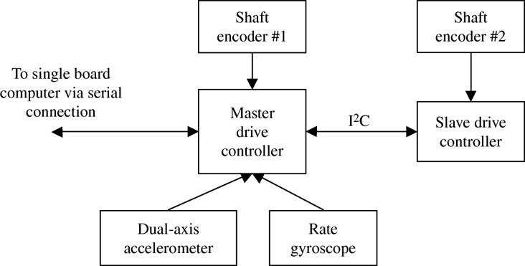

Figure 3. Illustration of drive controller layout (Butler & Bright, 2009)

The following pages contain detailed information about each of the sections in a report.

[Sample title page]

(Arial 16 point bold)

La Trobe University Subject code

(Ariel 20 point bold)
Title of Your Report

(Arial 16 point bold)

Your name(s) Student ID number(s) Lecturer: XXX XXXXX

(Arial 12 point)

A report submitted in partial fulfilment of the requirements of the unit XXX1XX
in the Bachelor of XXX

La Trobe University, Campus Month, year

Summary (also known as the abstract)

This section contains the following elements:
background and purpose – what the report is about in 1-2 sentences a summary of the main information contained in the report (this will vary depending on the nature and purpose of the report)
the main conclusions (e.g. recommendations, outcomes of a project).

In your summary, you should not refer to specific figures or include references. The length of the summary will vary depending on the total number of words required in the report. For a first year report, the summary would usually be approximately 100 - 300 words, but you should check the requirements for particular subjects.

Example

Summary

The growth in the proportion of people of retirement age in Victoria has grown substantially in the last twenty years due to increased longevity and better health care. Investment in the provision of retirement villages has also shown healthy returns for investors and developers. The Surething Property Development Group is considering expansion into this area.
Background
& purpose
Following an extensive review of the demographic and financial
data of the target population this report found potential for substantial returns on investment for a proposed development in the xxxxx local council area in Victoria and it is recommended that immediate plans be drawn up to purchase suitable land and commission design drawings for a retirement housing complex comprising 20 single residences and 15 couple residences.
Summary of
main info
Main
conclusions

Acknowledgements
This is the section where you can acknowledge anyone who helped with a project or a report. It may not be necessary to include this section in a first year report. Check the requirements for specific tasks.

Table of Contents
The table of contents (TOC) lists all of the sections in your report and includes the section numbers and the page numbers. It is written on a separate page. It is important that your TOC is formatted correctly. Using the automatic TOC function in Microsoft Word will assist you with correct formatting. The following example of a TOC should give you an idea.

Example

Table of Contents

0.0 Introduction 1
1.0 1
1.1 2
1.2 2
1.3 3
2.0 4
2.1 4
2.2 5
2.3 5
3.0 Conclusion 6
4.0 References 7 Appendix 1: 8

Glossary of terms

It may be useful to include a glossary of terms if you have a large number of technical terms in your report.

Example

Glossary of terms: Retirement village:
Target population:

Introduction
The introduction of a report usually includes the following:

The background or context for the task. This often includes an outline of the problem being investigated. You must include in-text references in this section.
A statement of the purpose of your report. For example,
- to evaluate several approaches to…
- to examine the use of … for the purpose of …
- to investigate the options available to Company G to develop…. An outline of what is in the report and what is not (the scope of the report)
The methods used and/or sources used to compile the report (this may not be necessary for all reports)

The introduction should start with more general information and gradually become more specific. This can be represented as a funnel shape.

General information

Specific information

Example

1.0 Introduction

The Surething Property Development Group (SPDG) already successfully manages a variety of residential properties in Victoria. In order to expand their portfolio, an investigation has been undertaken in the xxxx local council area to gauge the feasibility of developing a retirement village.

At present there are no competitors in xxxxx and the demographic data obtained from the Australian Bureau of Statistics (2010) provides evidence that a target population of residents aged 55-80 years already resides in the area. The company has a sound financial base and good projections for the 2010-2011 financial year (SPDG Annual Report, 2010).
background/context
This report will present the current and projected
demographics for the XXXX council area for the next five years, and provide substantial theoretical support for the entry of the SPDG into the development of a retirement village in the XXXX council area.
outline/scope of report

Body

The body of the report contains logically ordered sections with appropriate headings and sub-headings. You will need to organise your ideas into paragraphs. All ideas that you have taken from sources such as books, journal articles or websites must be paraphrased and referenced (see Referencing). Lists with dot points may be used within the body of the text if it makes the information easier to understand. Most of the information, however, will be in paragraphs. Tables and figures, such as diagrams, photographs and graphs can be used to present information. You will probably need to refer to some theory in your explanation of what you investigated or read.

Conclusion
The first sentence of your conclusion should relate to the problem or issue outlined in the introduction and then present a summary of the main findings. It may also be appropriate to include suggestions or recommendations based on these findings.

Example

4.0 Conclusion
This report has evaluated the likely prospects for an investment by the SPDG in retirement accommodation in the XXXX council area in Victoria. Based on the demographic data obtained and the company’s current and projected financial status there is sufficient evidence that the conditions exist for a successful venture. It is recommended that:…

Reference List
At the end of your report, you need to list the references that you cited throughout the text of your report. This also includes references for figures and tables. If you are required to use a different referencing style from APA (as described in this guide), you will need to ask your tutor for the referencing guidelines for that style. Note that references need to be organized in alphabetical order based on the author’s family name and are not numbered.

Example

5.0 References

Pride, P., Elliott, G., Rundle-Thiele, S.,Waller, D., Paladino,A., and Ferrell, O., (2007) Marketing: Core concepts and applications. 2nd Asia Pacific edition, Wiley, Milton, QLD.

Zubriski,S.(2009). Marketing to target populations. Journal of Marketing and Management, 19, 358-366.

Appendix (‘Appendices’ if you have more than one)

The appendix is where you put information that is too detailed to go in the main body of the report. The types of material that go in the appendix might include raw (uncollated) data, survey questionnaires, maps or diagrams which are relevant but not useful in the body of the report.

Essays

N.B. These are general guidelines only. Therefore, it is VERY IMPORTANT that you check specific requirements in each of your subjects. This information will be in your subject guides or on LMS. If you are not sure, check with your tutor.

The process of academic essay writing

No matter what field of study you are engaged in, the same basic process can be used to plan and write your essay. This process can be divided into five steps:

- Analyse the question - identify key instruction words (see table next page), the topic/s and specific aspects to be discussed. You will need to read and re-read the essay topic many, many times!

- Research the topic - ask a series of questions about your topic to focus your research. Seek information from a wide range of sources. Keep a record of all sources used so that you can include them in your in-text references and reference list.

- Plan the essay - organise key ideas and related themes, taking into consideration format restrictions and word limits. Make sure you record which sources you used for which information. The easiest way to do this is to write an in-text reference next to your notes.

- Write the essay - construct these ideas into the key elements of an essay: an introduction, a discussion (or body) divided into a number of paragraphs, and a conclusion. The writing style is formal and impersonal. Edit for errors.

- Write your reference list (see Referencing in this guide)

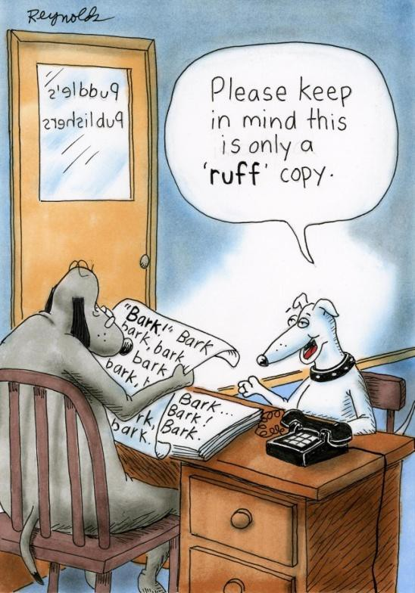

4. Guidelines for Assessment Tasks Common essay ‘instruction’ words
Analyse - break subject into parts and show how they relate to each other.

Comment - express your view or interpretation of a statement contained in the question. Support your view with argument and/or experience.

Compare and contrast - show similarities and differences between two or more systems, ideas or concepts.

Criticise - make judgments, favourable and/or unfavourable, using fair argument and balanced evidence.

Define - give clear concise meanings of terms. If necessary, use examples.

Describe - give an account with clear, well organised, logical structure. Present the different aspects of a problem. Judgements are not required.

Discuss - present different points of view about a subject from the readings. Give a balanced range of information. Investigate by argument and analysis.
Note: “Discuss the program” = √. “Discuss about the program = X

Evaluate - make judgments using argument, opinion and evidence. Similar to „criticise‟ but emphasis is on establishing standards of quality.

Examine - similar to „analyse‟, with a little more emphasis on judgment.

Explain - interpret meanings clearly by analysing events or systems, giving reasons, describing how things develop. Ask „how‟ and „why‟ of an issue.

Identify - select particular factors or circumstances required by question. Illustrate - use figures, diagrams or examples to explain/clarify a problem. Prove - confirm or verify by logical reasoning and evidence.
Relate - show how things are connected, correlated or cause one another.

Review - examine a subject critically, dealing with a number of explanations or theories; listing and relating a series of events being used as evidence for a theory.

Summarise - give a brief statement or account that covers the main points in sequence; without critical comments.

The essay writing process will be demonstrated using the essay question below.

- Analyse the question
Identify the key instruction words and think about what they mean in relation to the essay topic.

Discuss the factors which contribute to successful repatriation or re-entry for employees. Provide an evaluation of one successful and one unsuccessful repatriation process from the examples of companies that you have studied.

Discuss the factors- you will need to examine the theories which there are about successful repatriation of employees who have been working overseas. There may be consensus about what constitutes successful re-entry or there may be differing viewpoints. You will need to cover the field and determine which factors you will use for the next part of the essay.
Evaluate – you will need to make a judgement based on the factors which you have identified. Then you will need to provide the examples of one company that modelled a successful process and one which did not. In this question you would need to explain what the company did that worked. Similarly you would offer some analysis of what did not work and relate both to the factors for success which you identified in the first part of the essay.

- Research the topic
Brainstorm a list of research questions, based on the question you are writing about. This will help you to generate ideas and ensure that you do not overlook anything important. For the example essay topic, these questions might include:

What do we mean by successful repatriation?
What do we know about the factors which make re-entry successful?
Are there any differences between what employees see as successful and the views of managers or HR?
Is there any difference between countries in how they manage this process? Is there Australian research on this topic or is it all from overseas?

Begin with what you know from lectures and tutorials then proceed to books and journal articles and web resources. Use library catalogues – including electronic data bases and seek the assistance of your subject librarian (see Reading for Assignments in this guide).

- Plan the essay
Look at the questions you asked and brainstorm all the ideas that they generated. The next step of grouping is critical. This is where you attempt to find common ideas within the brainstorm. Give your grouped ideas a heading. These groups then become the themes for your essay. Finally, outline the essay in detail with each theme becoming a main point supported by factual evidence. Write down all necessary referencing details as you plan.

- Write the essay
Construct these ideas into the key elements of an essay: an introduction, a discussion (or body) divided into a number of paragraphs, and a conclusion. The writing style is formal (see Guidelines on Writing in a Formal Style). Read through your completed work and see if it answers the question. Proof read for any spelling or grammatical errors.

- Write your reference list
Make sure that all references cited (in-text) are included in your reference list and all references in your list have been cited in your essay (see Referencing).

The structure of academic essay writing

The following examples illustrate the essential elements of an essay – an introductory paragraph, a body paragraph and a concluding paragraph.

Model Introductory Paragraph

The introductory paragraph sets the scene for the whole essay. It consists of four sections which move from general to specific information.

- Introduce the general topic of your essay in an interesting way.

- Give background or context which gives relevance to the discussion.

- Include a thesis statement which is the main point of the essay

- List subtopics/themes to indicate the order of discussion to follow (each theme mentioned in the introduction, is addressed in the same order in the body).
A brief definition may belong in the introduction (one sentence only). Keep all information relatively general (no detailed evidence).

In a globally competitive and connected world, organisations often send employees to work overseas for periods of time. It has been calculated that the costs associated with a long term international placement in a multinational company could cost as much as $1 million dollars per person. (McNulty,2007 in Kulkarni, 2010). Having spent so much on expatriation expenses it is all the more remarkable that very little is known about how companies and individuals manage re-entry of those employees.
The phenomenon of repatriation or re-entry stress has been written about since the 1980s, (Adler, 1981; Sussman, 1986; Kulkarni, 2010) and the factors for success have been identified. There are basically five of them. They are the length of time spent away, the employee’s perceptions of the repatriation assistance, family interaction, career satisfaction and the advancement opportunities made available on return. These five factors will be explained and then two companies will be examined in detail. Company A has a reputation for good success in reintegrating employees while Company B has experienced less success. The reasons for this will be evaluated.

Introduce topic

Background or context

Thesis statement

Themes or sub-topics

Model Body (Discussion) Paragraph

Each body paragraph develops or expands the original thesis statement in a logical manner using evidence to illustrate the specific point being made.

- Topic sentence = the specific topic of this paragraph (only one per paragraph)
- Supporting sentences = evidence to support the topic sentence
- Concluding sentence = may restate initial point made, lead into next paragraph, provide a link to overall argument or make a final statement

4. = words and phrases that link one idea to another and show the relationship between them. They provide the logic and cohesion for the essay.
Connectives

While people expect culture shock when they move overseas for work, they are often unprepared for the same symptoms when they return.
Indeed ,there is evidence that repatriation may cause culture shock which is just as severe as that experienced with expatriation. (Adler, 2005 in Kulkarni, 2010). There are several studies which suggest that repatriation is context specific but that the length of time they have been away (Sparrow, 2002), the changes in the employee‟s own attitudes (Hart and Stroh, 2000) and the extent to which the HR department is pro-active (Black, 2008) all contribute to the severity or the alleviation of the severity of culture shock. In addition, an Indian study by Kulkarni (2010) showed that the home culture had also often changed which the employees had not anticipated.
Thus, it can be argued that repatriation is just as complex and problematic as expatriation and needs to be managed sensitively.
Topic sentence

Supporting sentences

Concluding sentence

Model Concluding Paragraph

The concluding paragraph rounds off your essay by reminding the reader of your main point, the supporting themes or sub-topics and a strong final comment. There are four aspects to consider in the conclusion.

- Signal the end of the essay with a connective: “In conclusion; To summarise”.

- Paraphrase your thesis statement (the main point of the essay).

- Paraphrase and summarise the sub-topics/themes addressed in the essay to remind the marker of your main discussion points.

- Leave the marker with a strong effective comment; a message they will remember.
Don’t add any new material.
Avoid detailed information – the conclusion is a more general statement.

five factors which contribute to successful repatriation have been identified in the literature. When all five of these factors are addressed by the company, the returning employee is more likely to avoid culture shock and settle back into their career. While Company B recognised that returning employees would require some time to settle back into the company, there was inadequate attention paid to the family interaction with work or to the future career opportunities of the returning employee.
In conclusion,

If the five factors which contribute to successful repatriation are recognised and HR departments are trained and resourced to deal with them sensitively and systematically, as was the case with Company A, then both the individual and the company are likely to benefit.

Paraphrased thesis statement

Summary of paraphrased themes

Final comment

Giving an Oral Presentation

These are general guidelines only. Therefore, it is VERY IMPORTANT that you check specific requirements in each of your subjects. This information will be in your subject guides or on LMS. If you are not sure, check with your tutor.

Preparation for the oral presentation

Preparation is the key to a successful oral presentation. Your speech will only be as good as the amount of work you put into it. It is also the best way to decrease nervousness.

  - Define the purpose: Are you informing/instructing or reporting?

  - Analyse the audience: For example, how many people will be there? Make sure you have enough handouts. Consider such factors as level of knowledge.

  - Consider context: Formal or informal? Will you need to bring anything?

  - Identify main ideas of topic: Brainstorm the main ideas needed to get the message across and then order them into a logical sequence.

  - Research supporting material: Ensure you gather strong factual evidence to support the main points. Is it current, relevant, accurate and documented? Unlike an essay, personal experience can also be relevant to illustrate your evidence.

  - Group presentations: Ensure that both preparation and presentation time is equally shared amongst all group members. Each team member should briefly introduce the next presenter and what they will talk about.

Writing the oral presentation

- Planning the material: Focus on the purpose of the speech at all times. Logically order each main point and its supporting evidence. Prepare an outline plan in conjunction with the marking criteria.

- Writing the presentation: An oral presentation is structured and each section has a specific purpose and organisation.
Introduction: aims to catch the audience’s attention and introduce the topic. Open in a way that stimulates interest. a short story (anecdote); an interesting fact, statistic or image related to your topic.

- Provide some background or context for the topic. In other words,
indicate to the audience why your topic is important and/or describe the problem you are working on. Don’t assume that the audience is already familiar with your topic or project.

- Give a clear statement of the main premise/point of your presentation.

- Provide a plan of your presentation by outlining the main points to follow.

Discussion/ Findings (body of the presentation): aims to inform your audience.

Present only 3-5 main points. It is better to discuss each point in depth.
Support each point with strong factual evidence.
Use a variety of examples, diagrams, graphs and statistics.
Use relevant personal experience (yours or others) where appropriate. Use connectives to link your ideas, such as Firstly, Secondly, In addition, Finally, However. This provides cohesion and logic for the audience.

Conclusion: is often overlooked! It is important to end on a strong note.

Give a clear signal that you are concluding: In conclusion, In closing,
Restate the original premise or point of view.
Summarise the main points used to support that premise.
End effectively with a relevant anecdote, recommendation or challenge.
Invite questions if appropriate.
Complete your talk with a suitable “Thank you” rather than “Well that‟s it”!!

NOTE: In some classes presenting is based on practical work so the content may be more specific. For example, the introduction may require an outline of the Aims and Hypotheses, followed by an explanation of the Materials and Methods. The Results and their interpretation would then be discussed before drawing Conclusions. The same logic and linking would still apply.

Using PowerPoint Effectively

Keep it Simple. If using a template, choose a simple one with easy to read fonts. Avoid special effects and animations unless they are related to a point you are making. Do not overuse colour.

Avoid overcrowding slides. Use bullet points if appropriate (but do not assume all text should be bulleted). Never use full sentences; use key words only. It is better to use more slides with fewer points on each than to overcrowd slides.

Make it readable. If the audience cannot read what is on your slides, there is no point in including it. Font size should be at least 20. Avoid capital letters. Diagrams can be a very effective way to convey information, but make sure they are easily readable. Make sure you guide the audience through your diagram by pointing to the relevant parts as you speak.

Choice of colour is a very important factor influencing readability. The Colour Visibility Chart on the next page shows different coloured fonts on different background colours.

Colour Visibility Chart
black on yellow |  | yellow on black
black on white |  | white on black
black on orange |  | orange on black
blue on white |  | white on blue
green on white |  | white on green
red on white |  | white on red
red on yellow |  | yellow on red
black on red |  | red on black
red on orange |  | orange on red
red on blue |  | blue on red
red on green |  | green on red

Delivering the oral presentation

Avoid reading the presentation as there is an automatic drop in both audience attention and marks. However, it is unwise to attempt to memorise the whole speech. Some useful hints:

  - Use power point slides as cues: Summarise each main supporting point. Use headings and sub-headings, a numbering/lettering system and key words. Try using the “presenter view‟ function on PowerPoint. This enables you to see which slides are coming up next, while the audience only sees the slide you are presenting.

  - Practise, practise, practise! Practise the complete presentation aloud and many times. Practise in front of an audience such as family, friends, videotape or a mirror! Time the speech and stick to given limits.

  - Have a backup plan in case the technology fails!

Use visual aids to add interest, to help simplify the message and to increase audience understanding. Visual aids need to be large, clear, simple and relevant. Make any handouts available before the speech begins. Refer directly to the visual aid in the speech. Know how to use the technology and ensure that equipment works before the presentation begins.

Know what’s coming up next. Be sure to know which slide is coming up next so that you can introduce it and link it to the previous slide before you hit the page down button. For example, “So after I designed and built my robot, I needed to test it” (the previous slides would have shown how the robot was designed and built and next slide would show how the functionality of the robot was tested).

Voice signals are vital. Speak more slowly, pronounce words more clearly than normal, raise your voice and project towards the back wall, and avoid “conversational” language such as “um, er, gonna and youse”.

Body signals are also important. Always face the audience (never board or screen unless you need to point to something on a diagram) and stand straight with chin up to direct your voice to the listeners. Keep hands open and avoid nervous gestures.
Eye contact is essential. Be sure to scan across the audience rather than focusing on one or two individuals.

Remember, nervousness is normal.
Thorough preparation and practice decreases anxiety. Organise equipment and visual aids early and ensure power point slides are simple and clear. It may help to bring detailed notes to get you started and as a „safety net‟ throughout the presentation. Breathe deeply. Develop positive mental thoughts.

If fear is extreme see a counsellor!

Working in a Team

Teamwork is widely practiced, and is considered by the University to be an important Graduate Capability. It’s also a lifelong skill – many employers rate good teamwork skills highly in their employees.

Getting started in a team: What do you need to do first?

- Break down the assignment into tasks and interim deadlines
- How will you decide who does which tasks?
- Who is responsible for circulating the information?
- Exchange contact details: email or email & phone, and check each team member’s availability
- Set up meetings to write, rehearse, prepare
- Put all meeting & submission dates in your diaries/calendars/phones
- Delegate a team member to send brief notes of the meeting to others by email or text (e.g. “Dave agreed to finish the intro. Min agreed to finalise graphs” etc.)

How to be a good team-member

- Provide clear boundaries: set basic rules for how the team will work together
e.g. listen respectfully when other team-members speak, don’t phone people after 9 pm etc.)
- Have definite tasks to perform: each team member knows exactly what they need to do to complete the task (e.g. Read other team-members‟ sections and then write the conclusion).
- Meet deadlines: Your tutor/lecturer expects assignments in on time, and penalties usually apply for late submission of work. Not having your task ready on time will make the whole group late, and this is stressful for everyone.
- Depend on co-operation: A well-functioning team means that the members support, trust and depend on each other to do their best.
- Keep in regular contact: Regular phone and email contact keeps the energy flowing and supports the team to get the task finished. If there is a problem, contact other team members immediately.
- Look at the task holistically (the whole thing, not just “your bit”)
- Listen to and respect your teammates’ opinions

Work to your strengths
- Knowing what kind of a team member you are allows you to use those qualities to the advantage of the group (and yourself). You might be good at coming up with good strategies and strategies for the task; summarising information and drawing it together; editing the final product

Good teamwork communication means
sharing information listening to learn
persuading other members to interact respecting team members
managing conflict constructively

Problems occur in teams when

- Common goals are not understood (or ignored) by one or more team members
- Team members have different goals
- Team members are highly competitive, or unmotivated to “do their bit‟.
- Team workload is unevenly distributed – one person has a huge task to complete, while another person has a 20 minute task.
- Goals or outcomes are unclear.
- One person dominates, so other peoples’ opinions are no heard.

Resolving conflict in your team

- Best treated within the group initially.
- Mutual respect is important, even when you disagree with a team-member’s behaviour.
- Allow people to say ‘what happened’ without judgement
- Remind each other of common goals
- Go to your tutor as last resort.

